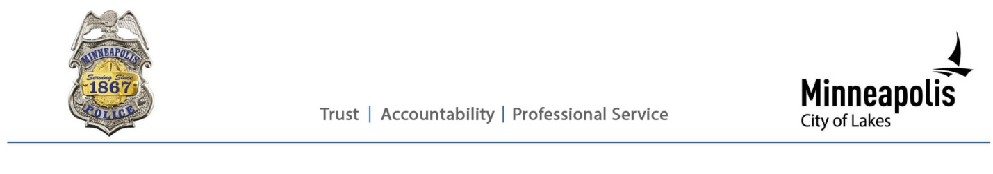
Public information release

Sgt Garrett Parten
(Cell) 612-673-5800
(Email) PolicePIO@minneapolismn.gov

Minneapolis Police Investigating Fatal Shooting
July 16, 2025 (MINNEAPOLIS) — Minneapolis Police Chief Brian O’Hara announced that officers are investigating a fatal shooting that occurred Tuesday evening.
At approximately 6:26 p.m. on July 15, 2025, First Precinct officers responded to a report of a shooting on the 1500 block of 11th Avenue South.
Officers found a man in his 30s on the porch of a residence with at least one life-threatening gunshot wound. Officers immediately rendered lifesaving aid until relieved by firefighters and paramedics. Despite their efforts, the man was pronounced dead at the scene.
Preliminary information indicates an altercation between a group of people on the sidewalk escalated into gunfire. A man reportedly produced a firearm and fired toward the residence. The gunman left the scene before officers arrived.
The Minneapolis Police Department is actively investigating the circumstances surrounding the shooting.
“Our investigators will do everything they can to identify the shooter in this homicide, including gathering any available video from the area,” Chief O’Hara said. “We need anyone with information — no matter how minor it may seem — to share that information with us.”
The Hennepin County Medical Examiner’s Office will release the man’s name, along with the official cause and manner of death.
Case number: 25-196660
Anyone with information is encouraged to contact MPD by emailing policetips@minneapolismn.gov or calling 612-673-5845 to leave a voicemail.
Those wishing to remain anonymous can contact CrimeStoppers at 1-800-222-TIPS (8477) or submit a tip online at www.CrimeStoppersMN.org. All tips are anonymous, and information leading to an arrest and conviction may be eligible for a financial reward.
####

