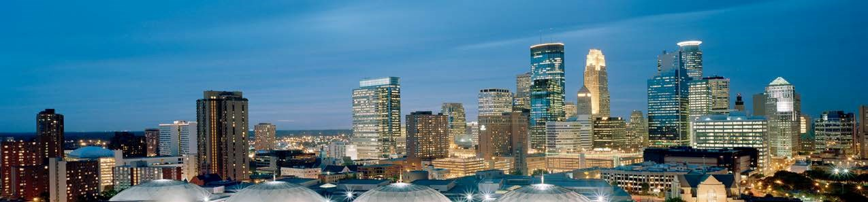

IMMIGRATION INFORMATION SESSION

Thursday, April 4, 2019
9:30AM-12:00 PM
Hosted by: Lao Assistance Center of Minnesota
503 Irving Ave N Ste 100A, Minneapolis, MN 55405
http://www.laocentermn.org/
and
The Minneapolis Office of Immigrant and Refugee Affairs

9:30-9:40: Purpose of session and introduction of speakers by Michelle Rivero, City of Minneapolis, Office of Immigrant and Refugee Affairs

9:40-11:10: Colleen Beebe Purisaca, Attorney and Immigration Service Project Manager, Volunteer Lawyers Network (VLN)— providing services to immigrants, what constitutes legal advice, what immigration focused legal service organizations exist in the Twin Cities and more

11:10-11:30: Nicky Leingang, Sr. Community Representative, Office of Representative Ilhan Omar:
Repatriation updates and congressional liaison assistance information

11:30-11:50: Kristian Doan, CAPI: Summary from Asian Americans Advancing Justice Conference

11:50-12:10: Mai Neng Moua, Immigration removal defense attorney

12:10-12:30: Questions

For more information or to request assistance in scheduling a community forum or legal clinic on immigration related issues please contact:
City of Minneapolis Office of Immigrant and Refugee Affairs (OIRA)
Michelle Rivero, Director
Phone: 612-673-6103 Cell: 612-357-1875
email: michelle.rivero@minneapolismn.gov
Website: http://www.minneapolismn.gov/ncr/oira/index.htm

