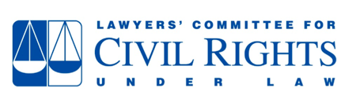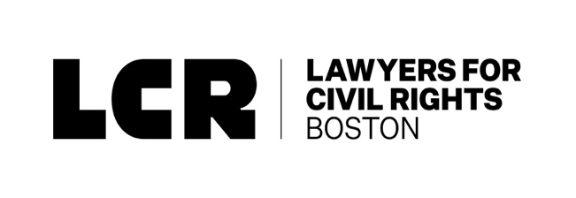

Liberian Immigrants Sue President Trump

Families, Community Groups, and Civil Rights Organizations File Lawsuit to Protect Life-Saving Immigration Program
For Immediate Release
March 8, 2019
BOSTON, MA – The Lawyers’ Committee for Civil Rights Under Law and Lawyers for Civil Rights jointly filed a lawsuit today challenging President Donald Trump’s termination of humanitarian protection and relief for immigrants from Liberia. The lawsuit, the first of its kind in the country, was filed on behalf of African Communities Together (ACT), the UndocuBlack Network, and fifteen affected individuals, including Liberians raising U.S. citizen children. The complaint was filed in the U.S. District Court for the District of Massachusetts.

The lawsuit challenges President Trump’s March 27, 2018 decision to terminate Deferred Enforcement Departure (DED), a life-saving immigration program, marshalling evidence of discrimination based on race, ethnicity, and/or national origin in violation of the Due Process Clause and the Equal Protection Clause of the U.S. Constitution.

Deferred Enforced Departure (DED) is a humanitarian program that protects approximately 4,000 Liberian immigrants in the United States. Over the past two decades, DED was renewed under both Republican and Democrat administrations because of environmental disasters and armed conflict in Liberia.
President Trump’s decision to terminate DED marked an abrupt departure from the practice established by previous administrations. Under DED, Liberians have been able to to live, work, and raise U.S. citizen children.

“The Trump administration’s decision to terminate Deferred Enforced Departure for Liberian immigrants was the direct result of intentional discrimination directed at the Liberian community, runs contrary to evidence, and violates the constitution. This lawsuit seeks to combat the discriminatory and xenophobic immigration policies driven by the Trump administration in order to keep Deferred Enforced Departure recipients and their families together,” said Kristen Clarke, president and executive director of the Lawyers’ Committee for Civil Rights Under Law. “We are turning to the courts to ensure stability for Liberians all across our country who have contributed positively to their communities and our economy, many for over thirty years.”

“This is the latest discriminatory attack from the Trump Administration on longstanding immigration programs. First, they came for DACA recipients brought to this country as children. Then, they came for immigrants of color protected under TPS. Now, they come for Liberians. We will not stand idly by as immigrants of color are threatened with detention and deportation. We will not allow the Trump Administration to trample on our dignity and our constitutional rights. We will resist all forms of discrimination, and we will hold the Trump Administration accountable for attacking Liberian families,” said Iván Espinoza-Madrigal, the Executive Director of Lawyers for Civil Rights.

“At the UndocuBlack Network, we know how it feels to be discriminated against, underestimated even when justice is on our side,” said Patrice S. Lawrence
National Policy & Advocacy Director of the UndocuBlack Network. “Consequently, we know how to fight back and win. President Trump set the termination date of the DED program for Liberians for March 31, 2019, negatively affecting up to 4,000 people we know and love. This means we now have days to ensure the stability of Liberians who have been in the country for almost 30 years. We join this lawsuit to challenge the discriminatory intentions of the Trump Administration, and to ensure that our Liberian communities can maintain the ability to thrive.”

"We are suing on behalf of our Liberian DED holder members who have been in this country for decades. They have renewed their status time and time again, been vetted time and time again, and have built their lives here in the United States," said Amaha Kassa, Executive Director of African Communities Together.

As it currently stands, DED is set to expire on March 31, 2019. The rescission of this program will result in the separation of families and harm thousands of Liberians across the country.

The complaint is attached.

About the Lawyers’ Committee for Civil Rights Under Law:
The Lawyers’ Committee for Civil Rights Under Law, a nonpartisan, nonprofit organization, was formed in 1963 at the request of President John F. Kennedy to involve the private bar in providing legal services to address racial discrimination. Now in its 55th year, the Lawyers’ Committee for Civil Rights Under Law is continuing its quest to “Move America Toward Justice.” The principal mission of the Lawyers’ Committee for Civil Rights Under Law is to secure, through the rule of law, equal justice for all, particularly in the areas of criminal justice, fair housing and community development, economic justice, educational opportunities, and voting rights.

About Lawyers for Civil Rights:
Founded in 1968, Lawyers for Civil Rights (LCR) fosters equal opportunity and fights discrimination on behalf of people of color and immigrants. The organization engages in creative and courageous legal action, education, and advocacy in collaboration with law firms and community partners. LCR filed the first lawsuits in the country against the Trump Administration to protect sanctuary cities; to save TPS on behalf of Central American immigrants; and to block immigration arrests in courthouses. For more information, visit www.lawyersforcivilrights.org.

