**MINNEAPOLIS POLICE DEPARTMENT**

***UPCOMING BLOCK LEADER TRAININGS***

***Thursday, March 1***

***Wednesday, April 4***

***Tuesday, May 8***

***Monday, June 11***

***(you need only attend one session)***

***6:30 to 8 PM***

***Minneapolis Police Dept***

***3rd Precinct Community Room***

***3000 Minnehaha Avenue***

***Crime Prevention Block Leaders………***

* Help build Community one block at a time.
* Organize your neighbors so that you have a direct impact on reducing crime. Neighbors who are informed are the strongest crime prevention tool for communities.
* Work with neighbors and MPD if there is a problem on the block.

***RSVP appreciated so we have enough materials. You can RSVP by calling Crime Prevention Specialist Karen Notsch at 612/673-2856 or email her at*** [karen.notsch@minneapolismn.gov](mailto:karen.notsch@minneapolismn.gov)

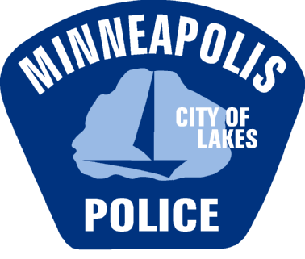

**MC900045085[1]**

**One of the Minneapolis Police Department’s top goals is to increase organized blocks.** **Neighborhoods and block clubs work with our Crime Prevention Specialists to prevent and reduce crime. It’s not just about crime…..it’s about building community. Get your block organized!**