Once logged in to MOPRO, click on the “Renew License” link.
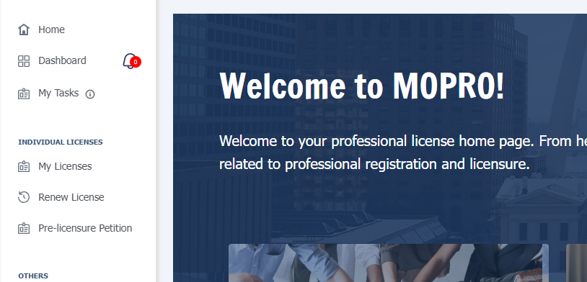

You will then select the eyeball icon to the far right of your license number.

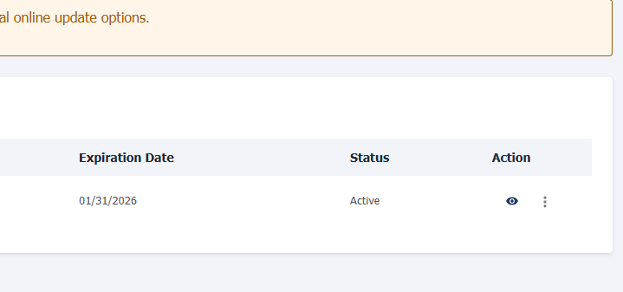

After selecting the eyeball, you will then choose between an online renewal or a paper renewal form. If choosing online renewal, you will select “Renewal Application”. If choosing paper renewal, you will select “Download Renewal Form”. This will open a PDF that you can then print off, fill out, and mail in with a check or money order.
