Step 1: Log in at www.mnresponds.org
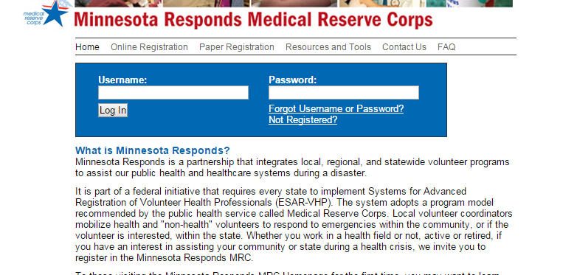

Not yet registered? Click on the “Not Registered?” link just below the Password field.

Step 2: Go to the “My Profile” Tab
In this tab, you can update or change any of your profile’s information.
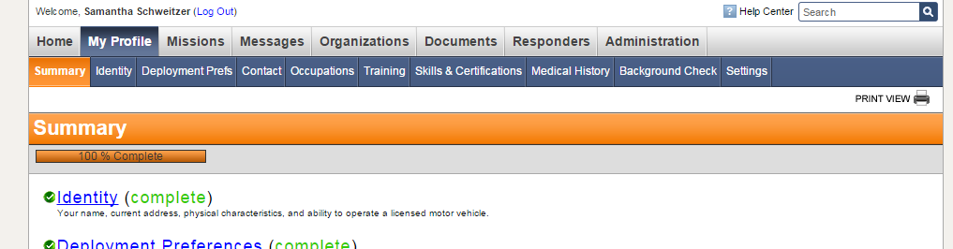
Click the “My Profile” tab on the gray tab bar.
Step 3: Go to the “Settings” Tab
In this tab, you can update your username, password, and security question.
Click the “Settings” tab on the blue tab bar.

Step 4: Go to the “Contact” Tab
In this tab, you can update your contact information; this information may be used by your Unit’s Coordinator and by MN Responds during exercises and real events.
Click the “Contact” tab on the blue tab bar.
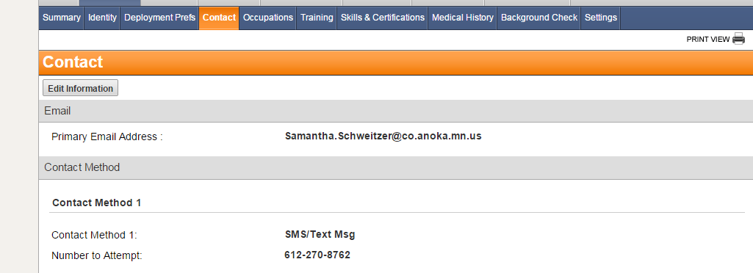
Click on the “Edit Information” gray button under the orange Contact bar.
You can add up to four telephone or text message numbers. You can add multiple email addresses.
Use the arrows on the right hand side to arrange contact methods in the order you would prefer they be contacted.
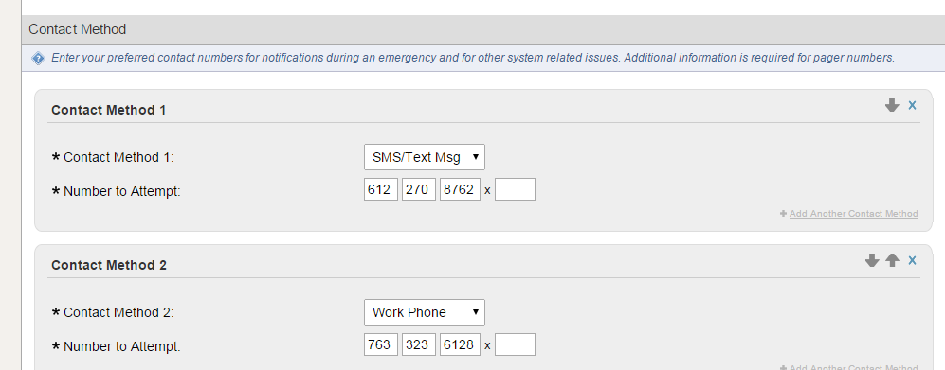
Use these arrows to arrange your numbers in your preferred order of contact.
You can add up to 4 contact methods in here – we ask that you list at least two.

