Free COVID-19 Vaccine Clinic
Appointments Available: July 12 through August 30, 2022

Locations & Times:
West St. Paul Clinic – Tuesdays, 5:30 to 7:30 p.m.
Brooklyn Park Clinic – Thursdays, 5:30 to 7:30 p.m.
Minneapolis Clinic –Saturdays (07/16, 07/30, 08/13, 08/27), 9 a.m. to 3 p.m.
St. Paul Clinic –Saturdays (07/23, 08/06, 08/20), 9 a.m. to 3 p.m.
Free parking available at all locations.
Walk-ins are welcomed, but appointments are recommended.
Vaccine Type: Pfizer-BioNTech
Booster doses now available for ages 5+
Fourth doses available for immunocompromised children 12+
For All Pfizer-BioNTech Doses: Must be 6 months-old or older
*Parents must give consent for all minors and are required to be present for children ages 6 mo.-15.

For more details and to sign up for an appointment:
- Appointments are now bookable for the first dose date listed above. To schedule, use this link: https://my.primary.health/r/childrens-mn?registration_type=default

- Or scan the below QR code:
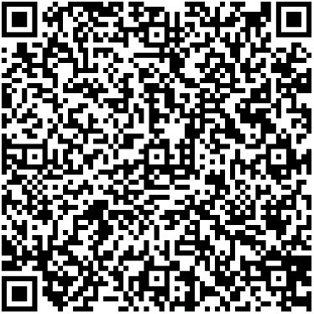

What you need to sign up for an appointment:

- You need to provide only your first name, last name, date of birth, and home address.
- You are encouraged to provide your mobile phone number and email address, if you have them.
- If you are unable to sign up for an appointment in advance, walk-ins are welcomed.

What you need for your appointment:

- You are required to wear a mask and comply with social distancing requirements.
- You need to confirm your first name, last name, date of birth, and home address.
- You do NOT need to show an ID.
- You do NOT need medical insurance.
- Language interpretation and American Sign Language (ASL) will be available onsite.
- ADA accommodations available onsite.

Public transportation:
- Metro Transit: Trip Planner (www.metrotransit.org/trip-planner).
- Metro Mobility Customers who are certified can call transportation providers to schedule their trips at 651-602-1111 (TTY 651-221-9886).

Minnesota Department of Health | health.mn.gov | 651-201-5000 625 Robert Street North PO Box 64975, St. Paul, MN 55164-0975
Contact health.communications@state.mn.us to request an alternate format.

