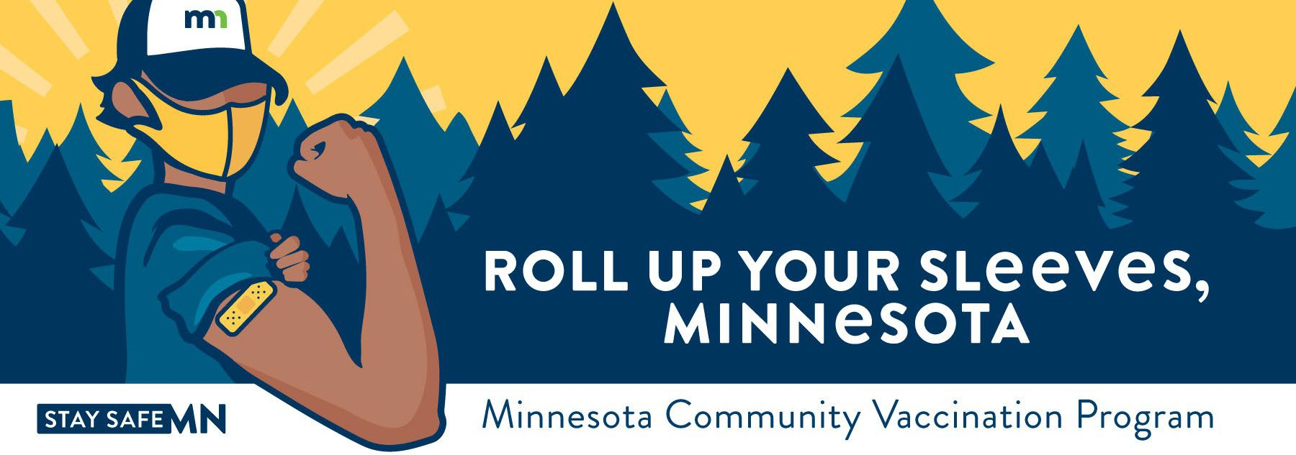

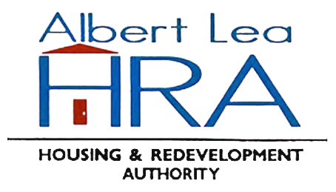
Free COVID-19 Booster and 2nd Dose Clinic
Location:
Shady Oaks
800 S 4th Ave Albert Lea, MN 56007

Vaccine Type:
Pfizer

No appointments necessary. Walk-ins accepted.
Wednesday, March 23, 2022
9:30 AM – 4:00 PM
For Pfizer 2nd Dose: Must be 5 years-old or older and received 1st dose 3 weeks ago
For Pfizer Booster Dose: Must be 12 years-old or older
*Parents must give consent for all minors and are required to be present for children ages 5-15.

What you need to receive a vaccine:

- You are required to wear a mask and comply with social distancing requirements.
- You need to confirm your first name, last name, date of birth, and home address.
- You need to bring your COVID-19 Vaccination Record card
- You do NOT need to show an ID.
- You do NOT need medical insurance.
- ADA accommodations available onsite.

Public transportation:
- SMART Southern MN Area Rural Transit
- Call to schedule a ride, 1-855-762-7821, TTY 1-800-627-3529

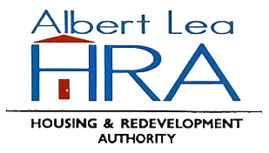


Minnesota Department of Health | health.mn.gov | 651-201-5000 625 Robert Street North PO Box 64975, St. Paul, MN 55164-0975
Contact health.communications@state.mn.us to request an alternate format.

