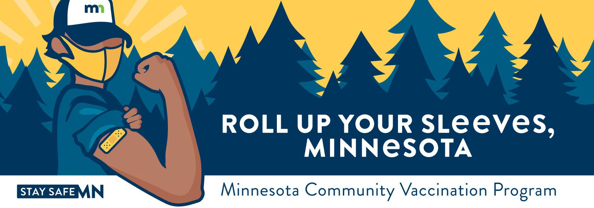


Free COVID-19 Vaccine Clinic

Location:
Seventh Avenue Apartments
3230 7th Ave E Hibbing, MN 55746
(Clinic entrance at back door #6)

Vaccine Type:
Pfizer

No appointments necessary. Walk-ins accepted.
Tuesday, March 8, 2022
9:00 AM – 5:00 PM

Second Dose Date:
Tuesday, March 29, 2022

For Pfizer 1st & 2nd Dose: Must be 5 years-old or older For Pfizer Booster Dose: Must be 12 years-old or older
*Parents must give consent for all minors and are required to be present for children ages 5-15.

What you need to receive a vaccine:

- You are required to wear a mask and comply with social distancing requirements.
- You need to confirm your first name, last name, date of birth, and home address.
- You do NOT need to show an ID.
- You do NOT need medical insurance.
- ADA accommodations available onsite.

Public transportation:
- Hibbing Area Transit
- Call at least two hours before to schedule a ride, 218-263-2115



Minnesota Department of Health | health.mn.gov | 651-201-5000 625 Robert Street North PO Box 64975, St. Paul, MN 55164-0975
Contact health.communications@state.mn.us to request an alternate format.

