COVID-19 and Chronic Disease
  - Know your risk messages
11/30/2020
The following messages and images are intended to be adapted and shared for your audience. Please feel free to edit them and share widely via social media, e-newsletters, etc.

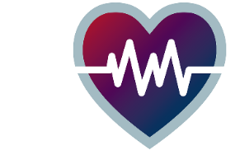
Know your risk for severe illnesses
- More than half of Minnesota adults have a health condition that puts them at higher risk for severe illness from COVID-19. If you have diabetes, high blood pressure or asthma, continue taking medications as directed and talk to your doctor about managing your condition. https://www.health.state.mn.us/people/conditions/index.html
- Serious heart conditions can mean more severe illness from COVID-19. Heart health is more important than ever during COVID-19. https://youtu.be/d65HUqRsLec
- Public health officials are emphasizing the risk between COVID-19 and cardiovascular disease. Your heart health matters, especially during the pandemic. https://youtu.be/d65HUqRsLec
- Having high blood sugar from prediabetes or diabetes can make it difficult to fight off COVID-19. There are ways to manage blood sugar and lower your risk of severe COVID-19. Learn about your prediabetes risk and changes you can make now: https://doihaveprediabetes.org/take-the-risk-test/#/
- Now, more than ever, it’s important to manage your health and reduce your risk for heart attack, stroke, and diabetes, which can all put you at higher risk for severe illness from COVID-19. Empower yourself with tools to reduce the risk of chronic disease through free virtual health lessons from the American Heart Association. Sign up at www.empoweredtoserve.org/communitylessons.

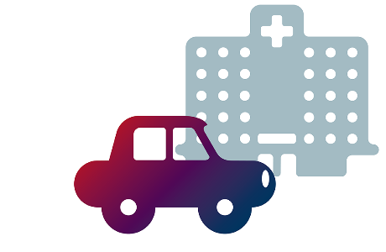
Check your health
- Understanding your risk for heart disease, high blood pressure or diabetes is important for making sure you stay healthy, especially during the COVID-19 pandemic. If it’s been a while since you’ve seen a health care provider, make an appointment now! Clinics have taken extra steps to keep patients and staff safe, like spacing out appointments and requiring masks.
- Diabetes and high blood pressure are more common than you might think, and many people don’t know they have them. The good news is these conditions are manageable. Check out some tips and see if you’re at risk: https://www.health.state.mn.us/people/conditions/index.html
- Don’t ignore your health concerns because of the pandemic. If you’re experiencing new symptoms or noticed a change in an existing condition, contact your doctor or local clinic. https://www.health.state.mn.us/people/conditions/index.html
- If you have diabetes, you should get an A1C check at least twice a year, which looks at your blood sugar over time. It’s important to know if you need to adjust your treatment, especially during the COVID-19 pandemic. https://www.cdc.gov/diabetes/managing/manage-blood-sugar.html
- Getting treatment for your diabetes is important to staying healthy. If you have diabetes and can’t afford insulin, you may qualify for emergency insulin assistance: A one-time, 30-day supply for $35. Rationing insulin could lead to diabetic ketoacidosis, which is dangerous and can be deadly. Learn more: MNinsulin.org
- Ask your doctors about your health numbers (such as A1C, blood pressure, cholesterol) and what they mean for you. You can take steps now to improve your health numbers. https://www.heart.org/en/health-topics/diabetes/prevention--treatment-of-diabetes/know-your-health-numbers
- Mammograms help catch breast cancer early, which can make treatment easier and save lives! Many clinics in Minnesota offer free mammograms and are taking extra precautions to keep patients safe, such as spacing out appointments and requiring masks. The Minnesota Sage Program offers free screenings for those who qualify. Call 1-888-643-2584 or learn more at www.health.state.mn.us/diseases/cancer/sage/screening/index.html.
- Cancer screenings are more important than ever. Early detection can make treatment easier and save lives! Many clinics in Minnesota offer free screenings and are taking extra precautions to keep patients safe, such as spacing out appointments and requiring masks. The Minnesota Sage Program offers free breast, cervical and colorectal cancer screenings for those who qualify. Call 1-888-643-2584 or learn more at www.health.state.mn.us/diseases/cancer/sage/screening/index.html.
Minnesota Department of Health | health.mn.gov | 651-201-5000
625 Robert Street North PO Box 64975, St. Paul, MN 55164-0975
Contact health.communications@state.mn.us to request an alternate format.

