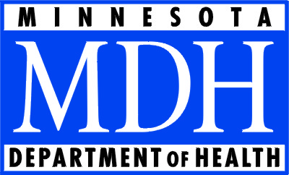

The Licensing and Certification Program at the Minnesota Department of Health will offer a free MDS class for new MDS nurses.
When: Wednesday, October 30, 2013, 8 a.m. - 4:30 p.m.
Where: Minnesota Department of Health
85 East 7th Place, St Paul, MN
Check in at Room 220
The class, Basic Training for New MDS Nurses, will be presented by the State RAI Coordinator, Nadine Olness, RN and will cover:
- OBRA and PPS Assessment Scheduling
- An Item by Item Review of the Comprehensive Item Set
- Common MDS Coding Errors
- A Brief Overview of CAAs
For the best experience participants should have some experience with the MDS. Participants should bring a blank copy of a comprehensive item set and a current copy of the RAI manual v1.11.
This class is offered to new MDS nurses only (less than one year experience with the MDS). Space is limited to 30 registrations and each facility may send one participant. Participants must register by the end of the business day on Monday, October 21, 2013 at the following link http://www.health.state.mn.us/registration/nocharge/
Due to budget constraints we are unable to provide meals, snacks and beverages. Vending machines are available. The Minnesota Department of Health is located in the Golden Rule building in downtown St. Paul. The Golden Rule building is on the skyway system which offers a variety of full service and fast dining options. For a list of restaurants and a skyway map please see the links below.
Restaurants: http://twincitiesdiningguide.com/pages/st_paul_downtown_restaurants.asp?page=50&sort=
Skyway System Map: http://www.stpaul.gov/DocumentCenter/Home/View/5052
If you have questions or desire additional information please call 651-201-4301

