

Hennepin County forestry survey

About survey
Hennepin County is working to better understand perspectives Hennepin County residents hold about trees on private property and in our communities. We will use what we learn to influence an educational forestry marketing campaign in 2026. The survey will be open from Wednesday, November 19 to Friday, December 6, 2025.

Resources to promote the forestry survey
Ways to educate the public about the forestry survey:
- Use the sample newsletter article to share on your organization’s website or in your newsletters. These are editable so you can customize the length or message.
- Use the sample social media post to share through your social media channels. These are editable so you can customize the message and website.
- To use images and graphics: right click on image and select save picture as, alt text for you to use is included with the pictures and graphics.
- Follow and reshare messages posted on the Hennepin County Environment and Energy social media channels: Hennepin Environment on Facebook, Hennepin Environment on Instagram, and @hennepinenviro on X/Twitter.

Contact
For more information about the survey, contact:
- Dustin Ellis, Forestry Supervisor, dustin.ellis@hennepin.us
- Angie Ziobro, Communications Lead, angie.ziobro@hennepin.us

Sample newsletter article

Love trees? Have tree troubles? We want to hear from you!

Hennepin County wants to hear from you about trees in your community
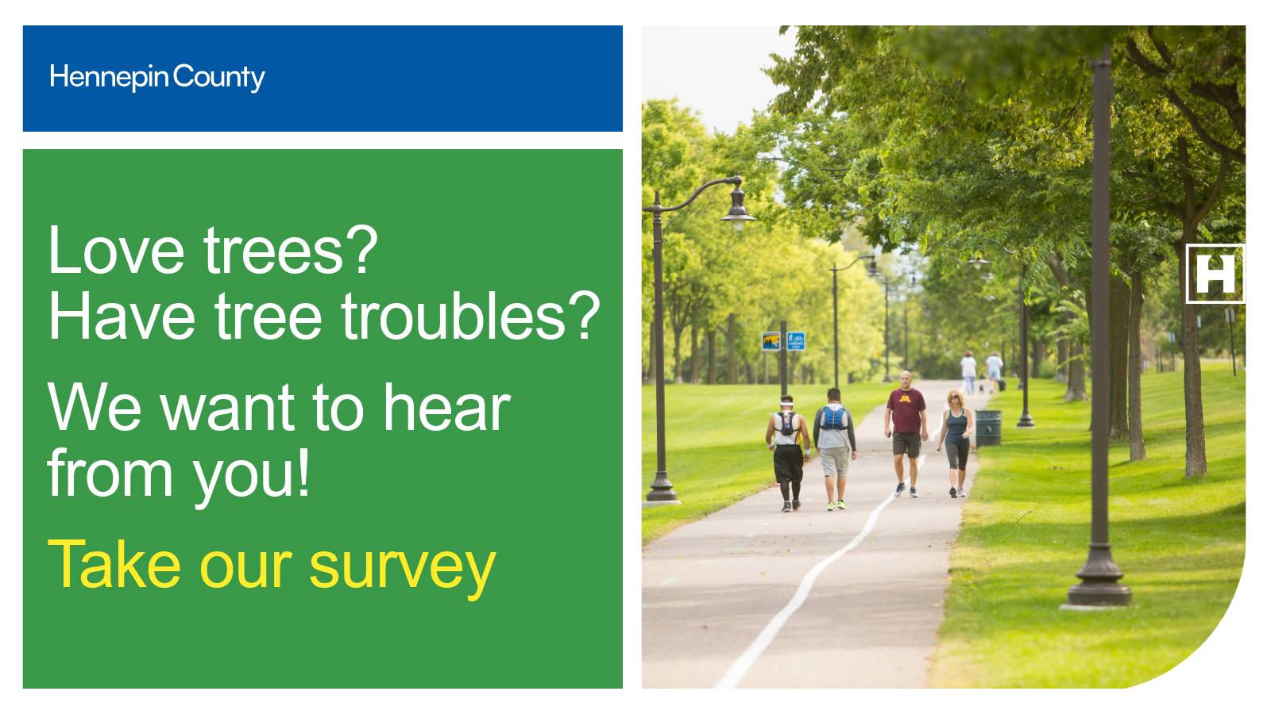
Whether you face challenges in caring for lawn, garden, and natural spaces or are an avid tree caretaker, your perspective matters. Share what you love about trees, what barriers you’ve run into, and how we can work together to grow a greener community that works for everyone.
Take a short survey.

Social media

Graphics for use on social media
Alt text is saved with each graphic.
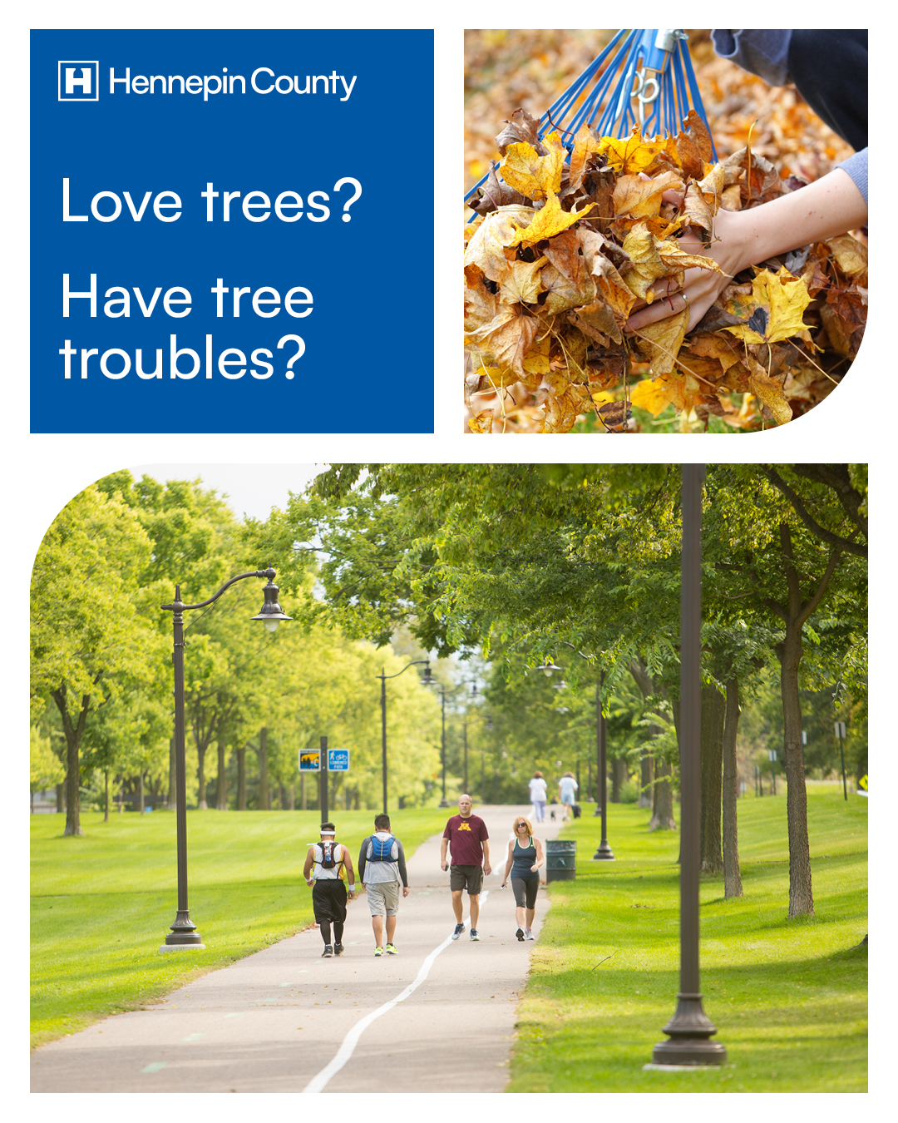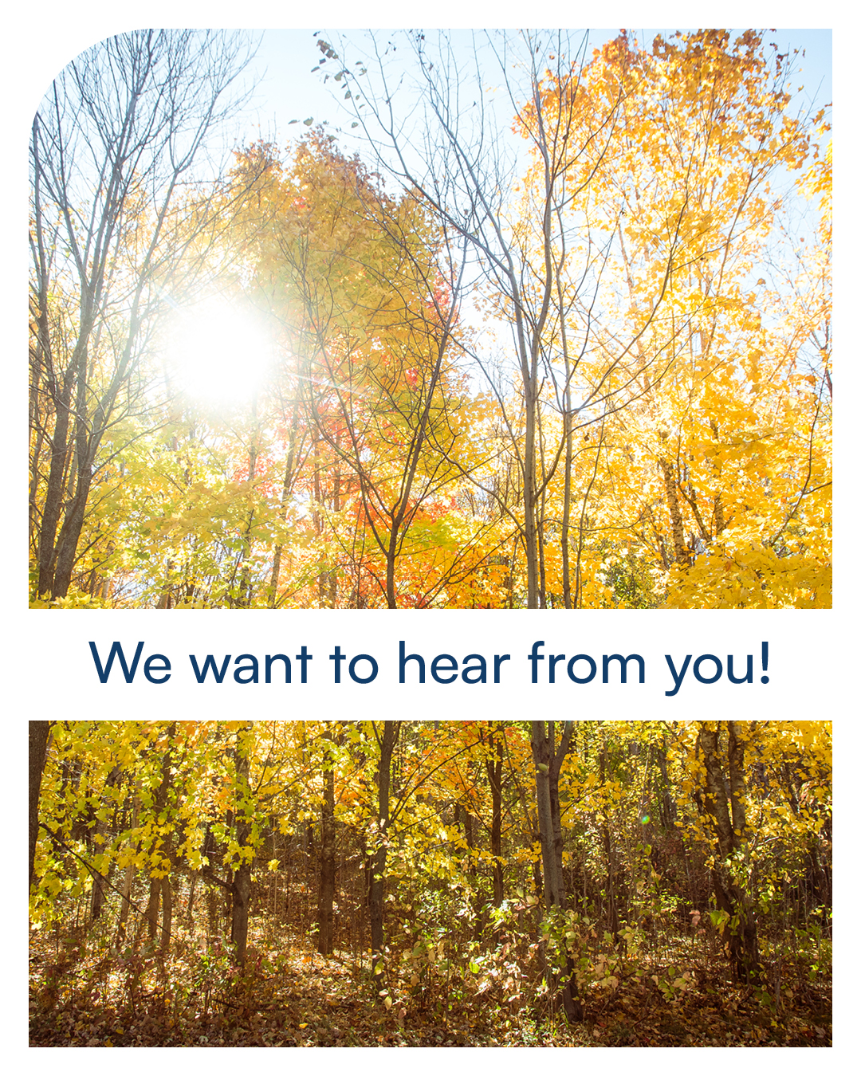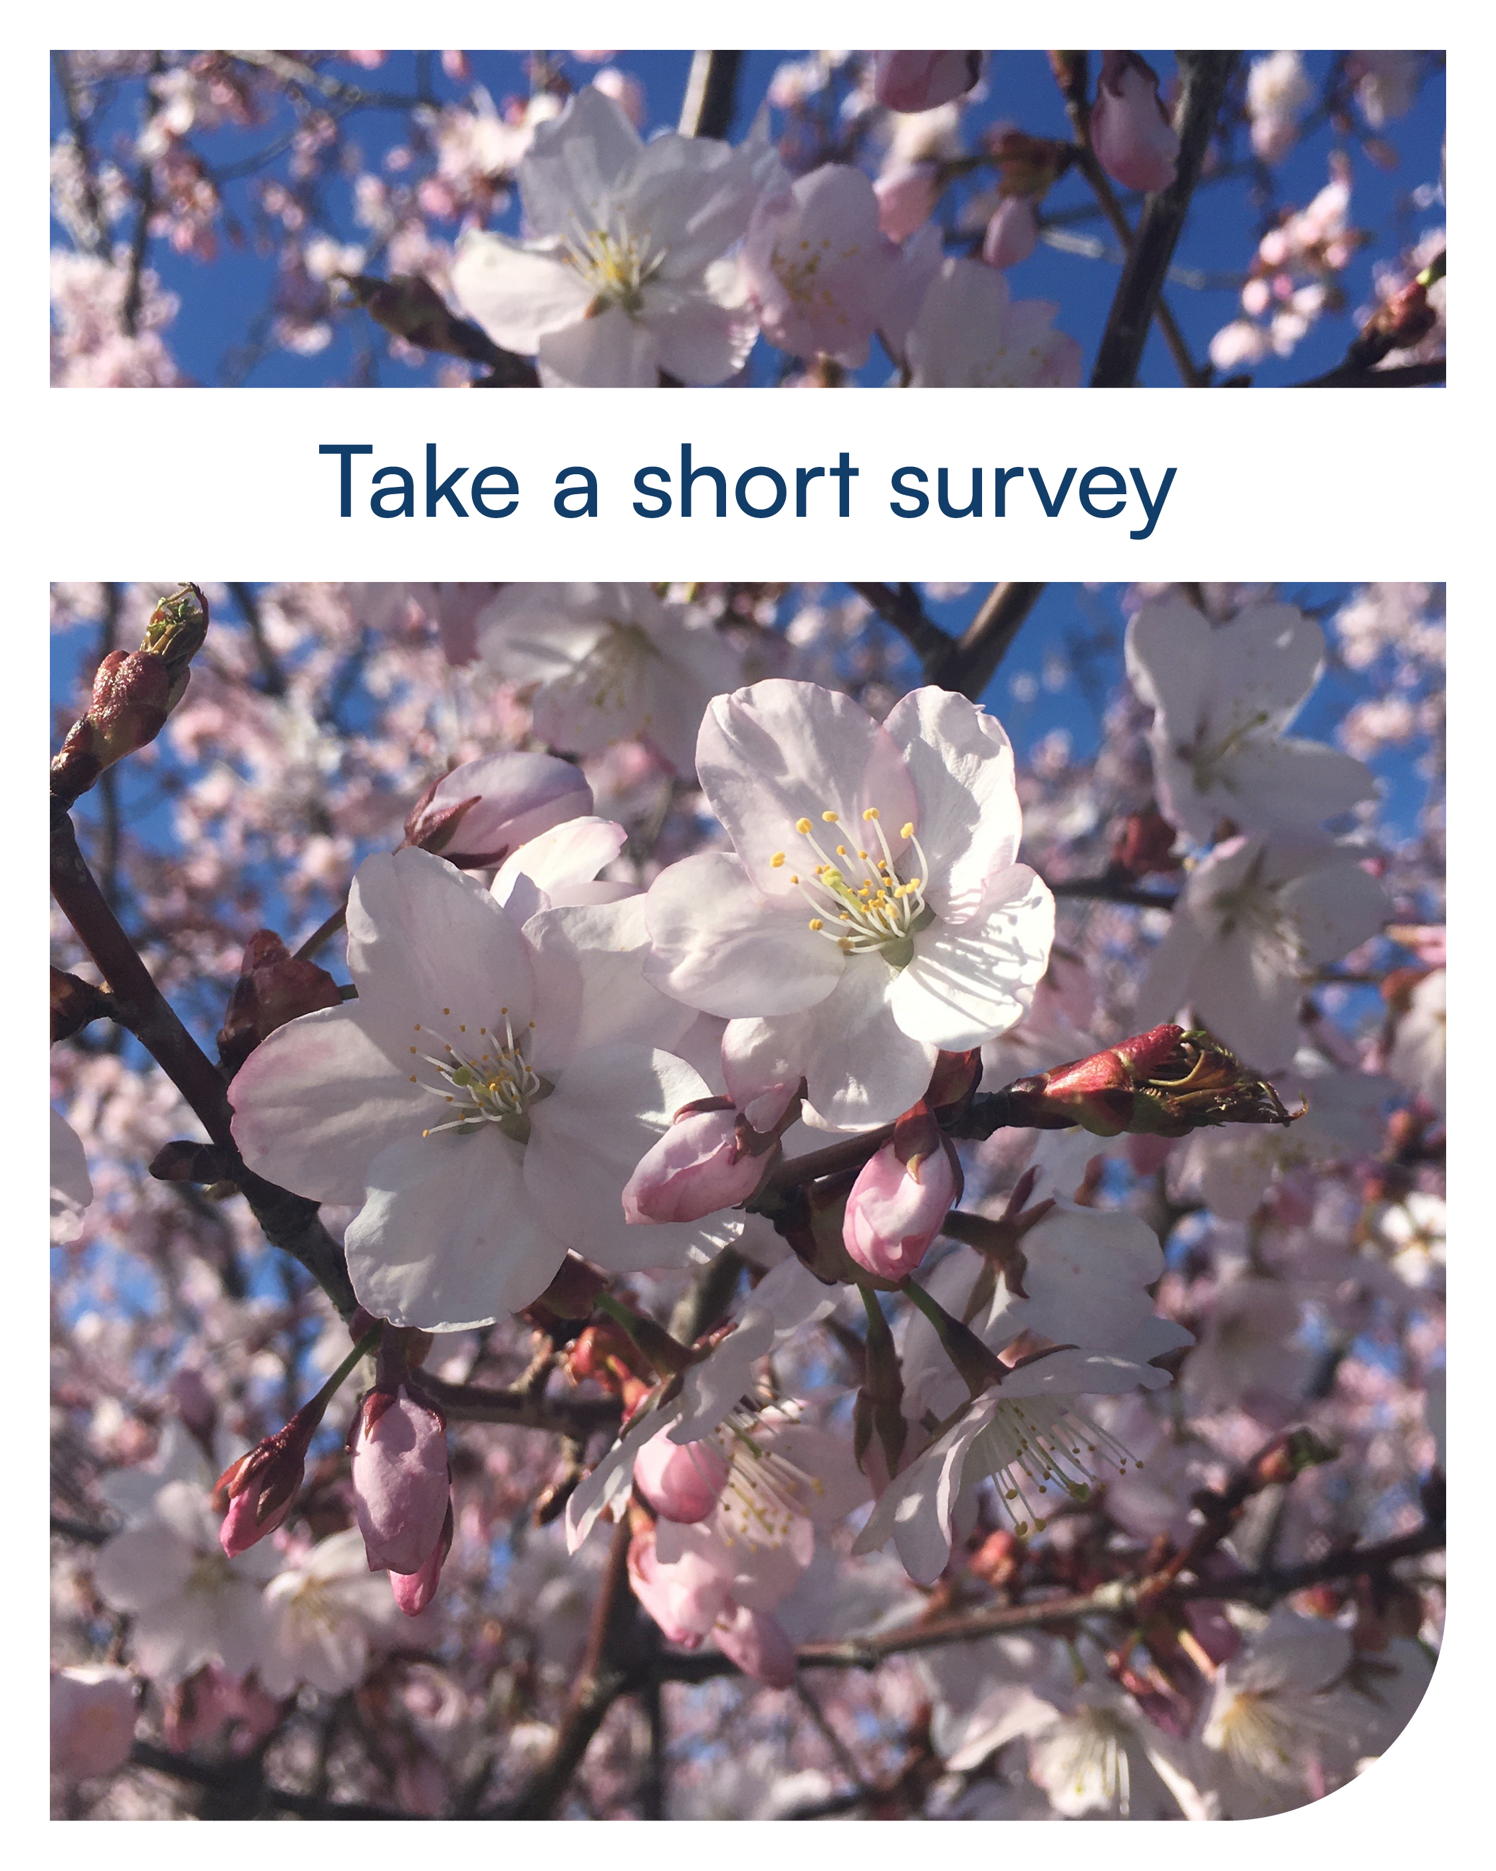

Post content:

Facebook:
Love trees? Have tree troubles? Hennepin County wants to hear from you! Whether you face challenges in caring for lawn, garden, and natural spaces or are an avid tree caretaker, your perspective matters. Share what you love about trees, what barriers you’ve run into, and how we can work together to grow a greener community that works for everyone. Take this short survey: https://survey.az1.qualtrics.com/jfe/form/SV_7ZHc6tG5urm4ON0?Q_CHL

Instagram:
Instagram note: please only share on Instagram if you can add a link in your bio. Link to put in your bio: https://survey.az1.qualtrics.com/jfe/form/SV_7ZHc6tG5urm4ON0?Q_CHL
Post content:
Love trees? Have tree troubles? Hennepin County wants to hear from you! Whether you face challenges in caring for lawn, garden, and natural spaces or are an avid tree caretaker, your perspective matters. Share what you love about trees, what barriers you’ve run into, and how we can work together to grow a greener community that works for everyone. Take this short survey at the link in our bio.

Twitter/X:
Love trees or have tree troubles? Hennepin County wants to hear from you! Share your thoughts & help us grow a greener community. Take a short survey: https://survey.az1.qualtrics.com/jfe/form/SV_7ZHc6tG5urm4ON0?Q_CHL
#Trees #UrbanForestry

