

Promotional materials for Hennepin County food waste webinars

About the webinars
Hennepin County is hosting multiple webinars in June for residents to learn how to prevent food waste. The webinars will help residents learn how to make the most of their food with tips and tricks for shopping, storing, and cooking.
Two webinars are open to Hennepin County residents who live in apartments and condos – these are scheduled for Monday, June 7 at 7 p.m. and Thursday, June 24 at noon.
Two webinars are open to all Hennepin County residents – these are scheduled for Wednesday, June 23 at 7 p.m. and Friday, June 25 at noon.
The webinars will be about an hour with time for questions. The webinars are offered free of charge, but registration is required.

Promote the webinars
Some ways you can help us spread the word and encourage people to sign up for a webinar:
- Use the sample newsletter article to share on your organization’s website or in your newsletters
- Use the sample social media posts to share through your social media channels. Use #HennepinZeroWaste
- Follow and reshare messages posted on the Hennepin County Environment and Energy social media channels: Hennepin Environment on Facebook and @hennepinenviro on Twitter

Sample newsletter article

Learn tips and tricks for stopping food waste at an upcoming webinar
Learn how to save money, set a good example, and have a positive impact on the planet by attending a food waste prevention webinar! The webinar will provide tips and tricks for making the most of your food through shopping, storage, and cooking.

Webinars for residents of apartments and condos
A webinar for Hennepin County residents who live in apartments and condos is scheduled for Thursday, June 24 at noon.

Webinars for all Hennepin County residents
Webinars for all residents of Hennepin County are scheduled for:
- Wednesday, June 23 at 7 p.m.
- Friday, June 25 at noon

Sign up to attend
The webinars will be hosted by Hennepin County GreenCorps member, Marielle Mateo.
The webinars will be about an hour with time for questions. The webinars are offered free of charge, but registration is required.
The webinars will be presented on Microsoft Teams, and those who have registered will receive a reminder email with a link to join the webinar the week of the event.
If you have any questions, email marielle.mateo@hennepin.us.

Social media posts

Post 1:
Learn how to stop food waste at an upcoming webinar. Hennepin County's food waste prevention webinars in June will provide tips and tricks for making the most of your food. Sign up for a free webinar https://forms.office.com/Pages/ResponsePage.aspx?id=n9_vioCHv0aPt0ySRlOovvpaQwYntEpEkgfoDKe5DgNUNzNOUVZQTDJLTUxUQzI0RzM3UjdTTVhaUi4u #HennepinZeroWaste
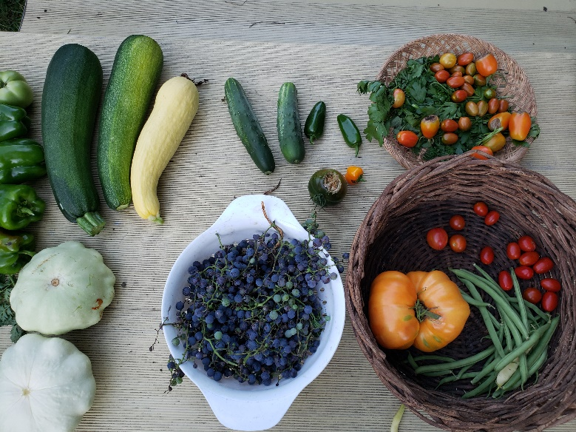

Post 2:
Learn how to save money, set a good example, and have a positive impact on the planet by attending a food waste prevention webinar, presented by Hennepin County! Get tips for shopping, storage, and cooking. Sign up now https://forms.office.com/Pages/ResponsePage.aspx?id=n9_vioCHv0aPt0ySRlOovvpaQwYntEpEkgfoDKe5DgNUNzNOUVZQTDJLTUxUQzI0RzM3UjdTTVhaUi4u #HennepinZeroWaste
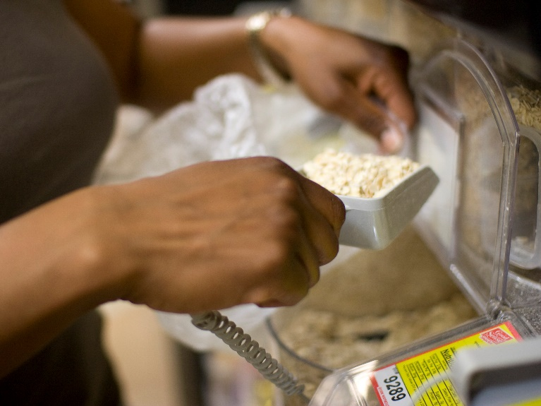

Post 3:
Learn tips and tricks for stopping food waste at an upcoming webinar. Webinars presented by Hennepin County are June 24 for residents of apartments and condos and June 23 and 25 for all county residents. Sign up now https://forms.office.com/Pages/ResponsePage.aspx?id=n9_vioCHv0aPt0ySRlOovvpaQwYntEpEkgfoDKe5DgNUNzNOUVZQTDJLTUxUQzI0RzM3UjdTTVhaUi4u #HennepinZeroWaste
