HUD Months Homeless is the third prioritization factor in the Hennepin CoC Coordinated Entry System.
Do you know how number of HUD Months Homeless is calculated in HMIS?

HUD Months Homeless is an element with many layers! It is calculated based on the household’s most recent answers to the questions in the Prior Living Situation series (below).
The answer to Prior Living Situation and the subsequent questions determine whether the household is considered literally homeless. If the household is literally homeless, then it compares "Total Number of Months..." and the time between "Approximate Date..." and the report end date (which is always today's date) and looks for whichever is greater - then displays the greater one.

In this series, conditional logic is built in. That means you only get the questions noted if you are literally homeless (in shelter or in a place not meant for human habitation) and answer in a certain way to the questions (see below).

"Prior Living Situation" refers to "prior to" having the CE assessment, or put another way, where the household is staying AT THE TIME of the assessment" – Not where they were before they became homeless.

In Hennepin CoC, in order to be eligible for an assessment a household must be literally homeless (in shelter or a place not meant for human habitation) or HUD Category 4 (Fleeing or attempting flee domestic violence).

Assessors should always be entering that a household's prior living situation is "Emergency Shelter" or "Place not meant for Human Habitation" unless the household is HUD Category 4 (Fleeing/Attempting to flee DV) and not literally homeless. *Please note, if the household is not literally homeless, the Prior Living Situation series will have different questions*

Important! Assessors should keep the entire Prior Living Situation series updated if the households's living situation changes. Also, answer all of the questions in the series! Missing data affects the report's ability to calculate correctly.

Prior Living Situation Series
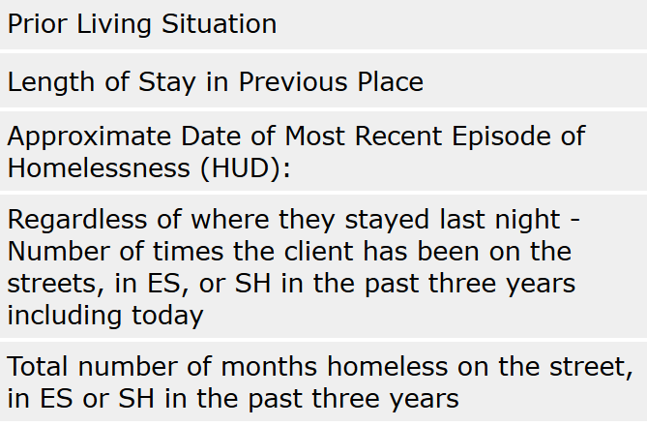

*Please note this series is based on answer the Prior Living Situation question as "Emergency Shelter or Place Not Meant for Human Habitation"

