Agency Name

Public Safety Answering Point

COVID-19 Pandemic Response Plan

[OUTLINE]

[DRAFT – MARCH 23, 2020]

This Pandemic Disease Plan can serve as a standalone document or be included as an appendix to the organization’s Continuity of Operations Plan (COOP)

[This page intentionally left blank]

Introduction
The United States is involved in an unprecedented global response to a pandemic disaster. A pandemic is a public health disaster that has occurred because of the emergence of a novel, or new, viral pathogen. The COVID-19 virus spreads easily among people because of a lack of preexisting immunity in the population. The effects of a pandemic will impact the operation of the [AGENCY NAME] public safety answering point (PSAP).

The nation’s emergency services and public safety organizations have been designated as a critical infrastructure sector by the Department of Homeland Security (DHS). Individuals serving in a public safety position in law enforcement, fire/rescue, emergency medical services (EMS), and emergency management have been designated as essential critical infrastructure workers. The work performed by public safety telecommunicators is critical to the health and safety of the community and must continue during the COVID-19 pandemic event.

Purpose
The [AGENCY NAME] will utilize this plan to maintain mission-essential functions during a pandemic event. This plan presents procedures and actions that are intended to mitigate the effects of the COVID-19 virus on the operational capacity of the agency’s (PSAP. The procedures and actions presented in this plan were developed based upon the recommendations of the Centers for Disease Control and Prevention (CDC). The PSAP manager(s) must coordinate operational decisions and actions with the first-responder agencies they serve. The PSAP manager(s) and supervisor(s) should participate in the local incident command system (ICS) structure.

Situation
Viruses, including COVID-19, are transmitted among individuals via three primary methods:

- Through the inhalation of virus-laden aerosols that have been expelled by another person by breathing, speaking, coughing, and sneezing.

- By direct physical contact with infected individuals (e.g., handshake, hugging) that directly transfers the virus to the skin and clothing of another.

- Through physical contact with a virus-laden surface (e.g., doorknobs, desktops, keyboards) then touching one’s eyes, nose, or mouth.

- COVID-19 symptoms may appear 2-14 days after exposure:
- Individual may be contagious before symptoms appear
- Symptoms can range from mild to quite severe and include:
- Fever
- Cough
- Shortness of breath
- Chest pain

The strategic mission objectives of the [AGENCY NAME] PSAP during the current COVID-19 pandemic include:

- Maintain the capability to continue the mission-critical functions necessary to support first responders and the community.

- Protect personnel by reducing exposure to the COVID-19 virus among staff.

- Maintain communications and coordinate operational decisions with the agencies that the PSAP serves.

- Maintain communication and public information with the local Office of Emergency Management (OEM) to maintain situational awareness of developing events and the management of resources.

- Maintain communication and coordinate public information with the local Public Health Department to obtain medical interventions (i.e., vaccines, prophylactic treatment) for PSAP staff members on a prioritized basis.

Pandemic Planning Assumptions
This plan was developed based upon the following assumptions:

- The human-to-human transmission of the novel COVID-19 virus has caused a pandemic that is spreading worldwide.
- A pandemic is a global public health disaster that is a very dynamic event with conditions changing very quickly.
- Antiviral medications are not yet available to treat the ill or prevent transmission of the virus.
- The PSAP may experience workforce shortages due to employee illness, employee family needs, and job/role abandonment.
- Though it is difficult to predict, workforce absenteeism may reach 40 percent.
- The PSAP has or will likely experience an increase in call volume for medical emergencies, domestic violence, and disturbances at retail and healthcare facilities.
- EMS providers and hospitals are, or soon will be, operating at or above capacity due to a surge of patients suffering from respiratory illness.
- Federal, state, and local government officials issued disaster declarations and enacted extreme measures to control the spread of the disease.
- There are shortages of critical medical supplies, including protective masks and gloves.
- The public is competing for limited household supplies including paper products, cleaning materials, and disinfectants.
- Some grocery stores are experiencing shortages of basic food stock.
- Public health officials have required individuals to practice social-distancing, i.e., maintain a distance of six feet, at a minimum, from other individuals.
- School systems have closed, or soon may close, thereby impacting employees who are the parents of school-age children.

Concept of Operations
The COVID-19 pandemic emerged very quickly in the U.S. with limited time to prepare. The CDC has developed the Pandemic Intervals Framework (PIF) that defines six stages or intervals through which a pandemic event will progress. The response tasks presented in this plan are aligned with the intervals presented in Figure 1 and described in Table 1.

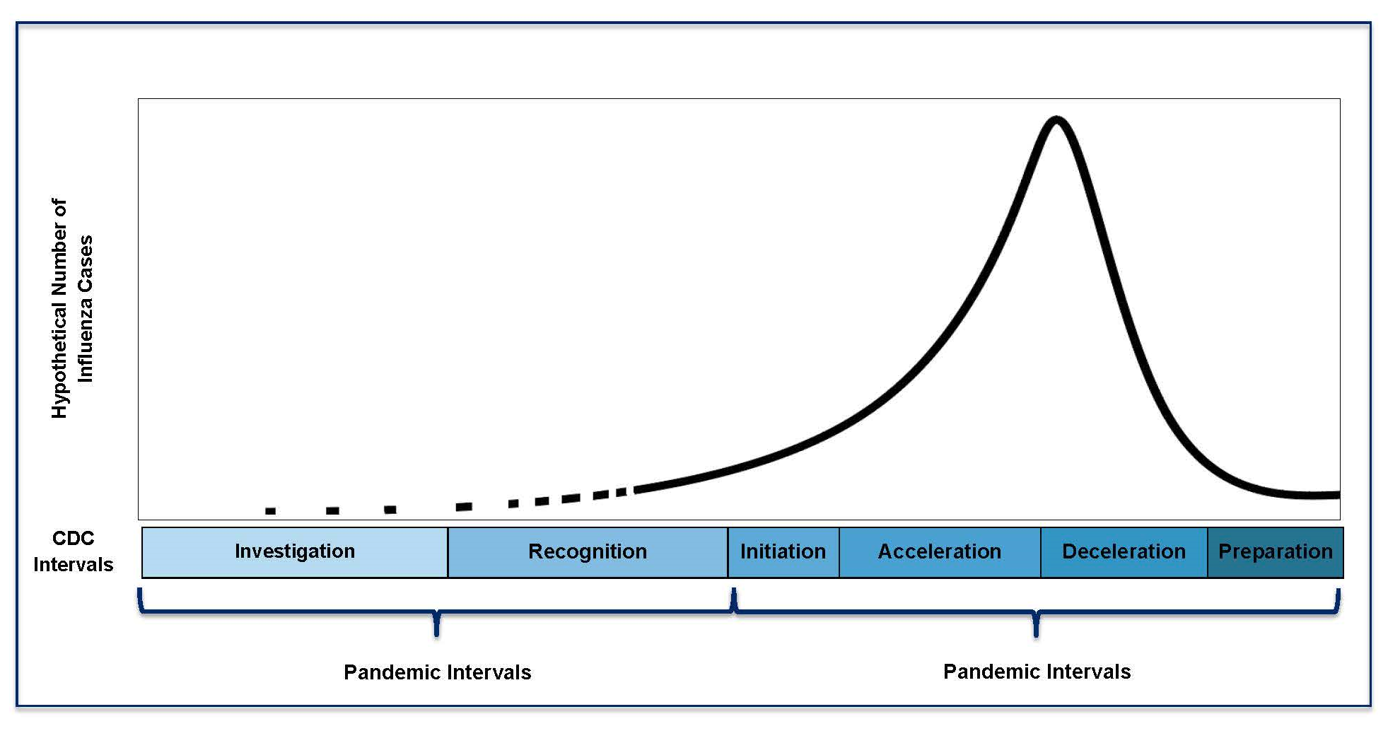
Figure 1: CDC Pandemic Intervals
Table 1: CDC Pandemic Interval Table
CDC Pandemic intervals
Interval | Definition | PSAP Response Actions
Pre-Pandemic Intervals
INVESTIGATION | Investigation of novel virus in humans | - Maintain situational awareness  - Monitor daily reports provided by local, state, and federal health authorities  - Review continuity procedures with PSAP staff  - Encourage family preparedness  - Test remote communications systems and applications  - Review incident management procedures with staff
RECOGNITION | Recognition of increased potential for ongoing transmission of a novel virus
Pandemic Intervals – Novel virus achieves efficient and sustained person-to-person transmission
INITIATION | Initiation of a pandemic wave –sustained human-to-human transmission is occurring | - Activate agency COOP  - Implement personal protective measures recommended by health authorities  - Monitor staff for illness  - Maintain contact with partner agencies and contractors  - Maintain situational awareness  - Regularly sanitize workspaces
ACCELERATION | Acceleration of a pandemic wave marked by increasing numbers of diagnosed cases
DECELERATION | Deceleration of a pandemic wave marked by reduction of cases
Transition Phase
PREPERATION | Preparation for future pandemic waves | - Conduct continuity planning  - Provide training to staff  - Enhance relationships with local public health authority  - Test and exercise plans  - Develop and maintain situational awareness of developing threats  - Assess response and conduct after-action review  - Update plans as necessary  - Replenish supplies  - Reconstitute staff as necessary

Protective Measures for the PSAP
The [AGENCY NAME] PSAP is implementing protective measures in the form of policies and procedures to assure continuity of operations. The measures being implemented are intended to reduce the spread of virus among the staff and to maintain a safe and functional work environment.

The PSAP’s work environment is intended to foster efficient communication among telecommunicators. Dispatch workstations are positioned adjacent to each other with personnel sitting only a few feet apart. The following measures [can/will be/have been] implemented to limit spread of the COVID-19 virus among PSAP staff.

COVID-19 symptoms may appear 2-14 days after exposure:
- Individual may be contagious before symptoms appear
- Symptoms can range from mild to quite severe and include:
- Fever
- Cough
- Shortness of breath
- Chest pain

- Conduct Personnel Screening

Employees should self-monitor and watch for signs and symptoms of the COVID-19 virus.

- Record temperature checks prior to entering the building – create a baseline and don’t waiver from it.

- Employees who are demonstrating symptoms or feel ill will notify their supervisor and not report for duty.

- Employees who become ill or demonstrate symptoms while at work should immediately move to a separate area of the facility.
- Those who are well enough should drive themselves home
- Those who are not well should be picked up by another person or be treated by EMS

- Employees who have a household member or close contact who has been diagnosed or is symptomatic will notify their supervisor and should not report for duty.

- Employees should not return to work until fully recovered from the virus and be free of symptoms for 72 hours, or on the clearance of a healthcare provider or the local health department.

- Practice Personal Hygiene

All employees should practice personal hygiene at all times. During this time it is especially important to adhere to the following practices:

  - Frequently wash your hands using soap and water for at least 20 seconds.
- Use an alcohol-based hand sanitizer when soap and water are not readily available.
- Avoid touching face, eyes, nose, mouth and any other mucous membranes.
- Practice respiratory etiquette by covering coughs and sneezes.
- Promptly dispose of used tissues in a trash receptacle.

- Practice Social-Distancing

The CDC recommends that individuals maintain a distance of six (6) feet, at a minimum, from others. This may be difficult while working in the PSAP.

- If possible, telecommunicators should be assigned to workstations that are separated by an unused workstation.
- Close the PSAP to everyday traffic.
- Limit training rooms and conference rooms to only PSAP personnel.
- Avoid congregating to visit – instead use other methods such as computer/smartphone-based chat functions, e.g., instant messaging.

Other options to consider:

- Divide personnel between the backup and primary facility.
- Develop a mutual-aid policy with neighboring PSAPs in case you need to support each other during time of heavy illness at one center or another.
- To further distance telecommunicators, consider implementing a telephone response unit (TRU) to handle non-emergency calls pertaining to auto burglary, auto theft, larceny, indecent exposure, and fraud/forgery, among other non-violent crimes. Configure the agency’s private-branch exchange (PBX) to send calls to 10-digit remote/home offices, and use radios to dispatch calls.

- Implement Frequent Workspace Cleaning

The COVID-19 virus can survive on various surfaces for several days. It is important to sanitize all surfaces in the workplace on a regular basis. Surfaces in shared workspaces—such as workstations, desks, break areas, and restrooms—should be cleaned before and after each use.

- Establish daily cleaning and sanitizing procedures for individual workstations.
- Clean workspace surfaces at the beginning and end of each shift. Include desktop, keyboards, chair seats and arms, desktop surfaces and all surfaces that employees touch.
- Have a 60-day supply of commercial cleaning materials.
- Frequent cleaning of common areas with commercial-grade disinfectant such as:
- Restrooms
- Kitchens
- Vending areas
- Breakrooms

- Use of Personal Protective Equipment

It is not practical to use Personal Protective Equipment (PPE) while working in the PSAP. Face masks and gloves are not readily available. A face mask will inhibit clear voice communications and gloves require frequent replacement. Employees should practice the recommended personal hygiene and cleaning procedures.

Pandemic Response Actions
The following action items are recommended during the pandemic acceleration interval:

- Activate continuity of operation plans (COOP):
- Brief staff on COOP procedures.
- Brief staff on pandemic response procedures.
- Test and Exercise plans and adjust as situation changes
- Review orders of succession and delegation of authority weekly as staff changes due to illness

- Encourage family preparedness by:
- Ensuring every has a family plan
- Guidance provided by FEMA’s Ready Responder
https://www.ready.gov/sites/default/files/documents/files/RRToolkit.pdf

- Maintain situational awareness of the COVID-19 pandemic by:
- Maintaining regular contact with state and local emergency management and public health officials.
- Monitoring local media outlets via online sources and broadcast media.
- Monitor local, state and federal briefings.
- Monitor and communicate with citizens via social media.

- Maintain contact with the emergency operations center (EOC) and provide situation reports as requested or on a scheduled basis.
- Coordinate with local Public Information Officer (PIO) on public facing messaging.

- Implement facility protective measures including:
  - Only essential personnel will be allowed into the PSAP.
  - Non-essential personnel and visitors will not be allowed into the PSAP.
  - Pre-employment observation activities will be canceled.
  - Avoid congregating to visit – instead use other methods such as computer/smartphone-based chat functions, e.g., instant messaging.

- Implement social-distancing measures within the PSAP to the extent possible.

- Monitor staff for signs and symptoms of illness.
- Modify shifts/schedules to accommodate staffing shortages.
- Staffing plan for losses due to exposure/illness

- Coordinate the tracking of personnel time and expenses with the jurisdiction finance officer for reimbursement through public-assistance disaster funds.

- Track and document expenses incurred that are related to pandemic response including:
- Overtime
- Cleaning supplies
- Contracted cleaning services
- Other disaster-related expenses

- Test generator(s) and assure that multiple sources of fuel delivery are available, including multiple contractors.

- Test remote communications systems and applications.

- Assure that essential contractors and vendors have adopted and tested business continuity plans:
- Telephony provider
- CPE equipment provider
- CAD vendor
- Radio vendor
- Agency IT/County IT
- UPS vendor
- Generator vendor
- Gas/Propane provider (for generator)
- Building Maintenance

- Establish daily cleaning and sanitizing procedures for PSAP:
- Acquire cleaning supplies, including antibacterial soaps, sprays, paper towels, and other sanitizing materials.
- Acquire and distribute hand sanitizer and tissues at each workstation and throughout the PSAP.
- Employees will clean shared workspaces at the beginning and end or each shift.
- Treat all material in trash cans as potentially infectious waste.
- Stock food items onsite to reduce the dependence on outside providers, such as restaurants.
- Replenish supplies weekly

- Provide personnel with agency identification cards to assure compliance with travel restrictions imposed for nonessential personnel.

- Delay routine modifications to computer hardware and software updates and upgrades.

- Consider establishing temporary sleeping quarters within the facility to support staff with lengthy commutes.

- Review Human Resources (HR) policies and make adjustments to accommodate for lengthy recuperation times:
- Sick leave usage
- Vacation leave/personnel leave
- Emergency call back or hold over
- Essential employee designation

Orders of Succession and Delegation of Authority
Certain positions are essential to the continued operation of [AGENCY NAME] PSAP and must be filled regardless of emergency circumstances. The following guidelines provide for the succession of authority in the event that the primary individual in a position is unavailable or incapacitated.

Each key position within the [AGENCY NAME] PSAP is staffed by an individual on a full-time basis. Some individual staff members may be unavailable during the pandemic. Alternate positions must be identified that will assume the duties of each key position. It is assumed that the authorities granted to each key position will transfer to the individuals assigned to serve as an alternate. However, certain authorities may be reassigned to alternate personnel.

Defining orders of succession and the delegation of authority are critical to ensuring effective leadership during an emergency. In the event that an incumbent staff member is incapable or unavailable to fulfill essential duties, successors have been identified to ensure that there is no lapse in essential decision-making authority. In addition to the incumbent, two alternate positions/individuals should be identified to ensure sufficient staffing in each leadership position within the PSAP.
Instructions: Use the tables below to enter information regarding the positions that support PSAP operations. Please provide a list of key tasks that are performed by each position and the authorities that will convey with temporary assignment to the primary position. (Note: All positions should be listed by title and not the names of individuals serving in those positions)

[Position Title]
Alternate 1:
Alternate 2:
Essential Tasks to Perform:
1.
2.
3.

Authority to be Delegated:
1.
2.
3.

[Position Title]
Alternate 1:
Alternate 2:
Essential Tasks to Perform:
1.
2.
3.

Authority to be Delegated:
1.
2.
3.

[Position Title]
Alternate 1:
Alternate 2:
Essential Tasks to Perform:
1.
2.
3.

Authority to be Delegated:
1.
2.
3.

[Position Title]
Alternate 1:
Alternate 2:
Essential Tasks to Perform:
1.
2.
3.

Authority to be Delegated:
1.
2.
3.

[Position Title]
Alternate 1:
Alternate 2:
Essential Tasks to Perform:
1.
2.
3.

Authority to be Delegated:
1.
2.
3.

[Position Title]
Alternate 1:
Alternate 2:
Essential Tasks to Perform:
1.
2.
3.

Authority to be Delegated:
1.
2.
3.

Partner Agencies
Local Office of Emergency Management

Name:
Title:
Contact:
Office:
Cell:
Email:
Text:

Name:
Title:
Contact:
Office:
Cell:
Email:
Text:

State Office of Emergency Management

Name:
Title:
Contact:
Office:
Cell:
Email:
Text:

Local Department of Public Health

Name:
Title:
Contact:
Office:
Cell:
Email:
Text:

Name:
Title:
Contact:
Office:
Cell:
Email:
Text:

State 911 Office

Name:
Title:
Contact:
Office:
Cell:
Email:
Text:

Homeland Security Presidential Directive 7: Critical Infrastructure Identification, Prioritization, and Protection
Memorandum on Identification of Essential Critical Infrastructure Workers during COVID-19 Response. (CISA) March 19, 2020
Principles and Practices of Clinical Virology

