
VMware-Horizon-Client-2111-8.4.0/Install Instructions
The recommend version of the VMware Horizon Client version is currently set at Horizon 8. Version 2111 for all agency staff using SSIS.
Use the following instructions to download the Horizon Client from VMware.
- Navigate to: https://www.vmware.com/go/viewclients
- Use the Select Version drop down box in the upper left corner to select Horizon 8
- Click the GO TO DOWNLOADS link for VMWare Horizon Client for Windows
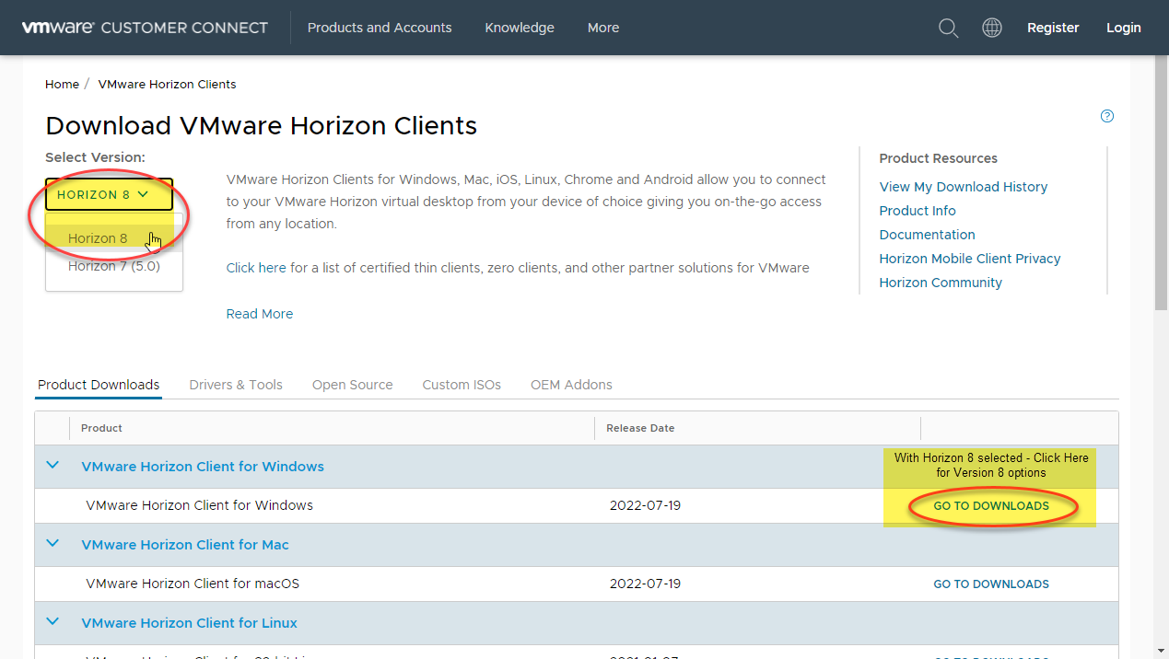

- Click the GO TO DOWNLOADS link for VMWare Horizon Client for Windows
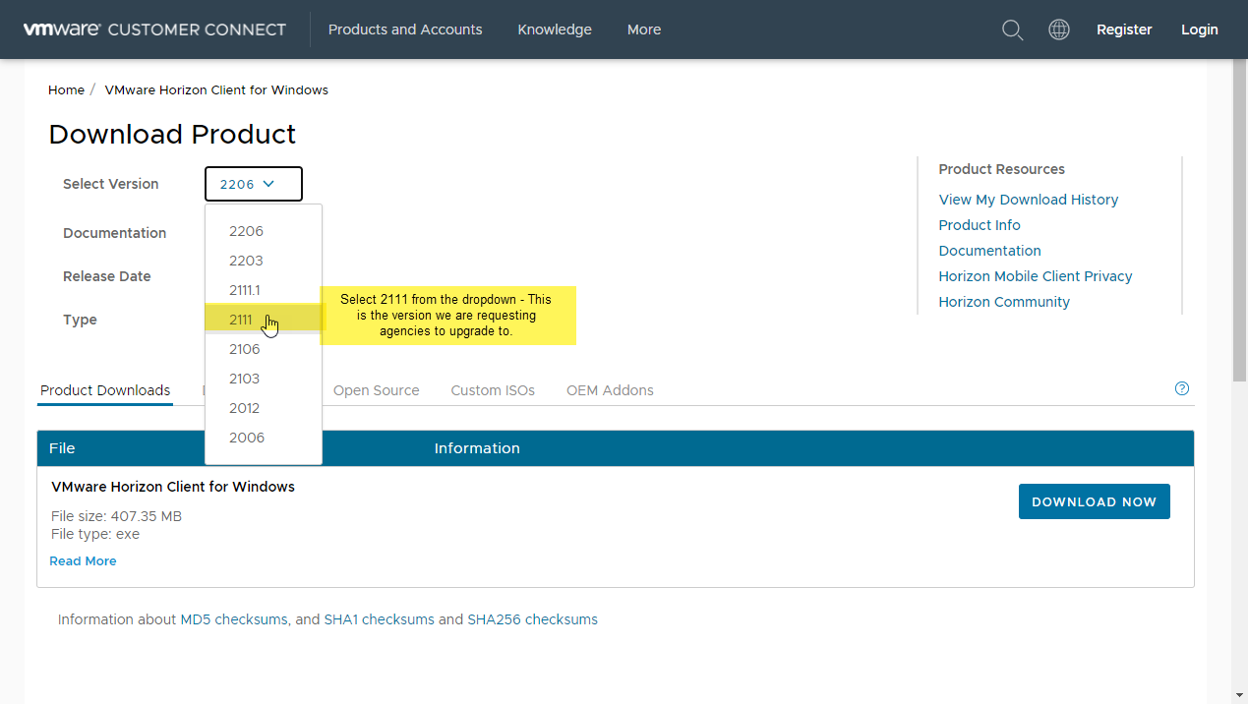

- Select Download Now
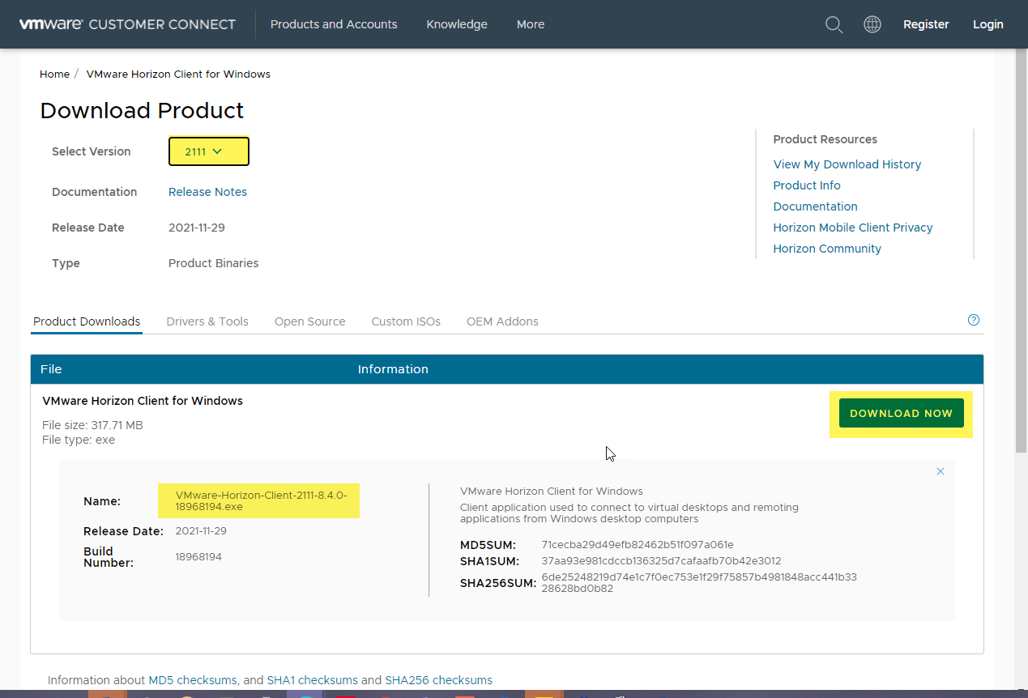
Note: you can expand the bottom section on this screen and view the file name:
VMware-Horizon-Client-2111-8.4.0-18968194.exe

- Click Agree & Upgrade
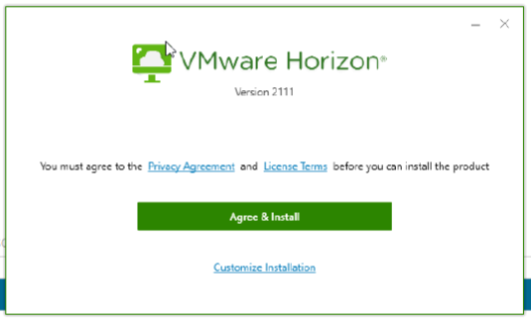

- The installation will begin and the upgrade is in progress when this progress box appears
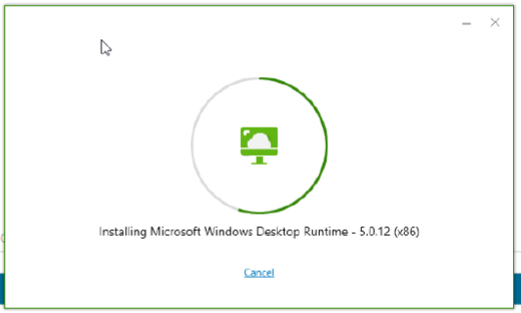

- Click Finish once the installation is complete
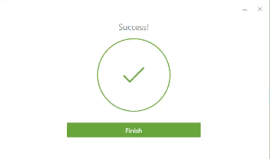

- Restart the computer to use the new version
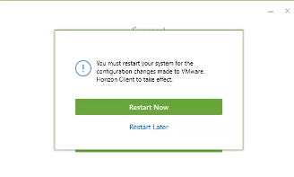

- Once restarted, verify version 5.5.3 by selecting the icon with three horizontal lines in the upper right corner and select “About VMware Horizon Client”
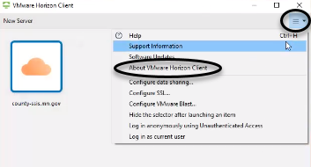
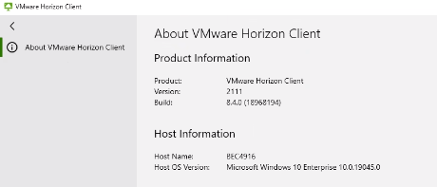

Questions regarding installation or upgrading should be directed to the SSIS Help Desk

