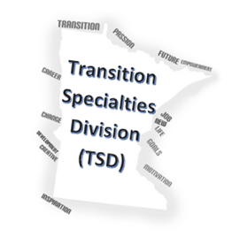

The Minnesota Rehabilitation Association Transition Specialties Division is proud to sponsor a Pre-ETS Virtual Training with Matthew Flanagan and Dr. Jennifer Bumble. This training will focus on learning how to utilize a mapping tool in serving students with disabilities. Participants will learn how to create and personalize the base map. This tool can be used for transportation training, post-secondary preparedness, independence in the community, customized employment, and organizing more advanced work experiences and workplace readiness information. All participants will leave with an understanding of how the mapping tool works and a PDF manual on developing a personalized map. Upon completion of the main session, Matthew Flanagan and Dr. Jennifer Bumble will return for an optional 1-hour Q&A session for additional support on developing your map.

**Registration:**

Please register for this event at EventBrite. You will receive the Zoom link upon registration.

<https://mratsdmapps.eventbrite.com>

**Accommodations:**

ASL Interpreters and Closed Captioning are available upon request during registration.

**Main Session:**

February 3rd, 2021 9am-10:30am CST

**Optional 1 Hour Question/Support Session:**

February 11th from 9am-10am CST

MAPS Virtual Community Mapping



[This Photo](https://www.techzim.co.zw/2018/02/maps-go-is-now-in-beta/) by Unknown Author is licensed under [CC BY-NC-ND](https://creativecommons.org/licenses/by-nc-nd/3.0/)

**Cost:**

--Free to MN VRS, Community Partners, and School Staff courtesy of MN Vocational Rehabilitation Services

--$50 for Other Professionals

**Certification:**

1.5 Hours of CRC CEU’s

Certificate of Completion is available upon request.