This is a SAMPLE TEMPLATE. Dental offices are not required to use this template and may design their own plan including the same information.

Facility (Dental Clinic)
Implementation Plan for Management and Treatment of Non-Emergent and Elective Dental Care
Plan for Prioritization of Procedures
List patient conditions that will be treated in phase 1 of elective care. This may include any diseases, disorders and/or conditions of the oral cavity, maxillofacial area and/or the adjacent and associated structures that left untreated for the next 3 to 6 months would result in further deterioration of the patient’s health. (Examples may include caries control, management of periodontal disease, management of endodontic needs including fabrication of crowns on endodontically treated teeth as indicated. Management of edentulous space’s in the edentulous and partially edentulous patient as indicated to prevent worsening of malocclusion or bone atrophy. Management of malocclusion for new and existing patients. Management of diseased, fractured or impacted teeth. Treatment of temporal mandibular disorders. Management of Pathology. Management of trauma). Hygiene is allowed as well if the practice facility planning is in place and they can sustain routine care. Prioritize perio patients due to the fact that they were postponed through the peacetime emergency. Think of every patient’s need and understand that every patient encounter uses PPE.
Facility (Dental Clinic) will employ clinical judgment and assess patient oral and overall health and risk to the patient if the procedure is delayed any further.

Treatment will be based on clinical judgements and evaluating
- Patients Medical History
- Risk factors
- Geographic incidence of COVID-19 in your clinic’s location.
- Previously cancelled and postponed cases due to the COVID pandemic
- Availability of PPE including N95 or KN95 masks, surgical masks, gowns, face shields and hair coverings
- Prioritization of patients with more urgent needs.
- Professional judgment to employ the lowest aerosol-generating armamentarium when delivering any type of restorative or hygiene care.
- Example: use hand scaling rather than ultrasonic scaling when appropriate. If ultrasonic scaling is required, it should be used in conjunction with high volume evacuation and considering use of an assistant

- For elderly patients with one or more diseases known to be associated with higher COVID mortality and/ or immunocompromised patients, it is recommended to use teledentistry consultation to assess the urgency of their dental condition prior to considering any treatment for them.

Infection Control- Engineering Controls, Administrative Controls
This plan includes PPE, Infection Control, and Engineering Control Guidance provided by the Minnesota Board of Dentistry, CDC, and OSHA.
PPE utilization per Minnesota Board of Dentistry, CDC and OSHA
- Gloves (nitrile or other non-latex alternatives)
- Cloth gowns or protective clothing to be laundered after each use when used for aerosol producing procedures.
- If there are shortages of gowns or protective clothing, they should be prioritized for:
  - Aerosol-generating procedures.
  - Clinical procedures where splashes and sprays are anticipated.
- Disposable gowns to be discarded after each patient. Note: Disposable gowns are available in the marketplace for purchase as well as launderable coats, smocks, and jacket alternatives.
- Eye protection (goggles or face shield)- Disinfect between patients
- N95 mask or KN95 for aerosol producing procedures.(Fit testing needs to be done as soon as feasible. Medical evaluation may be done online. We have provided a respiratory program template for use. Located on the Board website under COVID).
- Given the shortage of N95 masks, wearing an N95 and covering it with an ASTM Level 1-3 mask to prevent droplets and or splatter on your N95 mask. The N95 mask may be reused. The intent of this is to try to preserve the integrity of the N95 for reuse after bagging or disinfecting. We will still allow this at this time due to PPE shortages in MN
- OR:
- Updated CDC Guidance also allows a face shield and surgical mask for all procedures if N95 is not available to you. See the ASTM guidance related to surgical masks and use the highest available for the procedures.
- Proper donning and doffing will be practiced. (CDC Donning and Doffing)

List all Controls that you are using in your dental clinic to mitigate risk to patients and providers

Administrative Control Plan
- Placement of a plexiglass or other clear barrier between the front office/check out desk.
- If not feasible, front desk staff should wear level 3 mask and nitrile gloves during patient interactions.
- Pens used by patients and visitors should be disinfected after each use. We recommend a container for disinfected/ clean pens and a container for used/ dirty pens.
- Credit cards should be disinfected before their use by office staff.
- Handwashing protocols must be established.
- Ready access of hand sanitizer as patient’s enter or require hand washing prior to entry.
- Patients and visitors should arrive wearing masks, if they arrive without masks the dental office should provide them.
- Waiting room chairs will be placed 6 feet apart to maintain social distancing. If this cannot be accomplished, patients and visitors should remain in their car and phoned when you are ready for them to enter the office.
- All office toys, reading materials, remote controls or other communal objects, will be removed.
- On a regular schedule, all touchable surface areas will be sanitized with an approved surface cleaner.
- If visibly dirty, surfaces should be cleaned using a detergent or soap and water prior to disinfection.
- To disinfect, use https://www.epa.gov/pesticide-registration/list-n-disinfectants-use-against-sars-cov-2 products that meet EPA’s criteria for use against SARS-CoV and are appropriate for the surface.

Facility (Dental Clinic) Employees and Risk

List all employees and risk based on procedures that they are performing (same as you would with OSHA Bloodborne Pathogen Standards)

Eg.
Dental Admin
Dental Assistant
Sterilization Assistant
Dentists
Dental Hygiene

Well patients not suspected or confirmed active COVID
Dental procedures not involving aerosol-generating procedures | Dental procedures that may or are known to generate aerosols
Work clothing, such as scrubs, lab coat, and/or smock, or a gown | Gloves
Gloves | Gown or protective clothing
Eye protection (e.g., goggles, face shield) | Eye protection (e.g., goggles, face shield)
Face mask (e.g., surgical mask). Use the level appropriate for the procedure. | NIOSH-certified, disposable N95 filtering facepiece or face mask with shield Use the level appropriate for the procedure.

The chart for suspected COVID has been removed. Dental professionals should only treat an active COVID patient in a life threatening emergency situation and with the highest level of PPE.
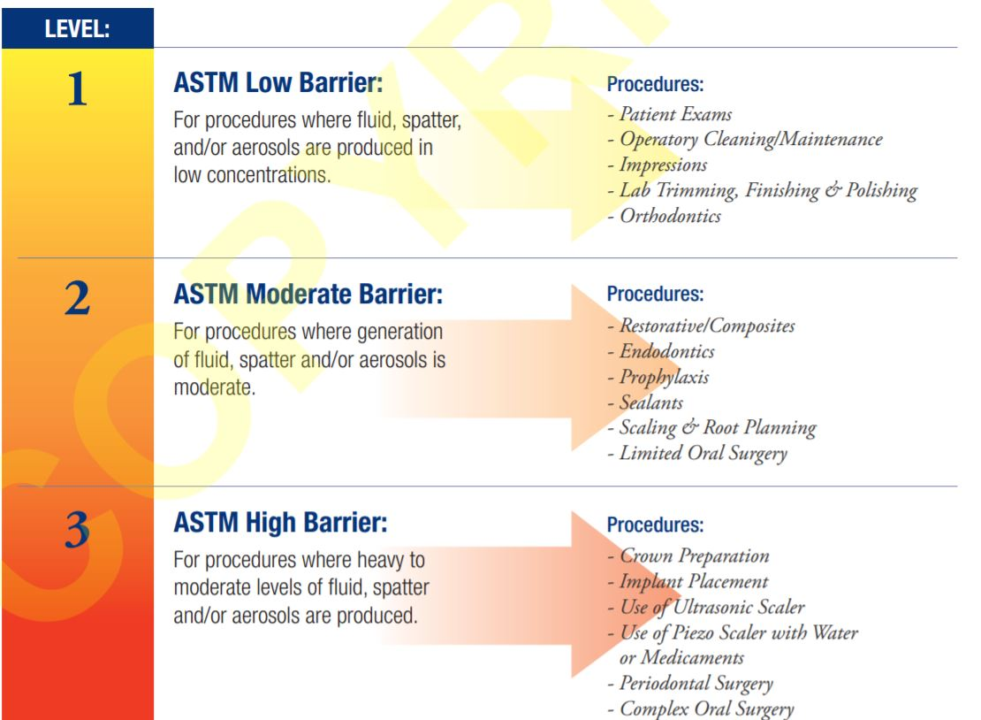

Facility (Dental Clinic) will only treat suspected or confirmed COVID patients in the event of a life-threatening dental emergency and only if N95 is available. Treatment with tele dentistry and medications may be necessary in the event it is not a life-threatening dental emergency.
COVID-19 Employee Screening
Every clinic day you must conduct an active health screening of all staff members to assess for signs and symptoms of COVID-19. This will include assessment for fever and symptoms associated with COVID infection as recommended by in CDC: Interim Infection Prevention and Control Recommendations for Patients with Suspected or Confirmed Coronavirus Disease 2019 (COVID-19) in Healthcare Settings. These daily screenings must be maintained in a logbook.
Staff will not work while sick, even if presenting with mild signs or symptoms. If during the workday they develop signs or symptoms of illness they should leave the office.

Training for N95/ KN95 Use
Facility (Dental Clinic) will ensure training and have fit testing performed when it becomes available. In the meantime, Facility will have all staff watch training provided in videos from 3M related to N95 use.
See https://www.osha.gov/memos/2020-04-08/expanded-temporary-enforcement-guidance-respiratory-protection-fit-testing-n95.
Facility (Dental Clinic) will use N95 or KN95 masks for aerosol generating procedures and employ MDH and CDC PPE preservation methods whenever possible. Per updated CDC guidance, dental professionals can also perform procedures utilizing a face shield and surgical mask if N95 is not available.
Patient Considerations
Facility (Dental Clinic) will require patients and visitors to wear cloth coverings or facemasks and will provide to patients when needed if they do not present with one. It is recommended to remind patients of the mask policy when phoning to confirm patient appointments.
Each patient must be informed that even with mitigation equipment and techniques there is risk of COVID transmission while receiving care in a dental setting and the procedure may be cancelled on short notice if the patient tests positive for or experiences symptoms of COVID-19.
Patients will be provided a consent form (See sample- your malpractice carrier may also have one that you can use).
Patients rinse with a solution of 1-1.5% hydrogen peroxide for 1 minute prior to exams and procedures (or other appropriate rinses. please evaluate your product or effectiveness against COVID). CDC Guidance does not align with this recommendation.
Social distancing and other infection prevention measures
- Make sure chairs are spaced in reception areas to allow social distancing (6 feet apart) and wipe down with disinfectant in between patients.
- Patient volume: Determine the maximum number of patients who can safely receive care at the same time in the dental facility, based on the number of rooms, the layout of the facility, and the time needed to clean and disinfect patient operatories.
- Make attempts to stagger appointments so that patients aren’t checking in and checking out at the same time.
- Place plastic or other barriers in between open air operatories to decrease the risk of aerosol into other areas of clinic.
- Masks will be worn at all times in clinic. Dental facilities should provide DHCP with training about when, how, and where cloth face coverings can be used, including frequency of laundering, guidance on when to replace them, circumstances when they can be worn in the facility, and the importance of hand hygiene to prevent contamination.

Facility (Dental Clinic) Plan for social distancing of patients, non-clinical staff, and clinical staff

Facility (Dental Clinic) Plan for Infection Control Prevention
You may include reference to the Board of Dentistry or CDC Guidance
Clinical staff that are licensed are required by the Board of Dentistry to have a course in infection control every biennial cycle. This is also a requirement for non-licensed clinical dental assistants.
Facility (Dental Clinic) will provide resources for infection control education for all staff, clinical and non-clinical.
(Resource- OSAP is a valuable resource in this area, although there are also others)
Assessment of Clinical Operatories
List operatories and if they are not uniform list risk mitigation strategies for operatories and what they will be used for (Example- ortho, fixed or removable prost, aerosol generating procedures, dental hygiene -using hand scalers only or use of ultrasonic only where High Volume Evacuation is available and hygienist has an assistant or another risk mitigation strategy to reduce aerosol production)

Consider the following when assessing your operatories and supply:
- Avoid production of aerosols when possible.
- Use 4-handed dentistry with high volume evacuation.
- Allow time for aerosols to settle following procedures before disinfecting the rooms. The updated CDC guidance states 15 minutes.
- No paper material of any kind should be in the operatory during treatment that uses sprays or aerosols.
- Consider HEPA filtration in operatories and clinical areas. Place HEPA unit within vicinity of patient’s chair, but not behind DHCP. Ensure DHCP are not positioned between the unit and the patient’s mouth. Position the unit to ensure that it does not pull air into or past the breathing zone of the DHCP.
- Use of professional judgment to employ the lowest aerosol-generating armamentarium when delivering any type of restorative or hygiene care.
- Have all supplies and materials in operatory before beginning a procedure.

Waterline Considerations
After a period of non-use, dental equipment may require maintenance and/or repair. Review the manufacturer’s instructions for use (IFU) for office closure, period of non-use, and reopening for all equipment and devices. Some considerations include:
- Dental unit waterlines (DUWL):
  - Test water quality to ensure it meets standards for safe drinking water as established by the Environmental Protection Agency (< 500 CFU/mL) prior to expanding dental care practices.
Many dental supply vendors have this available for purchase.

Community Considerations
Dental professionals will continue to collaborate with peers and supply chain representatives to ensure adequate supply, including PPE, is present in order to provide care for non-emergent and elective procedures and surgeries.
Reduction of Care
In the event of another surge in COVID-19 cases, Dental clinics would revert to treatment of urgent Dental care only. This would allow PPE preservation from the dental community providing elective care. Patients with urgent needs will be treated as previously and patients with elective needs will be postponed in the event of another Peacetime Emergency in the future. Patients will be screened for urgent needs and prioritized based on need for treatment.
Screening and Testing for Patients and Visitors
See Further Instructions when Developing your screening and testing plan
- Facilities should conduct screening and temperature check for couriers, delivery persons, and other visitors who enter the facility. Ill or febrile visitors are not allowed to enter the facility.
- All patients should undergo active screening for fever and symptoms of COVID-19, including measurement of body temperature.
- Patients, and any accompanying visitors, should come to the facility wearing a cloth face covering or facemask, or are provided one by the facility if needed.
- Facilities may use RT-PCR testing of patients prior to elective procedures to help inform infection prevention and control practices to protect staff and patient safety, with the understanding that a negative RT-PCR test represents a single point in time and patients may be infected in the interim prior to the procedure.
- If developing a protocol for RT-PCR or other diagnostic test prior to elective procedures, facilities sound consider testing within the shortest time window available (e.g., 24-72 hours) preceding the procedure, based on laboratory turnaround time.
- If dentists prefer to test patients that require procedures producing aerosolization, Oral DNA offers an option for dentists OraRisk COVID-PCR testing prior to the appointment. Consider this for longer restorative appointments that require several hours of aerosolizing. For more information and ordering, visit https://www.oraldna.com/.
- Depending on testing availability and how rapidly results are available, facilities can also consider implementing pre-admission or pre-procedure testing for COVID-19, which might inform implementation of PPE use as described above, especially in the situation of PPE shortages. However, limitations of this approach should be considered, including negative results from patients during their incubation period who could become infectious later, and false negative tests depending on the test method used.
- If no protocol for patient testing is implemented, facilities should consider all patients potentially COVID-19 positive and take appropriate precautions when conducting aerosol-generating procedures. This means use of N95 or KN95 masks, surgical masks, face shields, gowns, surgical suction and/or high-volume evacuation.
- Facilities should consider the availability, accuracy and current evidence regarding tests when developing their testing protocols.

Due to current lack of availability to dental clinic systems at this time, Facility (Dental Clinic) will continue to follow all other universal precautions when treating patients and use PPE to protect against exposure.

Criteria for Return to Work for Healthcare Personnel with Suspected or Confirmed COVID-19 (Interim Guidance)

Who this is for: Occupational health programs and public health officials making decisions about return to work for healthcare personnel (HCP) with confirmed COVID-19, or who have suspected COVID-19 (e.g., developed symptoms of a respiratory infection [e.g., cough, sore throat, shortness of breath, fever] but did not get tested for COVID-19).
See https://www.cdc.gov/coronavirus/2019-ncov/hcp/return-to-work.html for guidance.

Updated CDC Guidance May 2020
Full CDC Guidance- Updated 5/21/20 https://www.cdc.gov/coronavirus/2019-ncov/hcp/dental-settings.html

