August 31, 2019

«FIRSTNAME» «LASTNAME» «SUFFIX» Member ID: «member_id»
«ADDRCONM»
TDP Agreement Number
XXXXXX
«ADDRLINE1» «ADDRLINE2» «ADDRLINE3»
«CTRY_CD» «FRGN_POST» «FRGN_PROV»

Urgent Tax-Deferred Payment Notice
Dear «Firstname» «Lastname»:
Our records indicate that you entered into a Tax-Deferred Payment (TDP) agreement with your employer to purchase service credit. Our projections indicate that interest charges exceed your annual payment amount and/or your scheduled deduction amount is not enough to pay off the agreement within the recommended 15 years.
The information below contains your TDP agreement information as of July 1, 2018, when interest on the remaining balance was posted for fiscal year 2018.
Current Deduction Amount | Original Amount Due | Total Payment Amount | Total TDP Interest Assessed | Balance Due as of 07/01/2018*
$00.00 | $00.00 | $00.00 | $00.00 | $00.00

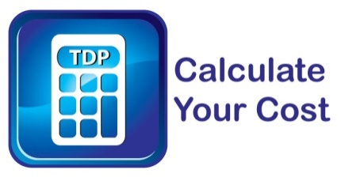
www.mi.gov/TDPcalculator
*Balance Due as of 07/01/2018 = Original Amount Due - Total Payment Amount + Total TDP Interest Assessed.

Increase Your Payment Amount
The Michigan Office of Retirement Services (ORS) recommends having your agreement paid off within 15 years from the effective date of your purchase. To have your agreement paid off by <<XX/XX/XXXX>> (15 years from the effective date of your purchase) increase your deduction to $00.00 (this amount assumes 21 payments per year). Or, use our online TDP calculator at www.mi.gov/TDPcalculator to find an amount that fits your budget and pays off your agreement before you plan to terminate employment.
To ensure you receive full credit for this agreement, increase your current TDP deduction amount by completing the enclosed Supplemental Tax-Deferred Payment Agreement (R0654C).
If you do not increase your deduction amount, make sure you are prepared to pay off your agreement with a direct transfer/rollover when you terminate employment.

Review Account Details with miAccount
For more service credit purchase and interest details, log in to your account at www.michigan.gov/orsmiaccount and click on Your Service, Purchase History tab.
Sincerely,

Michigan Office of Retirement Services
Big Plans. Small Steps.

Note: TDP agreements are binding and irrevocable; deductions cannot stop or be decreased, even if your financial situation changes, until the agreement is complete, or you terminate employment.

Enclosure

