March 7, 2014

Troy Police Arrest Three Suspects in Connection to Armed Robberies in Troy

On Monday, March 3, 2014 an armed robbery occurred at the Speedway Gas Station at 880 E. Maple Rd. (Rochester Rd./Maple) with the suspect brandishing a gun and fleeing with approximately $400 in cash. A K-9 track was unable to locate the suspect, however eyewitness accounts had the suspect fleeing on foot with money coming out of a “hat” the suspect was carrying. Officers also recovered a air-soft BB gun in a snow bank.
On Wednesday, March 5, 2014 another armed robbery occurred at the Kelly’s Liquor Store at 6037 Rochester Rd. The suspect also brandished a gun and was able to take approximately $4000 in cash. The suspect was last seen fleeing north bound on foot. Alert Troy officers, including K-9 “Kilo” with his handler – Officer Sinutko, initiated a track from the business and proceeded approximately a half mile north through snow in backyards and over fences to an address on Rochester Rd. (a single family dwelling). Officers found the tracks went to a pedestrian door at the residence. Officers made contact with the tenants of the residence and were allowed access to enter the residence. Officers found incriminating evidence in a bedroom to include both clothing and a bank bag which matched what was utilized in the robbery. A search warrant was obtained and further evidence of the armed robbery was discovered to include an air-soft gun. Upon further investigation listed suspects were arrested in connection to the two armed robberies:

Alonzo Lamont Harden, age 21 from Troy

Luranze Keon-Chavez Jones, age 17 from Troy

Donovan Sean Carlson, age 17 from Troy

All three were arraigned on March 7, 2014 at 52-4 District Court in Troy before Magistrate Clement J. Waldmann.

Alonzo Harden was arraigned on two counts of “Armed Robbery” a felony with upwards to a life sentence. Harden was denied bond.

Luranze Jones was arraigned on one count of “Receiving and Concealing Stolen Property – Less than $200.” A 93-day misdemeanor. Jones was given a $3500 bond - cash/surety and no 10%

Donovan Carlson was arraigned on one count of “Receiving and Concealing Stolen Property – Less than $200.” A 93-day misdemeanor. Carlson was given a $2500 bond cash/surety and no 10%.

Next court date for all three will be March 10, 2014 at 8:30 a.m. at 52-4 District Court before Judge William E. Bolle.

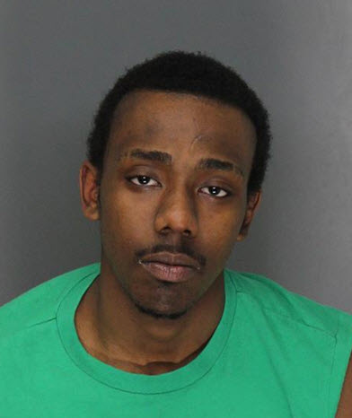
Alonzo Lamont Harden, age 21 from Troy

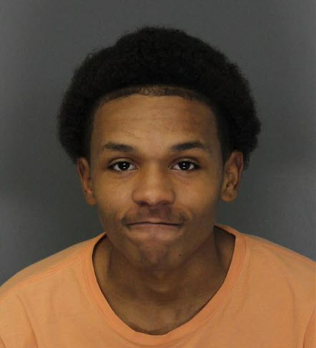
Luranze Keon-Chavez Jones, age 17 from Troy

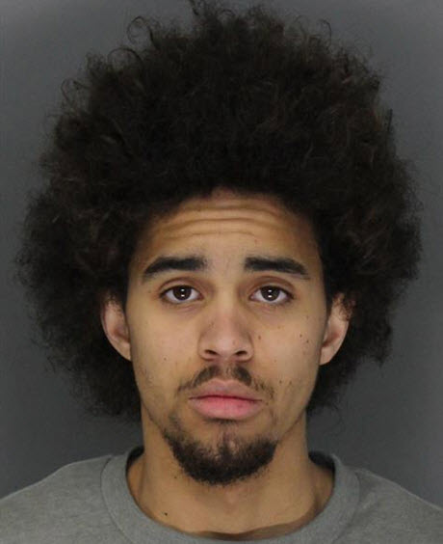
Donovan Sean Carlson, age 17 from Troy

