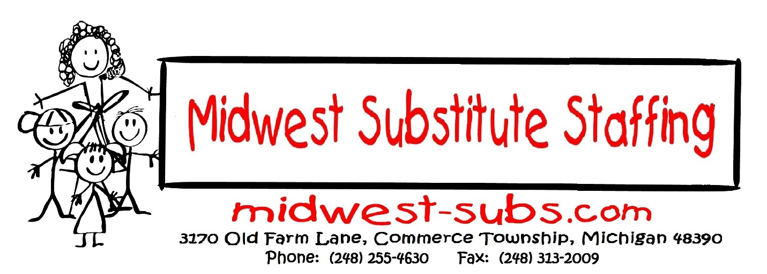
NOW HIRING/IN-PERSON HIRING EVENTS
Dates: Thursdays from January-April:
January 13 and 27
February 24
March 10 and March 24
April 7
Time: 10 a.m. - 1 p.m.
SEMCA Michigan Works! Livonia American Job Center
30246 Plymouth Rd., Livonia 48150
Immediate Openings for Substitute Teachers
in the Metro-Detroit Area.
This is a GREAT OPPORTUNITY for EAGER, MOTIVATED INDIVIDUALS to work in daily, short or long-term, full or part-time positions.
You will need to bring your resume, copy of official academic transcripts,
driver’s license, and Social Security Card.

SKILLS NEEDED:
-Experience Working with Children
-Outstanding Classroom Management
-Professional Behavior a MUST
REQUIREMENTS:
-60 College Credit Hours (State Requirement)
-Criminal Background check (State Requirement)
-Mask required to enter the schools
-Can’t attend but interested? You can call Karen Piontek at 248-675-5044
PAY RATE:
Substitutes: $135 per day

