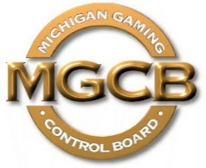 | PRESS RELEASE

Michigan Gaming Control Board

FOR IMMEDIATE RELEASE:  November 19, 2021 | Contact:  Mary Kay Bean  Beanm1@michigan.gov  www.michigan.gov/mgcb

Location: Cadillac Place, 3062 W. Grand Blvd., L-700 – Detroit
Time: 10:00 a.m.

For Immediate Release:

Gaming Control Board executive director meets with Michigan Charitable Gaming Association members to discuss better fundraising

Detroit, Nov. 19, 2021 — Michigan Charitable Gaming Association members faced difficult odds during 2020 and the first half of 2021 because pandemic-related health concerns meant they were unable to host charitable gaming fundraising events. Michigan Gaming Control Board Executive Director Henry Williams and Deputy Director Kurt Steinkamp recently expressed the agency’s willingness to work with the charities toward achieving better millionaire party fundraising success during MiCGA’s 2021 Legislative Day and Annual Meeting in Lansing.

“We want to partner with charities to ensure they are successful in raising funds so they can continue to support many positive efforts in their communities,” said MGCB Executive Director Williams. “We listened to the charities’ concerns and are committed to continuing conversations regarding matters that will benefit Michigan charities.”

Steinkamp described for attendees how the MGCB recently updated its requirements for millionaire party event expenses, providing charities with a higher allowable cap on supplier-related expenses. The agency hopes this change will encourage more suppliers to enter the market and help charities with their millionaire party events.

He also shared information on the MGCB’s efforts to develop internet-based license applications and new training opportunities for charities, which the agency plans to make available in 2022.

Charities had an opportunity to tell MGCB leadership about some of the causes they support.

“Many charities praised MGCB staff for their customer service, which includes an open-door policy and willingness to walk new applicants through the qualification and application process,” Williams said.

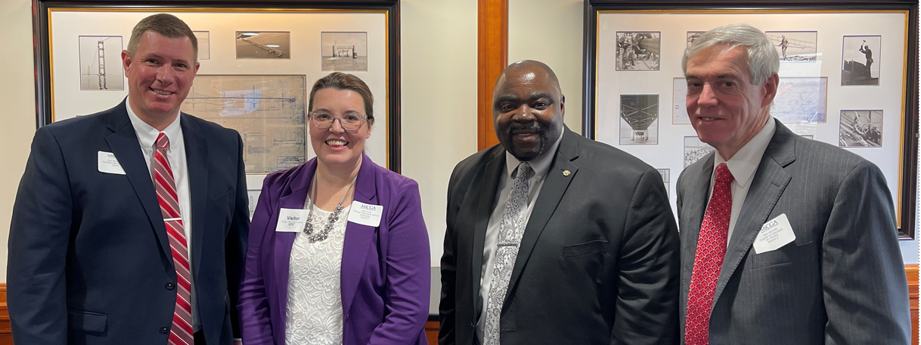
Photo: From left, MGCB Deputy Director Kurt Steinkamp, MiCGA Executive Director Katharine M. Hude, MGCB Executive Director Henry Williams and MiCGA Board Chairman Michael Horvath attended the Nov. 10 meeting in Lansing.

"The Michigan Gaming Control Board shall ensure the conduct of fair and honest gaming to protect the interests of the citizens of the State of Michigan."

####

