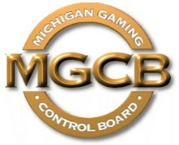 | PRESS RELEASE

Michigan Gaming Control Board

FOR IMMEDIATE RELEASE:  October 28, 2021 | Contact:  Mary Kay Bean  Beanm1@michigan.gov  www.michigan.gov/mgcb

Location: Cadillac Place, 3062 W. Grand Blvd., L-700 – Detroit
Time: 2:00 p.m.

For Immediate Release:

Northville Downs to offer 62 live racing dates in 2022 under Mich. Gaming Control Board order

Detroit, Oct. 28, 2021 — Northville Downs received authorization to offer 62 Standardbred race dates on Fridays and Saturdays in 2022 under a Michigan Gaming Control Board executive order issued this week. Northville Downs also was granted permission to simulcast races to and from the track and to offer pari-mutuel wagering on simulcast races in 2022 except on April 17, Nov. 24, Dec. 24 and Dec. 25.

“Horse racing fans can look forward to another year of live racing at Northville Downs, which has been a Michigan tradition since 1944,” said Henry Williams, MGCB executive director.

The race meeting will split into two sessions. The first session begins Friday, March 11, and concludes Saturday, June 25, and the second starts Friday, Sept. 9, and ends Saturday, Dec. 17.

The 2021 live racing season at Northville Downs concludes Dec. 18.

"The Michigan Gaming Control Board shall ensure the conduct of fair and honest gaming to protect the interests of the citizens of the State of Michigan."

####

