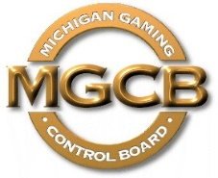 | PRESS RELEASE

Michigan Gaming Control Board

FOR IMMEDIATE RELEASE:  July 30, 2021 | Contact:  Mary Kay Bean  Beanm1@michigan.gov  www.michigan.gov/mgcb

Location: Cadillac Place, 3062 W. Grand Blvd., L-700 – Detroit
Time: 11:00 a.m.

For Immediate Release:

Mich. Gaming Control Board authorizes Gun Lake, Parx Interactive for online sports betting

Detroit, July 30, 2021 – The Michigan Gaming Control Board has authorized the Gun Lake Band of Pottawatomi Indians of Michigan and its platform provider, Parx Interactive, to launch online sports betting under the Gun Lake/Parx brand at 9 a.m. Monday, Aug. 2. The West Michigan-based tribe previously received approval to launch internet casino gaming on April 23.

“With Gun Lake Casino now fully authorized, 14 current Michigan operators and their platform providers may offer both internet casino gaming and online sports betting to patrons,” said Henry Williams, MGCB executive director. “The associated revenue payments will support responsible gaming, the First Responder Presumed Coverage Fund, K-12 education and economic development.”

Authorized online gaming operators and their platform providers are listed on the MGCB website.

"The Michigan Gaming Control Board shall ensure the conduct of fair and honest gaming to protect the interests of the citizens of the State of Michigan."

####

