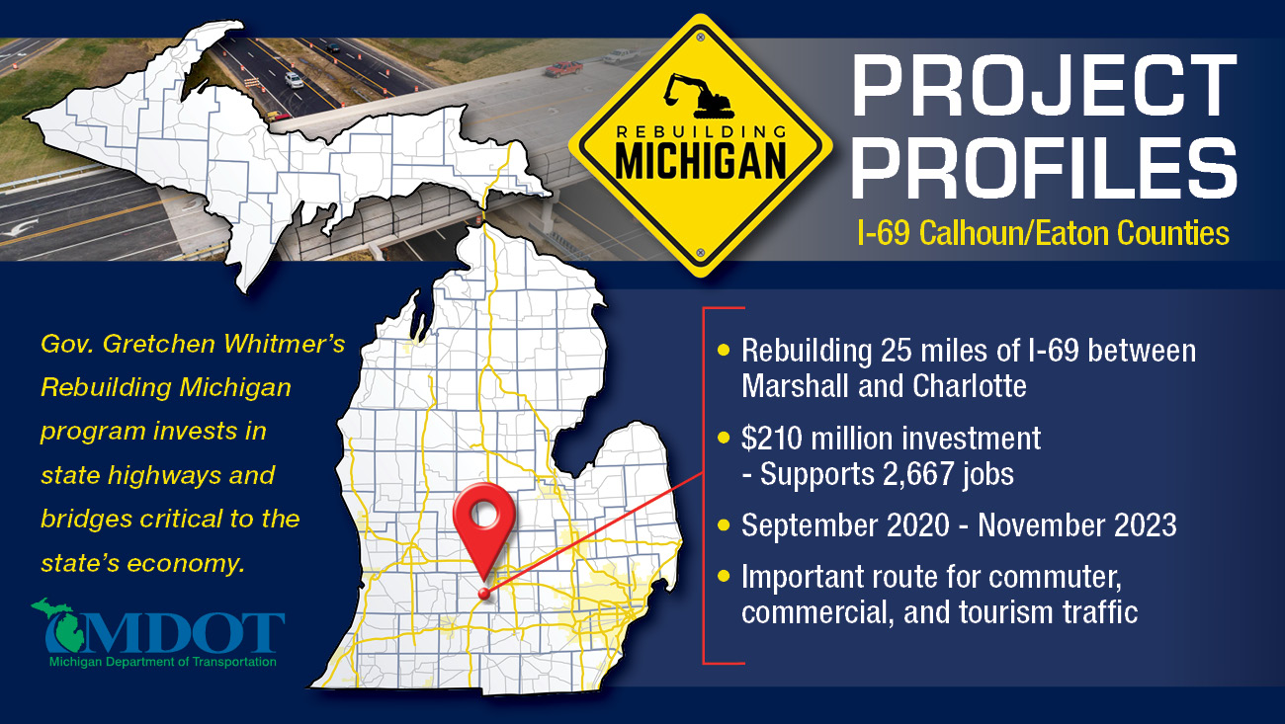
I-69 Rebuilding Michigan Project Update
October 7, 2021

Work to rebuild I-69 from north of Ainger Road to Island Highway continues to progress. With the work completed on the northbound lanes, progress has started on rebuilding the southbound lanes, expected to be completed by mid-November. Both northbound and southbound I-69 will be rebuilt in 2021, including the interchange ramps at Cochran Road and M-50.

Project Progress Last Month:
Southbound I-69 Roadwork
- Pavement removal is complete from north of Ainger Road to Island Highway.
- Grading, underdrain placement, new subbase, and aggregate base course placement is complete from north of Ainger Road to Cochran Road.
- Base course asphalt paving is complete from north of Ainger Road to Big Creek and from Cochran Road to the Battle Creek River.
- Grading, underdrain placement, new subbase, aggregate base course, asphalt base, and leveling course have been completed for the southbound I-69 exit ramp to M-50.
- Pavement removal, underdrains and subbase placement are complete for the M-50 entrance ramp to southbound I-69.
- Pavement removal has started on the southbound I-69 exit ramp to Cochran Road.
- Storm sewer work has been completed throughout the project.
- The box culvert at Five Corners Drain has been installed.
- Progress continues on building crossovers and temporary patching from I-94 to Ainger Road to maintain traffic for work in 2022 and 2023.
Bridge Work:
- Completed painting at Baseline Highway, Butterfield Highway and Sherwood Highway over I-69.
- Completed painting on northbound and southbound I-69 over Stine Road.
- Completed deck pathing and substructure repairs on southbound I-69 over Stine Road.
- Started painting at Kalamo Road and Garfield Road over I-69.
- Started concrete surface coating on various bridges throughout the project.

Project Expectations Next Month:
Southbound I-69 Roadwork
- Compete asphalt base course from Big Creek north to Cochran Road.
- Start paving asphalt leveling and top course throughout the project.
- Complete rebuilding of the M-50 entrance ramp to southbound I-69 and the southbound I-69 exit ramp to Cochran Road.
- Start rebuilding on the Cochran Road entrance ramp to southbound I-69.
- Complete resurfacing of the truck parking area at the Potterville Rest Area.
- Complete remaining work for building crossovers and temporary patching from I-94 to Ainger Road to maintain traffic for work in 2022 and 2023.

Bridge Work:
- Continue painting on Kalmo Highway and Garfield Road over I-69.
- Start work on Ainger Road over I-69.
- Continue concrete surface coating on various bridges throughout the project.

How Will Traffic Be Affected?
- One lane will be open in each direction on I-69 using crossovers.
- The southbound I-69 exit ramp to Cochran Road will be closed and detoured.
- The M-50 entrance ramp to southbound I-69 will be closed and detoured.
- The Lansing Road ramp to southbound I-69 will be closed and detoured.
- Ainger Road will be closed over I-69 and detoured.

General Project Information:
The Michigan Department of Transportation (MDOT) is investing $210 million to rebuild I-69 from south of I-94 in Marshall, Calhoun County, to Island Highway in Charlotte, Eaton County. The project is part of the Rebuilding Michigan Plan and will include rebuilding 25 miles of I-69, rebuilding six interchanges, rebuilding the 15 Mile Road bridge over I-94, repairing 26 bridges, and making drainage and safety improvements. In addition, crews will repave the Turkeyville Rest Area and carpool lot, as well as the Potterville Rest Area. The project will continue in 2022 and 2023.

Additional Information:
Visit the project website for more information and visual aids, including alternate route maps and additional links to project-related information.
Subscribe to the I-69 rebuilding project e-mail list.

Contact:
MDOT Lansing Transportation Service Center
517-335-3754
MDOT-LansingTSC@Michigan.gov

