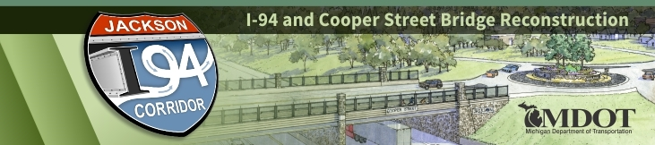
CONTACT: MDOT Jackson Transportation Service Center
517-780-7540
mdot-jacksontsc@michigan.gov
I-94 Project Update
July 27, 2020 – In the upcoming week, crews will continue reconstructing the median of I-94 by pouring a concrete barrier wall on westbound and eastbound I-94. Additionally, from Elm Avenue to Sargent Road, the contractor is working on grading and placing concrete base course in the median.
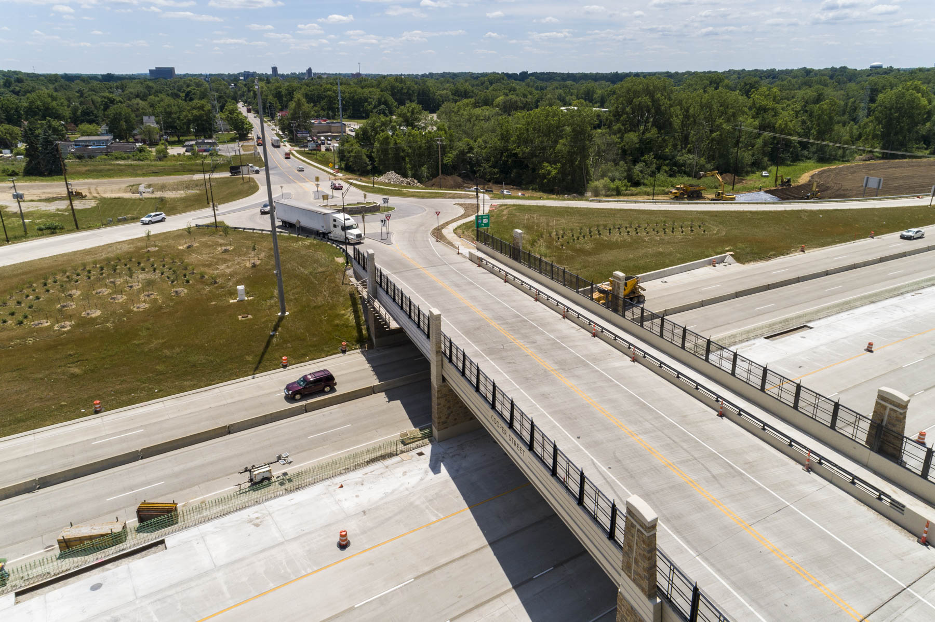
Figure 1: Cooper Street Interchange over I-94 in Jackson, MI
Maintenance of traffic for this upcoming week will include, traffic being maintained on I-94 with a “split-merge” configuration and reduced speed zones along I-94 between Sargent Road and Elm Avenue. Traffic will be maintained between Elm Avenue and Lansing Avenue with shoulder closures and reduced speed zones.

An I-94 Construction Video has been uploaded to YouTube and provides further information about the ongoing project.

For more information about the I-94 project, go to www.michigan.gov/i94jackson. The project website contains various visual aids including a link to our Construction Photos, a link to the most recent I-94 public meeting presentation, and additional links to project-related questions and answers.
###
Protect workers. Protect drivers. Safe work zones for all.
www.Michigan.gov/WorkZoneSafety

www.twitter.com/MDOT_LanJxn | www.facebook.com/MichiganDOT | www.youtube.com/MichiganDOT
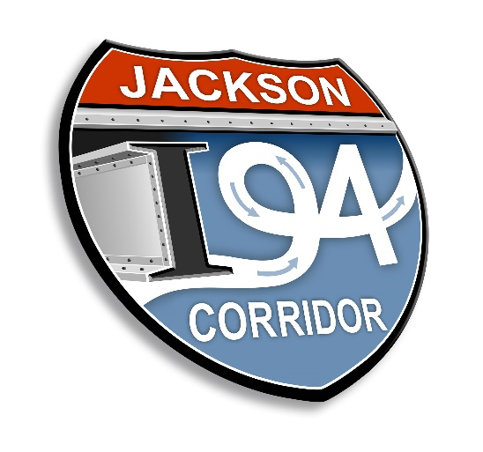
I-94 project logo (MDOT Graphics)

