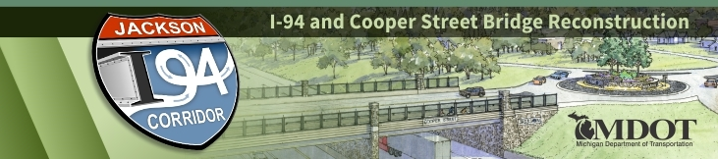
CONTACT: MDOT Jackson Transportation Service Center
517-780-7540
MDOT-JacksonTSC@Michigan.gov
I-94 Project Update
UPCOMING: Single-lane closures will be in place on eastbound and westbound I-94 throughout this week. There will be single-lane closures from M-60 to Sargent Road to accommodate road and bridge construction activities.

May 18, 2020 – In the upcoming weeks, work will continue on the westbound I-94 bridge over the Grand River. Work on the bridge will consist of pouring concrete for the bridge deck. Crews will continue reconstructing westbound I-94 by placing the continuously reinforced concrete pavement on westbound I-94. Additionally, the contractor will continue resurfacing the right lane of eastbound I-94 from Elm Avenue to Sargent Road. The contractor has milled the left lane of eastbound and westbound I-94 from M-60 to Lansing Avenue and is scheduled to begin hot-mix asphalt resurfacing on eastbound I-94 this week.

Traffic maintenance for this upcoming week will include traffic being maintained on I-94 with a "split-merge" configuration and reduced speed zones along I-94 between Sargent Road and Elm Avenue. Traffic will be maintained between Elm Avenue and Lansing Avenue with shoulder closures and reduced speed zones. Traffic being maintained from Lansing Avenue to M-60 will be reduced to one lane in each direction. The Cooper Street entrance ramp to westbound I-94 will be closed until July 31.

Watch the I-94 construction video on YouTube for further information about the ongoing project.

For more information about the I-94 project, go to www.Michigan.gov/I94Jackson. The project website contains various visual aids including a link to construction photos, a link to the most recent I-94 public meeting presentation, and additional links to project-related questions and answers.
###
Protect workers. Protect drivers. Safe work zones for all.
www.Michigan.gov/WorkZoneSafety

www.twitter.com/MDOT_LanJxn | www.facebook.com/MichiganDOT | www.youtube.com/MichiganDOT
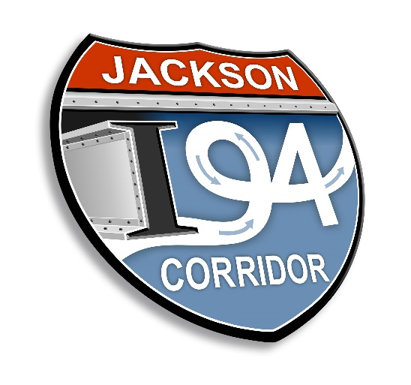
I-94 project logo (MDOT Graphics)

