Logon: www.gartner.com
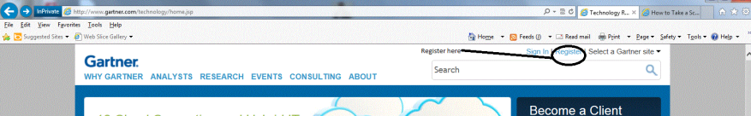
Complete Registration Info

Enter key search word(s)
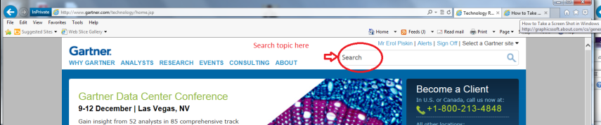
Select “Premium Research”

Document Number will appear in upper right corner – provide this number
