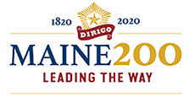
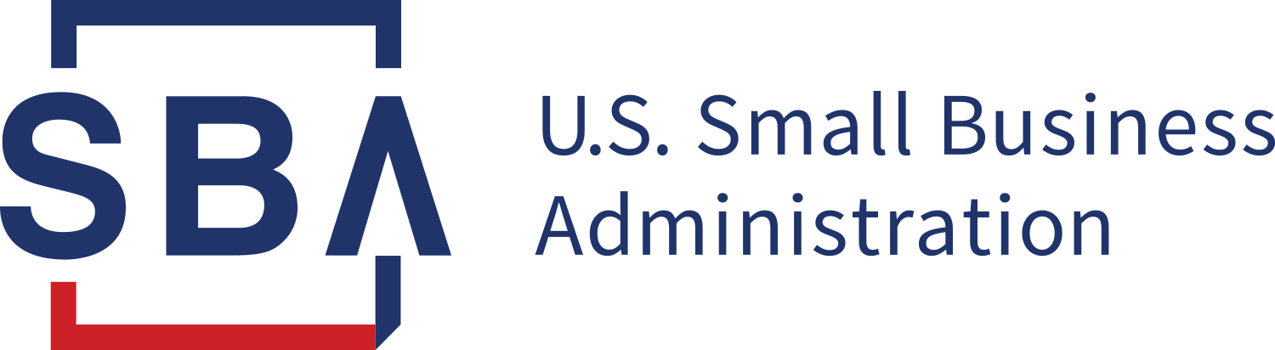

Calling All Maine Small Businesses:

PPP Application Deadline Extended!
New Loan Calculation Methods!

Please join the US Small Business Administration’s Maine District on Tuesday, April 20th at 3:30PM for a FREE webinar on COVID Relief resources.

We will discuss the recent extension of the PPP program and how you may qualify for more funds under new formula changes for IRS Form 1040, Schedule C filers. We’ll also provide a broad overview of other SBA COVID Relief Programs such as the Restaurant Revitalization Grant and Shuttered Venue Operators Grant Programs and provide information about SBA Resource Partners who may be able to help you and your business start, grow, expand, and recover from COVID 19.

Admission is FREE, but because space is limited Registration is REQUIRED
To Register Please Visit:
https://www.eventbrite.com/e/150721406785

