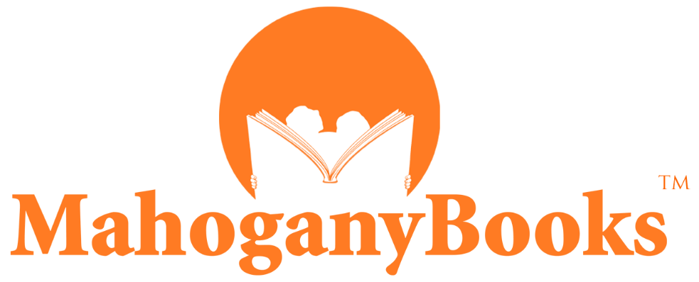

FOR IMMEDIATE RELEASE

FOR MEDIA AVAILABILITY CONTACT

media@mahoganybooks.com
202-844-2088
www.mahoganybooks.com

Vicki@Bendurepr.com
202-374-9259
www.nationalharbor.com
MahoganyBooks Opens Second Location at National Harbor
(WASHINGTON, February 11, 2021) —MahoganyBooks, an award-winning, New York Times reporting bookstore that specializes in books written for, by or about people of the African Diaspora, is opening its second bookstore at National Harbor located in Prince George's County, Maryland. MahoganyBooks will open their doors on the Juneteenth holiday (June 19th). Recently MahoganyBooks was featured on the Today Show after being surprised by President Barack Obama during their book club meeting.

“Growing up in Prince George’s County, this has become a full circle moment for me,” stated Derrick Young, co-owner and co-founder of MahoganyBooks. “MahoganyBooks is excited to open our doors to the visitors of National Harbor, and the residents of Prince George’s County. Opening on Juneteenth reminds us that we carry forward the rich history and legacy of our community.”

“This is truly a testament to the support of our MahoganyBooks family. Throughout the pandemic and the 13 years prior, our community has rallied around us.” said Ramunda Young, co-owner and co-founder of MahoganyBooks. “Our mission is clearer than ever. We will continue to provide a space that elevates Black authors and Black voices of the diaspora.”

“We are delighted to welcome MahoganyBooks to National Harbor,” said Kent Digby, EVP and senior asset manager at National Harbor. “This unique bookstore, with its regional and quickly growing national following, is the perfect complement to our retail portfolio of national brands and one-of-a-kind boutiques. National Harbor has quickly become a haven for successful retail entrepreneurs and well-loved brands.”

Derrick and Ramunda founded MahoganyBooks in 2007 as an online bookstore. In 2017, MahoganyBooks opened its first physical location in the historic Anacostia community in Washington, DC, becoming the first bookstore to do so in over two decades. Since then, MahoganyBooks has hosted book discussions and signings with prominent authors, leaders, and entertainers as well as book drives to promote children's literacy. Derrick and Ramunda have taken leadership roles in the African American community by promoting reading, writing, and cultural awareness as tools to improve self-esteem, self-love and ultimately our communities to enrich the lives of motivated individuals.

Co-owners and Co-founders of MahoganyBooks

Ramunda Lark Young
Occupation: Entrepreneur & Keynote speaker, co-founder/owner of MahoganyBooks in Washington DC. College/University: Langston University, Interests/Fun facts: Skydived once and eager for more. Passionate about people's voices being heard & decided to serve. Vice Chair of Human Rights Commission in VA, Mother to daughter Mahogany.

Derrick Young
Occupation: Entrepreneur, bookseller, co-founder/owner of MahoganyBooks in Washington DC. College/University: Bowie State University. Interests/Fun Facts: Comic book collector, sneakerhead, and avid cyclist, father to daughter Mahogany.

The store is named for their daughter, Mahogany.

About MahoganyBooks
Started in 2007 by husband and wife, Derrick and Ramunda Young, MahoganyBooks is the fastest growing online bookstore for people of the African Diaspora. It has grown from being exclusively an online bookstore to opening the doors of their first physical location in the historic Washington, DC neighborhood of Anacostia. Derrick and Ramunda’s love for culture, community and connection and their desire to see books empower others as it had empowered them. Over the years, MahoganyBooks has connected readers to writers for exciting and thought-provoking literary events with the likes of the late U.S. Representative John Lewis, Walter Mosley, Chimamanda Adichie, Ta-Nehisi Coates, Misty Copeland, Gabrielle Union, and D.C.’s “Mayor for Life” Marion Barry among others.

About National Harbor
Situated on the banks of the historic Potomac River and just minutes from the nation’s capital, National Harbor is a waterfront resort destination unlike any other. National Harbor is home to eight hotels including two of Maryland’s Four Diamond rated hotels—Gaylord National Resort and Convention Center and MGM National Harbor. Also, within National Harbor is Tanger Outlets’ 85 designer brands. The vibrant Waterfront District at National Harbor features boutique shops, restaurants, and entertainment options along picturesque promenades as well as the iconic Capital Wheel, a 180-ft observation wheel and the Guide by Cell outdoor art gallery tour. National Harbor typically welcomes more than 14 million visitors a year. For more information, visit www.NationalHarbor.com.

