**The Montgomery County Community Action Agency**

**Volunteer Income Tax Assistance (VITA) program invites community members to stop by the**

**WorkSource Montgomery Community Impact Team and Mobile Job Center**

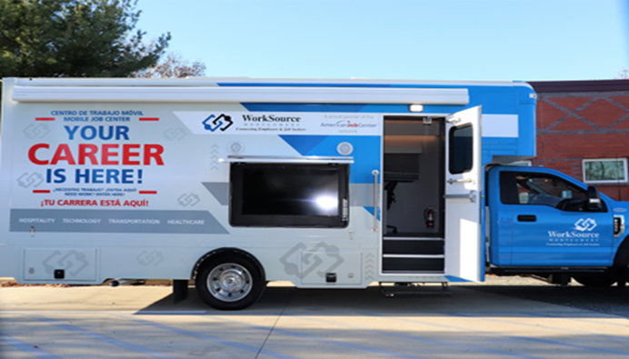

**DATE: October 29, 2024**

**TIME: 11am – 2 pm**

**LOCATION: 1401 Rockville Pike (FRONT PARKING LOT)**

The Mobile Job Center travels throughout Montgomery County, providing residents with a convenient opportunity to search for and apply for jobs. Staff members are available to assist jobseekers and offer guidance during this process.

WSM connects[**jobseekers**](https://worksourcemontgomery.com/home/job-seekers/) to [**employers**](https://worksourcemon1.wpengine.com/home/business-solutions/) and employers to jobseekers. WSM provides local job seekers with comprehensive employment and training services to promote economic sufficiency. For employers, WSM provides a robust set of business services and programs to help meet the talent needs of today and tomorrow.

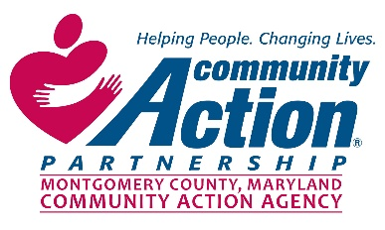  

To request accommodations, please call 240-777-1123 or send email to

**VITA@montgomerycountymd.gov** TTY users, please call Maryland Relay 711.

Montgomerycountymd.gov/CASHBACK