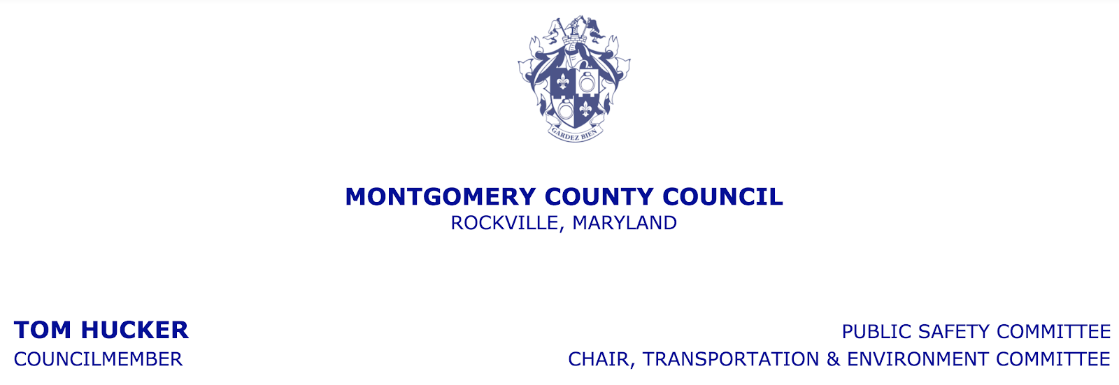

Secretary Pete K. Rahn and the Maryland Department of Transportation (MDOT) have been widely criticized for ignoring transit as part of the balanced solution that is needed to address congestion in the Washington metropolitan region, and for breaking promises to meaningfully involve the two major local governments that are the most affected by their plans.

If today’s announcement by MDOT is a sincere effort to take that criticism seriously and begin a new dialogue with local governments, we are happy to work in partnership with them to address the congestion in our region.

If this is merely window dressing to create the appearance of partnership with local officials without an appreciation for their legal obligations to protect their constituents or their expertise in local traffic and land use decisions, this will be a waste of time.

The proof is in the pudding.

