February 1, 2018

Mr. Paul J. Wiedefeld
General Manager and Chief Executive Officer
Washington Metropolitan Area Transit Authority
600 Fifth Street, NW
Washington, D.C. 20001

Dear Mr. Wiedefeld,

As members of the Montgomery County Council, we were troubled to hear that WMATA has backed away from its commitment of Board Resolution 2015-37 to eliminate the Red Line turnback at the Grosvenor-Strathmore station, and that the Red Line turnback is not addressed in the proposed FY19 budget.

Many of our constituents are affected by this Red Line turnback. Riders do not like to board and then reboard the train at Grosvenor to continue to go north on the Red Line. The turnback severely diminishes service to the White Flint, Twinbrook, Rockville, and Shady Grove stations, hurting ridership in a time when we are working hard to provide people reliable transit options. We understand the fiscal constraints WMATA has faced recently. However, one of the primary reasons for the turnback originally was a lack of rail cars, and now there are rail cars available. Please keep WMATA’s commitment to eliminate the Red Line turnback by the established July 1, 2018 deadline.

Furthermore, when more new rail cars are acquired, please allocate them to the elimination of the turnbacks on the east side of the Red Line, so that our residents boarding and alighting at the Forest Glen, Wheaton, and Glenmont Metro Stations finally get the full service that they deserve. Thank you for your prompt attention to this important matter.

Sincerely,

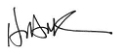 | 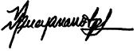 | 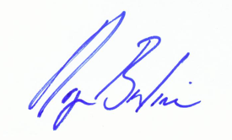
Hans Riemer  Montgomery County  Council President | Nancy Navarro  Montgomery County  Council Vice President | Roger Berliner  Montgomery County  Councilmember, District 1

 |  | 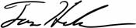
Marc Elrich  Montgomery County  Councilmember, At-large |  | Tom Hucker  Montgomery County  Councilmember, District 5

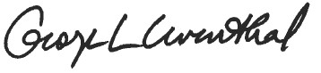 | 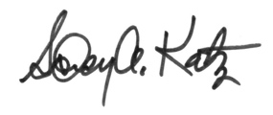 | 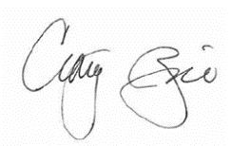
George Leventhal  Montgomery County  Councilmember, At-large | Sidney Katz  Montgomery County  Councilmember, District 3 | Craig Rice  Montgomery County  Councilmember, District 2

