

**Help spread the word about tax credits**

**Partner Promotion Bundle**

Refundable Tax Credits

Refundable tax credits put money back in the pockets of hardworking taxpayers.

The IRS offers various resources to explain these tax credits.

**How can you help?**

# Add a link to [eitc.irs.gov](http://www.eitc.irs.gov/) on your webpage and share resources about these tax credits.

**Earned Income Tax Credit (EITC)** helps low-to moderate-income workers.



[**Do you qualify for the Earned Income Tax Credit?**](https://www.irs.gov/pub/irs-pdf/p5998.pdf)

[**The Earned Income Tax Credit (EITC) is for people who work for someone else, are self-employed or receive certain disability payments.**](https://www.irs.gov/pub/irs-pdf/p5998.pdf)

[irs.gov/eitc](https://www.irs.gov/pub/irs-pdf/p5998.pdf)

[**To qualify, you must have low to moderate-income and meet the following rules.**](https://www.irs.gov/pub/irs-pdf/p5998.pdf)

[**To claim the EITC, you must file a federal tax return even if you owe no tax and are not required to file.**](https://www.irs.gov/pub/irs-pdf/p5998.pdf)

[Go to **www.irs.gov/eitc** for more information and to use the interactive EITC Assistant to see if you qualify for the credit and estimate the amount of your EITC.](https://www.irs.gov/pub/irs-pdf/p5998.pdf)

[Publication 5998 (7-2024) Catalog Number 95114D Department of the Treasury **Internal Revenue Service** www.irs.gov](https://www.irs.gov/pub/irs-pdf/p5998.pdf)

[See if you qualify for EITC](https://apps.irs.gov/app/eitc)

|  |
| --- |
| [**You (and your spouse, if filing a joint return)**](https://www.irs.gov/pub/irs-pdf/p5998.pdf) |
| [**Must**](https://www.irs.gov/pub/irs-pdf/p5998.pdf) |
| * [Have earned income under a certain amount](https://www.irs.gov/pub/irs-pdf/p5998.pdf) * [Have a Social Security number that is valid for employment issued on or before the due date of the return (including extensions)](https://www.irs.gov/pub/irs-pdf/p5998.pdf) * [Be a U.S. citizen or resident alien all year](https://www.irs.gov/pub/irs-pdf/p5998.pdf) * [Have a qualifying child or, if you do not have a qualifying child, you must:](https://www.irs.gov/pub/irs-pdf/p5998.pdf)   + [Be at least age 25 but under age 65 at the end of the year,](https://www.irs.gov/pub/irs-pdf/p5998.pdf)   + [Live in the United States for more than half the year and](https://www.irs.gov/pub/irs-pdf/p5998.pdf)   + [Not qualify as a dependent of another person](https://www.irs.gov/pub/irs-pdf/p5998.pdf) |
| [**May not**](https://www.irs.gov/pub/irs-pdf/p5998.pdf) |
| * [Have investment income, such as interest income, over a certain amount](https://www.irs.gov/pub/irs-pdf/p5998.pdf) * [File as married filing separately](https://www.irs.gov/pub/irs-pdf/p5998.pdf) * [Be a qualifying child of another person](https://www.irs.gov/pub/irs-pdf/p5998.pdf) * [File Form 2555 or 2555-EZ (related to foreign earned income)](https://www.irs.gov/pub/irs-pdf/p5998.pdf) |
| [There are special rules for qualifying children, military, clergy members and taxpayers and their relatives with disabilities.](https://www.irs.gov/pub/irs-pdf/p5998.pdf) |

[](https://www.irs.gov/pub/irs-pdf/p5120.pdf)

**Child Tax Credit (CTC)** helps families with children.



[Publication 5811 (4-2023) Catalog Number 94092Q Department of the Treasury **Internal Revenue Service** www.irs.gov](https://www.irs.gov/pub/irs-pdf/p5811.pdf)

[**Child Tax Credit (CTC)**](https://www.irs.gov/pub/irs-pdf/p5811.pdf)

[File a tax return to claim the child tax credit for each qualifying child who has a valid social security number issued before the due date of the return. Generally, the qualifying child must be:](https://www.irs.gov/pub/irs-pdf/p5811.pdf)

* [Your son, daughter, stepchild, eligible foster child, brother, sister, stepbrother,stepsister, half-brother, half-sister, or a descendant of any of them(for example, your grandchild, niece, or nephew) who can be claimed as a dependent on your return. For more information, see **Publication 501, Dependents, Standard Deduction, and Filing Information**.](https://www.irs.gov/pub/irs-pdf/p5811.pdf)
* [Under age 17 at the end of the year.](https://www.irs.gov/pub/irs-pdf/p5811.pdf)
* [A U.S. citizen, U.S. national, or U.S. resident alien. For more information, see **Publication 519, U.S. Tax Guide for Aliens**.](https://www.irs.gov/pub/irs-pdf/p5811.pdf)

[Use the IRS Interactive Tax Assistant tool “**Does My Child/Dependent Qualify for the Child Tax Credit or the Credit for Other Dependents?**” to determine if a person qualifies you for the Child Tax Credit or the Credit for Other Dependents (ODC).](https://www.irs.gov/pub/irs-pdf/p5811.pdf)

[Visit “**What You Need to Know about CTC, ACTC, and ODC**” for more information or scan the QR Code:](https://www.irs.gov/pub/irs-pdf/p5811.pdf)



[See if you qualify for CTC](https://www.irs.gov/help/ita/does-my-childdependent-qualify-for-the-child-tax-credit-or-the-credit-for-other-dependents)

**American Opportunity Tax Credit (AOTC**) helps taxpayers who pay higher education expenses.



[American Opportunity](https://www.irs.gov/pub/irs-pdf/p4772.pdf)

[Tax Credit (AOTC)](https://www.irs.gov/pub/irs-pdf/p4772.pdf)

[Generally, to be eligible for the American Opportunity Tax Credit, the student must:](https://www.irs.gov/pub/irs-pdf/p4772.pdf)

* [Be pursuing a degree or other recognized education credential.](https://www.irs.gov/pub/irs-pdf/p4772.pdf)
* [Be enrolled at least half time for at least one academic period beginning in the tax year.](https://www.irs.gov/pub/irs-pdf/p4772.pdf)
* [Not have finished the first four years of higher education at the beginning of the tax year.](https://www.irs.gov/pub/irs-pdf/p4772.pdf)
* [Not have claimed the AOTC or the former Hope credit for more than four tax years.](https://www.irs.gov/pub/irs-pdf/p4772.pdf)
* [Not have a felony drug conviction at the end of the tax year.](https://www.irs.gov/pub/irs-pdf/p4772.pdf)

[**Maximum Amount –** You can receive up to a $2,500 credit per eligible student, which phases out if your modified adjusted gross income is over $80,000 ($160,000 for joint filers). For most individuals, the modified adjusted gross income is the adjusted gross income reported on line 11 of their tax return.](https://www.irs.gov/pub/irs-pdf/p4772.pdf)

[**Qualified Paid Expenses –** Claim the credit for tuition, required enrollment fees, and books, supplies, and equipment needed for the course of study, whether or not the materials are purchased from the educational institution.](https://www.irs.gov/pub/irs-pdf/p4772.pdf)

[**Taxpayer Identification Number (TIN) –** The taxpayer and student, if different, must have a social security number (SSN) or other TIN that was issued by the due date of their tax return (including extensions). If the SSN is issued after the due date or the taxpayer or student applied for a different TIN from the IRS after the due date, the taxpayer cannot amend their return and claim the credit.](https://www.irs.gov/pub/irs-pdf/p4772.pdf)

[**Eligible Educational Institution –** Any accredited college, university, trade school, or other postsecondary educational institution eligible to participate in a student aid program administered by the](https://www.irs.gov/pub/irs-pdf/p4772.pdf)

[U.S Department of Education is included.](https://www.irs.gov/pub/irs-pdf/p4772.pdf)

[**Form 1098T –** Eligible educational institutions are required to send Form 1098-T, Tuition Statement, to students who paid qualifying expenses.](https://www.irs.gov/pub/irs-pdf/p4772.pdf)

[**Eligibility –** You can claim the AOTC for yourself, your spouse, or a dependent claimed on your return.](https://www.irs.gov/pub/irs-pdf/p4772.pdf)

[Claim the AOTC on **Form 8863**, Education Credits. **See Publication 970,** Tax Benefits for Education, or use the IRS Interactive Tax Assistant tool **“Am I Eligible to Claim an Education Credit?”** to help you determine if your education expenses qualify for a tax benefit.](https://www.irs.gov/pub/irs-pdf/p4772.pdf)

[For more information, visit **www.irs.gov/AOTC** or scan the QR Code:](https://www.irs.gov/pub/irs-pdf/p4772.pdf)

[Publication 4772 (Rev. 5-2023) Catalog Number 53262K Department of the Treasury **Internal Revenue Service** www.irs.gov](https://www.irs.gov/pub/irs-pdf/p4772.pdf)



[See if you qualify for AOTC](https://www.irs.gov/help/ita/am-i-eligible-to-claim-an-education-credit)

[](https://www.irs.gov/pub/irs-pdf/p5120.pdf)**Premium Tax Credit (PTC)** helps taxpayers cover the premiums for health insurance purchased through the Health Insurance Marketplace.



[See if you qualify for PTC](https://www.irs.gov/help/ita/am-i-eligible-to-claim-the-premium-tax-credit)

|  |  |
| --- | --- |
|  |  |
| [If you or a member of your family enrolls in health insurance through the Marketplace, you may be eligible for the premium tax credit, a refundable credit that helps eligible individuals and families pay for health insurance.](https://www.irs.gov/pub/irs-pdf/p5120.pdf)  [**Advance Payments**](https://www.irs.gov/pub/irs-pdf/p5120.pdf)  [During enrollment, the Marketplace determines if you’re eligible for advance payments of the premium tax credit.](https://www.irs.gov/pub/irs-pdf/p5120.pdf)  [If you’re eligible, you can choose to have **ALL**, **SOME** or **NONE** of the advance payments for which you are eligible sent to your insurance company:](https://www.irs.gov/pub/irs-pdf/p5120.pdf)   * [**ALL:** the entire amount of your pay- ments will be sent monthly to your](https://www.irs.gov/pub/irs-pdf/p5120.pdf)   [insurance company **Eligibility**](https://www.irs.gov/pub/irs-pdf/p5120.pdf)   * [**SOME:** a portion of your payments are If you or a family member enrolls in health coverage through the Marketplace for a month paid in advance to your insurance com- that you or the family member was not eligible for non-Marketplace health coverage, you pany, and then you wait to receive the may be allowed the credit if you:](https://www.irs.gov/pub/irs-pdf/p5120.pdf)   [rest of the benefit of the premium tax • Paid your share of Marketplace insurance premiums credit for which you are eligible when](https://www.irs.gov/pub/irs-pdf/p5120.pdf)  [you file your tax return • Have household income within certain limits](https://www.irs.gov/pub/irs-pdf/p5120.pdf)   * [**NONE:** you have nothing sent to your • Do not file a married filing separately return. There are exceptions to this rule for domes- insurance company during the year, tic abuse and spousal abandonment victims](https://www.irs.gov/pub/irs-pdf/p5120.pdf)   [and wait to get all the benefit of the • Cannot be claimed as a dependent by another person credit when you file your tax return](https://www.irs.gov/pub/irs-pdf/p5120.pdf)  [**Did You Know... You must file a federal tax return if either of these apply to you:**](https://www.irs.gov/pub/irs-pdf/p5120.pdf)  [**If you choose not to have advance** • Advance credit payments were made on your behalf to your insurance company](https://www.irs.gov/pub/irs-pdf/p5120.pdf)  [**credit payments made on your behalf,** • You are claiming the premium tax credit](https://www.irs.gov/pub/irs-pdf/p5120.pdf)  [**you will get the credit when you file** Failing to file your tax return will prevent you from getting the benefit of advance credit](https://www.irs.gov/pub/irs-pdf/p5120.pdf)  [**your tax return.** payments in future years.](https://www.irs.gov/pub/irs-pdf/p5120.pdf)  [**This will lower your tax balance due**](https://www.irs.gov/pub/irs-pdf/p5120.pdf)  [**and could increase your refund. Claiming and Reconciling the Credit**](https://www.irs.gov/pub/irs-pdf/p5120.pdf)  [When you file your tax return, you will use Form 8962, Premium Tax Credit, to claim the credit and to reconcile the credit with the advance credit payments made for you and your](https://www.irs.gov/pub/irs-pdf/p5120.pdf)  [**To access the** family. To reconcile the credit, subtract the total of your advance credit payments from the](https://www.irs.gov/pub/irs-pdf/p5120.pdf)  [**Marketplace, visit** amount of the premium tax credit computed on your tax return. The difference will change](https://www.irs.gov/pub/irs-pdf/p5120.pdf)  [**Healthcare.gov** the amount of tax you owe or the amount of your federal refund.](https://www.irs.gov/pub/irs-pdf/p5120.pdf)  [**Report life changes to the Marketplace**](https://www.irs.gov/pub/irs-pdf/p5120.pdf)  [Reporting life changes such as changes to income or family size – will help you avoid large differences between the advance credit payments made on your behalf and the amount of the premium tax credit you are allowed when you file your tax return.](https://www.irs.gov/pub/irs-pdf/p5120.pdf)  [Publication 5120 (Rev. 2-2018) Catalog Number 65487X Department of the Treasury **Internal Revenue Service** www.irs.gov](https://www.irs.gov/pub/irs-pdf/p5120.pdf) | |

# Encourage eligible taxpayers to file a tax return to claim these credits. Taxpayers can find many filing options on IRS.gov, including free options for qualifying taxpayers.

[Options for filing a](https://www.irs.gov/filing/individuals/how-to-file) [tax return](https://www.irs.gov/filing/individuals/how-to-file)

Post these messages on your social media accounts.

Let’s get the valuable Earned Income Tax Credit to all American families that qualify – including those who don’t normally file tax returns. Help #IRS spread the word about #EITC: [www.irs.gov/eitc](http://www.irs.gov/eitc)

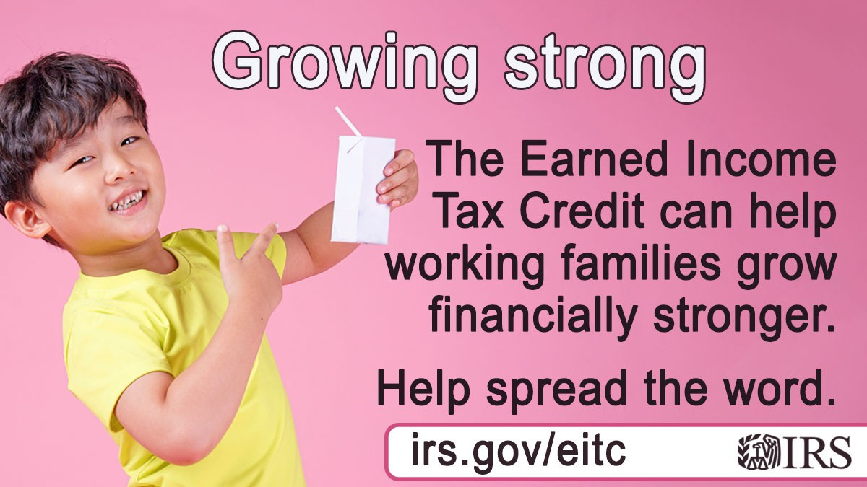

Raising kids can be expensive. But refundable credits like the #IRS Child Tax Credit can help. A refundable tax credit is a credit you can get as a refund, even if you don’t owe any tax. For more info, see: [www.irs.gov/childtaxcredit](http://www.irs.gov/childtaxcredit)

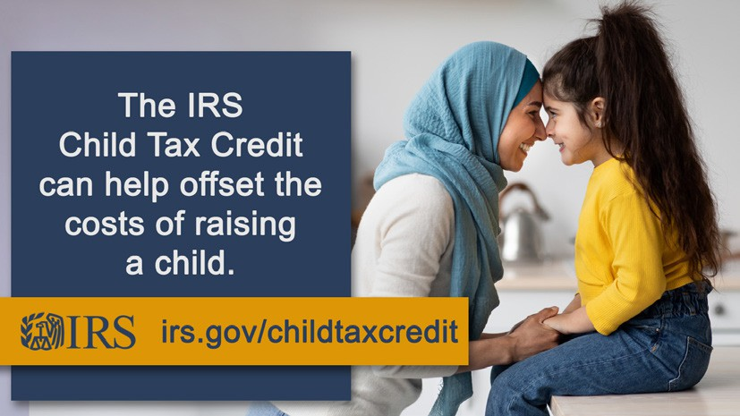

Check out tax benefits available for college students or their parents. Learn more at [www.irs.gov/education](http://www.irs.gov/education)



Do you know if you qualify for a tax credit that can make purchasing health insurance coverage more affordable? See how the refundable Premium Tax Credit can help: [irs.gov/ptc](https://www.irs.gov/affordable-care-act/individuals-and-families/the-premium-tax-credit-the-basics)



Publication 6011 (8-2024) Catalog Number 95206E Department of the Treasury **Internal Revenue Service** publish.no.irs.gov