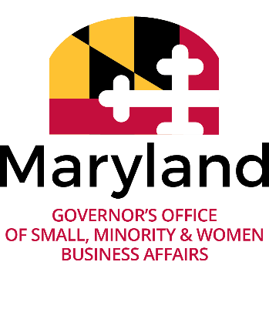
Governor’s Office of Small, Minority & Women Business Affairs
(GOSBA) Compliance Call Questions with Summarized Answers
(Click icon on topics of interest to expand and view.)

Compliance Call Library

General Topics

Contract Specific Administration / Management

CATS+

Does DoIT set the goal for CATS+ and statewide contracts and track the goal on the statewide contracts that agencies are utilizing? What are the agencies expected to do as it relates to tracking their IT contracts? *(1/22/2020)
- DoIT sets an overall CATS+ master contractor goal and subgoals. This does not mean that every Task Order for Proposals (TORFP) has be set at that goal; some will be higher and some will be lower, depending upon the pertinent circumstances of each task order. The procuring agency must evaluate and set individual MBE goals on a task order basis. The objective is to establish a reasonable and attainable MBE goal, given the specifics of the TORFP scope of work and other factors. The procuring agency is expected to track their individual IT contracts. https://doit.maryland.gov/contracts/Pages/CATSPlusMBEParticipation.aspx

Intergovernmental Agreements

Concerning IGAs (Intergovernmental Agreements): 1. Are IGA contracts with MBE/VSBE goals placed in FMIS? 2. If there is a goal, should Subcontractor data be tracked in FMIS? 3. Are IGAs exempt from reporting requirements? 4. At IGA Renewal, is documentation of MBE compliance needed from the contract monitor? *(1/22/2020)
- According to the Procurement Manual, section 3.4.7, an Intergovernmental Cooperative Purchasing Agreements (ICPA) solicitation must contain all clauses, terms, and conditions required under State procurement law and the contract is awarded in the same manner as a State contract, including any other required approvals. So, these agreements may have a goal and should be tracked for compliance and in FMIS. Primary Procurement units usually handle these types of contracts. https://procurement.maryland.gov/mpm-3-pre-solicitation/#3.4

PRG Process (Goal Setting)

Is it possible to get a walk-through of the proper way to establish MBE goals and subgoals? *(1/22/2020)
- The GOSBA Legal and Policy Advisor provided a high level walk-through of the PRG Process and goal setting. Please see BPW Advisory 2001-1, the Subgoal Guidance, and the PRG Template [May have to choose View, Edit Document to open] for more information. Due to demand, GOSBA is considering creating curriculum on goal setting. More to come on that later.

1. What are the best practices for setting MBE and VSBE goals and determining the scope of work for each? 2. How should the search be conducted for MBE and VSBE subcontractors? *(1/22/2020)
- Current legislation does not clearly define exactly how agencies should go about setting both MBE and VSBE goals on a contract simultaneously. It will take legislative action to clearly spell out a process. In hearing from the agencies, there are multiple ways this has been carried out. As BPW Advisory 2001-1 states, you should consider race neutral measures first, such as the SBR Program, then consider MBE and VSBE Goals. As a best practice, you should consult with your agencies AG, to ensure you are making a sound decision.
- When searching for MBE and VSBE firms, please remember that if three or more firms are found, you should consider adding a goal. PLEASE NOTE** Currently eMMA is not at optimal operation and so agencies can reach out to Tanita Johnson, in our office, for a better list of VSBE firms to consider, if necessary.

