Agile Work Order BPO Process for Requesting Agency

(Background: The requesting agency must create a BPO for each Agile work order. The agency will link their created work order BPO to the Agile contract PO).

Steps

- The Requesting agency will create a BPO in FMIS for the Agile work order.
- Link the work order BPO (BPO/Contract ID) to the Agile contract BPO (Original BPO field).

Note: The master BPO is referenced where it asks for the original BPO# on the 2342 Screen
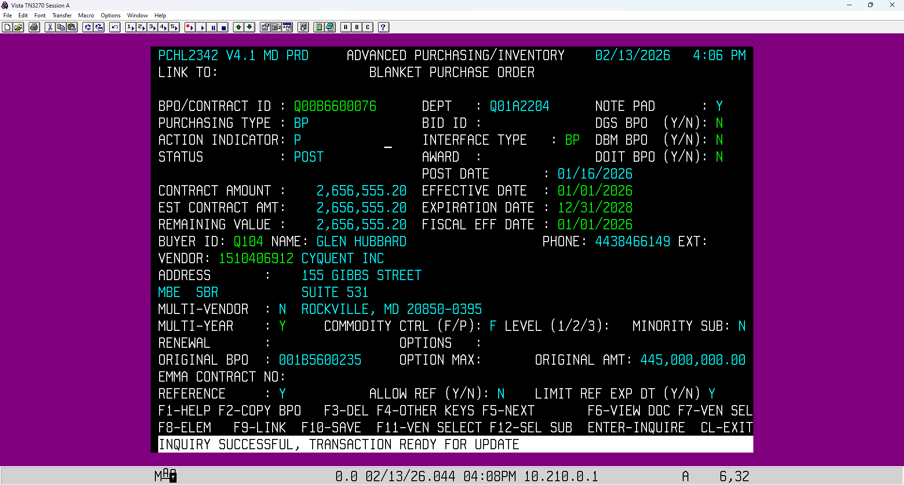

- Hit F10 to save the transaction.

- On the Element Screen 2353, enter the MBE and VSBE (VET) Commit Amounts.
- Enter the MBE and VSBE (VET) Goal %.

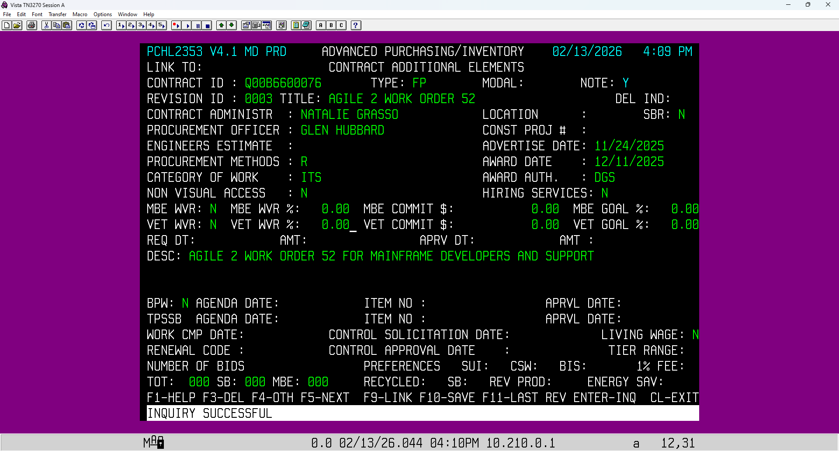

- Enter the work order subcontractor information on the 2345 Screen
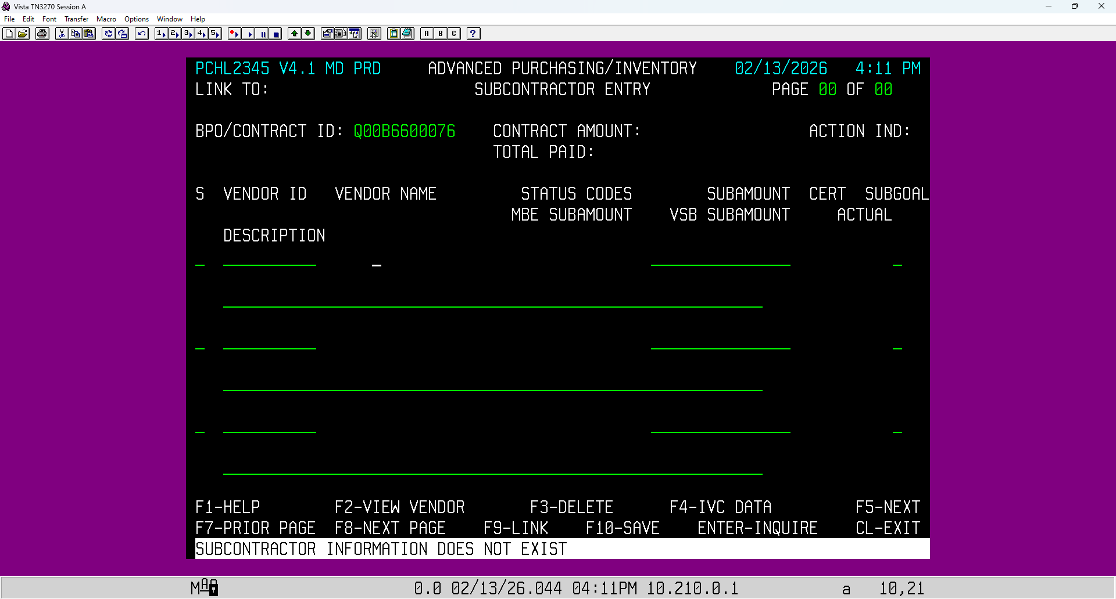

- From the 2342 Screen, hit F4 to change the commands at the bottom so it shows TERMS
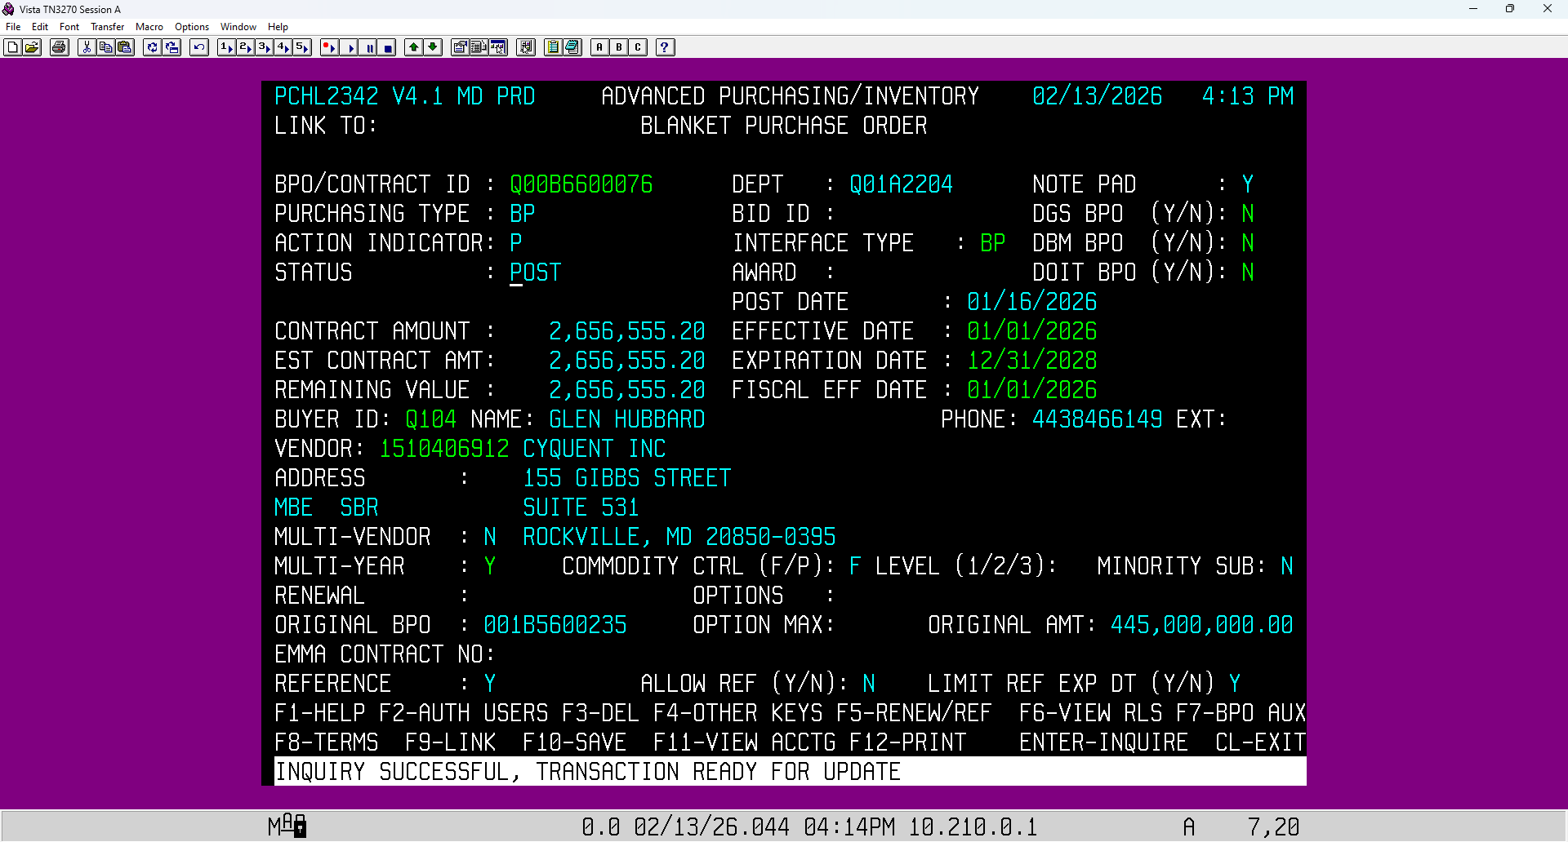

- Hit F8 to select “Terms.” Enter the terms, the agency contact phone number, and the email address in the fields.
    - Note: (Information will show up under the Block Function on the screen).
- 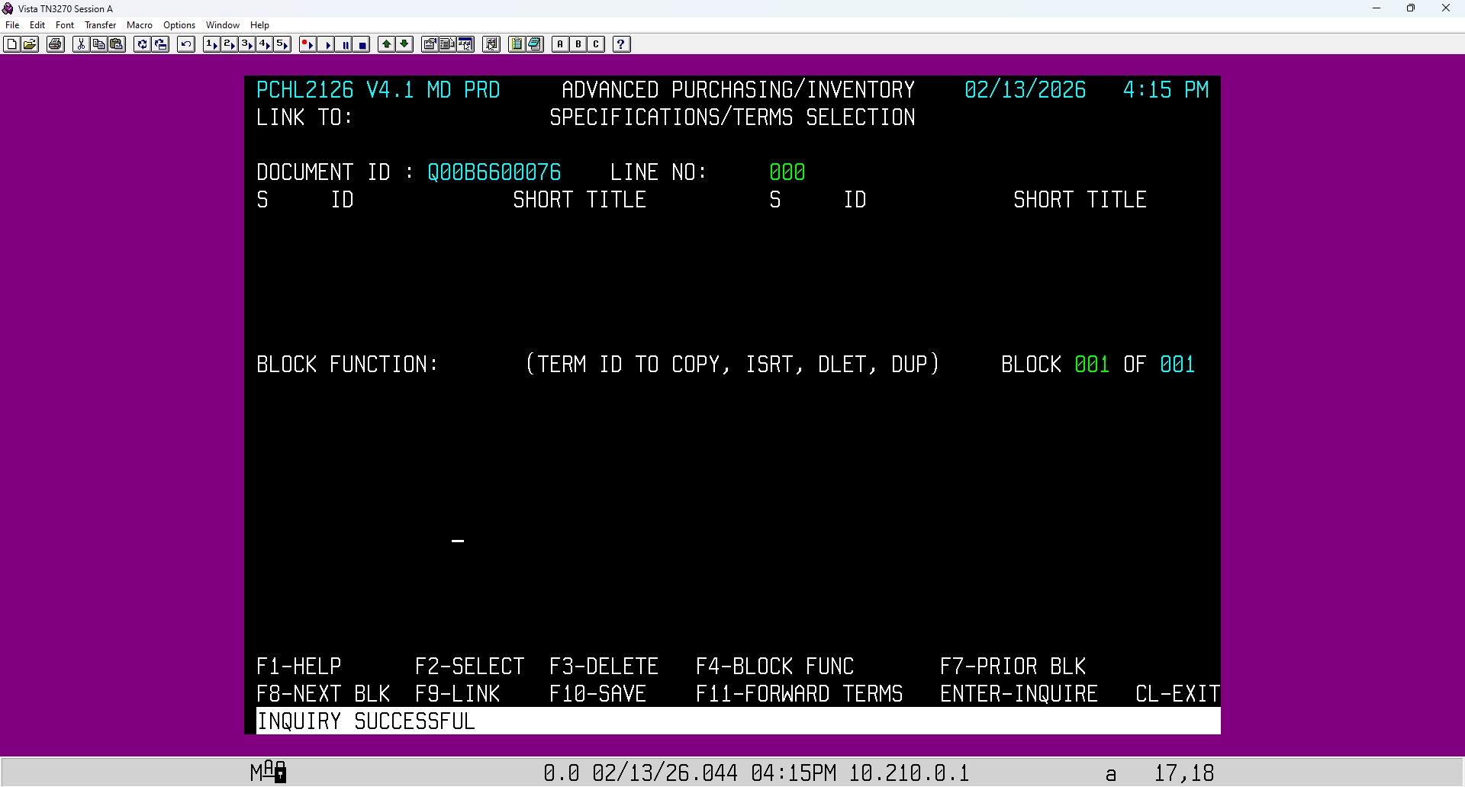

- Hit F10 to save the transaction.

