Payment Entry Guidelines

How to Enter Subcontractor Payments in FMIS

(Background: The agency will need to enter subcontractor payments into FMIS. This is the process for entering those payments into the FMIS system.

Steps
- Type FMIS and Enter
- Enter your Username and Password
- Type FMST and Enter
- From the menu screen, press F2 for ADPICS (This will bring you to the main menu)
- Press Home to the Link to Field type and enter 2342 (this will bring you directly to the Blanket Purchase Order Screen) or press F2 for the Procurement Transactions Menu
- If you press F2, then hit F5 for the Blanket Purchase Order (BPO) Writing
- Type or paste the BPO number
- Hit Enter
- Go to the Link to Field type Note
- In the note field, document the following:
  - Payment received date
  - Invoice number if provided
  - Invoice date
  - Invoice payment amount
    - Note: This information will be found on the MBE D4 (Prime Contractor Paid/Unpaid Invoice Report) and the MBE D5 (MBE Subcontractor Paid/Unpaid Invoice Report). Ensure that the payments on both forms match. If there are any discrepancies between the two forms, contact the prime and the subcontractor to determine the cause.
- Hit “home” to get to the “link to” field.
- Type 2342 then press F9
- Hit Home on the keyboard
- In the Link To field type 2345, then hit F9. Or from the 2342 screen,
- This will bring you to the Subcontractor Entry screen

Screen # 2345 example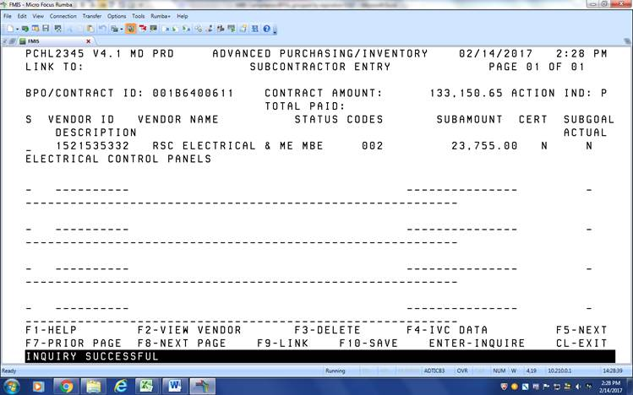
- Type S to select a vendor (see arrow above)
- Then hit F4 to move to the Subcontractor Invoice Information Screen or hit 2355, then hit F9
- In the Invoice number field, type the invoice number from the subcontractor payment form, MBE D5 (If there is no check # or invoice #, enter MBE14L and the payment # or payment summary)
- In the Invoice date field, type the date the payment was sent
- In the Invoice amount field, type the amount of payment
- Hit F10 to save
- Repeat this for each vendor payment to be entered
Screen # 2355 example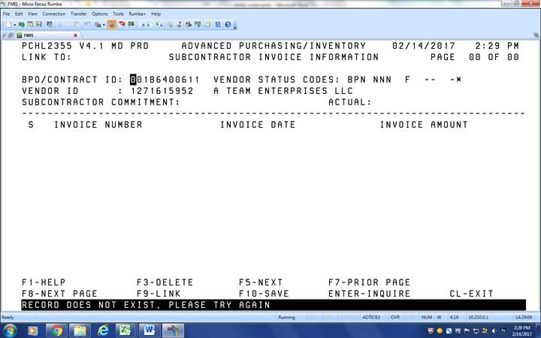

- Verify that the total amounts are correct by checking the amount paid on the subcontractor payment form and that the actual field on FMIS matches.
- File the subcontractor payment form with the hard file.
    - Note: If you enter a payment in error, select the payment by typing an S next to the invoice number and then hit F3 to delete it.

