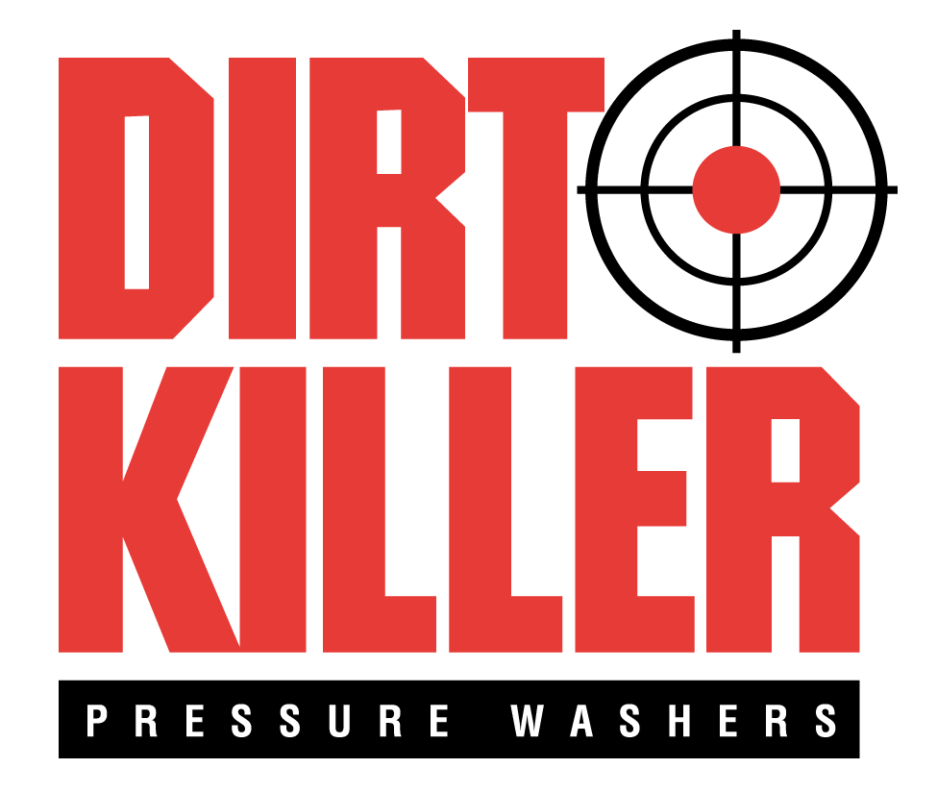
WAREHOUSE COORDINATOR

Hamilton Associates, Inc. is a growth-oriented, Lean-driven, ISO-Certified and diversified manufacturing company located in Owings Mills, MD. For additional information about our Company and each of our divisions and our product lines, please visit our websites at www.hamiltonassoc.com, www.elscoguides.com, www.atitest.com, and www.dirtkiller.com.

Dirt Killer Pressure Washers, a division of Hamilton Associates, is the US importer for Kränzle, a high-quality pressure washer manufacturer located in Germany. In addition, we use other components of the Kränzle line to manufacture our own brand of pressure washers under the Dirt Killer line. Kränzle and Dirt Killer pressure washers have a reputation for being the best in the business!

Not only do we sell our pressure washers through a national dealer network that includes pressure washer specialist stores, industrial and agricultural suppliers, and ecommerce sites, but we also operate a local retail store, Atlantic Pressure Washers Superstore. At this retail store, located in Baltimore, MD, we sell these commercial-grade pressure washers, as well as accessories, parts and cleaning chemicals to professional cleaners, businesses and government organizations. In our store, we also repair all makes and models of pressure washers. Our expert staff specializes in helping local cleaning professionals solve their toughest cleaning problems by providing the right equipment, chemicals and how-to-clean knowledge.

POSITION OVERVIEW
As our Warehouse Coordinator, this employee will perform a wide variety of warehouse functions. Job consists of interacting with customers both in person and by phone. Candidate will be responsible for picking, packing and shipping all orders, receiving, inventory management, and PO follow up as well as other duties as assigned.

Responsibilities include, but are not limited to:

- Support the team by attending to customers’ needs.
- Always be alert to customers coming and going. If there is no retail staff around greet customer and let customer service person know they are in the building.
- Always be cognizant of the phone. If the phone rings three times pick it up. Take calls if all other associates are on the phone. Discern the customer’s needs. Get them to the right person to help them or take a detailed message.
  - Follow in house scripts for responding to customer phone calls and walk ins.

- Manage incoming and outgoing deliveries and storage of product in warehouse.
- Accurately pick and pack items of various size to ensure customer satisfaction.
- Pack smaller items and palletize large items and wrap for shipment.
- Load and unload trucks and validate delivery tickets.
- Process Inventory Receipts.
  - Help drivers with unloading.
  - Inspect receipts for damage prior to acceptance.
  - Count and receive goods in Odoo.
  - Notify vendor of any issues, back orders, receiving discrepancies, or pricing issues.
  - Make adjustments in Odoo.

- Use of hand tools to unpack and repack merchandise.
- Restock showroom chemicals and parts as necessary.
- Physically put inventory in their proper bins, updating bins and adding bins as necessary.
- Maintain shipping/receiving documents and records required per internal processes and customer requirements.
- Safely operate and maintain forklift and hand truck/pallet jack.
- Participate in weekly cycle counts.
- Be available for work between the hours of 7:00am and 6:00pm according to schedule, some Saturday work is required.
- Keep the warehouse area tidy and free from debris.
- Break down boxes, and stack pallets, dispose of as necessary.
- Perform other duties as assigned.

Minimum Background and Skills Required:
- H.S. Diploma or equivalent
- 1-3 years’ experience working in an industrial or warehousing environment
- Ability to read product identification quickly and accurately
- Detail oriented, excellent organizational and time management skills, able to meet assigned deadlines
- Arrives on time ready to work
- Experience utilizing hand trucks, or pallet jacks
- Proficient in MS Office (Word, Excel, and Outlook) and experience with use of ERP business systems
- Basic math and data entry skills
- Ability to lift and carry up to 75 lbs. with assistance on a regular basis
- Ability to act and operate independently with minimal daily direction from manager to accomplish objectives
- Exceptional verbal communication skills, ability to communicate effectively, professionally, with tact and diplomacy
- Ability to take and follow directions and work well with others as part of a team
- Ability to work in a fast-paced environment
- Excellent interpersonal skills, with a passion for helping people and a friendly attitude and demeanor
- Clean driving record and able to drive a van

Additional Background and Skills Preferred:
- Ability to read engineering and electrical schematics
- Experience in small engine repair
- Experience in plumbing repair

Physical Requirements and Working Conditions
- Occasional Sedentary Work
- Frequent Standing
- Frequent Lifting
- Frequent Walking
- Frequent Ladder Climbing
- Speaking
- Hearing
- Visual Acuity

CONTACT US
If you are a driven, results-oriented individual seeking an opportunity to play a key role in the continuing growth of a reputable organization, please forward your resume, in WORD or PDF format, along with your salary history/requirements, to us for immediate consideration.

E-mail Address: dk.resumes@hamiltonassoc.com

DIRT KILLER PRESSURE WASHERS
A Division of Hamilton Associates, Inc.
823 Hammonds Ferry Road, Suite B-C
Linthicum Heights, MD 21090

Hamilton Associates, Inc. is an Equal Employment Opportunity (EEO) employer.
Qualified applicants will receive consideration for employment without regard to race, color, religion, sex, national origin, sexual orientation, gender identity, disability

