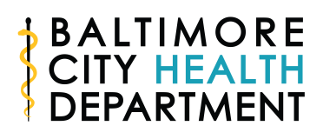

Baltimore City 80% by 2018
Baltimore City Cancer and Health Equity Coalition
FIT Testing Clinic Stipend Opportunity
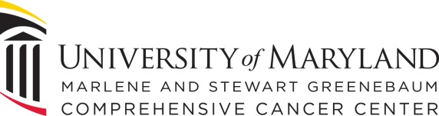
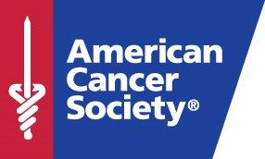
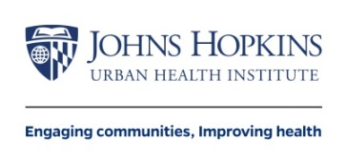
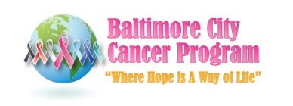
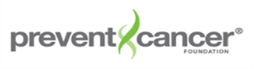
Stipend and reporting requirements:
-Provide aggregate data on number of people reached, basic demographics (race/ethnicity, gender, age) and if any patients were referred for further testing due to abnormal results by June 30, 2018. DO NOT SUBMIT ANY PATIENT LEVEL DATA.

-Utilize funding only to offset out of pocket costs or address barriers to testing compliance (postage, transportation, small incentive) for at least 40 people.

-Agree to have your staff trained by the BCCHEC for FREE with CEUs/CMEs provided. The training will be less than one hour and will occur at your clinic sites.

-Priority will be given to clinics in/near Baltimore City zip codes with high colorectal cancer mortality.

The Baltimore City Health Department and Baltimore City Cancer and Health Equity Coalition are seeking applications for FIT testing clinic stipends.
Made possible with funding from the Prevent Cancer Foundation, these stipends are intended to address barriers to colorectal cancer screening, particularly the potential out of pocket costs for FIT testing. Clinics that apply should refer for/order FIT tests for patients, as appropriate according to screening guidelines, and use the stipend to ensure compliance with the screening (i.e., the FIT tests are returned by the patients).
Dollars must be used to offset out of pocket costs for uninsured and underinsured patients or to address a barrier to screening such as return postage, transportation, or a small incentive to return the FIT test for at least 40 patients from January to June 2018.
Priority will be placed on clinics that are providing services in or near Baltimore City zip codes with high colorectal cancer mortality. See page 2 of this application for a map of colorectal cancer mortality rates in Baltimore City.
Applications are due on October 16, 2017 to emilie.gilde@baltimorecity.gov
Made possible with funding from the Prevent Cancer Foundation
In-Kind support from
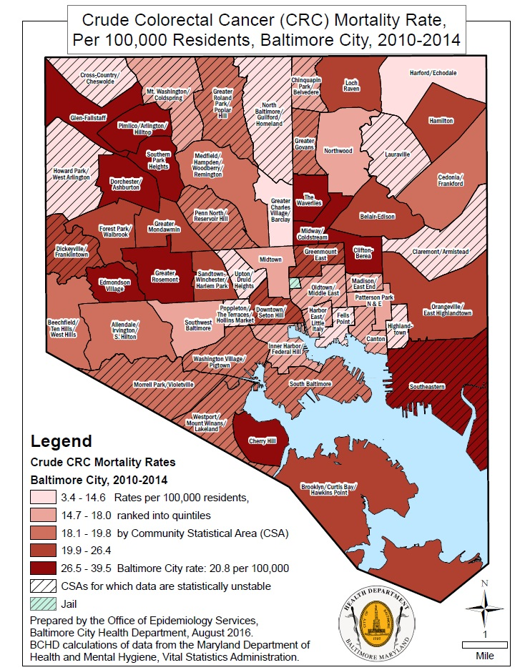
Baltimore 80% by 2018
Baltimore City Cancer and Health Equity Coalition
FIT Testing Stipend Application— $1,000
DUE October 16, 2017 to emilie.gilde@baltimorecity.gov

Name of Organization:______________________________________________________

Office Address : ___________________________________________________________

Contact: _______________________ Role/Title: ______________________________

Contact Email:______________________ Contact’s Phone: ______________________

What sites will services be offered at (please provide zip codes)?

______________________________________________________________________

Does your organization currently provide FIT screening? Yes No

Program Overview: In 250 words or less, describe how you will use funding to decrease patient out of pocket costs and address barriers (transportation, etc) to increase FIT testing.

Please provide at least two possible dates for FREE training with CEUs/CMEs, January 2017 or later:

Please provide three community outreach partners and their contact information. The coalition will be reaching out to do community outreach near your clinic sites.

