Louisville Metro Council
District 9 eNews | August 6, 2026

WELCOME TO D9'S BIWEEKLY E-NEWS!
“I am optimistic because today is a new day.”

HAPPY FIRST DAY OF SCHOOL JCPS!
Today is the first day of school for Jefferson County Public Schools (JCPS)! As students, teachers, and staff return to classrooms across the district, we wish everyone a successful, safe, and exciting start to the new school year.
The first day marks the beginning of new opportunities, new friendships, and new achievements. We encourage families to allow extra travel time, be mindful of school bus stops and school zones, and help students start the year off strong.
Here's to a wonderful school year filled with learning, growth, and success. Welcome back, JCPS! 🍎📚
REMINDER: A Change to the School Bus Safety Law
🚍 New Kentucky school bus stop law is now in effect
School is almost back in session, and there's an important change every driver should know.
Kentucky's updated school bus stop law, created through House Bill 7, expands when drivers must stop for a school bus with its stop arm extended and red lights flashing.
What changed?
Drivers must now stop in all lanes and in both directions, including on:
- Four-lane roads with a center turn lane
- Highways that are not divided by a physical barrier or unpaved median
When don't you have to stop?
The only exception is when you're traveling in the opposite direction on a roadway with four or more lanes that is separated by an elevated barrier or an unpaved median.
Know before you go
Passing a stopped school bus is dangerous and illegal. Drivers who fail to stop can face:
- $300 fine for a first offense
- $500 fine for each additional offense within three years
Slowing down and stopping for school buses helps protect children as they get on and off the bus. A few extra seconds can make all the difference.

177th Annual St. Joe’s Picnic for the Kids Returns August 7-8
Councilman Andrew Owen invites District 9 residents and families from across Louisville to attend the 177th Annual St. Joe’s Picnic for the Kids on Friday, August 7, and Saturday, August 8 at St. Joseph Children’s Home Picnic for the Kids, located at 2823 Frankfort Avenue.

This beloved community tradition is a free, family-friendly fundraiser supporting St. Joseph Children’s Home, which has provided care and services for children in Kentucky for generations. Attendees can enjoy carnival and casino games, food and drink vendors, raffle prizes, a kids’ carnival area, the famous cake booth, and live entertainment throughout the weekend.

Picnic hours are Friday from 5:00 p.m. to 11:00 p.m. and Saturday from noon to midnight. Live music includes The Juice Box Heroes on Friday evening and performances by Dancesenation, Checkmates, Famous on Friday, and Rearview Mirror on Saturday.

Free parking is available on-site, and free shuttle service will be offered Saturday from the overflow parking lot at the Southern Baptist Theological Seminary. For more information, tickets, volunteering opportunities, and event updates, visit sjkids.org/picnic.

Pencil Belle of Louisville Riverboats in this weekend!
We’ve got a FLASH SALE to celebrate all things Back to School!
Take 25% off all cruises on August 7, 8 and 9 with code SCHOOL.
Book now at https://www.belleoflouisville.org/calendar/
Data Center Public Meetings
- Thursday, August 6, 2026, at 5 p.m. - Online meeting (to join, a meeting link will be available on the Upcoming Meetings webpage)

- Monday, August 10, 2026, at 5 p.m. - Kentucky Center for African American Heritage, 1701 W. Muhammad Ali Boulevard

For more information visit: https://louisvilleky.gov/government/office-planning/data-centers.

NEW! Codes & Regulations Dashboard
The Department of Codes & Regulations recently launched new public-facing dashboards to give residents a clearer look at the work happening across the city. These dashboards make it easier to quickly find helpful information, including whether a property is scheduled for inspection, whether a home has a permit for construction work, or whether a vacant property is scheduled for cutting and cleaning.
Each dashboard webpage includes navigation tips, page descriptions, and definitions to help residents better understand the information available. Explore the dashboards here and see how Codes & Regulations is working every day to support safer, cleaner, and stronger neighborhoods.
🌺 Luau Night Was a Tropical Success! 🚋
Thank you to everyone who joined us for the Frankfort Avenue Trolley Hop: Luau Night on July 31! Frankfort Avenue was filled with community spirit as residents and visitors shopped, dined, rode the trolley, and enjoyed the tropical-themed festivities throughout the evening.

A special thank you goes to our participating businesses, volunteers, sponsors, community partners, and everyone who embraced the Luau Night theme with decorations, leis, special promotions, and island-inspired fun. The energy and enthusiasm helped make this one of our most successful Trolley Hops yet.

🚋 Save the Date: September 11
The next Frankfort Avenue Trolley Hop is scheduled for Friday, September 11, from 4:00 PM to 9:00 PM. Stay tuned for theme announcements, participating businesses, and event details.

🏪 Small Business Sponsorships Available
Annual Trolley Hop sponsorships are still available for Frankfort Avenue businesses. Sponsorship benefits include:
- Visibility on the Trolley Hop website
- Recognition in event promotional materials
- Naming rights at one of the twelve trolley stop locations

Annual sponsorships are $250.

Businesses interested in supporting the Trolley Hop and increasing their visibility along Frankfort Avenue should contact Regina Garr at regina.garr@louisvilleky.gov or Jasmine Presley at jasmine.presley@louisvilleky.gov.

Learn more: https://louisvilleky.gov/government/metro-council-district-9/fat-friday-sponsorship-information

Thank you again for helping make Luau Night such a memorable event. We look forward to seeing everyone back on Frankfort Avenue on September 11!

LIHEAP Summer Subsidy
August 3rd-September 11th
What is LIHEAP Summer Subsidy?
LIHEAP Subsidy is for all eligible households for home cooling costs. Subsidy benefits can be applied as a credit on your utility account. The one-time benefit amount is determined by your housing category, fuel type, and income level. Summer Subsidy is an electric benefits only program.
Who is eligible?
LIHEAP Summer Subsidy is available to Jefferson County residents who are within 150% of Federal Poverty Guidelines (see table).
Applicant must be responsible for home energy utility costs or pay energy costs if utilities are included as an undesignated portion of rent.
How to schedule an appointment
1) Call 502-991-8391
2) Visit online at louisvilleky.cascheduler.com
For a complete list of documentation, LIHEAP eligibility, & instructions, visit louisvilleky.gov/LIHEAP. Residents may call Metro311 at 311 or 574-5000, or visit www.louisvilleky.cascheduler.com for more information. Funding is provided by the Kentucky Cabinet for Health and Family Services through a block grant from the U.S. Department of Health and Human Services. What documents will I need?
AARP Shred Event
Shred it, Louisville!
Every 2 seconds, someone’s identity is stolen, but you can take steps to protect yourself. Join us to fight back against fraud!
AARP will have on-site shredding trucks available from 9:00 to 11:00am to shred your sensitive documents. Shredding services, provided by Shred-It, are free of charge and open to the public.
Here’s what you need to know:
- Onsite shredding of all sensitive documents
- Paper shredding only
- Business shredding is not permitted
- All Empty containers must be taken back by owner
- There is a 4-box limit!
Saturday, August 8th
9:00am-11:00am
AARP Kentucky State Office
10401 Linn Station Rd
Although this is a free event, you must register so we have enough trucks available.
Register HERE or by calling toll free 877-926-8300
Margaret's Consignments 35th Anniversary Celebration
August 10–14, 2026 | Margaret's Consignments, 2700 Frankfort Ave.
Celebrate 35 years of style during Margaret's weeklong customer appreciation event! August 10–14, shoppers who donate an item from the Kentucky Humane Society Wish List will receive 35% off their in-store purchase while helping animals in need. The celebration wraps up on Friday, August 14, from 5–7 p.m., when the Kentucky Humane Society brings adorable puppies to the store for guests to meet and snuggle. Join Margaret's in celebrating 35 years of fashion, community, and giving back.

Metro Council Community Night X Louisville Bats
The Louisville Bats, AAA Affiliate of the Cincinnati Reds are once again delighted to host two Metro Council Community Nights of baseball this season. These two games are scheduled for Tuesday, August 11th ; and Wednesday, September 9th . While supplies last, the offer will include free admission for a reserved seat at Louisville Slugger Field, and a voucher good for one free hot dog, and one free small soft drink.

These Metro Council Community game night offers are available to all constituents of the 26 Metro Council Districts, geared toward, but not exclusively for residents who might otherwise not be able to afford attending a Bats game. The offer is extended to both individuals and mentoring organizations, social service agencies, underprivileged kids’ groups, etc.

Forms will be monitored and will close once each district has reached their maximum capacity of 300 tickets – Please advise groups or individuals to request their tickets in advance to ensure availability!

INDIVIDUALS/GROUPS of - 20 GUESTS: https://bit.ly/4ttW776
ORGANIZATIONS/GROUPS of 20+ GUESTS: https://bit.ly/3RzfApE

The cutoff date for ticket requests for the August 11th date will be August 3rd and September 1st for the September 9th game.

Ticket distribution will be done as responses come in. Please be patient and allow time for tickets to be distributed. If you do not receive your tickets by August 3rd, please email mgraham@batsbaseball.com.

Upcoming TRIAD Meeting
Hawaiian Luau Theme...Wear your favorite resort attire!

August 11th, 2026
Networking 11:00am
Lunch Served at 11:30am
Our Mother of Sorrows Cafeteria
770 Eastern Parkway
Louisville, Ky 40217

Lunch Sponsored by: TRUIST

RSVP REQUIRED:
Please call the Office for Aging & Disabled Citizens 502-574-5092 or by email to allison.woosley@louisvilleky.gov

Parking is available in the enclosed lot next to the cafeteria or in the lot to the right of school. Street parking is allowed.

Be Cart Smart
Keeping Louisville Metro clean takes all of us. From collection crews to residents to businesses, everyone plays a role in reducing litter and creating cleaner, safer neighborhoods. That's why we're encouraging everyone to Be Cart Smart!
Your garbage and recycling carts may seem ordinary, but they are important tools in keeping waste contained and off our streets. A few simple habits can help prevent litter, protect your carts from damage, and make collection day more efficient.
Over the next few weeks, we'll share easy tips to help you become Cart Smart! Here's a sneak peek:
- Bring carts back onto your property after collection.
- Avoid overloading carts and make sure lids close.
- Label carts with your address and save the serial number.
- Keep carts clean and in good condition.
- Report damaged carts and request repairs when needed.
These simple steps protect city property, reduce neighborhood litter, and keep collection services running smoothly.
Together we can help keep Louisville Metro clean, one cart at a time!
Be Cart Smart

Pop-Up Drop-Off Returns Aug. 15
Ready to clear out unwanted items and recycle responsibly? Join us for our next Pop-Up Drop-Off event on Saturday, Aug. 15, from 10 a.m. to 2 p.m. at Fern Creek Elementary and High School.
To help traffic flow smoothly, all vehicles should enter through the Fern Creek Elementary School entrance at 8815 Ferndale Rd. and follow staff directions through the collection area. Participants will exit through the Fern Creek High School parking lot.
Bulky plastic collection is back!
Due to popular demand, we will once again be accepting bulky plastic items at this event. This is a great opportunity to recycle larger plastic items that aren't allowed through curbside recycling programs.
Donate usable items to Goodwill
We're also excited to continue our partnership with Goodwill Industries of Kentucky, which will be onsite collecting donations of gently used clothing, household goods, and furniture. Donating usable items helps extend their life while supporting Goodwill's mission of strengthening our community through education, employment, and career services.
Please don't arrive early
While we appreciate everyone's enthusiasm, we strongly recommend not arriving before the event begins at 10 a.m. Early arrivals create long vehicle lines that can back up onto surrounding roads and impact traffic in the area. Arriving during the event hours helps keep the process safe and efficient for everyone.
We look forward to seeing you at Fern Creek Elementary/High on Aug. 15 and helping you recycle, donate, and dispose of items responsibly. Together, we can reduce waste, increase recycling, and keep usable items out of the landfill.
Learn More
Dive into fun at the Under the Sea Preschool Party!
Children and families are invited to an underwater adventure on Friday, August 22, 10 AM to 1 PM, at Southwest Regional Library! Interact with animal ambassadors from Newport Aquarium's WAVE Foundation, including a shark and tide pool creatures. We’ll also have hands-on activities, a visit from Louisville Princesses’ Ariel, and a free book for each child that attends, courtesy of Jefferson Co. Early Childhood Regional Collaborative. Best for ages 0-5.

SAVE THE DATE

Family Canoe Day at Chickasaw Park
Get the family outdoors and on the water at Family Canoe Day on August 22 from 10 a.m. to 1 p.m. at Chickasaw Park. This free, family-friendly event introduces participants to the fun of canoeing and exploring nature together. All equipment is provided, making it easy for families of all experience levels to enjoy a day of outdoor adventure, learning, and recreation!

Register for the 2026 World of Cultures Parade
There is still time to register for the 2026 World of Cultures Parade! Gather your family, friends, and community to proudly represent your country and celebrate your heritage during one of the most inspiring traditions of WorldFest. If you're already organizing a group, share your flyer or promotional graphic with us, and we'll help spread the word.
Join us in making the 2026 World of Cultures Parade our biggest and most colorful celebration yet!
Register Your Group

Save the Date: 21st Annual Back to School Block Party
Mark your calendars! Councilman Andrew Owen and the 9th District Metro Council Office invite families to the 21st Annual Back to School Block Party on Friday, September 18, 2026, from 6:00 p.m. to 9:00 p.m. at the Mary T. Meagher Aquatic Center, 201 Reservoir Avenue.

This free community event is a great way to celebrate the start of the school year with neighbors and friends. Families can enjoy pizza, swimming, door prizes, Kids IDs, and plenty of family-friendly fun throughout the evening.

Don't miss one of District 9's favorite annual traditions as we come together to support local students and celebrate a successful school year ahead.

📅 Friday, September 18, 2026
⏰ 6:00 p.m. - 9:00 p.m.
📍 Mary T. Meagher Aquatic Center
201 Reservoir Avenue

Save the date and join us for an unforgettable evening of fun, food, and community! 🎒🍕🏊‍♀️🎉

You’re Invited to the 5th Annual Legacy Fest!
Join us on Saturday September 19th at Repurposed on Main as we celebrate five years of impact, entrepreneurship, and community at the 5th Annual Legacy Fest—The Presley Post’s signature event bringing together entrepreneurs, creatives, nonprofits, business leaders, and changemakers from across Louisville.
This year’s celebration will feature inspiring conversations, fashion show, live performances, local vendors, art exhibit, and a special look ahead at the exciting next chapter for The Presley Post, founded in 2021 by our very own Jasmine Presley.
Whether you’ve been part of our journey since day one or are discovering us for the first time, we’d love to celebrate with you. This event is free and open to the public.
Location: Repurposed on Main 615 W Main Street
Here's how you can get involved:
Become a vendor
RSVP HERE
📅 Save the date and learn more at LegacyFest.org.
Save the Date: Community Fish Fry & Fall Festival
Join us for an evening of food, fun, and community at the Community Fish Fry & Fall Festival on Saturday, September 26, 2026, from 4:00–8:00 p.m. along Frankfort Avenue between Birchwood and Kennedy.
Hosted in partnership with St. Mark's Episcopal Church, Crescent Hill Baptist Church, and Grace Immanuel United Church of Christ, this family-friendly event will benefit United Crescent Hill Ministries and the neighbors we serve.
Come enjoy delicious fish, hot dogs, brats, beer, live music, cornhole, games, and more while supporting UCHM's mission of serving our community. Whether you're bringing the whole family, meeting up with friends, or simply looking for a fun way to spend a fall evening, there's something for everyone.
Mark your calendars—we can't wait to celebrate with you while making a difference in our community!

Violence Reduction Summit
Be part of the solution.
Mark your calendars for Oct. 23 and join us for our annual Violence Reduction Summit.
It's a chance to connect, collaborate, and make real change in our city.
Keep an eye on our social channels for more information!

The Dot Experience Welcomes Visitors for Special Preview Event
The Dot Experience recently welcomed attendees of the Association for Education and Rehabilitation of the Blind and Visually Impaired (AER) International Conference for exclusive preview tours, giving many their first opportunity to experience the museum while it is still under construction ahead of its grand opening on Friday, October 30.

During the conference, APH also celebrated the ribbon cutting for the new Hall of Fame for the Blindness Field space, which honors individuals who have made lasting contributions to the blindness field through their leadership, innovation and advocacy.

These milestone events marked another exciting step toward opening The Dot Experience to the public while highlighting the museum's mission to inspire visitors through immersive, accessible experiences that explore blindness, braille and the power of inclusive design.

Temporary Traffic Signal Installed at Lexington Road and Stilz Avenue/Garden Drive
Traffic is moving again at the intersection of Lexington Road and Stilz Avenue/Garden Drive, where a temporary traffic signal is now operational following a recent water main break.

The Louisville Metro Department of Transportation (LouDOT) assisted the Louisville Water Company and the Kentucky Transportation Cabinet (KYTC) with the installation of the temporary traffic signal. LouDOT will continue working with both agencies on a permanent traffic signal solution for the intersection.

The intersection is now fully open to traffic. Motorists are encouraged to use caution, obey the temporary traffic signal, and remain alert for crews who may still be working in the area.

We appreciate the community's patience and the collaboration among agencies to restore safe traffic operations as quickly as possible.

Seneca Park Tennis Court Renovation
We're excited to announce that the Seneca Park tennis court renovation project has begun. Our office has been coordinating the grant process for this project over the past year, and we're finally breaking ground! Special thanks to USTA for awarding a grant to help this project come into fruition.

Over the past month, Louisville Parks and Recreation has been working closely with the USTA groups that regularly use the Seneca courts to identify alternative locations for their programming during construction.

If you have any questions regarding the project, please feel free to contact Jason Canuel with LPR (Jason.Canuel@louisvilleky.gov) or visit the link below to stay updated on the project:

https://louisvilleky.gov/government/parks/park-improvements

MSD N. Galt Avenue Project
After finding several blockages in the sanitary and stormwater drainage lines on N. Galt Avenue, an MSD contractor has completed the needed repairs and is now getting ready to place a protective lining in the street’s sewers.

In the coming weeks, Robinson Pipe Cleaning will begin lining the storm and sanitary sewers with Cured in Place Pipe (CIPP), which is a trench-less process that will add 50 to 100 years to the lifespan of the pipes.

It is expected to take about two weeks, depending on the weather.

Both lanes of traffic on N. Galt will remain open until the CIPP project begins, but, once the work starts, traffic may go down to one lane at times.

Before the contractor leaves, restorative ground and asphalt work will be done.

Louisville Water Company Project Update
Crescent Hill Treatment Plant Work Activity.

Reservoir Avenue is currently restricted primarily due to our Crescent Hill PAC System. Below is a summary of that project and other work activity at the Crescent Hill treatment plant property

Crescent Hill PAC System

Louisville Water’s work to upgrade the existing powder activated carbon (PAC) system and construction of silos for additional PAC storage is progressing. PAC is critical to our treatment process, and this upgrade will allow us to improve water quality and continue to meet new drinking water standards. Construction is expected to last another 12 months. To safely access the site, it was necessary to construct a temporary access road between Pennsylvania Avenue and the construction site. Residents should expect normal construction activity and noise during the project. It will also be necessary to close the sidewalk between Pennsylvania and Reservoir Avenues. After completion of the project the access road will be removed, and the sidewalk will be restored and opened.

As part of this project, we must install new piping across Reservoir Avenue. This will require the closure of Reservoir Avenue near Frankfort for approximately 1 week. This work is scheduled to start August 28 to coincide with the closure of the Mary T. Meagher Aquatic Center. Except for this road closure on August 29 and 30th, Reservoir Avenue will reopen for traffic on weekends to accommodate access to the Aquatic Center.

Residual Line Project at Crescent Hill

Louisville Water is constructing a new residual line to remove treatment residual from the plant. This line will connect with the recently constructed residual line we installed in Zorn Avenue and River Road. Our contractor is currently working between the railroad tracks and Reservoir Avenue. Due to this project and the PAC System project, access to the green space remains limited.

Reservoir Relining Project

Our project to reline the reservoir is progressing. The contractor has removed the bulk of the residual in the North Basin, which is the basin closet to the Mary T. Meagher Aquatic Center. This multi-year project is on schedule, but each basin will take approximately two years to complete.

Paving This Week
With paving season now fully underway, crews continue improving streets and advancing roadway projects across Louisville Metro.

Louisville Metro repaves streets each year to preserve roadway conditions, extend the life of existing pavement, and provide safer, smoother travel for everyone. Regular paving helps prevent more costly repairs in the future and protects the city’s infrastructure investment.

To see which streets are currently scheduled for paving, visit the "Paving" page at louisvilleky.gov. Please note that all listed projects are weather permitting and subject to change.

-------------------------------------------------------------------------------------------------------Public Hearings, Meetings, & Applications
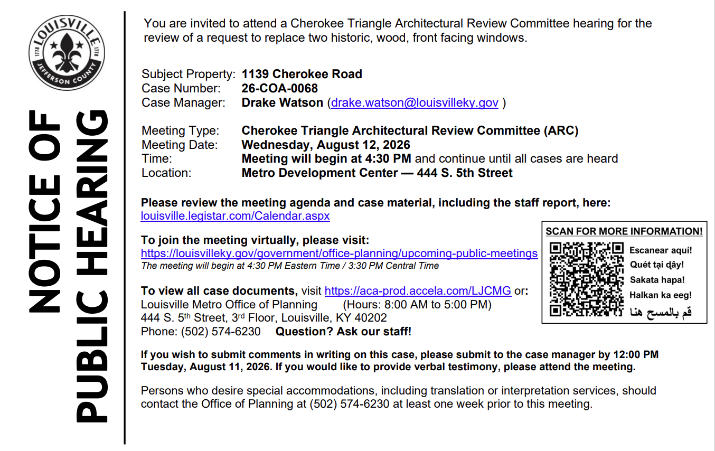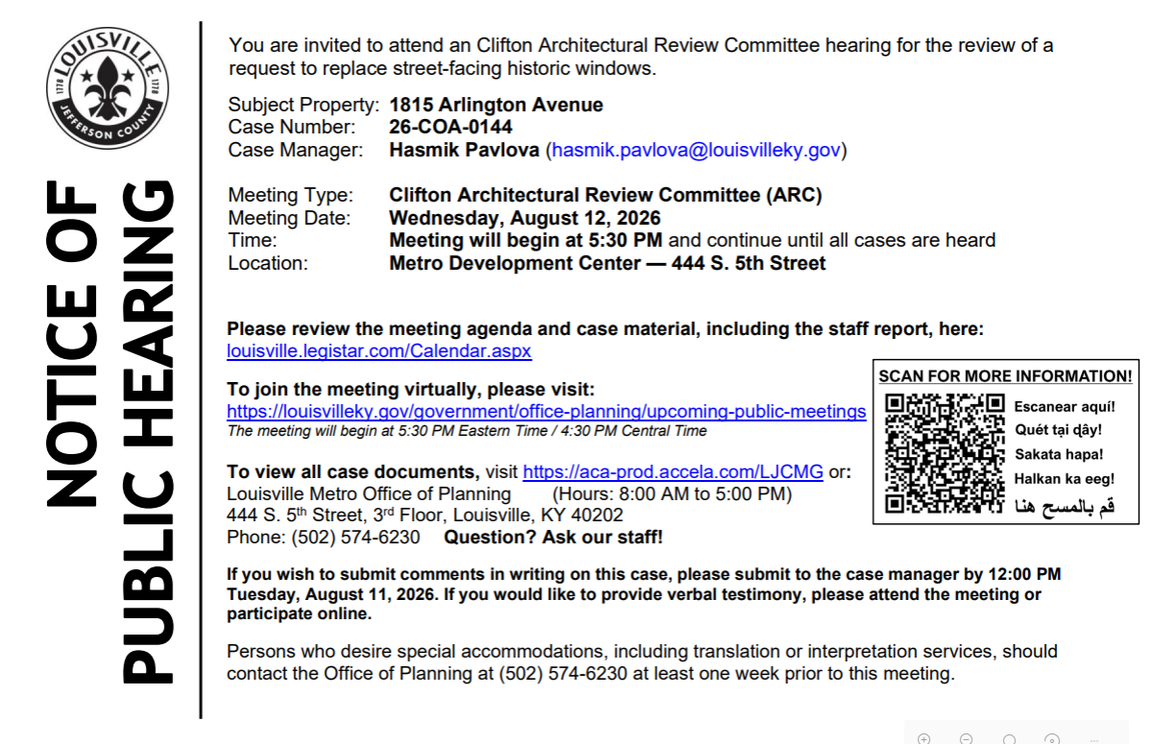

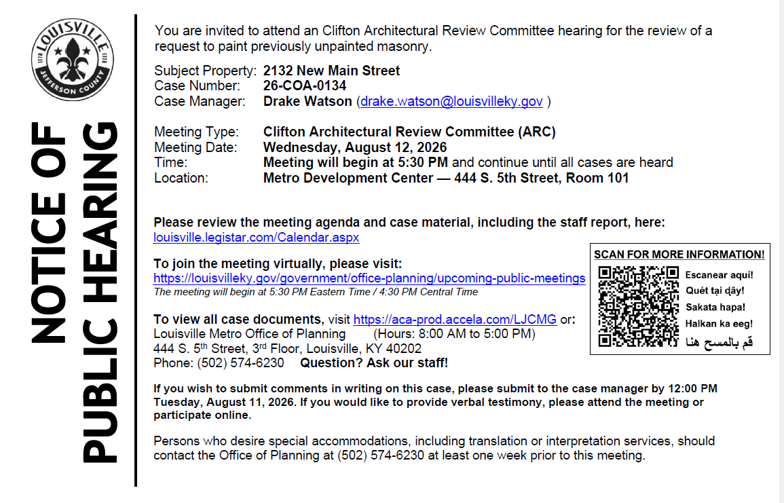

------------------------------------------------------------------------------------------------------

Alcoholic Beverage
Ad Date: 07/15/2026 | 30-Day Date: 08/14/2026
Protest must be submitted by: LMPD Division 5TH DIVISION

PUBLIC NOTICE
Axis Fuels 9 LLC, 12800 Townepark Way, Suite 100, Louisville, KY 40243, Hereby declares intention(s) to apply for a NQ Retail Malt Beverage License and 2:00am extended hours license(s) no later than July 14, 2026. The business to be licensed will be located at 3795 Lexington Rd., Louisville, Kentucky 40207 doing business as Lexington Road Shell. The owner(s) are as follows: Pandher Holdings, LLC with an address of 311 Ash Run Rd., Louisville, KY 40245. Managers are Sukhminder Pandher of 311Ash Run Rd., Louisville, KY 40245, Tirath Pandher of 14614 Inspiration Ct, Louisville, KY 40245, Gurmukh Pandher of 35 Lizas Cir, Simpsonville, KY 40067, and Sanjit Pandher of 15728 Shadowalk Dr., Louisville, KY 40245. Any person, association, corporation, or body politic, may protest the granting of the license(s) by writing the Department of Alcoholic Beverage Control, 500 Mero St 2NE33, Frankfort, Kentucky, 40601 , within thirty (30) days of the date of legal publication. July 15 2026 LSBN0556196
Ad Date: 08/04/2026 | 30-Day Date: 09/03/2026
Protest must be submitted by: LMPD Division 5TH DIVISION

PUBLIC NOTICE
Mockingbird Soccer Management, LLC doing business as Mockingbird Indoor Soccer Club with a mailing address of 3000 Mellwood Avenue, Louisville, Kentucky 40207, Hereby declares intention(s) to apply for a Transitional Malt Beverage License and an NQ4 Retail Malt Beverage Drink license(s) no later than August 5, 2026. The business to be licensed will be located at 3000 Mellwood Avenue, Louisville, Kentucky 40207. The owner(s) are as follows: The officers and owners of Mockingbird Soccer Management, LLC are Tessa Dunteman, 3000 Mellwood Avenue, Louisville, Kentucky 40207; Corey Johnson, 3000 Mellwood Avenue, Louisville, Kentucky 40207; and Michael Miescke, 3000 Mellwood Avenue, Louisville, Kentucky 40207. Any person, association, corporation, or body politic, may protest the granting of the license(s) by writing the Department of Alcoholic Beverage Control, 500 Mero St 2NE33, Frankfort, Kentucky, 40601 , within thirty (30) days of the date of legal publication. August 4 2026 LSBN0569021
-------------------------------------------------------------------------------------------------------

District 9 Events

Monday, August 10 - 7:00pm: Martin Sorge presents Great Bakes. https://carmichaelsbookstore.com/event/2026-08-10/martin-sorge-presents-great-bakes

Thursday, August 13 - 7:00pm: Maggie Harlow presents Everyday Extraordinary. https://carmichaelsbookstore.com/event/2026-08-13/maggie-harlow-presents-everyday-extraordinary

Friday, August 14 - 7:00pm: Elito Glazer presents The Terrible, Horrible, No Good, Very Bad Gay. https://carmichaelsbookstore.com/event/2026-08-14/eliot-glazer-presents-terrible-horrible-no-good-very-bad-gay

Saturday, August 29 - 2:00pm: An Afternoon of Poetry with Accents Publishing. https://carmichaelsbookstore.com/event/2026-08-29/afternoon-poetry-accents-publishing

Computer Tune Up & Repair
At the St. Matthews Eline Library (small conference room). A Free Computer Tune-up and Repair service will be offered the first Saturday of each month from 1-4 PM. Help will be limited to the first 2 persons making a reservation. To make a reservation, email taylor_rae@hotmail.com. Participants must bring any additional devices that they may need such as a keyboard, monitor, and mouse for desktops. If participants are bringing a laptop, please bring your battery charger.

UCHM Programs & Events
United Crescent Hill Ministries News

🙋 Volunteers Needed
Help us serve our neighbors by volunteering just a few hours each Thursday!
🚗 Retail Food Pickup Driver
- Pick up donated food from Clifton Kroger
- Thursdays, 9:00 a.m.–12:00 p.m.
- Reliable vehicle and valid driver's license required
💻 Food Pantry Check-In Volunteer
- Assist clients with computer check-in
- Thursdays, 1:00–4:00 p.m.
Interested? Contact Courtney Goff at UCHMLouisville@gmail.com or call (502) 893-0346.

🎒 Back-to-School Assistance
School supplies, backpacks, hats, gloves, and undergarments are still available for K–12 students living in the 40206 ZIP code while supplies last.
Visit our Back-to-School Assistance page or call (502) 893-0346 for details.

❤️ Sponsor the UCHM 60+ Program
Support local seniors by sponsoring a meal, activity, entertainment, birthday celebration, bingo prizes, crafts, or wellness program.
Sponsors receive recognition in our newsletter, on social media, and during their sponsored event.
Learn more: Contact Monique Shaughnessy at SeniorCoord@uchmlouky.org or (502) 893-0346.

