Louisville Metro Council
District 9 eNews | July 23, 2026

WELCOME TO D9'S BIWEEKLY E-NEWS!
“I am doing the work that works for me.”

🌺 Frankfort Avenue Trolley Hop – Luau Night! 🌴
Mark your calendars for the next Frankfort Avenue Trolley Hop on Friday, July 31, from 4:00 PM to 9:00 PM! This month's theme is Luau Night, bringing tropical fun, shopping, dining, entertainment, and community spirit to the Frankfort Avenue corridor.

We're encouraging Frankfort Avenue businesses to join the celebration by embracing the luau theme! Consider decorating your storefront, offering tropical-themed specials or discounts, handing out leis, featuring island-inspired menu items, or creating other festive experiences for shoppers and riders throughout the evening.

🚋 Small Business Sponsorships Still Available
Annual Trolley Hop Small Business Sponsorships are still available for Frankfort Avenue businesses.

Sponsorship benefits include:
- Visibility on the Trolley Hop website
- Recognition in promotional materials
- Naming rights at one of the twelve trolley stop locations

Annual sponsorship packages are $250.

Businesses interested in becoming a sponsor should contact Regina Garr at regina.garr@louisvilleky.gov.

Learn more: https://louisvilleky.gov/government/metro-council-district-9/fat-friday-sponsorship-information

🙋 Volunteers Needed
We're still looking for volunteers to help make Luau Night a success! Three volunteer shift options are available, making it easy to find a time that fits your schedule.

Sign up to volunteer here: https://forms.louisvilleky.gov/261046050486049

Learn More
For event details, trolley stop information, participating businesses, and event updates, visit: https://louisvilleky.gov/government/metro-council-district-9/fat-friday-trolley-hop

Whether you're riding the trolley, shopping local, dining with friends, volunteering, or sponsoring a stop, we hope you'll join us for a festive Luau Night on July 31. Put on your favorite Hawaiian shirt and enjoy a summer evening on Frankfort Avenue! 🌺🚋🌴

Join OFW ALLIES: A One-Day Training Mobilizing Men for Gender Equity in Louisville
The Office for Women ALLIES is a one-day immersive training program addressing how men can collaborate in promoting gender equity. Through the program, participants will learn about the Office for Women, discuss men's mental health, men’s role as caregivers and prevention of gender-based violence as well as how to strengthen individual and collective leadership.
OFW Allies will also be able to participate in other OFW engagement events and assist in sharing information about the OFW. Open to all.
The OFW ALLIES will be held from 8:30 a.m. to 4 p.m. on Friday, July 24 at Goodwill West Louisville Opportunity Center, 2820 West Broadway. Food and childcare will be provided on site. To register, please use this link or scan the QR code.
For more information, contact the office at OFW@louisvilleky.gov.
THIS SATURDAY! The Annual Beargrass Creek Clean Sweep!
Join us for the Annual Beargrass Creek Clean Sweep on Saturday, July 25th! Kentucky Waterways Alliance and our partners—Louisville Metro Sewer District (MSD), Olmsted Parks Conservancy, Ohio River Valley Water Sanitation Commission, Louisville Metro District 9 Councilman Andrew Owen, Louisville Metro District 8 Councilman Ben Reno-Weber, Clean Collaborative, and Brightside—are coming together to help address litter around Beargrass Creek.

Enjoy a special performance by musician Andy Blanton, along with coffee, donuts, and fun prizes (including one for the most unusual item found). It’s a great opportunity to connect with neighbors and make a positive impact in our community.

Date: Saturday, July 25, 2026
Location: Meet at the parking lot at the corner of Lexington and Ledge Roads to clean up Beargrass Greenway & Cherokee Park
Timeline: Check-in: 8:30–9:00 AM | Cleanup: 9:00 AM–12:00 PM

Registration: https://forms.gle/aJPfKiJrrKa7KbTA7

We hope to see you there as we work together to keep our community clean and beautiful!

Come Out for the Bike Louisville Neighborway Kick-off Ride
Grab your bike and help shape the future of Louisville's Neighborway network!
Bike Louisville and LouDOT is inviting residents to join the Neighborway Evaluation Team Kick-Off Ride, where volunteers will learn how to evaluate Neighborways and provide feedback that will help guide future improvements.
Kick-Off Ride
When: Sunday, July 26, at 10 a.m.
Where: Full Stop Station, 1132 E. St. Catherine St.
The event begins with a walkthrough of the rider survey, followed by a group ride where participants can test the survey before exploring the Neighborway network on their own.
Help Make Neighborways Better
Over the next two months, volunteers are encouraged to ride Louisville's Neighborways and share feedback on:
- Safety concerns
- Areas that need improvement
- Opportunities to make routes more comfortable and accessible
Your input will help Louisville Metro DOT prioritize future Neighborway improvements across the city.
Can't Make the Ride?
You can still participate! Access the survey using the link in our bio and complete your evaluation whenever it works best for you.
Survey deadline: Sept. 30, 2026.
TAKE THE SURVEY
EggFEST Food Festival Returns July 31–August 1 to Benefit Two Local Hunger Relief Organizations
LOUISVILLE, Ky. – Kentucky Harvest and A Recipe to End Hunger invite the community to the Big Green EggFEST Food Festival, hosted by Brownsboro Hardware & Paint, on Friday, July 31, and Saturday, August 1, 2026.

This two-day celebration combines incredible food, live cooking competitions, bourbon tastings, cooking demonstrations, and family-friendly entertainment—all while supporting two local nonprofits dedicated to fighting hunger. Every food sample served during the festival is prepared on Big Green Egg® ceramic grills by talented professional and amateur cooks.

Guests will enjoy unlimited food tastings while watching exciting culinary competitions, including the Friday evening People's Choice Competition and a fast-paced "Chopped" Big Green Egg Style showdown featuring professional chefs. Saturday highlights include amateur competitions for Best Beef Dish, Best Pork Dish, and Best Dessert, along with Big Green Egg cooking classes and cocktail-making classes and bourbon tastings courtesy of Buzzard's Roost.

Throughout the weekend, guests can also browse and bid in the popular EggFEST Silent Auction, featuring grills, outdoor cooking equipment, bourbon collectibles, travel packages, gift certificates, and much more. Featured auction items open July 1, with all remaining items opening July 27. Bidding concludes Sunday, August 2.

Free parking and continuous shuttle service will be available from St. Matthews Episcopal Church, 330 North Hubbards Lane. Because of ongoing construction, attendees are strongly encouraged to avoid Brownsboro Road when possible.

Tickets for each day must be purchased separately at EggFESTTickets.com. Children 12 and under are admitted free with a paid adult.

Come hungry, enjoy outstanding food and bourbon, support two worthy causes, and experience one of Louisville's premier outdoor food festivals.

I-65 Central Corridor Project Update
The Kentucky Transportation Cabinet (KYTC) reports that the I-65 Central Corridor project remains on schedule, with I-65 expected to reopen to two lanes of traffic in each direction by Aug. 1.

Although the interstate will reopen, work on the three bridges currently under construction will continue through March 2027. Drivers should continue to expect an active work zone and are encouraged to use the signed detour when traveling through Louisville to help minimize congestion. Drivers with destinations in Louisville should use mapping apps to find the best route at their time of travel.

Once I-65 reopens, the speed limit through the construction zone — from south of the Hill Street/CSX Railroad/Burnett Avenue bridge to downtown — will be reduced by 10 mph.
The Louisville Metro Department of Transportation will continue to monitor traffic conditions on local roadways, coordinate closely with KYTC, and address traffic signal timing and other transportation issues as needed to help minimize impacts on residents, businesses, and commuters.

Looking ahead, KYTC is also planning for the replacement or rehabilitation of six additional I-65 bridges between Broadway and Liberty Street near Hospital Curve. The preferred construction approach is still being evaluated, and an updated timeline, including any impacts to surface streets, will be shared once those plans are finalized.

KYTC will also update I65CentralCorridor.com as I-65 reopens with the latest project information, maps, and travel guidance. Click here to sign up for I-65 Central Corridor project updates. Updates are also shared on KYTC District 5 Facebook and X pages.

New TARC Network Launching in August
The New TARC Network launches on August 2, 2026. This will be a historic, once-in-a-lifetime change for our community with new route names and numbers, new bus-stop locations—with a significant number of existing stops being removed to improve reliability—better frequencies of service, and a new Downtown Transit Center!

For more information, Click HERE

Back-to-School Immunizations: What Families Need to Know
As the new school year gets closer, now is the perfect time to make sure your child is up to date on their vaccines. Vaccines protect children from serious diseases like measles, whooping cough, and meningitis. They also help keep schools and our community safe.
What parents should do:
- Check your child’s immunization record.
- Schedule an appointment if any vaccines are missing.
- Ask your healthcare provider if you have questions.
Why it matters:
- Schools require certain vaccines for attendance.
- Vaccines prevent outbreaks and missed school days.
- Staying up to date helps protect babies, older adults, and people with health conditions.
Need help?
“Widespread immunization leads to an immediate concrete benefit,” said Dr. Kris Bryant, associate medical director for the Louisville Metro Department of Public Health and Wellness and pediatric infectious disease specialist with Norton Children’s. “Children who stay healthy stay focused on growing, playing and learning.”
Our health department offers immunizations for children and adults. Call 502-574-5380 to schedule an appointment or learn about upcoming back-to-school clinics.

A Change to the School Bus Safety Law
🚍 New Kentucky school bus stop law is now in effect
School is almost back in session, and there's an important change every driver should know.
Kentucky's updated school bus stop law, created through House Bill 7, expands when drivers must stop for a school bus with its stop arm extended and red lights flashing.
What changed?
Drivers must now stop in all lanes and in both directions, including on:
- Four-lane roads with a center turn lane
- Highways that are not divided by a physical barrier or unpaved median
When don't you have to stop?
The only exception is when you're traveling in the opposite direction on a roadway with four or more lanes that is separated by an elevated barrier or an unpaved median.
Know before you go
Passing a stopped school bus is dangerous and illegal. Drivers who fail to stop can face:
- $300 fine for a first offense
- $500 fine for each additional offense within three years
Slowing down and stopping for school buses helps protect children as they get on and off the bus. A few extra seconds can make all the difference.
Join LMPD 5th Division for National Night Out 2026!
Mark your calendars for National Night Out 2026, hosted by the Louisville Metro Police Department's 5th Division on Tuesday, August 4, from 5:00 p.m. to 8:00 p.m. at Douglass Park, 2305 Douglass Boulevard, adjacent to the LMPD 5th Division.

This free, family-friendly event brings neighbors and public safety partners together to strengthen community relationships and promote crime, drug, and violence prevention. Attendees can enjoy food, drinks, prizes, giveaways, children's activities, live music by the Caribou Band, free Child ID cards, LMPD specialty units, Fire and EMS demonstrations, neighborhood crime prevention information, and much more.

No pre-registration is required. Come out and meet your neighbors, connect with local first responders, and celebrate community partnership at America's Night Out Against Crime!

Register for the 2026 World of Cultures Parade
Registration is now open for the 2026 World of Cultures Parade! Gather your family, friends, and community to proudly represent your country and celebrate your heritage during one of the most inspiring traditions of WorldFest. If you're already organizing a group, share your flyer or promotional graphic with us, and we'll help spread the word.
Join us in making the 2026 World of Cultures Parade our biggest and most colorful celebration yet!
REGISTER YOUR GROUP
Save the Date: Community Fish Fry & Fall Festival
Join us for an evening of food, fun, and community at the Community Fish Fry & Fall Festival on Saturday, September 26, 2026, from 4:00–8:00 p.m. along Frankfort Avenue between Birchwood and Kennedy.
Hosted in partnership with St. Mark's Episcopal Church, Crescent Hill Baptist Church, and Grace Immanuel United Church of Christ, this family-friendly event will benefit United Crescent Hill Ministries and the neighbors we serve.
Come enjoy delicious fish, hot dogs, brats, beer, live music, cornhole, games, and more while supporting UCHM's mission of serving our community. Whether you're bringing the whole family, meeting up with friends, or simply looking for a fun way to spend a fall evening, there's something for everyone.
Mark your calendars—we can't wait to celebrate with you while making a difference in our community!
Violence Reduction Summit
Be part of the solution.
Mark your calendars for Oct. 23 and join us for our annual Violence Reduction Summit.
It's a chance to connect, collaborate, and make real change in our city.
Keep an eye on our social channels for more information!

The Dot Experience Update
Exhibit installation is officially underway at The Dot Experience! Our friends at Louisville-based exhibit design firm Solid Light are bringing the space to life, transforming each area into an immersive, hands-on destination designed to spark curiosity, inspire discovery, encourage exploration, and welcome visitors of all abilities.

As we get closer to opening our doors on October 30, we’ll continue sharing behind-the-scenes updates as exhibits, technology, and stories come together to create this one-of-a-kind attraction. Follow The Dot Experience on Instagram to watch the progress and be part of the excitement!

Follow The Dot Experience on Instagram at @the.dot.experience

Image description: In a room with floor to ceiling windows, two rectangular wooden objects stand near building tools and materials.

Image description: In a long room with windows on the right side and a curved wall on the left, a kneeling man works on an L-shaped wooden structure. Large wooden rectangle and other construction materials are visible on the floor.

Paving This Week
With paving season now fully underway, crews continue improving streets and advancing roadway projects across Louisville Metro.

Louisville Metro repaves streets each year to preserve roadway conditions, extend the life of existing pavement, and provide safer, smoother travel for everyone. Regular paving helps prevent more costly repairs in the future and protects the city’s infrastructure investment.

To see which streets are currently scheduled for paving, visit the "Paving" page at louisvilleky.gov. Please note that all listed projects are weather permitting and subject to change.

-------------------------------------------------------------------------------------------------------Public Hearings, Meetings, & Applications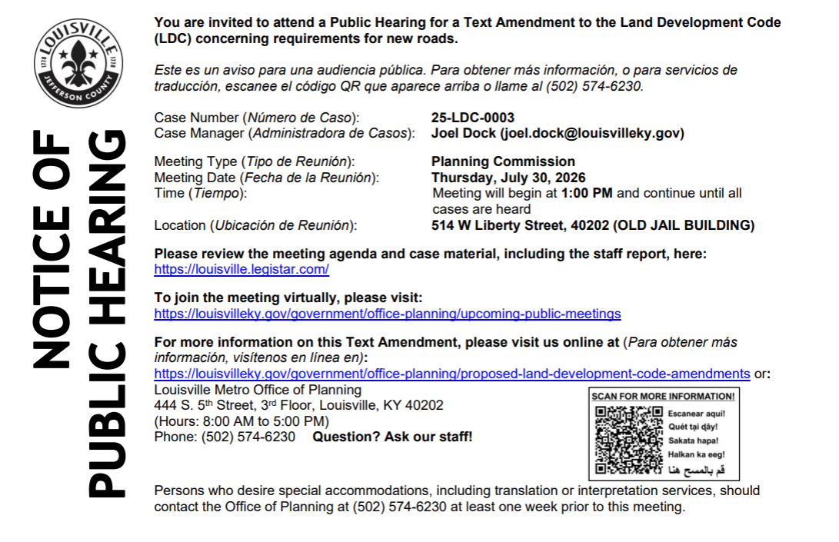------------------------------------------------------------------------------------------------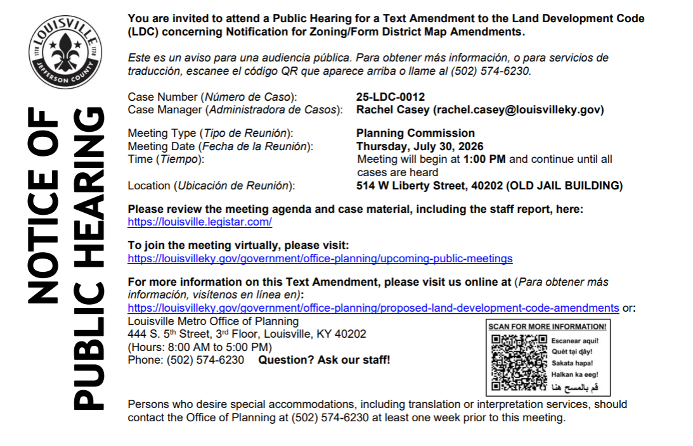
------------------------------------------------------------------------------------------------------

-------------------------------------------------------------------------------------------------------

District 9 Events

Saturday, July 25 - 10:30am: Special Saturday Storytime. Zoë Slaughter and Karen Herold present Colby the Gemologist. https://carmichaelsbookstore.com/event/2026-07-25/zoe-slaughter-and-karen-herold-present-colby-gemologist

Sunday, August 2 - 3:00pm: Tommy Siegle presents Extremely Accurate Birds. https://carmichaelsbookstore.com/event/2026-08-02/tommy-siegel-presents-extremely-accurate-birds

Monday, August 10 - 7:00pm: Martin Sorge presents Great Bakes. https://carmichaelsbookstore.com/event/2026-08-10/martin-sorge-presents-great-bakes

Thursday, August 13 - 7:00pm: Maggie Harlow presents Everyday Extraordinary. https://carmichaelsbookstore.com/event/2026-08-13/maggie-harlow-presents-everyday-extraordinary

Friday, August 14 - 7:00pm: Elito Glazer presents The Terrible, Horrible, No Good, Very Bad Gay. https://carmichaelsbookstore.com/event/2026-08-14/eliot-glazer-presents-terrible-horrible-no-good-very-bad-gay

Saturday, August 29 - 2:00pm: An Afternoon of Poetry with Accents Publishing. https://carmichaelsbookstore.com/event/2026-08-29/afternoon-poetry-accents-publishing

UCHM Programs & Events
🎒 Back-to-School Supplies Giveaway
United Crescent Hill Ministries is helping students in the 40206-zip code start the school year prepared for success! Thanks to the generosity of our partner churches, local businesses, and community supporters, we will be providing backpacks, school supplies, and undergarments to eligible students entering Kindergarten through 12th grade.
Need School Supplies?
Families must reside in the 40206-zip code and provide proof of address. To apply, visit uchmlouky.org/events.

❤️ Sponsor a Student
For just $30, you can help equip one child with the supplies they need to begin the 2026–2027 school year ready to learn.
Your gift provides:
- Backpack
- School supplies
- Undergarments
Donate online at uchmlouky.org/give, or mail a check or cash to:
United Crescent Hill Ministries
150 State Street
Louisville, KY 40206

Every donation makes a difference and is deeply appreciated!

School supply distribution will take place at United Crescent Hill Ministries, 150 State Street, Louisville, KY 40206.

For questions, please contact Courtney Goff at uchmlouisville@gmail.com or 502-893-0346.

