Louisville Metro Council
District 9 eNews | July 9, 2026

WELCOME TO D9'S BIWEEKLY E-NEWS!
“I am responsible for myself, and I start there.”

🌺 Frankfort Avenue Trolley Hop – Luau Night! 🌴
Get ready for a tropical evening of fun at the Frankfort Avenue Trolley Hop: Luau Night on Friday, July 31, from 4:00 PM to 9:00 PM! Hop on the trolley and enjoy shopping, dining, entertainment, and community spirit all along the Frankfort Avenue corridor.
The theme for our July Trolley Hop is Luau Night, and we're encouraging Frankfort Avenue businesses to join in the fun by embracing the tropical spirit. Consider decorating your storefront, offering special discounts or promotions, handing out leis, featuring island-inspired menu items, or creating other festive experiences for shoppers throughout the evening. The more businesses participate, the more memorable the event will be for everyone!

🚋 Small Business Sponsorships
Annual Trolley Hop Small Business Sponsorships are now being renewed for Frankfort Avenue businesses. Sponsorship benefits include:
- Visibility on the Trolley Hop website
- Recognition in event promotional materials
- Naming rights at one of the twelve trolley stop locations
Annual sponsorship packages are $250.
Businesses have until July 15 to claim a sponsorship location for the upcoming Trolley Hop season.
To become a sponsor, contact Regina Garr at regina.garr@louisvilleky.gov.
Learn more: https://louisvilleky.gov/government/metro-council-district-9/fat-friday-sponsorship-information

🙋 Volunteers Needed
We're also looking for volunteers to help make Luau Night a success! Three volunteer shift options are available, making it easy to find a time that works for your schedule.
Sign up to volunteer here: https://forms.louisvilleky.gov/261046050486049

Learn More
For event details, participating businesses, trolley stop information, and updates, visit: https://louisvilleky.gov/government/metro-council-district-9/fat-friday-trolley-hop

Whether you're hopping on the trolley, shopping local, dining with friends, volunteering, or sponsoring a stop, we hope you'll join us for a festive evening on Frankfort Avenue. Grab your Hawaiian shirt, bring your friends and family, and get ready for a fun-filled Luau Night in District 9! 🌺🌴🚋

Join Us for Plastic Free July
This month, we are challenging you to take one small step toward a cleaner, greener Louisville.

Yesterday, Louisville Mayor Craig Greenberg and the Mayor’s Office of Sustainability (OS), in partnership with the Department of Public Works’ kNOw Waste Louisville team and Louisville MetroTV, have launched Louisville’s 2026 Plastic Free July campaign, a month-long effort to reduce single-use plastic waste and encourage more sustainable choices.

“Each of us - individuals and organizations - can make more conscious choices to reduce the use of single-use disposable plastic,” said Mayor Greenberg. “This month, we’re challenging our community to take small steps that can add up to a significant impact.”

Plastic Free July in Louisville is part of a global movement that empowers millions of people across more than 190 countries to reduce single-use plastic waste. By joining this international effort, the city of Louisville aligns with a shared mission to create cleaner and healthier communities, protect natural ecosystems, and inspire long-term environmental change.

Whether it's swapping single-use plastics for reusables, saying no to plastic straws or bringing your own bags to the store -- every action counts.
Not sure what's recyclable in Louisville?

Download the Recycle Coach app and follow kNOw Waste Louisville on social media to get personalized tips, collection reminders and the "What Goes Where" tool to help you reduce waste the smart way.

Throughout the month, the OS will highlight practical tips and local solutions on @SustainLouisville and @KnowWasteLou, encouraging residents, businesses, and organizations to share their sustainable solutions via social media.

Residents can participate by posting a photo or video using a reusable item or practicing a sustainable habit and tagging @SustainLouisville and @KnowWasteLou on social media. Together, we can kNOw Waste and say YES to a cleaner future.

Plastic Free Resources

KYTC's East Phase of Main Remade Project Progressing in Downtown Louisville
Drivers should expect new traffic patterns on Main Street beginning this week as crews continue work to convert the corridor to two-way traffic.
Work was temporarily scaled back during the recent I-65 bridge repairs to help reduce downtown congestion. Now, with southbound I-65 reopened ahead of schedule and all lanes expected to reopen by Aug. 1, the project is moving into its next phase.
Here's what to expect:
- Traffic will shift to the north side of Main Street in its permanent configuration.
- Most intersections along the corridor will temporarily operate as all-way stops while crews connect new traffic signals. The intersections at Second and Main streets and Second and Market streets will remain signalized.
- Eastbound traffic on Main Street will remain closed until the new traffic signals are activated.
Drivers should be prepared for changing traffic patterns throughout the month, follow posted signs and temporary traffic controls, and allow extra travel time through the work zone.
The goal is to open Main Street to two-way traffic by the end of July, weather permitting.
The two-way conversion is a major step toward making downtown Louisville easier to navigate. The project will improve access to businesses and neighborhoods while adding safer crosswalks, protected bike lanes, dedicated turn lanes and upgraded traffic signals.

I-65 Central Corridor Project and Downtown Traffic
As work continues on the Kentucky Transportation Cabinet's I-65 Central Corridor project, motorists should expect changing traffic conditions on nearby surface streets as construction progresses.
This week, alternating lane closures were in place on Muhammad Ali Boulevard beneath I-65 at Hospital Curve in downtown Louisville. The closures occurred from 9 a.m. to 3 p.m. July 7 while contract crews patched the concrete bridge deck on I-65 above Muhammad Ali Boulevard.
Temporary changes to local traffic patterns are a normal part of construction. Drivers are encouraged to stay informed about upcoming traffic impacts. For the latest updates on the I-65 Central Corridor project, follow the KYTC District 5 Facebook page.
Independent Living & Older Individuals Who Are Blind
The Independent Living & Older Individuals Who Are Blind programs are designed to provide a broad range of services enabling Kentuckians with vision impairments to achieve their maximum level of independence within the home, community and/or workplace. Free, customized services are offered statewide.
What Can I Expect from IL/OIB Services? ​
Customized training is offered to help individuals learn adaptive daily living skills.​ This training focuses on adaptive skills to help with writing, using a telephone, tactile labeling, navigating the internet, cooking and cleaning, combined with the use of low-vision devices and assistive technology.
Eligibility
Anyone living in Kentucky with significant vision loss can be considered for service. Every county is covered. There is no cost for program participation.
Call 502.429.4460 to Learn More

South Points Buy Local Fair
Sunday, July 12, 12n-4pm | Iroquois Park near the Amphitheater

Find diversity and adventure in South Louisville! The Louisville Independent Business Alliance (LIBA) will host the South Points Buy Local Fair on Sunday, July 12th from 12n-4pm near the Iroquois Amphitheater. The Fair offers shopping with local, independent South Louisville businesses along with music, libations, food, a kids’ area, silent auction and more. Admission and parking are free. For more information, visit keeplouisvilleweird.com/SouthPoints.
Coffee with a Cop
Join the Louisville Metro Police Department for Coffee with a Cop on Tuesday, July 14 at 9:00 AM at Ntaba Coffee, 2407 Brownsboro Road.

This informal community gathering is a great opportunity to meet local police officers, ask questions, share concerns, and get to know the officers serving your neighborhood. There is no formal agenda or speeches—just coffee and conversation in a relaxed setting.

Whether you have a specific concern or simply want to connect with members of LMPD, all are welcome to attend.

📍 Ntaba Coffee
2407 Brownsboro Road
📅 July 14
⏰ 9:00 AM

For additional information, contact Lt. Steve McAtee at (502) 574-7636.

Upcoming TRIAD Meeting
July 14th, 2026
Networking 11:00am
Lunch Served at 11:30am
Our Mother of Sorrows Cafeteria
770 Eastern Parkway
Louisville, Ky 40217

Lunch Sponsored by: Episcopal Church Home

RSVP REQUIRED:
Please call the Office for Aging & Disabled Citizens 502-574-5092 or by email to allison.woosley@louisvilleky.gov

Parking is available in the enclosed lot next to the cafeteria or in the lot to the right of school. Street parking is allowed.

Help Public Works Name the Bike Lane Sweeper
Meet one of Public Works' newest and hardest-working pieces of equipment: the bike lane sweeper.
These compact, motorized utility vehicles are specially designed to maintain cycling infrastructure. While they may look small, they play a big role in keeping bike lanes safe by clearing away leaves, gravel, litter and other debris.
Because of their specialized design, bike lane sweepers can cover more ground than manual crews and tackle larger debris with ease. That means cleaner bike lanes, safer rides and a healthier environment.
City public works departments and maintenance contractors across the country rely on these machines to help keep cycling infrastructure in top shape. Here in Louisville, they're another tool helping make it easier and more enjoyable for everyone to get around on two wheels.
But there is a problem. This tough machine is turning heads, but it doesn't have a name. Take a moment to submit what you want to name the bike lane sweeper. We will be accepting submissions through July 17. After that we will let the public vote on four of the best submissions. We'll then announce the winner!
There is no limit to how many names you can submit, so have some fun! But remember, we're naming a bike lane sweeper, so keep it clean 😎.
Submit your name today
Discover the Flavors and Traditions of Haiti
Saturday, July 18 | 1:00 - 2:30 PM
Experience the rich culture of Haiti through food at the fourth annual Celebrating Our Neighborhood series. Join local chef Mackendy Alcinvil of Caribbean Café at the Northeast Regional Library for a free cooking demonstration and cultural presentation. Registration is required, so reserve your spot early and enjoy this unique opportunity to connect through food, history, and community.
Reserve Your Spot

CHW Training
This training focuses on an age-friendly approach grounded in the 4Ms framework: What Matters Most, Mentation, Medication, and Mobility. These core principles help CHWs better support communication, understand health needs, and improve care coordination for older adults and their caregivers.

The training is delivered primarily through 11 hours of self-paced online modules, with opportunities for reflection, skills practice, and group discussion throughout. The final 4 hours are a hybrid experience, offered in-person or virtually, to reinforce key concepts and applied skills in geriatric care.

The pilot hybrid session will take place on July 22 from 1:00–5:00 PM EST and is being offered at a 50% discounted rate of $125. Please find the attached flyer for additional details.

For more information, contact Sophia HERE

Join OFW ALLIES: A One-Day Training Mobilizing Men for Gender Equity in Louisville
The Office for Women ALLIES is a one-day immersive training program addressing how men can collaborate in promoting gender equity. Through the program, participants will learn about the Office for Women, discuss men's mental health, men’s role as caregivers and prevention of gender-based violence as well as how to strengthen individual and collective leadership.
OFW Allies will also be able to participate in other OFW engagement events and assist in sharing information about the OFW. Open to all.
The OFW ALLIES will be held from 8:30 a.m. to 4 p.m. on Friday, July 24 at Goodwill West Louisville Opportunity Center, 2820 West Broadway. Food and childcare will be provided on site. To register, please use this link or scan the QR code.
For more information, contact the office at OFW@louisvilleky.gov.
The Annual Beargrass Creek Clean Sweep
Join us for the Annual Beargrass Creek Clean Sweep on Saturday, July 25th! Kentucky Waterways Alliance and our partners—Louisville Metro Sewer District (MSD), Olmsted Parks Conservancy, Ohio River Valley Water Sanitation Commission, Louisville Metro District 9 Councilman Andrew Owen, Louisville Metro District 8 Councilman Ben Reno-Weber, Clean Collaborative, and Brightside—are coming together to help address litter around Beargrass Creek.

Enjoy a special performance by musician Andy Blanton, along with coffee, donuts, and fun prizes (including one for the most unusual item found). It’s a great opportunity to connect with neighbors and make a positive impact in our community.

Date: Saturday, July 25, 2026
Location: Meet at the parking lot at the corner of Lexington and Ledge Roads to clean up Beargrass Greenway & Cherokee Park
Timeline: Check-in: 8:30–9:00 AM | Cleanup: 9:00 AM–12:00 PM

Registration: https://forms.gle/aJPfKiJrrKa7KbTA7

We hope to see you there as we work together to keep our community clean and beautiful!

New TARC Network Launching in August
The New TARC Network launches on August 2, 2026. This will be a historic, once-in-a-lifetime change for our community with new route names and numbers, new bus-stop locations—with a significant number of existing stops being removed to improve reliability—better frequencies of service, and a new Downtown Transit Center!

For more information, Click HERE

Metro Council Community Night X Louisville Bats
The Louisville Bats, AAA Affiliate of the Cincinnati Reds are once again delighted to host two Metro Council Community Nights of baseball this season. These two games are scheduled for Tuesday, August 11th ; and Wednesday, September 9th . While supplies last, the offer will include free admission for a reserved seat at Louisville Slugger Field, and a voucher good for one free hot dog, and one free small soft drink.

These Metro Council Community game night offers are available to all constituents of the 26 Metro Council Districts, geared toward, but not exclusively for residents who might otherwise not be able to afford attending a Bats game. The offer is extended to both individuals and mentoring organizations, social service agencies, underprivileged kids’ groups, etc.

Forms will be monitored and will close once each district has reached their maximum capacity of 300 tickets – Please advise groups or individuals to request their tickets in advance to ensure availability!

INDIVIDUALS/GROUPS of - 20 GUESTS: https://bit.ly/4ttW776
ORGANIZATIONS/GROUPS of 20+ GUESTS: https://bit.ly/3RzfApE

The cutoff date for ticket requests for the August 11th date will be August 3rd and September 1st for the September 9th game.

Ticket distribution will be done as responses come in. Please be patient and allow time for tickets to be distributed. If you do not receive your tickets by August 3rd, please email mgraham@batsbaseball.com.

First Hour Grief for the 3rd annual Angel Walk
Join First Hour Grief for the 3rd annual Angel Walk on October 10th from 9:00am to Noon at Waterfront Park-Brown-Forman Amphitheater for a meaningful morning of remembrance as we walk a mile to honor the lives of unborn babies who have passed due to miscarriage, those born sleeping and infant loss. Give Love A Voice and Say Their Name. This is free to the community. Please go to AngelWalk.org for more information or call 502 791-9938.

Take the Next Step with the Evolve502 Scholarship
Graduating from high school is just the beginning. The Evolve502 Scholarship helps eligible JCPS Class of 2026 graduates continue their education tuition-free by earning an associate degree, workforce credential, or up to 60 credit hours at Jefferson Community and Technical College, any KCTCS college, or Simmons College of Kentucky. Explore this opportunity and invest in your future.

Check Eligibility and Apply Now

Applications Open for Ignite Louisville Class of 2027
Leadership Louisville is now accepting applications for the Ignite Louisville Class of 2027. This six-month leadership development program is designed for mid-career professionals ready to take the next step in their leadership journey. Participants will strengthen skills in communication, delegation, conflict resolution, and leading with influence. With one highly competitive cohort selected each year, interested professionals are encouraged to apply early.

Learn More Here

LFPL Art and Culture Programming
- July 7 – Kentucky Shakespeare: Hip Hop Shakespeare
- July 13 – Moving Minds & Dancing Bodies: A Modern Dance Workshop
- July 18 – Teen Improv Class
- July 18 – Parkland Craft Supply Swap
- July 21 – Build Your Own Cosplay
- July 26 – COLLIDER Artist in Residence Program: Plastic Sleeping Mats Community Project

The Summer Reading adventure continues!
There's still time to join LFPL's Summer Reading Program before it wraps up on August 1. Whether you've already read a stack of books or are just getting started, it's not too late to sign up, start reading, earn prizes, and get Wild About Reading this summer!

Plus, there's still plenty of summer programming for kids and teens at all LFPL locations.

Read Books – Win Prizes – Have Fun!

Save the Date: Community Fish Fry & Fall Festival
Join us for an evening of food, fun, and community at the Community Fish Fry & Fall Festival on Saturday, September 26, 2026, from 4:00–8:00 p.m. along Frankfort Avenue between Birchwood and Kennedy.
Hosted in partnership with St. Mark's Episcopal Church, Crescent Hill Baptist Church, and Grace Immanuel United Church of Christ, this family-friendly event will benefit United Crescent Hill Ministries and the neighbors we serve.
Come enjoy delicious fish, hot dogs, brats, beer, live music, cornhole, games, and more while supporting UCHM's mission of serving our community. Whether you're bringing the whole family, meeting up with friends, or simply looking for a fun way to spend a fall evening, there's something for everyone.
Mark your calendars—we can't wait to celebrate with you while making a difference in our community!
The Dot Experience Update
Momentum continues to build for The Dot Experience as exciting progress brings the vision closer to reality. Furniture is now in place throughout offices and meeting rooms, and the next major milestone is just around the corner as museum fixture installation begins. The grand staircase is also taking shape, with its stunning terrazzo steps nearly complete and handrails and final finishes coming soon. Throughout the museum, thoughtfully designed flooring with contrasting textures and colors will help guide guests through the space while naturally signaling places to pause, explore exhibits, and engage with interactive experiences.

Image description: An image of the stairs. There are wooden handrails and construction materials scattered around the area.

Image description: An image of a gallery among a large row of windows. There is light and dark grey carpet. Part of the carpet is covered to avoid damage.

MSD N. Galt Avenue Project
After finding several blockages in the sanitary and stormwater drainage lines on N. Galt Avenue, an MSD contractor has completed the needed repairs and is now getting ready to place a protective lining in the street’s sewers.

Robinson Pipe Cleaning will begin lining the storm and sanitary sewers by early-to-mid August with Cured in Place Pipe (CIPP), which is a trench-less process that will add 50 to 100 years to the lifespan of the pipes.

The work is expected to take about two weeks, depending on the weather.

Both lanes of traffic on N. Galt will remain open until the CIPP project begins, but, once the work starts, traffic may go down to one lane at times.

Before the contractor leaves, restorative ground and asphalt work will be done.

Paving This Week
With paving season now fully underway, crews continue improving streets and advancing roadway projects across Louisville Metro.

Louisville Metro repaves streets each year to preserve roadway conditions, extend the life of existing pavement, and provide safer, smoother travel for everyone. Regular paving helps prevent more costly repairs in the future and protects the city’s infrastructure investment.

To see which streets are currently scheduled for paving, visit the "Paving" page at louisvilleky.gov. Please note that all listed projects are weather permitting and subject to change.

-------------------------------------------------------------------------------------------------------Public Hearings, Meetings, & Applications
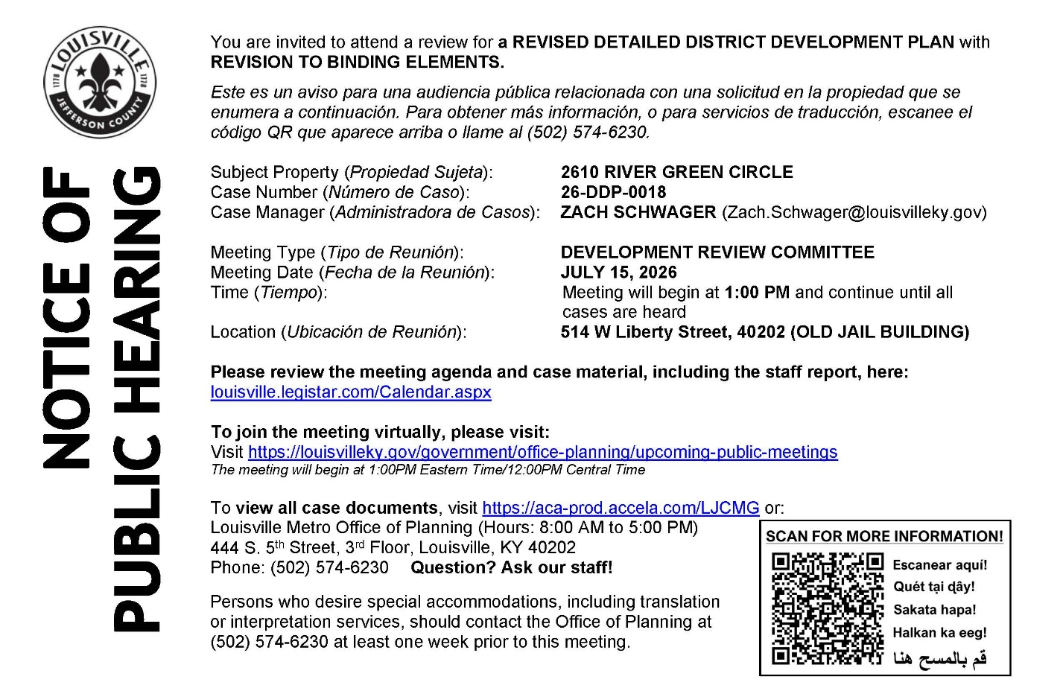
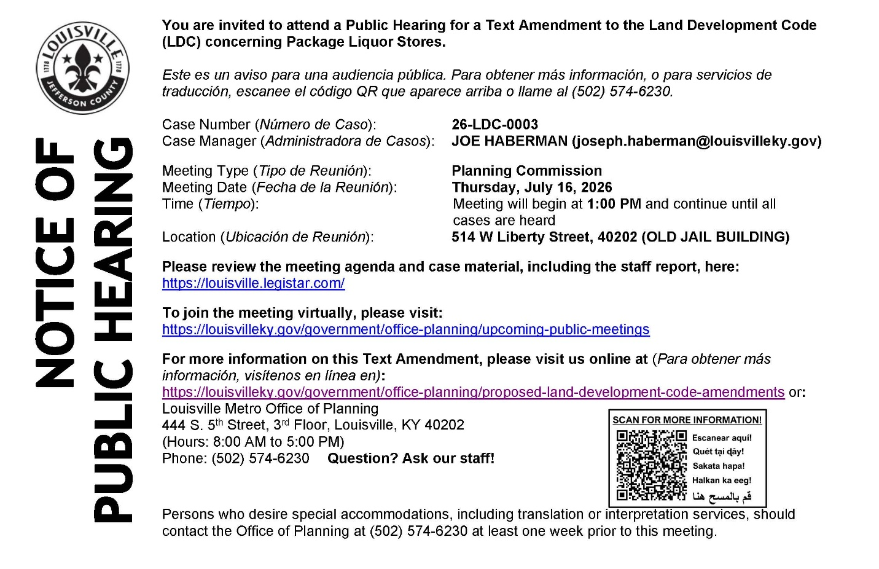
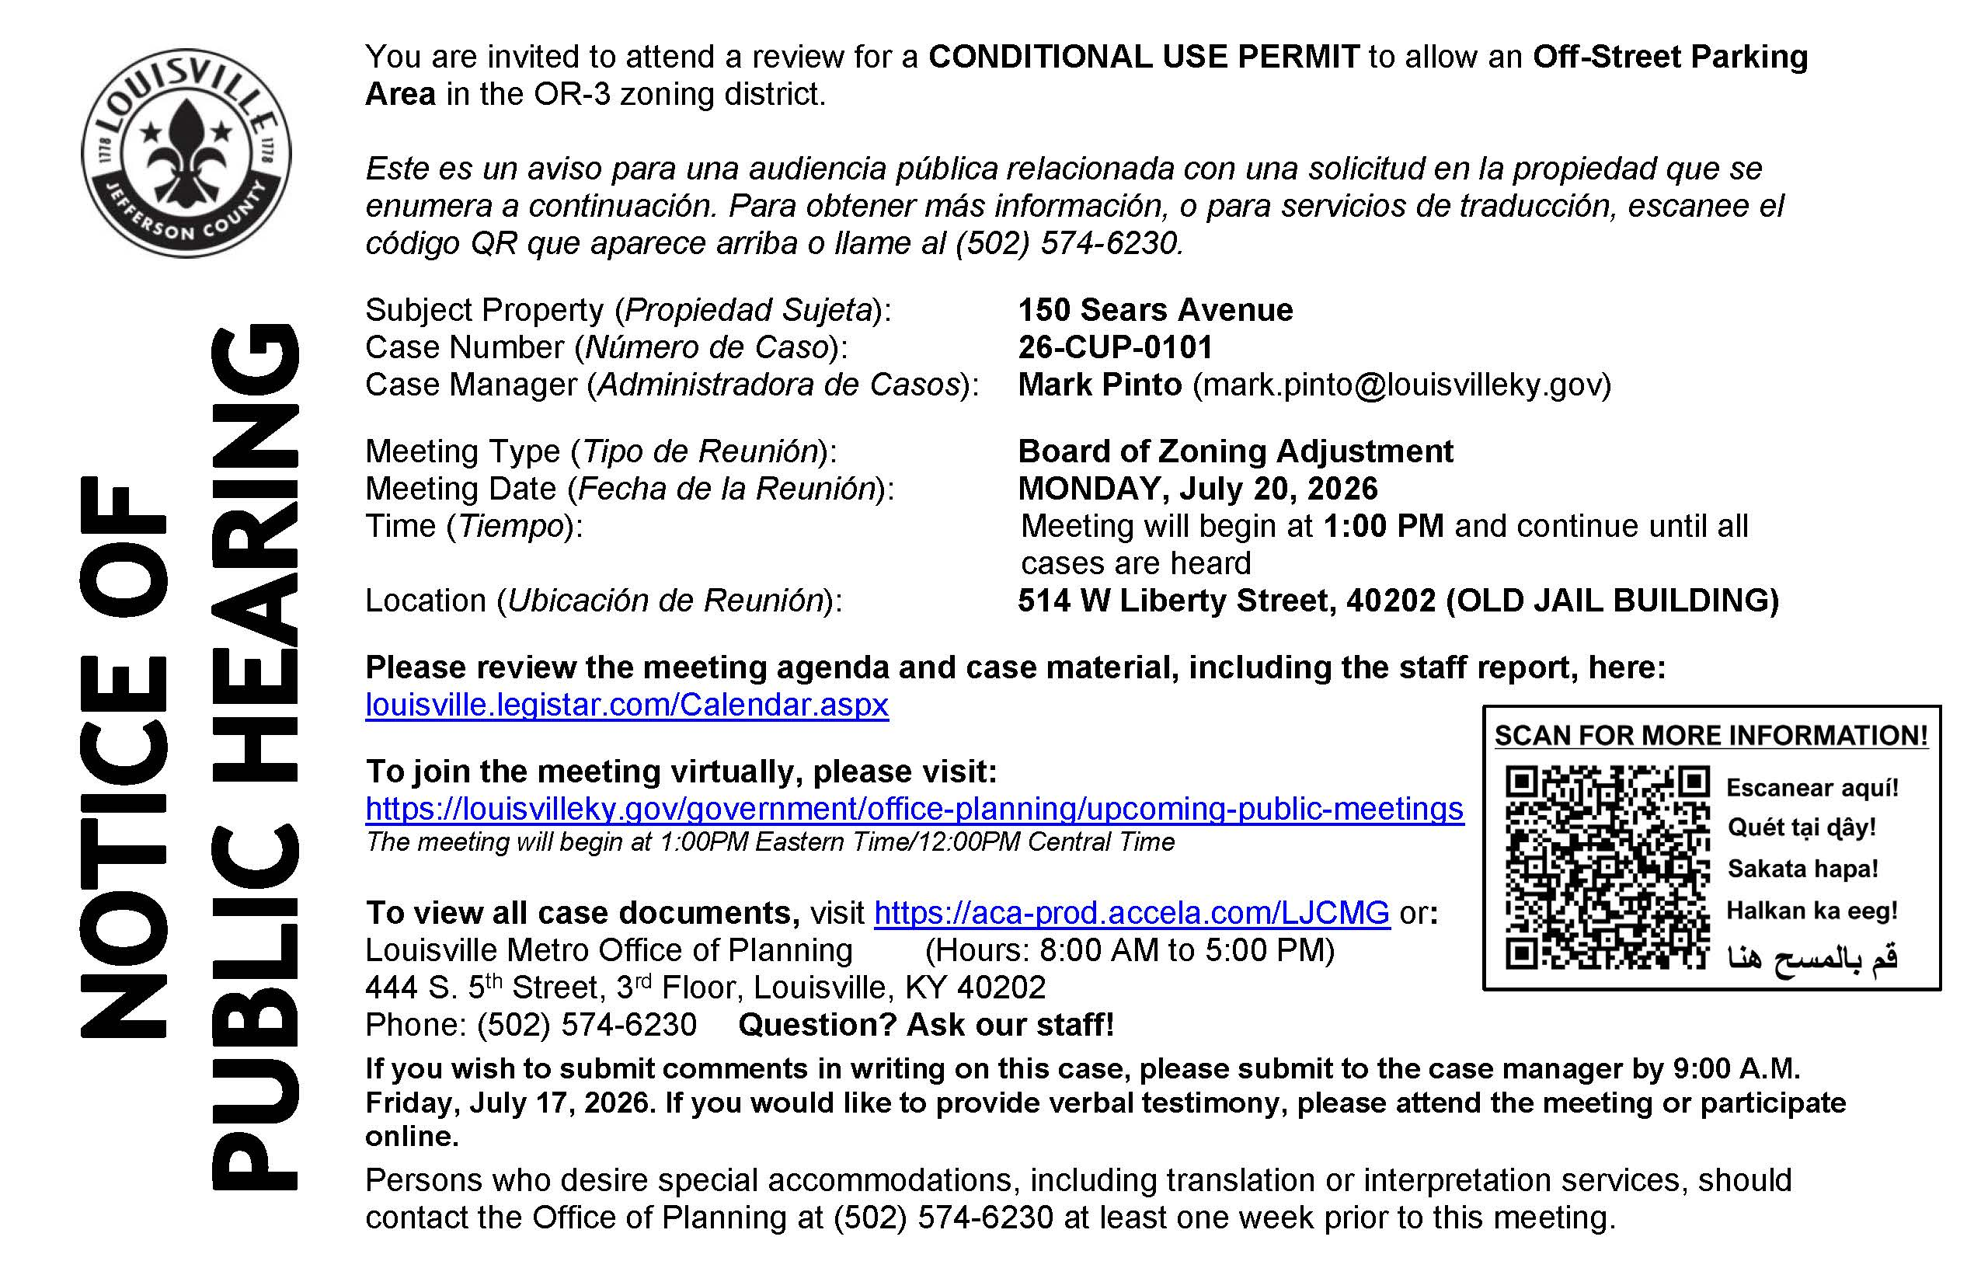
------------------------------------------------------------------------------------------------------

UCHM Programs & Events
Get Ready to Be Wowed!
Join us for an inspiring presentation by conservation photographer John Hulgren on Thursday, July 23, at 10:15 a.m. during our 60+ Program. Through his stunning photography, John shares the beauty of the natural world while raising awareness about environmental conservation. Don't miss this opportunity to experience breathtaking images, hear the stories behind them, and enjoy a fascinating morning with friends. We hope to see you there! 🌿📸

🎒 Back-to-School Supplies Giveaway
United Crescent Hill Ministries is helping students in the 40206-zip code start the school year prepared for success! Thanks to the generosity of our partner churches, local businesses, and community supporters, we will be providing backpacks, school supplies, and undergarments to eligible students entering Kindergarten through 12th grade.
Need School Supplies?
Families must reside in the 40206-zip code and provide proof of address. To apply, visit uchmlouky.org/events.

❤️ Sponsor a Student
For just $30, you can help equip one child with the supplies they need to begin the 2026–2027 school year ready to learn.
Your gift provides:
- Backpack
- School supplies
- Undergarments
Donate online at uchmlouky.org/give, or mail a check or cash to:
United Crescent Hill Ministries
150 State Street
Louisville, KY 40206

Every donation makes a difference and is deeply appreciated!

School supply distribution will take place at United Crescent Hill Ministries, 150 State Street, Louisville, KY 40206.

For questions, please contact Courtney Goff at uchmlouisville@gmail.com or 502-893-0346.

