Louisville Metro Council
District 9 eNews | June 11, 2026

WELCOME TO D9'S BIWEEKLY E-NEWS!
"Every day is a fresh start. I choose to focus on progress, embrace new opportunities, and welcome joy into my present moment."
-Unknown

Summer Reading is back...and it’s WILD!
LFPL’s Summer Reading Program has been a Louisville tradition for nearly a century, helping encourage children and teens to read for fun during the summer by offering prizes and incentives. Join the fun and get "Wild About Reading" this summer!
Summer Reading runs through August 1.

READ BOOKS · WIN PRIZES · HAVE FUN! LEARN MORE

Bus Stops are Changing
TARC began replacing old bus-stop signs with the new signs this month. Customers are beginning to see the news signs and flyers (indicating whether a stop will be new, continue being served, or will be closed) posted at bus stops across the region. The bus stop changes are expected to help TARC provide faster and more reliable service, while the new bus stop signs will provide more information to customers about the routes that serve each stop and where they go.
Whereas the old network had a stop almost every block (3341 stops in total), the new network is consolidating to one stop every three blocks (1430 stops in total—a reduction of 1911 stops) to help with on-time performance and service efficiency. No existing TARC bus stops will be removed prior to August 2, 2026.
A full list of existing bus stops and how they will be affected by the New TARC Network can be found on the New TARC Network website: https://www.ridetarc.org/newtarcnetwork/bus-stop-changes-in-the-new-tarc-network/

Splash Into Summer!
Image of children cooling off at the brand new Camp Taylor Waterpark
Longer days, warmer weather, and one question on everyone’s mind: where are we cooling off this summer? At Louisville Parks and Recreation, aquatics season is officially here, and we’re ready to welcome everyone to our pools, waterparks, and spraygrounds!
Last summer, we celebrated the opening of the brand-new Algonquin Waterpark, and this year, the momentum has continued with the opening of the new Camp Taylor Waterpark. Each offers waterslides, a climbing wall, smaller play features for children and more.
Alongside our newest water attractions, Fairdale Pool and Sun Valley Pool continue to serve as favorite summer destinations. Sun Valley Pool is next in line for renovations, continuing Mayor Greenberg's commitment to investing in quality aquatic experiences across Louisville.
But aquatics at Louisville Parks and Recreation goes far beyond open swim.
Each season, we hire and train our own team of lifeguards, offering lifeguard certification and training opportunities before pool season begins. Residents can also dive into a wide variety of aquatics programming and swim lessons, helping swimmers of all ages build confidence, stay active, and enjoy the water safely.
And the fun doesn’t stop when summer ends. Mary T. Meagher Aquatic Center, home to an indoor Olympic-size pool, keeps Louisville swimming all year long with programs, lap swim, and opportunities for every age and ability.
To find all of the details about our aquatics division, visit the Aquatics' page on bestparksever.com.
Fighting the Bite: LMPHW Ramps Up Mosquito Prevention Efforts
Mosquito season is officially underway. When temperatures stay above 50 degrees, mosquitoes become active, and in Louisville their peak season stretches from May to October. To protect residents from mosquito-borne diseases like West Nile virus, the Louisville Metro Department of Public Health and Wellness (LMPHW) takes several measures to control mosquitoes:
LMPHW works year-round to control the mosquito population
- To prevent mosquitoes from breeding or hatching we apply pretreatment larvicides to 385 areas known to hold water around the county including wet wooded areas, swampy areas, areas that frequently flood, right of ways, drainage easements, and vacant properties.
- At least three times a year, we apply larvicides to approximately 14,500 Metropolitan Sewer District (MSD) catch basins. By design, catch basins hold water to prevent sewer odors from escaping from the sewer Because these catch basins hold water, they provide an excellent breeding habitat for disease-carrying mosquitoes which is why we prioritize treating them.
- We place numerous mosquito traps around the community which attract different types of mosquitos. The mosquitoes are speciated and tested for disease. When mosquitoes carrying West Nile virus or other diseases are found in those traps, it triggers misting and fogging to kill mosquito larvae as well as adult mosquitoes.
- Gambusia, a small native fish, is found in most creeks and permanently wet ditches in Louis These fish are voracious eaters of mosquito larvae and pupae. We transplant them into creeks, decommissioned wastewater treatment plants, ponds, lakes, water retention areas, untreated swimming pools, and ditches where mosquito breeding is found.
Mosquito prevention resources
- Here are ways to protect yourself from mosquito bites.
- Watch this video to learn how to reduce mosquito breeding sites around your home.
- To make a complaint about mosquitos in your neighborhood call Metro311 by dialing 311 or 502-574-5000.

Protect Your Family from Measles Before Summer Travel
Since early 2025, measles cases have been increasing in the United States and in many places around the world. Almost 2,000 cases have been reported in 40 states or jurisdictions. Measles can be dangerous, especially for babies and young children.
“While we can’t predict where measles will spread, outbreaks occur when measles is introduced into communities with large numbers of people who are not protected against measles. The American Academy of Pediatricians continues to recommend the measles, mumps, and rubella (MMR) vaccine as the best way to prevent measles,” said Dr. Kris Bryant, associate medical director for the Louisville Metro Department of Public Health and Wellness and a pediatric infectious disease specialist with Norton Children’s.
What you can do
If you’re unsure if you’re protected against measles, talk to your doctor about MMR vaccine, especially if you or your child plan to travel.
Timing tips
“If you’re making summer vacation travel preparations, plan to be fully vaccinated at least two weeks before your trip,” said Dr. Bryant. “If your trip is less than two weeks away and you're not protected, you should still get a dose of MMR vaccine. Call your doctor to schedule your vaccination appointment.”
For individuals 12 months and older who are traveling outside the US or to an area in the US where measles is actively spreading, two doses of MMR vaccine provide the best protection against infection. The second dose of MMR vaccine can be given 28 days after the first.
Infants 6–11 months old should get one dose of the MMR vaccine before travel. They should then get two more doses after their first birthday to provide long-term protection against measles.
The Louisville Metro Department of Public Health and Wellness provides the MMR vaccine as well. We provide vaccines to people without insurance or a medical home, as well as for children whose insurance or doctor do not cover vaccines. We also accept most insurance plans. There is a $12 administration fee for each vaccine, but no one will be turned away if they are unable to pay. To schedule an appointment, call 502-574-5380.
Learn more about how to protect children when there’s a measles outbreak.
Louisville Youth Summer Programs Guide 2026
Hello Community Partners,
As summer gets underway, we wanted to share the updated Louisville Youth Summer Programs & Opportunities Guide 2026. What started as a simple spreadsheet has grown into a community resource connecting families, youth, teens, and young adults to programs, camps, internships, workforce opportunities, mentoring, and more across Louisville.
We currently have 100+ opportunities listed and will continue updating the guide throughout the summer as new programs are added.
Our goal is simple: help keep Louisville youth safe, engaged, connected, and supported this summer.

Thank you for all you do for our community. Together, we can make sure every young person has access to positive opportunities this summer.

Youth Summer Programs & Opportunity Guide: https://bit.ly/LouisvilleYouthPrograms

Follow Louisville Youth Programs & Services on Facebook: https://www.facebook.com/groups/louisvilleyouth

I-65 Closure Underway
(Photo Courtesy: KYTC District 5)
The I-65 Central Corridor closure is now underway, with a five-mile stretch of interstate between I-264 and downtown Louisville closed through Aug. 1.
A two-mile section of southbound I-65 is expected to reopen to two lanes of traffic by July 1, restoring access to ramps at Crittenden Drive, Eastern Parkway, and University Boulevard. I-65 is expected to reopen to two lanes of traffic in each direction by Aug. 1.
I-65 is closed to accelerate replacement of three aging bridges. The temporary two-month closure is expected to save at least a year of additional traffic restrictions and construction delays.
KYTC reports that crews have been working around the clock since the closure began and have already reached a major milestone. The bridge deck on the I-65 bridge over Kentucky Street/Brook Street—one of three bridges being replaced—has been completely removed. Bridge demolition and reconstruction will continue throughout the summer as crews work to accelerate the project schedule.
Louisville Metro Public Works and the Department of Transportation continue to work closely with KYTC, monitoring traffic conditions, evaluating impacts on local streets and neighborhoods, and coordinating responses to issues as they arise.
For project updates, detour maps, and traffic information, visit I65CentralCorridor.com, where users can also sign up for email or text alerts.
Updates are also shared on KYTC District 5's Facebook and X pages.
LEARN MORE
Understanding 988 And Knowing When to Call
The United States launched 988 in 2022 as an easy-to-remember number for anyone experiencing a mental health, emotional, or substance-use crisis. The 988 Suicide & Crisis Lifeline is free, confidential, and available 24/7/365, connecting callers with trained counselors who listen, offer support, and help you stay safe.
You don’t have to be suicidal to call.
Anyone—at any age—can reach out for help, and you can also contact 988 if you’re worried about someone else. Veterans, service members, and their families can be connected with specially trained counselors. Interpretation is available for people who speak languages other than English or Spanish.
How to reach 988 (https://988lifeline.org/)
- Call
- Text
- Chat online
Why people contact 988
People reach out for many reasons, including anxiety, depression, substance-use concerns, stress, trauma, loneliness, or simply needing someone to talk to.
What happens when you call
A trained counselor will:
- Listen without judgment
- Check on your safety
- Talk through what you’re experiencing
- Offer support and local resources
Most people feel calmer and more hopeful after connecting with a counselor.
Privacy and safety
You don’t have to share personal information. Counselors only involve 911 in rare situations when someone is in immediate danger.

2026 Theme: Beyond Awareness: Making Elder Abuse Prevention Work
Between 2019 and 2030, the number of persons aged 60 years or over is projected to grow by 38%, from 1 billion to 1.4 billion, globally outnumbering youth, and this increase will be the greatest and the most rapid in the developing world, and recognizing that greater attention needs to be paid to the specific challenges affecting older persons, including in the field of human rights.
Elder abuse is a problem that exists in both developing and developed countries yet is typically underreported globally. Prevalence rates or estimates exist only in selected developed countries — ranging from 1% to 10%. Although the extent of elder mistreatment is unknown, its social and moral significance is obvious. As such, it demands a global multifaceted response, one which focuses on protecting the rights of older persons.
Approaches to define, detect and address elder abuse need to be placed within a cultural context and considered along side culturally specific risk factors. For example, in some traditional societies, older widows are subjected to forced marriages while in others, isolated older women are accused of witchcraft. From a health and social perspectives, unless both primary health care and social service sectors are well equipped to identify and deal with the problem, elder abuse will continue to be underdiagnosed and overlooked.
For more information click HERE ............................................................................
In recognition of Elder Justice Awareness Month, ACL and the Elder Justice Coordinating Council (EJCC) are hosting a webinar series on protecting older adults by strengthening awareness, prevention, and response to fraud, abuse, and exploitation. This series offers practical tools and insights for professionals, advocates, and community members. This series reflects the EJCC’s ongoing commitment to ensuring that all older adults can live with dignity, independence, and security in their communities.
Thursday, June 11, 1:00 p.m. ET Elder Fraud & Scams: Communication Strategies To Promote Recovery and Reduce Recidivism Hosted by the U.S. Department of Justice’s Elder Justice Initiative
Tuesday, June 16, 2:00 p.m. ET Voices Unheard: Turning Awareness Into Action Against Abuse and Exploitation Hosted by the U.S. Administration for Community Living
Tuesday, June 23, 2:00 p.m. ET From Frontline Training to Legal Innovation: Interdisciplinary Approaches To Prevent Elder Mistreatment Hosted by the Health Resources and Services Administration at HHS
Thursday, June 25, 2:00 p.m. ET Civil Legal Interventions in Elder Abuse Hosted by the Legal Services Corporation
Tuesday, June 30, 2:00 p.m. ET Money Smart for Older Adults Fraud Prevention Webinar Hosted by the U.S. Federal Deposit Insurance Corporation and U.S. Securities and Exchange Commission
To Join, Click HERE

2026 Cultural Pass
As part of the Cultural Pass program, FREE programming is available to Seniors 65+ from Cultural Pass partners across the region from May 30 – August 9, 2026.
Please Note:
- In the past, a Senior Pass or Senior Pass app was needed for admission — NO PASS is needed for 2026 programming.
- No pre-registration or ticketing of any kind is required unless specified by the partner.
  - Partners may require identifying or contact information for reporting processes as part of check-in, including but not limited to ID, email address, and zip code
- Event admission fee coverage is for Seniors 65+ ONLY, unless otherwise specified by the partner.
Click HERE for a list of participating programs
Whitehall to Hold Garden Party Fundraiser
Louisville, KY. – Whitehall House & Gardens is pleased to announce that it will host its fourth annual Garden Party at the historic mansion at 3110 Lexington Road on Friday, June 12. The festivities will begin at 6:30 p.m. with cocktails, hors d’oeuvres, and a silent auction in the formal garden, followed by a seated dinner under the tent on the garden terrace. The dinner will be followed by live music courtesy of Kudmani.

Individual tickets to the Garden Party are $200 per person. Tickets for the event may be purchased at www.historicwhitehall.org/gardenparty2026. Sponsors of this year’s event include Bartlett Wealth Management; Karen and Michael Cronan; Dwyer DesignScapes; Highland Cleaners; J. Kathryn Interiors; Laura Rice & Associates, Lenihan Sotheby’s; Northdwell; Stites & Harbison; and Sterling Thompson Company.

Whitehall House & Gardens
Proceeds from the Garden Party will benefit Whitehall House & Gardens, a historic home owned and operated by the nonprofit Historic Homes Foundation. The mansion began its life in the 1850s as an Italianate farmhouse. After extensive renovations in 1909, the house was transformed into the Classical Greek Revival-style mansion known today as Whitehall. Its collection features original gaslight fixtures and French and American antiques. Guided tours are offered Monday-Friday, at 11 a.m. and 1 p.m.

At just under ten acres, Whitehall’s gardens have become the primary focus of its educational outreach, offering unique opportunities for both the amateur and professional horticulturalist. Throughout the year the public is invited to participate in workshops, lectures, and tours – all inspired by Whitehall’s special collection of trees and plants. A small, but ever-growing arboretum features over 500 trees, including a rare specimen collection that has become an important resource for propagation of interesting species. Whitehall’s woodland garden, a Victorian stumpery nestled in a wooded corner of the grounds, presents a regionally unprecedented collection of ferns and other woodland plants. Not only a popular tour destination for garden clubs and other horticultural groups, the garden has received national recognition as an official display garden of the Hardy Fern Foundation. The gardens are open to the public free of charge from sunup to sundown 7 days per week all 12 months of the year.

Olmsted Parks Beer Garden in Bingham Park
Olmsted Parks Beer Garden in Bingham Park
June 12 5:00pm - 8:00pm
Bingham Park (160 Coral Avenue)
The Olmsted Parks Beer Garden Series brings pop up events to various parks within the Olmsted Park System. These events are great opportunities to meet your neighbors and spend time in our beautiful urban green spaces.
Enjoy beer from West Sixth Brewing and food from local food trucks. Admission is free. This family friendly event features lawn games and fun for all!

Ballet Bound Audition Tour
Ballet Bound is an initiative of Louisville Ballet that provides young dancers from across Greater Louisville the opportunity to study classical ballet — FREE of charge — in Louisville Ballet’s Downtown Studios. This summer, we are seeking 20 dancers for the 2026–2027 Ballet Bound class. No experience required!
Auditions are open to all children ages 7–9 by August 1, 2026. Space is limited — reserve your spot today! Visit louisvilleballet.org/education/community-engagement/ballet-bound.
Pop-Up Drop-Off comes to Doss High School - featuring bulky plastic recycling!
Mark your calendars — Louisville Metro’s Pop-Up Drop-Off event is coming to Doss High School on Saturday, June 13 from 10 a.m. to 2 p.m., with another chance to recycle bulky plastic items!
We'll be recycling the following large plastic items:
- Old or broken laundry baskets
- Busted storage totes and bins
- Leaky buckets
- Broken large flowerpots
- Unusable plastic shelving and drawer units
These items don’t belong in curbside recycling and typically end up in the landfill — but at this event, by collecting them separately, they'll be able to be recycled.
In addition to bulky plastics, the Pop-Up Drop-Off will continue accepting a variety of other materials, most of which are diverted from the landfill through recycling, reuse, or proper disposal. This makes the event a convenient, one-stop opportunity to clear out hard-to-dispose items while supporting Louisville Metro’s sustainability goals.

A Nature-Based Art Day for Little Ones
Join us for a hands-on, nature-based outdoor art class, followed by some cool-down time at the splash pad. Baby & Me: Art with Nature is the perfect event for families to get messy, get creative, and make art using natural materials.

The event begins at 2 p.m. on June 13 at the Louisville Zoo, 1100 Trevilian Way. Please click here to RSVP for this fun event. Anyone who RSVPs will receive a confirmation with further details or be placed on a waitlist.

Your ticket includes parking, a full-day zoo pass, and all class fees.

Office of Violence Prevention Invitation: Safe Summer Kickoff
Start the summer off right! The Office of Violence Prevention and Parks and Recreation are teaming up to offer lots of great activities at community centers around the city on Saturday, June 13 from 1-5 pm. Come out and enjoy all the fun and help your community have a safe summer!

(Here's a link for more information as well: https://louisvilleky.gov/government/office-violence-prevention/upcoming-events-join-us)

Upcoming Juneteenth Events
Agape Day
- Date: June 12, 2026
- Time: 2:00 pm – 4:00 pm
- Location: Dare to Care Food Bank Distribution Warehouse, 5803 Fern Valley Road, Louisville, KY 40228
- Brief description: Local Divine 9 Black Greek fraternities and sororities partner with Dare to Care to deliver food to communities.

Juneteenth Awards Press Conference
- Date: June 16, 2026
- Time: 10:00 am
- Location: Baxter Community Center, 1125 W Liberty St. Louisville, KY 40203
- Brief description: The Mayor presents awards to individuals and organizations in the community who have been nominated by the Juneteenth Jubilee Commission in recognition of their outstanding service, leadership, and contributions that advance the spirit and legacy of Junete

The Legacy of York Program
- Date: June 16th, 2026
- Time: 5:30 pm – 8:30 pm
- Location: George Rogers Clark Park, 1024 Thruston Ave, Louisville, KY 40217
- Brief description: The Juneteenth Jubilee Commission, Frazier, Filson, African American Heritage Center, and Roots 101 are collaborating on a program featuring York. It will involve well-known artist like Ed Hamilton, Frank X Walker, Jim Holmberg, they will be giving tours and speaking, and Dr. John Chenault will also be speaking.

Play: Before Freedom Rang: A Juneteenth Story of Kentucky’s Emancipation
- Date: June 19th, 2026
- Time: 7:00 pm – 8:00 pm
- Location: Bombard Theater, Kentucky Center for the Performing Arts, Bomhard Theater, 501 W Main St, Louisville, KY 40202
- Brief description: In Kentucky, freedom did not begin with an announcement. Before freedom rang across America, enslaved Kentuckians were already imagining it, praying for it, and courageously daring to believe liberty was coming. Experience the powerful story behind Juneteenth and Kentucky’s August 8 Emancipation tradition.

Juneteenth schedule changes and closings
Juneteenth schedule changes
There will be no waste collection on Friday, June 19. Friday garbage and yard waste collections will be delayed till Saturday, June 20. Be sure to use the Recycle Coach app to keep up with any unexpected delays or changes in waste collection. You can also learn "what goes where" and get notified about collections and events.
Residents who rely on private waste haulers should consult those haulers about holiday collection schedules.
Juneteenth closings
Our three staffed recycling drop-off locations, the Waste Reduction Center, and the Haz Bin will be closed on Friday, June 19 for the holiday. A map and complete list of the drop-off sites and regular operating hours can be found at our website.
Music in the Park
Thursday, June 18th | 11am-1pm | Alberta O. Jones Park
Live Music, Lunch (while Supplies last), Ice Cream and Health Vendors for ages 55+
Bring your own lawn chair!

Whitehall to Host Woodland Garden Tour
Whitehall is pleased to announce that it will host a program entitled “Urban Ecology in the Woodland Garden” on Wednesday, June 24th, at 6:00 p.m. On this relaxing stroll through Whitehall’s Woodland Garden, participants will consider the important services that gardens provide for our human, animal, and plant neighbors. Are you curious to learn more about Louisville’s tree canopy, biodiversity, water, or land use history? The Woodland Garden provides inspirational examples of ways that we can create positive impacts anywhere in the city and offers us a place to deepen our connections to the place where we live. Whether you are new to the Woodland Garden or a regular visitor, this experience will have you seeing urban woodlands in a whole new way. If you've attended this class in the past, you will enjoy new takes and updated information on these familiar concepts. Reservations are required. The cost is $25 per person. For more information or to make reservations, visit https://www.historicwhitehall.org/whitehall-workshops.
The tour will be led by Carolyn Waters, PhD. A native of Louisville, Dr, Waters has a Ph.D. in Education and Social Change from Bellarmine University and a M.Ed. in Environmental Education from Western Washington University. She is a consultant for initiatives that deepen human relationships with nature, and is an instructor of Environmental Studies at Bellarmine University. Now a Clifton resident, she previously lived at Whitehall in the caretaker’s residence and worked there as interim gardener.
In the Whitehall Workshop series, Whitehall House and Gardens will host educational workshops for adults that focus on plants within the disciplines of art, gardening, science and forestry. We partner with flower farmers, florists, arborists, horticulturalists and naturalists to bring fresh new programming to plant lovers in Louisville.
Proceeds from the program will benefit Whitehall, a historic house and estate garden owned and operated by the not-for-profit Historic Homes Foundation. Originally built in the mid-1850s as an Italianate farmhouse, the house was transformed in 1909 into the iconic Classical style mansion we know today that epitomizes the stately beauty of early twentieth-century architecture. At just under ten acres, Whitehall’s grounds offer the public multiple special gardens that are a horticultural treasure to the community.

Mayor Greenberg invites community to kick off the 2026 CycLOUvia season in the Shelby Park and Smoketown neighborhoods
Louisville Mayor Craig Greenberg invites residents and visitors to kick off the 2026 CycLOUvia season on Sunday, June 28, from 2 p.m. to 6 p.m. as Logan Street is transformed into a car-free community gathering space.
During the event, Logan Street will be closed to vehicular traffic from Goss Avenue to East Broadway, creating a safe and welcoming environment for people of all ages and abilities to walk, bike, skateboard, roller skate, use mobility devices, dance, socialize, and enjoy the city in a new way.
“This is an amazing opportunity for people of all ages and abilities to stay active and experience these great neighborhoods in a whole new way,” said Mayor Greenberg. “I encourage everyone to bring their friends and family and take part in this great Louisville tradition.”
CycLOUvia is modeled after Bogotá, Colombia’s renowned “Ciclovía” program and is designed to encourage active transportation while bringing neighbors together to experience Louisville Metro’s streets as public spaces.
“This will be the first time this stretch of Logan Street has been completely closed to vehicle traffic for CycLOUvia,” said Lou Lepping, transportation planner with the Louisville Metro Department of Transportation and CycLOUvia program manager. “It’s a unique opportunity for residents to explore the businesses, shops, restaurants, and community spaces that are helping shape this changing corridor. When people experience a street at a slower pace — whether walking, biking, rolling, or simply gathering with neighbors — they discover places and connections they might otherwise miss.”
Along the route, participants can enjoy activities, community organizations, local businesses, and opportunities to learn more about active transportation and neighborhood resources.
TRAFFIC INFORMATION:
Logan Street along the event route will be closed to vehicle traffic during the event. Goss Avenue, East Broadway, and South Shelby Street will remain open to vehicular traffic. Drivers should follow posted detour signs and allow extra travel time in the area.
For more information, visit louisvilleky.gov/CycLOUvia.
FREEDOM FESTIVAL
Independence Bank and St. Matthews businesses will be hosting the First Annual Freedom Fest on Friday, July 3rd from 4:00 – 9:00 p.m.
This will be a 100% family focused event with net proceeds benefiting the St. Matthews Fire & Benevolence Fund as well as the newly established Foundation 31, that supports the St. Matthews Police Department. Our goal is to support local first responders and veteran’s organizations every year while also supporting local businesses.
We will be closing Westport Rd. from Chenoweth Lane to St. Matthews Ave. The event will kick off with a Little Patriot Fun Run with a fire truck splash pad for cooling off. There will be a family fun zone with inflatables and life-size games, touch-a-truck, car show, LOCAL food vendors (no random food trucks) 50-60 vendors (no random businesses that don’t benefit the family), bands and live entertainment, facepainting, balloon art and so much more. There is something for everyone!
Crescent Hill 4th of July Festival on Saturday, July 4
Celebrate America’s 250th birthday at one of Louisville’s most beloved traditions, the Crescent Hill 4th of July Festival on Saturday, July 4, 2026, from 10 AM–10 PM on the grounds of the historic Peterson Dumesnil House, 301 South Peterson Avenue.
This free, family-friendly event features a full day of activities and entertainment, including an art fair, food trucks, craft beer, live music, a cake wheel, raffle and silent auction, pet contest, cake baking contest, magician, children’s inflatable Fun Zone—plus much more!
Musical acts this year include: Gary Falk and the Falklanders with their Dixieland jazz; the Allen Lane Band for an afternoon of honky tonk; and Stonewheel to help us rock out for this most epic birthday party.
The celebration culminates with the national anthem and fireworks at 10 PM, honoring 250 years of American independence.
For event details, contest registration, and the full schedule, visit:
https://crescenthill.us/4th-of-july-event/
The Louisville Zoo and the Louisville Orchestra present ROARchestra: Summer Breeze with Yacht Rock classics
Mayor Craig Greenberg announces that The Louisville Zoo and the Louisville Orchestra are teaming up once again to bring back ROARchestra for another unforgettable summer night under the stars. ROARchestra returns Saturday, July 11 with SUMMER BREEZE: YACHT ROCK CLASSICS, a nostalgic evening packed with smooth hits, summer vibes and live music at the Louisville Zoo.
Led by beloved ROARchestra conductor Bob Bernhardt, the concert will feature iconic Yacht Rock favorites including Margaritaville, Africa, Escape (The Piña Colada Song), Sailing, What a Fool Believes and many more performed live by the Louisville Orchestra.
Guests are invited to bring blankets and lawn chairs and enjoy a relaxing summer evening at the Zoo. Food, drinks and adult beverages will be available for purchase during the event.
“ROARchestra has quickly become one of Louisville’s favorite summer traditions,” said Louisville Zoo Director Dan Maloney. “There’s something magical about spending a summer night outdoors at the Zoo with great music, friends and family. This year’s Yacht Rock theme is going to make for an incredibly fun and memorable evening.”
“ROARchestra combines two of Louisville’s most beloved organizations to create a one-of-a-kind community experience,” said Nathaniel Koch, Louisville Orchestra Executive Director. “SUMMER BREEZE brings together timeless music, a beautiful outdoor setting and the incredible musicians of the Louisville Orchestra for a concert audiences won’t want to miss.”
The Zoo gates will open at 7 p.m. with the concert beginning at 8:30 p.m. Guests may enjoy select Zoo areas prior to the performance before settling in on the Oasis Field for the concert.
Tickets go on sale Friday, May 29 at noon at LouisvilleZoo.org/roar.
Advance tickets start at $30 for adults (ages 12+) and $15 for kids (ages 3-11) and include parking. Tickets for adults increase to $35 beginning July 1.
ROARchestra: SUMMER BREEZE — YACHT ROCK CLASSICS is expected to be one of the highlights of Louisville’s summer entertainment season. Guests are encouraged to purchase tickets early.
Rain date for the performance is Sunday, July 12.
Join OFW ALLIES: A One-Day Training Mobilizing Men for Gender Equity in Louisville
The Office for Women ALLIES is a one-day immersive training program addressing how men can collaborate in promoting gender equity. Through the program, participants will learn about the Office for Women, discuss men's mental health, men’s role as caregivers and prevention of gender-based violence as well as how to strengthen individual and collective leadership.
OFW Allies will also be able to participate in other OFW engagement events and assist in sharing information about the OFW. Open to all.
The OFW ALLIES will be held from 8:30 a.m. to 4 p.m. on Friday, July 24 at Goodwill West Louisville Opportunity Center, 2820 West Broadway. Food and childcare will be provided on site. To register, please use this link or scan the QR code.
For more information, contact the office at OFW@louisvilleky.gov.
The Annual Beargrass Creek Clean Sweep
Join us for the Annual Beargrass Creek Clean Sweep on Saturday, July 25th! Kentucky Waterways Alliance and our partners—Louisville Metro Sewer District (MSD), Olmsted Parks Conservancy, Ohio River Valley Water Sanitation Commission, Louisville Metro District 9 Councilman Andrew Owen, Louisville Metro District 8 Councilman Ben Reno-Weber, Clean Collaborative, and Brightside—are coming together to help address litter around Beargrass Creek.

Enjoy a special performance by musician Andy Blanton, along with coffee, donuts, and fun prizes (including one for the most unusual item found). It’s a great opportunity to connect with neighbors and make a positive impact in our community.

Date: Saturday, July 25, 2026
Location: Meet at the parking lot at the corner of Lexington and Ledge Roads to clean up Beargrass Greenway & Cherokee Park
Timeline: Check-in: 8:30–9:00 AM | Cleanup: 9:00 AM–12:00 PM

Registration: https://forms.gle/aJPfKiJrrKa7KbTA7

We hope to see you there as we work together to keep our community clean and beautiful!

Metro Council Community Night X Louisville Bats
The Louisville Bats, AAA Affiliate of the Cincinnati Reds are once again delighted to host two Metro Council Community Nights of baseball this season. These two games are scheduled for Tuesday, August 11th ; and Wednesday, September 9th . While supplies last, the offer will include free admission for a reserved seat at Louisville Slugger Field, and a voucher good for one free hot dog, and one free small soft drink.

These Metro Council Community game night offers are available to all constituents of the 26 Metro Council Districts, geared toward, but not exclusively for residents who might otherwise not be able to afford attending a Bats game. The offer is extended to both individuals and mentoring organizations, social service agencies, underprivileged kids’ groups, etc.

Forms will be monitored and will close once each district has reached their maximum capacity of 300 tickets – Please advise groups or individuals to request their tickets in advance to ensure availability!

INDIVIDUALS/GROUPS of - 20 GUESTS: https://bit.ly/4ttW776
ORGANIZATIONS/GROUPS of 20+ GUESTS: https://bit.ly/3RzfApE

The cutoff date for ticket requests for the August 11th date will be August 3rd and September 1st for the September 9th game.

Ticket distribution will be done as responses come in. Please be patient and allow time for tickets to be distributed. If you do not receive your tickets by August 3rd, please email mgraham@batsbaseball.com.

The Dot Experience Update
The Dot Experience is on Instagram! Follow us @the.dot.experience. We're excited to share our mission, the voices of people who are blind or low vision, and timely updates as we prepare to open our doors on October 30.

We'll still be sharing updates on Facebook, so be sure to give us a follow there, too! See posts, photos and more on Facebook @The Dot Experience.

Notice: Temporary Walkway Closure at Clifton & Weikel
The pedestrian walkway at Clifton and Weikel across the railroad tracks is temporarily closed while CSX conducts maintenance work, including the replacement of railroad ties. At this time, the asphalt has been fully removed on both sides of the tracks.
For pedestrian access, individuals may walk to Frankfort and Weikel and use the sidewalk in front of Cunningham Overhead Door and Window to reach N. Clifton.
Please note that no estimated completion date has been provided for this work. We appreciate your patience and understanding while these improvements are underway.
Note from the CCC.

MSD N. Galt Avenue Project
After investigating the sewer and stormwater drainage lines on N. Galt Avenue, MSD has found several blockages that will be fixed through point repairs and pipe rehabilitation. The work is underway and is expected to be complete by the end of summer.

Here’s the latest news:

• An MSD contractor recently finished replacing a manhole at 102 N. Galt. On the week of June 15, they will replace a manhole at 125 N. Galt and make a point repair at 129 N. Galt. Traffic will go down to one lane near the work. Street parking may be reduced near the work.

After all point repairs are complete, Robinson Pipe Cleaning will line the storm and sanitary sewers with Cured in Place Pipe (CIPP), which is a quick and trench-less process that will add 50 to 100 years to the lifespan of the pipes. Before the contractor leaves, restorative ground and asphalt work will be done.

Reservoir Park June 2, 2026 - Meeting Minute
This meeting was organized to share information about the Neighborhood
Watch program and to review procedures on the safe use of our easement /
emergency exit.
Linda Wilhelms and Steve Mershon led the meeting. Some 20 neighbors
attended.
Manuela Mattingly from LMPD’s Community Engagement Unit offered the
latest information on establishing an official (meaning LMPD assisted)
Neighborhood Watch program. She advised that while we may have had a
watch program in the past, there is no official Reservoir Park Neighborhood
Watch now.
Ms. Mattingly also told us that Sgt. John Keeling is our 5th District LMPD
Resource Officer. He has met with us before and will again to give crime
information, answer questions and help us develop our Neighborhood Watch.
Conversation included questions about what a Neighborhood Watch could
accomplish and whether there were indications it could actually curb crime. Metro
will replace our old Neighborhood Watch signs. We will also ask Metro to put
them in better lit places and provide more street lights.
Ms. Mattingly told us that presently LMPD is very understaffed. She noted
however that statistics show that well organized and visible Neighborhood
Watches have a positive effect.
If anyone would like to volunteer in the Neighborhood Watch program,
please let Linda or Steve know.
Many expressed interest in improving the method of having the easement
gates unlocked when the RR crossings are blocked. Research is needed to
determine the most efficient and cost effective method of developing an
emergency plan of action, including the possible funding of an improved gate
locking mechanism. All agreed this project needed further attention and help from
Metro Government.
Steve Mershon will update the list of “gate-opening volunteers” for Metro
Government. Steve also gave an update on the paving project planned for the
area around the emergency gate.
Concerns were also raised of having no single method of communication
all neighbors can access (Facebook, other social media, e-mail, text, hand-outs,
etc.) Sara Lucia will establish a Reservoir Park group e-mail to help build a more
efficient means of communication.
Finally, we briefly discussed of the problem of the unoccupied houses on
Claremont Avenue. Further research and discussion is required to address this.
The energy of the participants indicated a willingness to make our
neighborhood safer by working together.

UCHM Programs & Events
Join us this June for fellowship, wellness, creativity, and fun at United Crescent Hill Ministries! All adults ages 60+ are welcome to participate in our weekly activities and special events.

Tuesday Activities
- Ongoing Chair Yoga with Arnie — Every Tuesday at 10:30 AM (join anytime!)
- June 4 — Guest Speaker: Anita Wentworth, Outreach & Project Manager with NAMI of Louisville.— 10:30 AM
- June 16 — Chair Dancing with Charity D. (Part 1) — 10:30 AM
- June 23 — Chair Dancing with Charity D. (Part 2) — 10:30 AM

Wednesday Activities
- Strength & Resistance Training with Joe — Every Wednesday at 10:00 AM
- Crochet Group (All Ages Welcome) — Every Wednesday at 10:00 AM

Thursday Activities
June 4 — Guest Speaker: Anita Wentworth, Outreach & Project Manager with — 10:30 AM
- June 11 — Live Music by the Wandering Minstrels — 10:30 AM
For additional information about the 60+ Program, please contact United Crescent Hill Ministries at 502-893-0346 or follow us on Facebook for updates and future events.
Volunteer Line Dance Instructor Needed! UCHM is looking for a volunteer line dance instructor for our 60+ Program on the 2nd and 4th Tuesdays in July and August from 10:15–11:00 AM. Help our seniors stay active, social, and engaged through fun and movement! Contact UCHM for more information.

Youth Program
June 1–5 from 9:30 AM–2:30 PM – Join us for UCHM Summer Camp for rising 1st–5th graders! Enjoy a week of STEM activities, hands-on learning, field day fun, and daily breakfast & lunch.

UCHM Community
Mahjong at UCHM
Join us for Mahjong at United Crescent Hill Ministries on the second Tuesday of every month! Whether you are an experienced player or interested in learning more about the game, all are welcome to enjoy an afternoon of fellowship, fun, and friendly competition.
Mahjong is a great way to stay socially connected, keep your mind active, and build community with others in a welcoming environment.
Interested in participating or learning more? Please check out our Facebook page for upcoming dates and details or contact our office at 502-893-0346.
We are also looking for volunteers to assist with setup prior to the event. If interested, please reach out to our office. We can't wait to see you on June 10th.

UCHM School Supply Drive
- A donation of $30 will help one school-aged child return to school ready to learn. Here's how to sponsor a student: visit www.uchmlouky.org/give and select "Youth Program" OR mail a check or cash to UCHM at 150 State St. Louisville, KY 40206. The deadline for donations is July 17th, 2026.
- If you are in need of school supplies for your child for the upcoming school year, applications for the school supply drive will go live in June on the UCHM website at www.uchmlouky.org. For more information, you can contact Courtney Goff at 502-893-0346.

Public Works bike lane sweeper makes its maiden voyage
As Louisville Metro’s network of bike lanes continues to grow, maintaining them has become increasingly important. Many bike lanes are separated from vehicle traffic by barriers, curbs or flexible posts that improve safety for cyclists but can make routine cleaning difficult. Traditional street sweepers are often too large to access these narrower spaces.

To address that challenge, Public Works has purchased a specialized bike lane sweeper designed specifically for tight, protected corridors. Smaller and more maneuverable than conventional sweepers, the machine can navigate bike lanes and remove debris, dirt, leaves and litter that can create hazards for cyclists. Regular sweeping also helps improve drainage and extends the life of pavement markings and lane infrastructure.

Last week, Solid Waste Management Services put the new bike lane sweeper to work on its first cleaning assignment. After unloading on Castlewood Avenue, the crew quickly cleared debris from the lane and restored a cleaner riding surface.

With more bike lanes being added throughout Louisville Metro, this specialized equipment will play an important role in keeping those facilities safe, accessible and well maintained. Keep an eye out for this new addition as it travels across the city helping keep Louisville’s bike network clean.

Paving This Week
With paving season now fully underway, crews continue improving streets and advancing roadway projects across Louisville Metro.

Louisville Metro repaves streets each year to preserve roadway conditions, extend the life of existing pavement, and provide safer, smoother travel for everyone. Regular paving helps prevent more costly repairs in the future and protects the city’s infrastructure investment.

To see which streets are currently scheduled for paving, visit the "Paving" page at louisvilleky.gov. Please note that all listed projects are weather permitting and subject to change.

-------------------------------------------------------------------------------------------------------Public Hearings, Meetings, & Applications
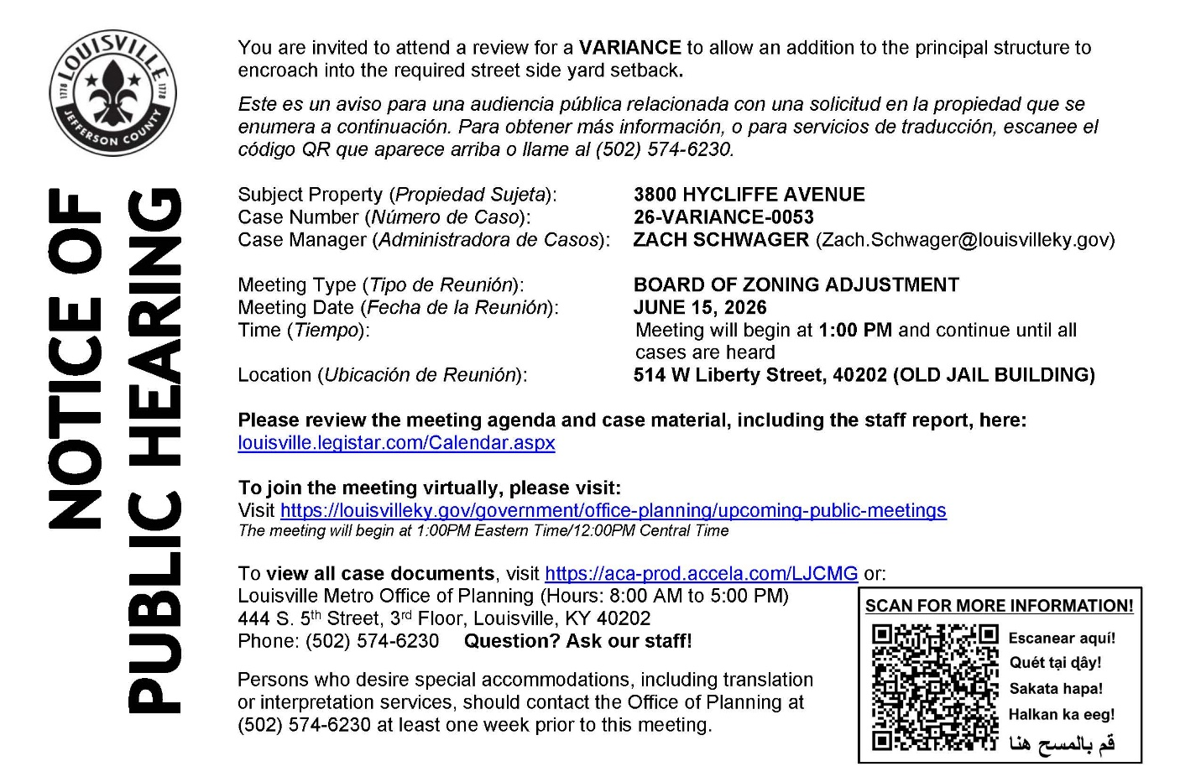
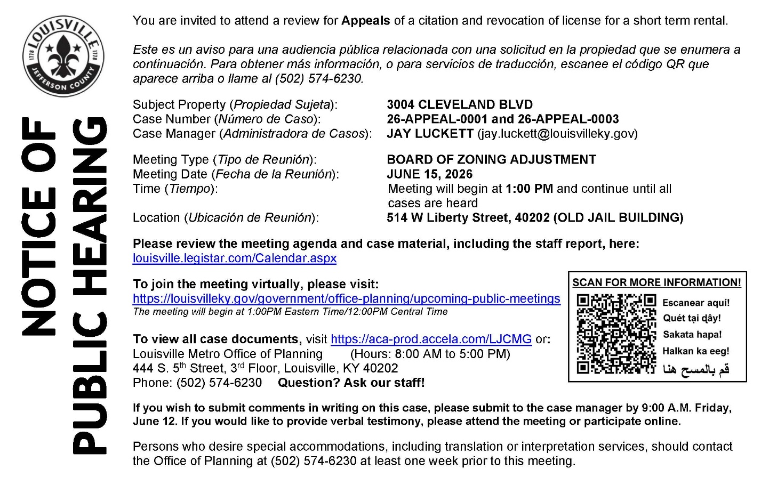
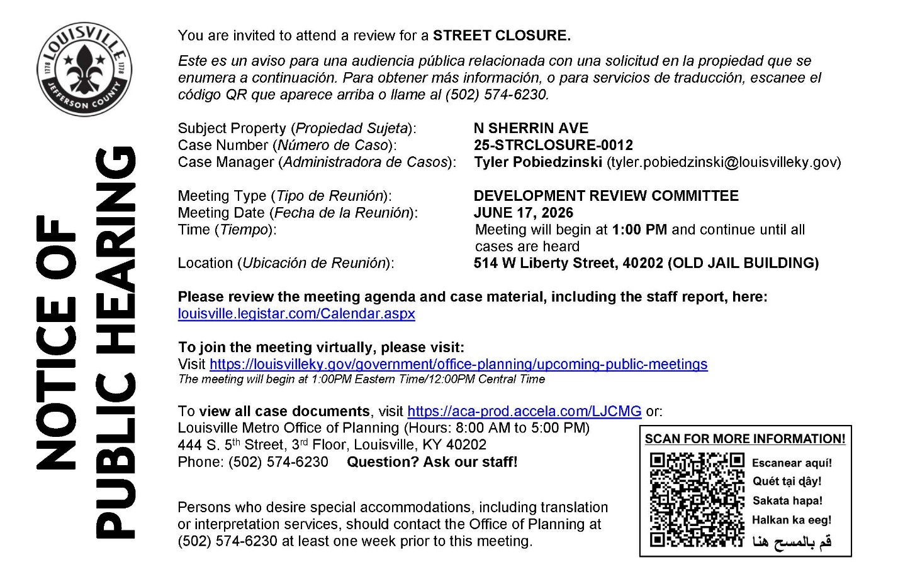
------------------------------------------------------------------------------------------------------

District 9 Events

- Saturday, June 13 - 3:00pm: Willie Davis presents Honeysuckle Season joined by Lisa Jensen for All is Well. https://carmichaelsbookstore.com/event/2026-06-13/willie-davis-and-lisa-jensen
- Wednesday, June 17 - 7:00pm: Lennie Hay discusses I Feed the Dead with Martha Greenwald. https://carmichaelsbookstore.com/event/2026-06-17/lennie-hay-discusses-i-feed-dead-martha-greenwald
- Tuesday, June 23 - 6:00pm: An Evening with David Sedaris for The Land and Its People. https://carmichaelsbookstore.com/event/2026-06-23/evening-david-sedaris
- Tuesday, June 30 - 7:00pm: Johanna Gohmann presents All Toddlers Are Scorpios.
https://carmichaelsbookstore.com/event/2026-06-30/johanna-gohmann-presents-all-toddlers-are-scorpios

