Louisville Metro Council
District 9 eNews | April 16, 2026

🚋 Frankfort Avenue Trolley Hop Is Next Friday | April 24, 4–9 PM
🚋 Frankfort Avenue Trolley Hop – Next Friday!
The Frankfort Avenue Trolley Hop returns next Friday, April 24, from 4:00 to 9:00 p.m., kicking off the 2026 season and launching Derby festivities along Frankfort Avenue. Residents and visitors are invited to hop on the trolley, explore local businesses, and enjoy an energetic evening along the corridor.
📣 Trolley Hop Stop Sponsorships Available
There are still two Trolley Hop stop locations actively seeking small business sponsors, located at Frankfort & Vernon and Frankfort & Ewing. Sponsoring a trolley stop is a great opportunity to gain visibility while supporting one of District 9’s most popular community events.
Trolley Hop Small Business Sponsors receive:
- A highlighted feature on the District 9 website for a full year
- Naming rights at one of the remaining trolley stop locations
📩 Interested in becoming a Trolley Hop stop sponsor?
Please contact Regina Garr at regina.garr@louisvilleky.gov for more information.
Sponsor Deadline:
- July 15, 2026 – Renewal and payment deadline for 2025 sponsors wishing to continue in 2026

🚋 Volunteers Needed: Frankfort Avenue Trolley Hop
The Frankfort Avenue Trolley Hop is coming up, and we need volunteers to help make this popular community event a success! The Trolley Hop brings hundreds of residents and visitors to Frankfort Avenue to shop local, dine, and enjoy a lively evening along the corridor.

Volunteers play a key role by assisting at trolley stops, helping with wayfinding, supporting riders, and keeping everything running smoothly throughout the event. Whether you’re able to help for part of the evening or the full event, your support makes a big impact.

📅 Friday, April 24
⏰ 4:00 – 9:00 p.m.
📍 Frankfort Avenue

If you’re interested in volunteering, please sign up using the link below:
👉 Volunteer Sign-Up Form: https://louisvilleky.wufoo.com/forms/mkgqnu10odk510/

Thank you for helping us support local businesses and create a fun, welcoming experience for the entire community!

St. Joe's Construction
Dear Neighbor,

Thank you for being a support through the community for our kids at St. Joseph Children’s Home.

As we continue to improve our St. Joe’s campus for our families and children, we will be making more changes to increase security and care for the children who live here.

The entrance on the west side of our campus will be installed with a sliding gate. Campus guests will be able to exit there, however entry at that gate from the street will be limited to only a few staff/fleet automobiles. This will limit traffic on that side street and increase the safety on the neighborhood side too. We are told the construction to that gate will begin the week of April 13th and the fence construction will begin the week of April 20th.

The rest of the campus is getting a new playground for the children who live here, additional parking being added to the east side of an existing lot, a sidewalk along our Child Development Center playground and an Amphitheatre for our kids.

If we can answer any questions, please don’t hesitate to email me at AmandaG@sjkids.org.

Thank you again,
Amanda Gehring
Chief Executive Officer
St. Joseph Children’s Home

April Quarterly Community Meeting with the Independent Monitor
Please join us for our second Quarterly Community Meeting:
·Date: Thursday, April 16 , 2026 — Doors open at 5:30 PM; Program from 6:00 to 7:30 PM
·Location: South Central Regional Library — 7300 Jefferson Blvd., Louisville, KY 40219.
·Light refreshments will be available starting at 5:30 PM.
·Spanish-language interpretation and ASL interpretation will be available.

As your Independent Monitor, Effective Law Enforcement for All (ELEFA) will share an update on our work under Louisville’s Community Commitment — including who we are, how the monitoring process works, and what we have been doing since our first community meeting in February — and answer your questions, followed by an opportunity for community feedback.

For questions, please contact ELEFA Deputy Monitor and Community Liaison Brian Corr at brian@elefalvl.org.

Sincerely,
The ELEFA Louisville Independent Monitor Team

This meeting is not sponsored or endorsed by the Louisville Free Public Library.
The League of Women Voters invites You to Attend the April 16 Metro District 9 Candidate Forum and to Meet the Candidates
Whitehall to Offer Terrarium Workshop
Louisville, KY. – Whitehall is pleased to announce its next Whitehall Workshop program. On Thursday, April 16, Carolyn Minutillo of Lavender Hill Florals will lead an Open Terrarium workshop. Students will create their own miniature eco-system and learn how to add some ‘living décor’ to their homes. Terraria are generally self-sustaining and need very little care; students only need to bring a creative mind and a desire for a dash of green to their living space. Space is limited and reservations are required. The cost is $75 per person and includes all necessary materials. The program will be held from 6:00 – 7:30 p.m. Students may register for the program at https://www.historicwhitehall.org/whitehall-workshops.

Carolyn Minutillo AIFD EMC PFCI, is the Owner and Principal Designer at Lavender Hill, a Floral and Lifestyle Shop in Jeffersonville, IN. She is a Certified Floral Designer, Floral Judge and Evaluator with the American Institute of Floral Designers. Carolyn has her European Masters Certification from Brugge, Belgium, is a floral industry public speaker, and is also a Floral Business Coach and Educator.

CASA Updates: Give Children a Voice This April
April is Child Abuse Prevention Month. In Jefferson County we’re hosting a pinwheel planting at the family courthouse on April 17th at 11:30AM to raise awareness — please help share this event with your community (flyer attached). All are welcome!
So far this year, CASA has served nearly 400 children locally, yet 206 remain unserved due to limited volunteer capacity. Kentucky ranks 4th in the nation for child abuse and neglect, nearly double the national average. You can help by spreading awareness and supporting children in need.
Thank you for helping give children a voice and shining a light on this critical issue!
Louisville East Lions Club Spaghetti Dinner
Come join the Louisville East Lions Club for a delicious spaghetti dinner. You'll enjoy a great meal including Salad, Spaghetti, Garlic Bread, Dessert and drinks for only $10. The dinner will be held at Saint Mark’s Episcopal Church, 2822 Frankfort Avenue on April 17.Doors open at 4:00 with food service from 4:30 to 7:00 PM. While there, please ask about our Savers Cards, Braille Key chains and 50/50 raffle tickets. All major credit cards accepted! Carry outs are welcome! Even if you can't attend, you can still help by sharing this post on all your social media platforms. It really does make a difference. Come out, enjoy some great food, and support a wonderful cause! If you have any questions, please contact us by phone or text at (502) 230-1355 or via email at LouisvilleEastLions@gmail.com.

The Annual Beargrass Creek Clean Sweep
Let’s celebrate our Earth together at the Annual Beargrass Creek Clean Sweep! Kentucky Waterways Alliance and our partners Louisville Metro Sewer District (MSD), Olmsted Parks Conservancy, Ohio River Valley Water Sanitation Commission, Louisville Metro District 9 Councilman Andrew Owen, Louisville Metro District 8 Councilman Ben Reno-Weber, Clean Collaborative, and Brightside are hosting this cleanup event to address litter around Beargrass Creek. Enjoy a special performance by musician Andy Blanton, coffee and donuts, and prizes for the weirdest item found, as part of the celebration! We hope to see you on April 18th, as we clean up Cherokee Park and the surrounding areas of Beargrass Creek.
Date Saturday, April 18th, 2026
Location Meet at the parking lot at the corner of Lexington and Ledge Roads to clean up Beargrass Greenway & Cherokee Park.
Timeline Check-in: 8:30-9:00 AM; Cleanup: 9:00 AM-12:00 PM.
Registration:https://forms.gle/aJPfKiJrrKa7KbTA7
Prescription Drug Take Back Day Returns to the Zoo!
After a hugely successful event last year, the Prescription Drug Take Back is back at the Louisville Zoo—and we’re excited to do it again. The timing and location worked especially well for the community, making it easy for people to safely dispose of unused medications.

Join us Sunday, April 19, 2026, from 10:00 a.m. to 2:00 p.m. at the Louisville Zoo bus lot. LMPD officers will be on site to collect and safely dispose of unused or expired prescription drugs, helping protect our community and local waterways. All prescription medications and narcotics are accepted; sharps must be capped or placed in a sealed plastic container (such as a milk jug).

This event is part of Party for the Planet, a monthlong celebration of Earth, powered by LG&E, KU Foundation, and The Louisville Zoo. Clean out your medicine cabinet and be part of a safer, healthier environment for everyone.

Mulch Mondays Are Back!
Mulch Mondays are a free service offered by Louisville Parks and Recreation's Urban Forestry division, providing natural, dye-free mulch for residential, non-commercial use. Mulch is available by appointment only beginning April 20 and is distributed on Mondays from 1–3 p.m. at 9200 Whipps Mill Road.

League of Women Voters to Address the Intersection of Affordable Housing and Community Uplift: Why Affordable Housing is Vital for a Thriving Community At April 20 Democracy in Action Program
Louisville needs more affordable housing; we know that. How can we understand that housing and an investment in human capital can help communities thrive? The public is encouraged to attend the April 20 League of Women Voters Housing program that addresses this issue. The program will be held from 6:00-7:30 p.m. at Lang House, the League Headquarters at 115 S. Ewing Avenue.
Bridgette Johnson, President and CEO of New Direction will speak on "The Intersection of Affordable Housing and Community Uplift: Why Affordable Housing is Vital for a Thriving Community".”
Her presentation will be followed by a panel of experts that will take a deeper dive into how creating affordable housing and investing in education, healthcare, and job creation simultaneously can help communities thrive and reduce their dependency on affordable housing.

The panel will feature:
Tony Curtis, Executive Director, Metropolitan Housing Coalition;
George Eklund, Director of Education and Advocacy, Coalition for the Homeless;
Leslie Woods, Chief Program Officer, Habitat for Humanity

Doors will open at 5:30 and the program will run from 6-7:30. The program is free and open to the public.

The League of Women Voters is a nonpartisan, grassroots organization working to protect and expand voting rights and ensure everyone in our democracy is represented.

For more information, contact Gail Henson, Co-President, grhenson@gmail.com or call the League of Women Voters at 895-5218.

Greater Louisville Sierra Club April, 2026 News
GLSC April Program
A Better World Is Possible: Global Youth Confront the Climate Crisis
by Danica Novgorodoff

Please join us April 21, 7:00 p.m., at the United Crescent Hill Ministries building, 150 State St., 40206 when Danica Novgorodoff will present her new graphic novel, A Better World Is Possible: Global Youth Confront the Climate Crisis. She will discuss her artistic practice, the process of collaborating with a climate journalist, and approaches to turning complex climate data into colorful and engaging stories for audiences of all ages.

In their stunning graphic novel, A BETTER WORLD IS POSSIBLE: Global Youth Confront the Climate Crisis, New York Times best-selling illustrator Danica Novgorodoff and award-winning environmental journalist Meera Subramanian share experiences from their lives and the lives of the four youth activists who’ve witnessed climate change up close—from wildfires in the Pacific Northwest to floods in Bangladesh.

Woven through the stories are deeply researched and fact-checked interludes that explore climate science, environmental justice, biodiversity, and more, along with— of course—solutions! They show us anyone can make meaningful change, because a better world is possible—and together, we can create it.

Danica Novgorodoff is an artist, writer, and New York Times best-selling illustrator. Her books include the graphic novel Long Way Down, written by Jason Reynolds; the cookbook The Simple Art of Rice; and the picture book Alexander von Humboldt: Explorer, Naturalist, and Environmental Pioneer. In 2022, Danica was awarded the Yoto Kate Greenaway Medal, the UK’s most prestigious award for children’s book illustration. She is on the board of the Cofan Survival Fund, working to protect a million acres of Amazon rainforest through Indigenous stewardship in Ecuador, was on the steering committee of the Save Bernheim Now group, and was a co-leader of 350 Brooklyn's Stop the Money Pipeline action group. Her new graphic novel, A Better World is Possible: Global Youth Confront the Climate Crisis, was co-created with climate journalist Meera Subramanian.

Register here to attend: https://tinyurl.com/betterworldpossible

Note: This will be a hybrid meeting, that is, both in-person and virtual. Once you hit the RSVP button, two things will happen:
(1) You’ll be taken to a Zoom meeting registration page. We hope you’ll attend in person, but if you want the option of attending virtually, then please complete the Zoom registration form (this secondary registration enhances security).
(2) You’ll receive a confirmation email that will also contain the Zoom registration link.

Our meetings are always free and open to the public.

Jazz in Bloom: Concert at Joe Creason Park
Jazz in Bloom is a free, family-friendly Earth Day celebration featuring a live jazz performance by the Bellarmine University Jazz Faculty Quintet! The event takes place at Joe Creason Park with music beginning at 6 p.m. and food and drink vendors opening at 5 p.m.

Public Meetings Announced for Proposed Freight Routes
The Louisville Metro Department of Transportation (DOT) is inviting residents to learn about and share feedback on a proposed network of freight routes — or routes commonly used by large trucks — across Jefferson County.
The DOT will host three open house-style meetings where community members can review the draft network, ask questions, and provide input. These meetings are part of the Freight Mobility Action Plan, which aims to improve how big truck traffic moves through Louisville Metro while reducing impacts on neighborhoods.
Meeting dates and locations:
- Tuesday, April 21 | 4 p.m. – 6 p.m.
Southwest Regional Library, 9725 Dixie Hwy.
- Wednesday, April 22 | 6 p.m. – 8 p.m.
Americana World Community Center, 4801 Southside Dr.
- Thursday, April 23 | 5 p.m. – 7 p.m.
Edison Center, 701 W. Ormsby Ave.
A new online tool will also be available ahead of the meetings, making it easy to view the draft routes and submit comments from home.
The plan is being developed in partnership with HDR Engineering to better understand how freight, or big truck traffic, interacts with neighborhoods and to identify safer, more efficient routes.
Your feedback matters. Community input will help shape truck routes that support local businesses while minimizing disruptions in residential areas.
The 32nd Annual Whitehall Wedding Show
Louisville, KY. - Whitehall is pleased to announce that it will host the Whitehall Wedding Show on Thursday, April 23rd, from 5:00 p.m. – 8:00 p.m. at its historic mansion at 3110 Lexington Road. Now in its 32nd year, the Whitehall Wedding Show presents a perfect opportunity to explore Louisville’s premier wedding vendors, featuring caterers, florists, DJs, planners, photographers and many more. Guests will enjoy displays throughout the first floor of the historic mansion, as well as under a tent on the garden terrace. Tickets to attend are FREE for the bride and groom, guest admission is $10 at the door. Complimentary valet parking is provided. Visit our web site to see participating vendors and to pre-register at https://www.historicwhitehall.org/bridal-show.
For more information, please contact Whitehall at (502) 897-2944 or whitehallcarol@historichomes.org.
Proceeds from the Whitehall Wedding Show benefit Whitehall, a historic house and estate garden owned and operated by the not-for-profit Historic Homes Foundation. Originally built in the mid-1850s as an Italianate farmhouse, the home was transformed in the early 1900s into the iconic Greek Revival-style mansion we know today as Whitehall. At just under ten acres, the grounds feature multiple unique gardens and specimen trees, making Whitehall truly the place where “history grows.”

23rd Annual Ken-Ducky Derby
We’re gearing up for the Ken-Ducky Derby, and we need your help to make a splash! As a valued council member, we ask that you please share our flyer and encourage your network to support Harbor House by adopting a duck.
For those who may not be familiar, Harbor House is a Louisville nonprofit dedicated to empowering individuals with disabilities, seniors, and children of all abilities through inclusive programs, education, and support services. Every duck adopted helps fund these vital programs and creates opportunities for the people we serve to learn, grow, and thrive.
Thank you for your continued support and for helping us make this year’s derby our biggest yet!

Bigger, Bolder, Brighter! Mayor Greenberg And the Louisville Zoo Announce Return of Popular Wild Lights Festival
Louisville Mayor Craig Greenberg and the Louisville Zoo are excited to announce the return of the stunning Wild Lights lantern spectacular. After a one-year hiatus, this popular event returns to illuminate evenings at the Zoo from May 15 through July 26, 2026. Tickets went on sale today at louisvillezoo.org/wildlights.
“We’re excited to welcome Wild Lights back to the Louisville Zoo,” said Mayor Greenberg. “This spectacular event has become a favorite for families and visitors, and it’s something people of all ages can enjoy together. We can’t wait for guests to see the Zoo transformed once again with incredible light displays and artistry.”
Wild Lights guests will venture through the Zoo’s 1.4-mile path and experience hand-crafted, illuminated art displays. The event will feature more than 50 lantern displays arranged in themed areas, depicting everything from dragons to butterflies. Highlights include a stunning illuminated walkway with a gigantic chameleon at the Zoo’s entrance, a 20-foot, three-headed dragon, a magical 15-foot unicorn, and incredible glowing displays of prehistoric and underwater scenes. Interactive lanterns invite guests to enhance the experience by powering movements with step-activated pads, along with plenty of selfie-worthy photo opportunities throughout the festival.
Chinese lantern-making is more than mere decoration; it is a vibrant art form that embodies Chinese philosophy, symbolism, and communal celebration. This delicate and intricate artform is more than 1,000 years old and the artisans from Zigong, China who accompany Wild Lights are living bearers of this tradition. In addition to viewing the lantern displays, guests are invited to visit the artisans. There is also a marketplace tent, where unique handcrafted goods will be available for purchase. This 41-night immersive event features live cultural performances, including lightning-fast mask changing, acrobatics and more.
The Zoo’s food and amenity vendor, SSA Group, will serve themed snacks and cocktails at several locations throughout the Zoo, and the Zoo Gift Shop will remain open with special Wild Lights merchandise available for guests to commemorate their visit.
The event is wheelchair and stroller-friendly on a paved path. The festival will take place rain or shine and is held from 7 p.m. – 10 p.m. on Thursdays through Sundays. The last ticket sold will be at 9:30 p.m., and the route will be open until 11:30 p.m.
Wild Lights is in partnership with Stewart Promotions and Tianyu Arts & Culture Inc., an international event design company.
Pricing
Tickets are available for purchase in advance online for a lesser rate and at the admission window the evening of the event. Early Bird ticket pricing is available from March 31- April 13. Children under three do not require a ticket. Prices begin at $17 for adults and $13 for children/seniors based on dates and Zoo membership status. Discounted four-packs are also available. Regular daytime Zoo admission tickets and Wild Lights tickets must be purchased separately. Parking for this event is $7 and can be purchased in advance online or at the Zoo admission windows. For more information and the full tier of pricing, visit louisvillezoo.org/wildlights.
Regular Zoo Hours
The Zoo is open daily year-round. Now through September 20, 2026, hours are 10 a.m. to 5 p.m., with guests exiting by 6 p.m. The Zoo is closed on Thanksgiving, Christmas, and New Year’s Day. Visit louisvillezoo.org for more information on hours and admission.
2026 Forest Fest at Jefferson Memorial Forest
Grab your blanket and lawn chairs and come out to Forest Fest on May 16 for a full-day celebration of live music and local makers set in the beauty of Jefferson Memorial Forest! Gates open at 11:30 AM, admission is $15 per car.

Music for a Purpose Upcoming Events
Hi Music Lovers,
Thank you for making our recent Music for a Purpose concert series supporting the Louisville Urban League such a success!
Our weekend began with a private event on Friday featuring a program of all Black composers, followed by live concerts on Saturday and Sunday featuring the fantastic Kevin Harris Project. Chris Lee and Hassan Sabree joined in for an unforgettable experience!! For those who couldn't join us, we have put together a highlight reel HERE.
We are proud to share that we raised $5,500 for the Louisville Urban League. We are still accepting contributions at this link for those who would like to support their mission of fostering economic equity through housing, education, and job security.
Additionally, WAVE 3 News covered our education series performances at the West End School this past Monday. You can view that clip here: [WAVE 3 features MFP].
Please join us for our next concert series benefiting Kentucky Refugee Ministries on May 22, 23, and 24. This is an issue close to many in our community, and we look forward to supporting Louisville’s thriving international culture together!
Fan Fair Event
For the 11th year in a row, KIPDA Area Agency on Aging and Independent Living, and the Louisville Metro Office for Aging and Disabled Citizens are teaming up to provide fans for older adults and persons with disabilities to help offer relief from the sweltering summer heat. Working with community organizations, churches, businesses, private citizens and the local media, we hope to generate monetary donations to purchase new fans. Persons or businesses interested in sponsoring fans will be able to make tangible or monetary donations to this effort until May 22nd, 2026
Fan Fair Event
June 6th, 2026
9:00am-11:00am
Edison Center
701 W. Ormsby Ave
Louisville KY 40203
If you or your organization are interested in sponsoring, please contact Alli at 502.574.5092 or allison.woosley@louisvilleky.gov
CRESCENT HILL 32nd ANNIVERSARY GARDEN TOUR
SATURDAY, JUNE 6 | 9 A.M. - 5 P.M.
PETERSON-DUMESNIL HOUSE - 301 S. PETERSON AVENUE
The Crescent Hill Garden Club is excited to be hosting our 32nd anniversary garden tour! With your ticket purchase, gain access to private gardens in the Crescent Hill neighborhood PLUS the grounds of the historic Peterson-Dumesnil House. We are planning lots of fun activities to celebrate our anniversary, including a local vendor fair, free door prizes, tours of the Peterson-Dumesnil House, music, breakfast treats and more!
Peterson-Dumesnil Tour Schedule:
- Peterson-Dumesnil House Tours will be available at 10 am, 11 am, 12 pm and 1 pm.
- Peterson-Dumesnil Grounds Tours will be available at 9:30 am, 10:30 am, 11:30 am and 12:30 pm.

TICKETS
You can purchase tickets the day of the tour at the Peterson-Dumesnil House, 301 S. Peterson Avenue, where the tour begins or in advance on our website: https://www.crescenthillgardenclub.org/tour-tickets.html
Tickets are $20.
YOUR TICKET PURCHASE SUPPORTS LOCAL ORGANIZATIONS
Funds from the tour are used to support local community organizations, such as United Crescent Hill Ministries, Waterfront Botanical Gardens, Louisville Free Public Library, and others. Your ticket purchase also funds garden projects throughout the Crescent Hill area and our annual Appalachian Redbud Tree Giveaway Project.

To learn more, visit www.crescenthillgardenclub.org.

Shakespeare in the Park
Kentucky Shakespeare, the Official Shakespeare Festival of the Commonwealth, presents the annual FREE Shakespeare in the Parks tour of THE TEMPEST, touring to a record 46 parks this spring.
“O brave new world, that has such people in’t!”
Shakespeare’s final play is a testament to the redeeming power of love and forgiveness – featuring fools, spirits, monsters, shipwrecks, and magical spells. This one-act magical comedy is performed with five actors in neighborhood parks across the region this spring.
- These are FREE, Family-friendly performances for the community and do not require reservations or tickets.
- The show is approximately 80 minutes long without an intermission.
- Please bring your own chairs, blankets, or other sitables that are most comfortable for you, for most venues.
- In case of inclement weather, most locations have alternate in-door spaces, still currently being determined below. All location changes will be shared on our Facebook and Instagram pages.
- Our artists utilize a sound system with speakers.
- If there are physical accessibility questions related to a specific location, please contact us for recommendations.
- At every performance, we have sensory tools and noise-cancelling headphones for both adults and youth available for use.

The Dot Experience Update
The external façade of The Dot Experience is coming together beautifully. Crews are currently pouring the concrete pad along the drive lane in front of the building, which curves from the main driveway to State Street. Also visible in this image are the newly installed sunshades along the front of the building, enhancing the main gallery area.

Follow us on Facebook and Instagram for continued updates on construction, introductions to our cast, exhibits, and stories from individuals who are blind or have low vision.

Facebook: @The Dot Experience
Instagram: @the.dot.experience

Image description: An aerial view of The Dot Experience. The concrete pad is being poured.

Pet of the Week & Metro Animal Services Updates
Get ready to smile until it hurts! This week’s featured pup is a total heartbreaker...he’s BIG handsome and guaranteed to brighten your day..

"Think of Hazelnut as the Dan Conner of the dog world: a big hearted, blue collar lovable lug who is essentially a 100lb pile of mush. He’s got that classic Connor charm authentic, easygoing, and more interested in a comfortable nap than a workout. Maybe he could learn to fetch you a cold one or two.

Despite his powerhouse physique, he’s a total goofball who would rather make hilarious faces and sniff the local flora than chase a ball. While he could stop a villain just by sitting on them, he’d rather lay on his back while you rub his belly.. This refined gentleman tires out quickly, preferring a short walk followed by a long nap.

Hazelnut is loved by volunteers & staff. He's ready to get out of the shelter and into his new life!

Hazelnut McSofthands likes other dogs to play play play but he would prefer not to share his things with them; we recommend a single dog house hold for Mr. McSofthands.
He is around 4yrs old, neutered male, microchipped, up to date on vaccines. He is a Champion; his adoption comes with 3yrs of core vaccines, 6 months of heartworm prevention, leash, harness, crate by request and a lifetime Jefferson County pet license!

Hazelnut is available for foster to adopt or adoption; come meet him at 3516 Newburg Rd, open daily noon-6pm.

Dogs over 40 pounds are always FREE.
Adoptions include spay/neuter, up-to-date shots, one free training session with Micky's House, one month free membership @ PG&Js dog park, and more!
-------------------------------------------------------------------------------------------------------
Eve is our hopeful pup this week.

***STAFF & VOLUNTEER FAVORITE***
Eve is our queen of silly facial expressions! She will keep you cracking up! Eve is a professional leaner, a belly rub connoisseur, and the best passenger on car rides (though she thinks she's most deserving of riding shotgun, she knows she's safer in the back seat:). She'll sit kinda like a person but also loves hanging her head out the window to take in the breeze. Eve has more spring in her step than you'd expect for a 9 year old dog, she gets around great and loves taking you on a journey of everything she sniffs and hears. She sits for treats and takes them so gently from your hands. Eve is so ready for and most deserving of her second chapter! Come make her yours today!

Dogs over 40 pounds are always FREE. Adoptions include spay/neuter, up-to-date shots, one free training session with Micky's House, one month free membership @ PG&J's Dog Park, and more!

CHAMPION dogs come with extra perks! Core vaccines for 3 years, Lifetime Jefferson County pet license, freedom harness with leash, bag of starter food, six months of heartworm preventative, and crate upon request! Eve picked out some special treats for herself while on a recent outing and those come with her adoption too!

LMAS Animal House
3516 Newburg Rd, Louisville
Open daily 12–6pm
Adopt, foster, volunteer & more: linktree.com/yourcityshelter
#Yourcityshelter #Todayattheshelter
-----------------------------------------------------------------------------------------------------
Upcoming Events in April:
- Sunday, April 19th Microchip Clinic 3528 Newburg Rd 1pm-3:30pm Register online required (payment in person)
- Saturday, April 25th Districts 24, 13, and 25 Low-Cost Rabies Clinic The Eagles Club 201 Outer Loop 10am-1pm
- Tuesday, April 28th Happy Tail Hour: A Dog Friendly Event at Waterfront Park Great Lawn 5pm
- Thursday, April 30th 11am-9pm 2221 Frankfort Ave
Dinner Pawty CM Chicken X Friends of Metro Animal Services 15% of Dine in Sales and 10% of Online Sales go to FOMAS to support #YourCityShelter

Seneca Park Pathway Lighting Upgrade
As of yesterday, April 14th, LG&E is about 50% of the way complete with about 20 new lights installed. We are expecting them to wrap up the project and be 100% complete within the next 2 weeks.

Louisville Water Company Updates
No Update

MSD N. Galt Avenue Project
After investigating the sewer and stormwater drainage lines on N. Galt Avenue, MSD has found several blockages that will be fixed through point repairs and pipe rehabilitation. The work is underway and is expected to be complete by the end of summer.

Here is the latest work schedule for the project:

- A manhole is set to be installed on Thursday, April 16 at 109 N. Galt Avenue. Work on the manhole is expected to be complete the following day.

- During the week of April 20, an MSD contractor will continue making point repairs along the street. Traffic will go down to one lane near the work. Street parking may be reduced near the work.

- During the week of the Kentucky Derby, April 27-May 3, work will be paused for the convenience of residents. The road will be securely plated and open to traffic. Equipment will be removed from the street.

- During the week of May 4, equipment will be returned and point repairs will continue.

After all point repairs are complete, Robinson Pipe Cleaning will line the storm and sanitary sewers with Cured in Place Pipe (CIPP), which is a quick and trench-less process that will add 50 to 100 years to the lifespan of the pipes. Before the contractor leaves, restorative ground and asphalt work will be done.

UCHM Programs & Events
United Learning Summer Camp is Back! ☀️
☀️ June 1–5 @ 9:30 AM–2:30 PM – Join us for UCHM Summer Camp for rising 1st–5th graders! Enjoy a week of STEM activities, hands-on learning, field day fun, and daily breakfast & lunch.
🤝 Volunteers Needed – Food Pantry Support - Wednesdays @ 10:30 AM–12:30/1:00 PM – We’re looking for caring volunteers to help stock our food pantry and support families in our community. Your time makes a meaningful difference!
👉 Apply at: https://www.uchmlouky.org/volunteer/

UCHM 60+ Program – April/May Highlights
Join us this month for engaging activities, wellness opportunities, and live music at United Crescent Hill Ministries
🌿 Thursday, April 23 @ 10:30 AM – Join us for a special presentation by Danielle Archer from the Olmsted Parks Conservancy. Learn more about our local parks, their history, and how they continue to serve our community.
🎉 Tuesday, May 5 @ 10:30 AM – Join us as we celebrate Cinco de Mayo with a festive morning of fun, culture, and community at our 60+ Program!
🗣️ Thursday, May 7 @ 10:30 AM – Guest Speaker Mike O’Leary from the Clifton Community Council will join us to share insights and updates about our local community.
👉Thursday, May 14 @ 10:30 AM – Join us for a delightful morning at our Mini French Fest! Enjoy live music by La Petite Musique as we bring a touch of French culture, music, and fun to our community.
🎹 Tuesday, May 26 @ 10:30 AM – Join us for a relaxing morning as Deanna Scoggins plays the piano for our 60+ Program. Enjoy beautiful music in a welcoming and uplifting atmosphere.
📅 Full Monthly Calendar
For a complete list of activities and events, please contact Monique at 502-893-0346.

UCHM Community Event
🀄 Tuesday, May 13 @ 5:00–8:00 PM – Mahjong Night Fundraiser
Join us for a fun evening of Mahjong while supporting UCHM! All are welcome—beginners, experts, and everyone in between.
Admission is $5 or a donation of chef boyardee, salad dressing, pasta and sauce.
Check out our Facebook page to RSVP or just come by!

Paving Operations RESUME!
Paving operations have resumed now that temperatures have warmed up for the season. Crews are back out improving streets across Louisville Metro.

Louisville Metro repaves streets each year to preserve roadway conditions, extend the life of existing pavement, and provide safer, smoother travel for everyone. Regular paving helps prevent more costly repairs in the future and protects the City’s infrastructure investment.

To see which streets are currently scheduled for paving, visit the "Paving" page at louisvilleky.gov. Please note that all listed projects are weather permitting and subject to change.

-------------------------------------------------------------------------------------------------------Public Hearings, Meetings, & Applications
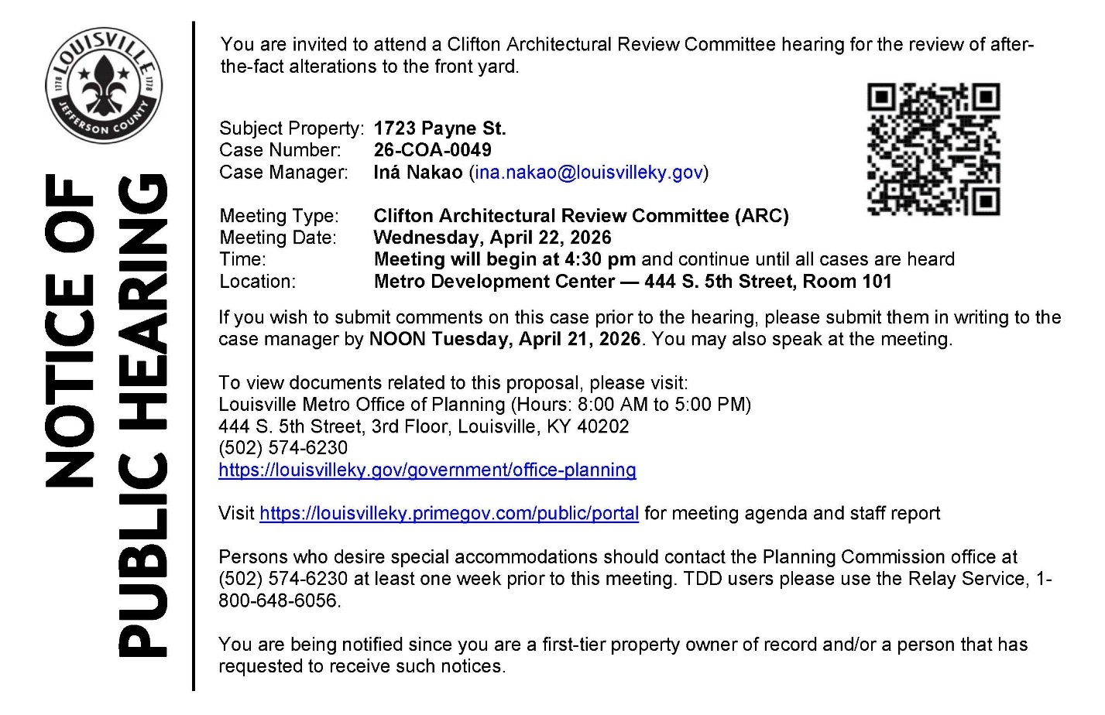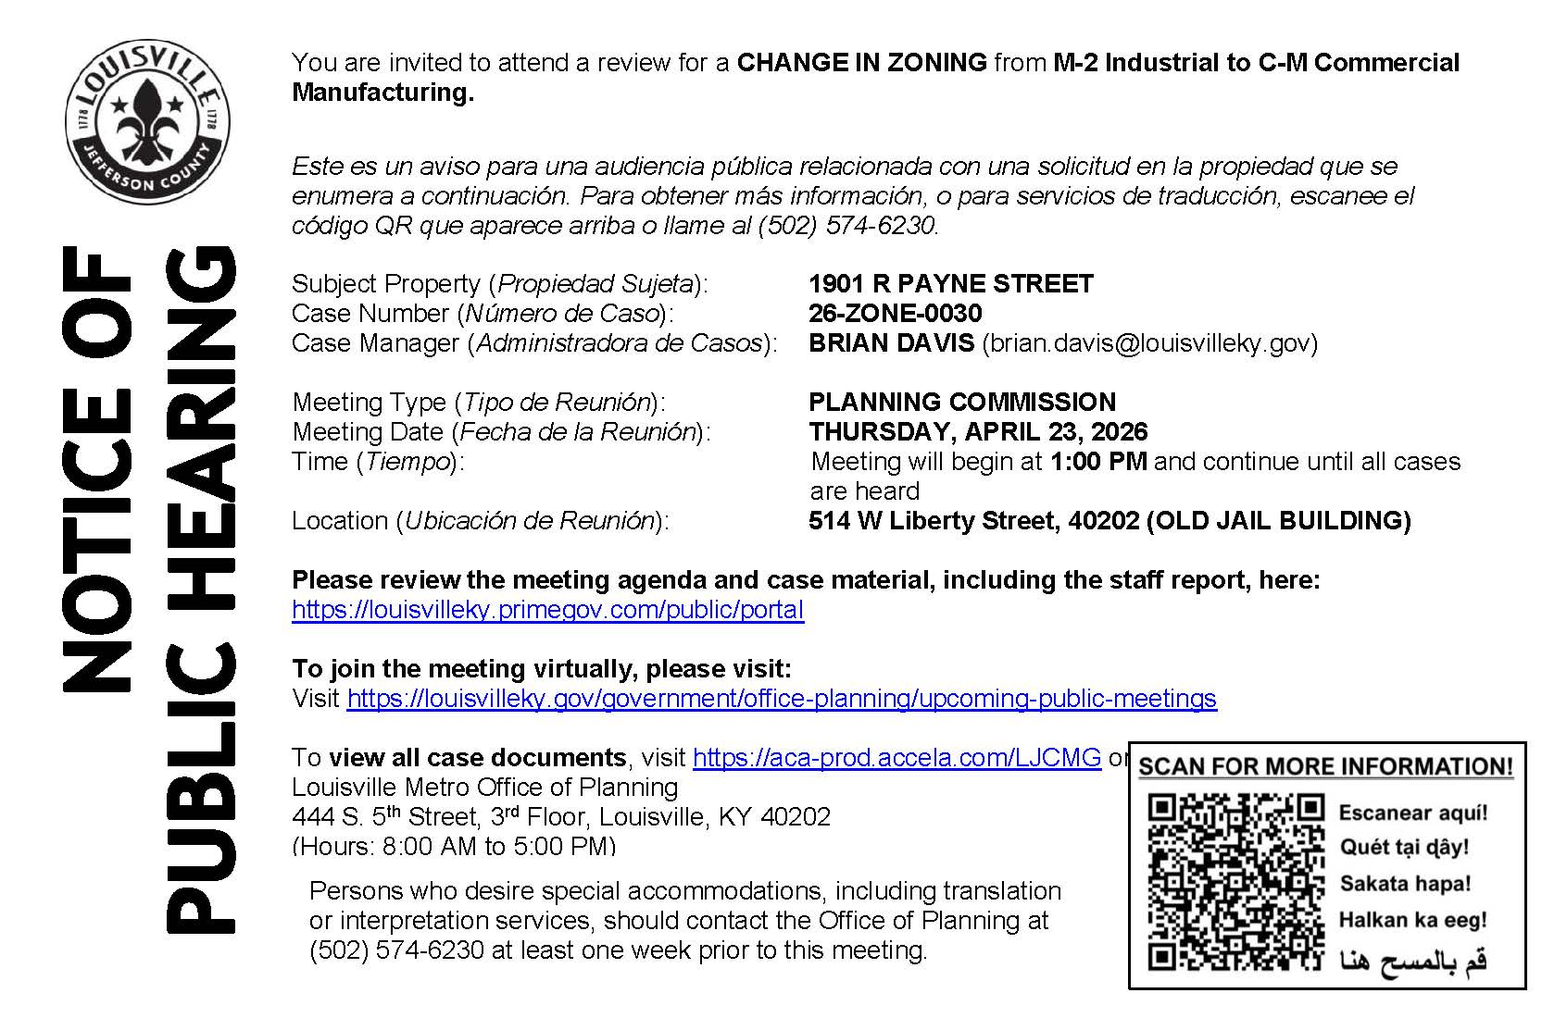

------------------------------------------------------------------------------------------------------

Alcoholic Beverage
Ad Date: 03/25/2026 | 30-Day Date: 04/24/2026
Protest must be submitted by: LMPD Division 5TH DIVISION

PUBLIC NOTICE
Kim Preher, 212 Logsdon Ct Louisville, ky 40243, Hereby declares intention(s) to apply for a Southern Sips LLC Catering license with alcohol service license(s) no later than March 13, 2026. The business to be licensed will be located at 2901 Brownsboro Rd Ste 2, Kentucky 40206 doing business as Southern Sips LLC. The owner(s) are as follows: Kim Preher 212 Logsdon Ct Louisville KY 40243. Any person, association, corporation, or body politic, may protest the granting of the license(s) by writing the Department of Alcoholic Beverage Control, 500 Mero St 2NE33, Frankfort, Kentucky, 40601 , within thirty (30) days of the date of legal publication. March 19 2026 LSBN0479465
------------------------------------------------------------------------------------------------------
Ad Date: 03/29/2026 | 30-Day Date: 04/28/2026
Protest must be submitted by: LMPD Division 5TH DIVISION

PUBLIC NOTICE
STATEMENTBARBERSHOP LLC, 2250 Frankfort Ave, Louisville, KY 40206, Hereby declares intention(s) to apply for a NQ4 Retail Malt Beverage Drink license(s) no later than March 12, 2026. The business to be licensed will be located at 2250 Frankfort Ave Louisville, Kentucky 40206 doing business as Statement Barbershop. The owner(s) are as follows: Michael Hack, Owner, 369 Winton Ave Louisville, Kentucky 40206. Any person, association, corporation, or body politic, may protest the granting of the license(s) by writing the Department of Alcoholic Beverage Control, 500 Mero St 2NE33, Frankfort, Kentucky, 40601 , within thirty (30) days of the date of legal publication. Publication Dates LSBN0487734
------------------------------------------------------------------------------------------------------
Ad Date: 04/03/2026 | 30-Day Date: 05/03/2026
Protest must be submitted by: LMPD Division 5TH DIVISION

PUBLIC NOTICE
JN Spirits Limited Liability Company, 2732 River Green Circle, Louisville, Ky. 40206, Hereby declares intention(s) to apply for a Distillers license(s) no later than April 1, 2026. The business to be licensed will be located at 2732 River Green Circle, Louisville, Kentucky 40206 doing business as JN Spirits. The owner(s) are as follows: Danielle Mann of 11906 Reading Room Rd. Louisville, Ky. 40059. Any person, association, corporation, or body politic, may protest the granting of the license(s) by writing the Department of Alcoholic Beverage Control, 500 Mero St 2NE33, Frankfort, Kentucky, 40601 , within thirty (30) days of the date of legal publication. April 3 2026 LSBN0492039
------------------------------------------------------------------------------------------------------
Ad Date: 04/05/2026 | 30-Day Date: 05/05/2026
Protest must be submitted by: LMPD Division 5TH DIVISION

PUBLIC NOTICE
Clifton Hospitality, LLC, 1800 Frankfort Ave. Louisville, Ky. 40206, Hereby declares intention(s) to apply for a 2 am extended hours addition on quota drink and NQ4 beer drink license(s) no later than April 1, 2026. The business to be licensed will be located at 1800 Frankfort Ave. Louisville, Kentucky 40206 doing business as Clifton Tavern. The owner(s) are as follows: Daniel Regneri of 243 Delmont Ave. Louisville Ky 40206 and David Britton Richardson of 758 Greenridge Ln. Louisville, Ky. 40206.. Any person, association, corporation, or body politic, may protest the granting of the license(s) by writing the Department of Alcoholic Beverage Control, 500 Mero St 2NE33, Frankfort, Kentucky, 40601 , within thirty (30) days of the date of legal publication. April 5 2026 LSBN0491971
-------------------------------------------------------------------------------------------------------

District 9 Events

- Thursday, April 16, 2026 - 6:00pm: Linda Sue Park discusses Just One Gift with Brittany J. Thurman: https://www.carmichaelsbookstore.com/event/linda-sue-park-presents-just-one-gift

- Thursday, April 16, 2026 - 6:30pm: David Baldacci present Hope Rises: https://www.carmichaelsbookstore.com/event/david-baldacci-presents-hope-rises

- Thursday, April 23, 2026 - 7:00pm: Kim Michele Richardson discusses The Mountains We Call Home with Emily Bingham: https://www.carmichaelsbookstore.com/event/kim-michele-richardson-presents-mountains-we-call-home

- Wednesday, April 29, 2026 - 7:00pm: Lili Kobielski presents At the Derby: Kentucky’s Grandest Celebration of Fashion: https://www.carmichaelsbookstore.com/event/lili-kobielski-presents-derby-kentuckys-grandest-celebration-fashion

