Louisville Metro Council
District 9 eNews | March 5, 2026

🚋 Frankfort Avenue Trolley Hop: 2026 Kickoff & Small Business Opportunities
The Frankfort Avenue Trolley Hop is gearing up for an exciting new year—our first 2026 Hop will kick off Derby celebrations on Friday, April 24! Be sure to check out the Save the Date flyer for the full 2026 schedule and start planning how your business can shine.

Small businesses are invited to promote their trolley-night specials, offers, or in-store experiences to help elevate the energy along the Avenue. Submit your details using the form below.
Please submit at least two weeks prior to each Trolley Hop.

👉 Share Your Trolley Hop Specials

We also have two remaining Trolley Hop stop-location sponsorships available at Frankfort & Vernon and Frankfort & Ewing. Trolley Hop Small Business Sponsors receive:
- A highlighted feature on the District 9 website for a full year
- Naming Rights at one of the remaining trolley stop locations

Sponsor Deadlines:
- March 31, 2026 – Final day to become a new 2026 Trolley Hop sponsor
- July 15, 2026 – Renewal & payment deadline for 2025 sponsors wishing to remain sponsors in 2026

Cleanup: City Efforts and How Residents Can Help
With the snow now melted, litter that was hidden beneath weeks of winter weather has become more visible across Louisville Metro. Our Clean Collaborative crew and partners are actively working to catch up on debris removal and address areas impacted across both local roadways and interstates, the latter maintained through a dedicated contract with KYTC.
Louisville Metro works year-round to keep streets, neighborhoods, and public spaces clean and safe. While litter may stand out more after winter weather, cleanup efforts never pause. Crews continue removing debris, addressing illegal dumping, and maintaining public spaces across the city.
A cleaner Louisville is a shared responsibility, and small actions from residents and businesses make a big difference:
- Pick up litter around your home or workplace. Even a few minutes helps keep streets and storm drains clear.
- Secure trash and recycling carts. Close lids and avoid overfilling to prevent windblown debris. If a cart is damaged or missing a lid, submit a repair request through Metro311 by selecting “Waste Container Request” and then “Damaged.”
- Report illegal dumping or litter through Metro311 so crews can respond quickly.
- Cover and secure truck loads. Never allow debris to blow from a pickup truck or vehicle.
- Do not place household or business trash in public receptacles. These containers are for pedestrian litter only.
- Organize or join a neighborhood cleanup. Brightside provides tools and support for community cleanups.
When the city and community work together, we keep Louisville Metro's streets safer, storm drains clearer, and neighborhoods more welcoming for everyone.
Mayor Greenberg Announces Completion of Two Major Corridor Improvement Projects
(Pictured above: East Market Streetscape Project)
This week, Louisville Mayor Craig Greenberg announced the completion of two major transportation improvement projects — the East Market Streetscape Project and the River Road Multi-Modal Project, significant milestones in the city’s efforts to create safer, more accessible, and more vibrant public spaces.
“These projects show how we can invest in safer, more beautiful streets and public spaces that serve people, strengthen businesses, and connect our community,” said Mayor Greenberg.
East Market Streetscape Project
The $12-million East Market Streetscape Project has transformed nearly one mile of East Market Street between Brook Street and Baxter Avenue, improving conditions for pedestrians, cyclists, and drivers.
Improvements include a dedicated separated bike lane, improved crosswalks and curb ramps, and new landscaped medians, with a few finishing touches, including final lighting and landscaping, nearly complete.
“This project required patience and collaboration from everyone along East Market Street,” said Rosa Halcomb, project manager with the Louisville Metro Department of Transportation. “Our focus was always on keeping businesses accessible while delivering a project of this scale with as little disruption as possible. Thanks to the strong partnership with NuLu, our construction team with Pace, Michael Baker, and JLL, we were able to navigate complex conditions and deliver a transformative project in just two years — something we’re truly proud of.”
“The NuLu Business Association is honored to join the Mayor in announcing the completion of this $12-million streetscape initiative — a transformative investment more than twelve years in the making,” said Adam Caperton, NuLu business owner and vice president of the NuLu Business Association. “This project represents a shared commitment to creating a safer, more accessible, and more inviting district for residents, businesses, and visitors alike. With expanded sidewalks, improved crossings, and thoughtfully designed tree-lined streets, the new streetscape enhances both the character and connectivity of NuLu. We look forward to welcoming local neighbors and guests from across the region to experience the vibrant energy and economic vitality that define our community.”
The East Market Streetscape Project was led by Louisville Metro’s Department of Transportation in partnership with the Kentucky Transportation Cabinet (KYTC).
River Road Multi-Modal Project
Mayor Greenberg also announced that the River Road Multi-Modal Project is nearing completion.
The project has improved safety, operations, and aesthetics along River Road and the Louisville Loop between 3rd Street and 7th Street. The project creates a park-like setting beneath I-64 and the Belvedere, serving as a critical connection between the existing Waterfront Park and Waterfront Park Phase IV.
(Pictured below: River Road Multi-Modal Project)
The designs expand the Louisville Loop by removing the northernmost westbound lane of River Road between 4th and 7th Streets, with traffic modeling conducted by project consultants indicating minimal impact on travel times.
Enhancements include an expanded multi-use path for pedestrians and cyclists, decorative lighting and wayfinding signage, and roadway alignment consistent with the upcoming River Road West Extension Project, expected to begin in 2026, with lighting under the I-64 overpass nearly complete.
About $2.2 million in local and federal funding supported the project, along with partnership from Hall Construction, JLL, and Gresham Smith.
You can view coverage of these announcements on WDRB, WHAS 11 and the Courier Journal. See the full announcement on Metro TV.
LMPD 5th Division Community Meeting – March 6
Join Major Brown and the LMPD 5th Division for a community meeting on Friday, March 6th at 9:00 a.m. at Gilda’s Club (2440 Grinstead Dr.).

This is an opportunity to connect with your local police division, ask questions, share concerns, and participate in open dialogue that helps shape our community.

📅 Friday, March 6, 2026
🕘 9:00–10:30 a.m.
📍 Gilda’s Club, 2440 Grinstead Drive

All residents are welcome.

International Women's Day Breakfast Briefing: The Power of Her
Saturday, March 7, from 9am
Americana’s International Women’s Day Breakfast Briefing brings together leaders, partners, and community members for a morning of dialogue and collaboration. This gathering honors the resilience, leadership, and contributions of women across cultures while recognizing International Women’s Day as a global call to advance gender equity. The program will elevate the voices and experiences of immigrant and refugee women and focus on strengthening collective efforts to expand access to opportunity and inclusion.

Click Here for Tickets

Upcoming TRIAD Meeting
Wear your favorite St. Patrick's Day attire!

March 10th, 2026
Networking 11:00am
Lunch Served at 11:30am
Meeting 12:00-1:00pm

Our Mother of Sorrows Cafeteria
770 Eastern Parkway, Louisville, Ky 40217

Lunch Sponsored by: CLLB Law

RSVP REQUIRED:
Please call the Office for Aging & Disabled Citizens at 502-574-5092 or by email to allison.woosley@louisvilleky.gov

Parking is available in the enclosed lot next to the cafeteria or in the lot to the right of school. Street parking is allowed.

Ready For a New Opportunity? Meet Us at The Career Fair
Looking for a new opportunity or know someone who is? Louisville Metro Government will host a Career Fair on Tuesday, March 10, 2025, from 10 a.m. to 3 p.m. at Louisville Slugger Field, 501 East Main St.
More than 25 Metro agencies will be in attendance, with over 70 open positions available across city government. Attendees can learn about current openings, speak directly with hiring teams, and explore career paths in public service.
Free parking will be available at the venue, and the location is accessible via TARC routes for added convenience.
Interested applicants can view current job postings and apply online at:
https://www.governmentjobs.com/careers/louisvilleky
Please see the attached flyer for more information and share this opportunity with family and friends who may be interested.
The ElderBloom Trio at United Crescent Hill
📅 Thursday, March 12 | ⏰ 10:30 – 11:00 PM | 📍 150 S. State Street Louisville, KY 40206

🌿 Greater Louisville Sierra Club – March 2026 Program
Join us on March 17 for an update on the Ohio River Restoration Program Act, the bipartisan federal bill introduced by Rep. Morgan McGarvey that would create the first national restoration program for the Ohio River Basin. The act would establish an EPA office and provide funding for habitat restoration, pollution control, workforce training, and clean-water initiatives across the region.

Our speaker will be Michael Washburn, Executive Director of Kentucky Waterways Alliance. He’ll share the latest on the legislation, related advocacy efforts, and the multi-partner Restoration and Protection Plan led by the Ohio River Basin Alliance, the National Wildlife Federation, and the Envirome Institute at UofL.

Michael brings two decades of nonprofit and academic leadership experience and is a Louisville native, writer, and 2025–26 Alden Fellow.

📅 March 17 at United Crescent Hill Ministries
150 State St, Louisville 40206
Social time with light refreshments at 6:30 p.m.; program begins at 7:00 p.m.

➡️ Register to attend (in person or virtual): https://tinyurl.com/OhRiBaAl
This will be a hybrid meeting; completing the Zoom registration ensures secure access.

As always, meetings are free and open to the public.

Feathers and Friends Gala
SAVE THE DATE - MARCH 21 - Harbor House is proud to kick off our Annual Ken-Ducky Derby season with our signature Feathers and Friends Gala—a celebration that directly supports our mission of serving children, adults with disabilities, and seniors through inclusive, community-based programs. Every dollar raised helps Harbor House provide life-enriching care, meaningful opportunities, and lifelong support for individuals and families across our community.

This year’s event will be hosted at Harbor House, 2233 Lower Hunters Trace, Louisville, KY 40216, and promises to be a night to remember. Guests will enjoy an immersive evening filled with Ducks & Diamonds, a speakeasy atmosphere, cigars, bourbon tastings, great music, and even better company. With a silent auction and a unique experience in every room, this unforgettable night sets the tone for a season of impact.

Get your tickets today: https://one.bidpal.net/feathersandfriends2026/welcome

This Year's First Pop-Up Drop-Off Event Announced!
Louisville Metro's first Pop-Up Drop-Off event of the year is right around the corner, and we want to make sure you have the official information. Please share the graphic below with friends, neighbors, and community groups.

We're thrilled to announce a new addition for 2026: Goodwill Kentucky will be on-site collecting gently used textiles and household items. It you've still got the bag of donations sitting in your trunk, this is the perfect chance to finally give those items a second life.
These events are designed to be a one-stop-shop for responsible decluttering - recycling, donating, and proper disposal all in one place. And your participation truly makes a difference. Last year, Pop-Up Drop-Offs achieved a 53% diversion rate, keeping more than half of all collected material out of the landfill. That's momentum worth building on.
As we kick off a new year, we're encouraging residents to embrace a reduce and reuse mindset rather than a throw-away one. Reducing waste starts long before items reach the curb or a Pop-Up Drop-Off - by choosing durable products, avoiding unnecessary purchases, and being mindful consumers. Every item donated, recycled, or avoided in the first place helps reduce waste and supports a cleaner, more sustainable Louisville.

We can't wait to see you at a Pop-Up Drop-Off this year! Join us at Sun Valley Park and Ashby Lane Baptist Church on March 21, 2026 for the first one. And mark your calendars for the second one at UofL Shelby Campus on April 4!

🌱 Mayoral Candidate Forum on Sustainability & Clean Energy
We are proud to co-sponsor an upcoming Mayoral Candidate Forum focused on sustainability, climate resilience, and clean energy issues. This virtual event is hosted by LouisvilleCAN and partner organizations.

📅 Date & time available on the event page
📍 Zoom event: Wednsesday, March 25th | 7-8:30pm
➡️ Details & Official Flyer: https://www.louisvillecan.org/events

Celebrate Earth Fest at Alberta O. Jones Park
Saturday, March 28, from 1 - 5 PM
Join us for Earth Fest, a fun, family-friendly kickoff to Louisville Earth Month hosted by the Office of Sustainability, Parks Alliance of Louisville, J Wagner Group, and our incredible community partners. Celebrate with us at Alberta O. Jones Park, where you will enjoy live music, hands-on activities, and the company of neighbors who care about our planet.

Everyone is invited to stop by for free burritos, t-shirts, and great entertainment. Be sure to mark yourself as “Going” on the Earth Fest Facebook event page and follow @SustainLouisville to stay up to date.

Learn More Here: https://louisvilleky.gov/government/sustainability/earth-fest

2026 Spring Break Camps
Get ready for a week full of creativity, adventure, and making friends during our Spring Break programs, happening April 6–10! Kids and teens can enjoy days packed with games, arts & crafts, outdoor activities, and opportunities to make new friends at community centers across the city. With both structured camps and open programming, there’s something for every age and interest. It’s the perfect way to stay active and engaged during time off school!

Beyond the Rent: Policy Driven Solutions for Housing and Utility Burdens
The Metropolitan Housing Coalition's EveryHome Program is hosting an all-day conference entitled Beyond the Rent: Policy Driven Solutions for Housing and Utility Burdens on April 7, 2026 at the Muhammad Ali Center in Louisville, Kentucky. This all-day conference will convene national and local leaders to advance solutions to housing and utility affordability and highlight findings from our 2025 Housing and Utility Affordability Report. The event features three keynote speakers, two breakout sessions, an expert panel, networking opportunities, and meals provided by Mayan Cafe. For more information and to secure your tickets, go to beyondtherent.org.

Look Again Louisville - A Derby Style Event
Derby season is around the corner, and Margaret’s Consignment is proving that standout style does not require a high price tag. On Friday, April 10 from 2–6 PM, guests are invited to Margaret’s Consignment, 2700 Frankfort Avenue, for a free Derby Style Show featuring head-to-toe looks curated for $100 or less. Attendees will gain real inspiration for assembling a winning Derby outfit on a budget.
The event will also include wine and light snacks, door prizes, a gift with purchase, $10 dress racks, and a wide selection of hats, fascinators, shoes, handbags, and jewelry. In addition, makeup artist Becca Schell will offer complimentary 15-minute mini makeovers featuring personalized make-up application, along with a small take-home touch-up kit. Admission is free.
2026 TreeFest
We’re excited to bring TreeFest 2026 to Thurman-Hutchins Park for Louisville’s largest Arbor Day celebration! Kick off the day by helping us plant more than 100 trees before the festivities begin, or sign up to be an event volunteer.
Sign up to volunteer here.

Fan Fair Event
For the 11th year in a row, KIPDA Area Agency on Aging and Independent Living, and the Louisville Metro Office for Aging and Disabled Citizens are teaming up to provide fans for older adults and persons with disabilities to help offer relief from the sweltering summer heat. Working with community organizations, churches, businesses, private citizens and the local media, we hope to generate monetary donations to purchase new fans. Persons or businesses interested in sponsoring fans will be able to make tangible or monetary donations to this effort until May 22nd, 2026
Fan Fair Event
June 6th, 2026
9:00am-11:00am
Edison Center
701 W. Ormsby Ave
Louisville KY 40203
If you or your organization are interested in sponsoring, please contact Alli at 502.574.5092 or allison.woosley@louisvilleky.gov
Voting Rights Session
Join the Center for Accessible Living and KY Protection and Advocacy for an important conversation about voting rights and disability access. Come learn, engage, and strengthen your voice.

Wednesday, March 18th
11:00am
The Center for Accessible Living
501. E Broadway; Suite 310
To Register, click HERE

Humana Tower to Become World-Class Convention Center Hotel
Louisville is set to transform one of its most iconic buildings into a world-class destination:

- The Humana Tower will be reimagined as a 1,000-room convention center hotel, bringing new jobs, visitors from around the country, and revenue to the city.
- Poe Companies will lead the $600–700 million redevelopment, featuring restaurants, 100,000 sq. ft. of meeting space, and a 40,000 sq. ft. grand ballroom.

📣 CASA Volunteers Needed in Jefferson County
CASA of the River Region is seeking volunteers to serve as a consistent, caring voice for children navigating Family Court. More than 200 local children are currently waiting for a CASA advocate.

CASA volunteers ensure a child’s voice is heard and their safety is prioritized. With their new streamlined training program, you can become a volunteer in just 2½ weeks, which includes:
- 2 in-person sessions
- 3 online sessions
- Flexible self-study

Give a child a voice. Give a child hope. Become a CASA volunteer advocate.
Learn more: www.casarr.org/volunteer

If you’re interested in helping spread awareness—through speaking opportunities, tabling events, fundraisers, or even placing a yard sign—CASA welcomes your support.

New Opportunities for Young Learners and Students
 Louisville continues to expand opportunities for young learners, students, and families:
- Grow Up Great: A $250,000 PNC Foundation Grow Up Great grant will expand early-literacy programs at Louisville Free Public Library branches citywide.
- Book Works: The Book Works Louisville is now at Shelby Park Community Center, offering free academic support and connecting students with critical resources.
- Bezos Academy: Applications are open through April 20 for free, full-day preschool for 3- and 4-year-olds for the 2026-2027 school year.

Shakespeare in the Park
Kentucky Shakespeare, the Official Shakespeare Festival of the Commonwealth, presents the annual FREE Shakespeare in the Parks tour of THE TEMPEST, touring to a record 46 parks this spring.
“O brave new world, that has such people in’t!”
Shakespeare’s final play is a testament to the redeeming power of love and forgiveness – featuring fools, spirits, monsters, shipwrecks, and magical spells. This one-act magical comedy is performed with five actors in neighborhood parks across the region this spring.
- These are FREE, Family-friendly performances for the community and do not require reservations or tickets.
- The show is approximately 80 minutes long without an intermission.
- Please bring your own chairs, blankets, or other sitables that are most comfortable for you, for most venues.
- In case of inclement weather, most locations have alternate in-door spaces, still currently being determined below. All location changes will be shared on our Facebook and Instagram pages.
- Our artists utilize a sound system with speakers.
- If there are physical accessibility questions related to a specific location, please contact us for recommendations.
- At every performance, we have sensory tools and noise-cancelling headphones for both adults and youth available for use.

The Dot Experience Update
We’re excited to share the latest progress at The Dot Experience! Outside, a brand-new sidewalk now extends from the front of the building all the way to Frankfort Ave. The stairs at the entrance have been removed to ensure barrier-free access for all guests, enhancing both safety and convenience for visitors and the surrounding community. Crews are currently leveling the gravel in preparation for concrete, which will be poured as weather permits.

Exciting progress is happening every day, and we can’t wait to welcome you this October!

Image description: The front of The Dot Experience. At the bottom right is the original architecture rendering.

Image description: The early stages of the new sidewalk from The Dot Experience extending to Frankfort Ave.

Pet of the Week with Metro Animal Services
Sourdough Starter - a handsome boy looking for a home!

"Like any good starter, Sourdough is bubbly, full of life, and ready to rise to the occasion of being your new best friend.

He’s friendly, gentle, and a total tail wagging machine. He’s tolerant of rambunctious pups and knows how to be respectful around his furry neighbors. He takes treats with a gently and isn't the type to jump all over you.
Sourdough is an avid walker who loves to follow his nose and explore every sniff worthy spot.

We think the yeast" you could do is adopt this boy to brighten your life for good!
adopt Sourdough Starter TODAY!

4yrs old, dog friendly, neutered, microchipped, all the goodest things from this goodest boy.
Dogs over 40 pounds are always FREE. Adoptions include spay/neuter, up-to-date shots, one free training session with Micky's House, one month free membership @ PG&Js dog park, and more!

LMAS Animal House
3516 Newburg Rd, Louisville
Open daily 12–6pm
Adopt, foster, volunteer & more: linktree.com/yourcityshelter #Yourcityshelter #Todayattheshelter"

Our next microchip clinic will be March 22nd 1pm-3:30pm
We will be offering the first 50 microchips for free and $10 after that.
We have a sign up link we are asking folks to use but it is not required to sign up.

"Join us for our 3rd microchip clinic at #YourCityShelter
First 50 microchips will be free but you must sign up here to qualify for the free microchip.
After 50, microchips will be $10 per pet for Jefferson County residents. Please use this link to sign up for the microchip clinic. It is not required to sign up but it is preferred.
Sgn up here https://LMASschedule.as.me/microchipclinic

3528 Newburg Rd 1pm-3:30pm, you must be in line by 3:30pm.
Please follow signs and volunteers to get you where you need to go.
We look forward to serving our community! "

Louisville Water Company Updates
Louisville Water Crescent Hill Construction Activity
Louisville Water has three major projects and active construction zones underway on our Crescent Hill Treatment Plant property. For safety purposes, access to the green space across from the reservoir will be limited. Temporary fencing will be installed around portions of the green space and the construction zones. The projects also involve closures of the Reservoir, Reservoir Avenue, and sidewalks. To assure your safety, please respect all fencing and signage. Following is a summary of each project. For more information go to Louisvillewater.com, Where we are working. We recognize this work activity is an inconvenience, and we greatly appreciate your understanding as we work to complete these important projects.

Reservoir Relining Project
Our project to reline the reservoir is progressing. The walkway around the reservoir is closed and Reservoir Avenue will remain closed on weekdays between Frankfort Avenue and Mary T. Meagher Aquatic Center to allow the work to continue safely and smoothly. Reservoir Avenue will reopen at the close of business every Friday and stay open until Monday morning. Due to increased construction activity, Reservoir Avenue at Frankfort Avenue will be closed Monday – Friday. To access Mary T. Aquatic Center, please use Brownsboro Road. Louisville Water would like to remind the public that there is no parking on Reservoir Avenue between Frankfort Avenue and Mary T. Aquatic Center. It will be necessary to tow vehicles if the no parking ban is ignored.

Residual Line Project at Crescent Hill
Louisville Water is constructing a new residual line to remove treatment residual from the plant. This line will connect with the recently constructed residual line we installed in Zorn Avenue and River Road. Currently, our contractor is working on our property that is adjacent to the fountain on Frankfort Avenue. In the coming weeks we will bore under Frankfort Avenue. This work will not impact traffic on Frankfort Avenue. After boring under the road, the line will run behind our basins parallel to Pennsylvania Avenue. We are currently installing temporary fencing in this area. This will restrict access to the green space from Pennsylvania and portions of Reservoir Avenues. The project is expected to last approximately 12 months. When completed the temporary fencing will be removed and the area will be restored.

Crescent Hill PAC System
Louisville Water has started construction activity at the Crescent Hill Treatment plant adjacent to the railroad tracks between Pennsylvania and Reservoir Avenues. The work will involve upgrading the existing powder activated carbon (PAC) system and construction of silos for additional PAC storage. PAC is critical to our treatment process, and this upgrade will allow us to improve water quality and continue to meet new drinking water standards. Construction is expected to last approximately 18 months.

To safely access the site, it is necessary to construct a temporary access road between Pennsylvania Avenue and the construction site. Residents should expect normal construction activity and noise during the project. It will also be necessary to close the sidewalk between Pennsylvania and Reservoir Avenues. After completion of the project the access road will be removed, and the sidewalk will be restored and open.

For more information on these projects, go to louisvillewater.com to see “Where We are Working”.

MSD N. Galt Avenue Project
After investigating the sewer and stormwater drainage lines on N. Galt Avenue, MSD has found several blockages that will be fixed through point repairs and pipe rehabilitation. The work is underway and will take approximately three months.

An MSD contractor has already made two point repairs near 109 N Galt Ave and will continue to move north along the street until all the point repairs have been complete.

The next repairs will happen near 119 N. Galt.

Traffic will go down to one lane near the work. Street parking may be reduced near the work.

After the point repairs are complete, Robinson Pipe Cleaning will line the storm and sanitary sewers with Cured in Place Pipe (CIPP), which is a quick and trench-less process that will add 50 to 100 years to the lifespan of the pipes. Before the contractor leaves, restorative ground and asphalt work will be done.

Winter Pause for Paving Operations
As temperatures drop, the Louisville Metro Department of Transportation is pausing paving operations for the winter season. Cold weather and moisture prevent asphalt from bonding and curing correctly, which can lead to weak pavement and shorter roadway life.

By waiting for warmer, more stable conditions -- our crews can ensure that new pavement is durable, long-lasting, and safe for everyone who travels our streets.

We appreciate the community’s patience and look forward to resuming paving work as soon as weather conditions allow. PAVING

Help Us Smooth the Ride — Report A Pothole
Four snow events this season, repeated freezing and thawing, and winter road treatments have taken a toll on Louisville Metro streets. These harsh conditions weaken pavement and lead to potholes.

In 2025 alone, Louisville Metro's Department of Transportation has filled more than 48,860 potholes.

Reporting potholes helps crews respond more quickly, keeping roads safer and smoother for everyone throughout the winter months.

You can report potholes by:
- Filling out the online form at LouisvilleKY.gov
- Using X (previously Twitter) by sending the location to @LouMetro311 and including #502pothole
- Calling Metro311 or 502-574-5000 to report potholes or other service issues

REMINDER: 2026 Winter Yard Waste Collection Update
Solid Waste Management Services will pause yard waste collection beginning the week of January 19. Regular curbside pickup will resume the week of March 23.

During this temporary suspension, all Jefferson County residents may bring their bundled yard waste to the Waste Reduction Center, located at 636 Meriwether Ave., where it can be dropped off free of charge.

This seasonal adjustment allows the Solid Waste team to use time and resources more efficiently while significantly less yard waste is generated during the winter months.

Key details
- Collection paused: Week of January 19
- Collection resumes: Week of March 23
- Free drop-off location: Waste Reduction Center, 636 Meriwether Ave.

Solid Waste Management Services appreciates the community's cooperation and commitment to keeping our city clean and sustainable

Complete Calendar of Events for Waterfront Park
From weekly yoga to cultural programming and everything in between, Waterfront Park hosts a diverse schedule of events with something to appeal to everyone.

✨ March Events
- Big Four Bridge Lighting Schedule
Runs March 1–31, nightly from 6:00 PM–11:00 PM.
Enjoy the colorful, ever-changing lights of one of Louisville’s most iconic landmarks.

- FREE History Lecture Series: Riverfront Reflections
Sunday, March 8 | 2:00–3:30 PM
Join local historian Rick Bell at the PlayPort Event Building for a deep dive into Louisville’s early history, including its riverfront origins and the people who shaped our community. Free parking available.

https://ourwaterfront.org/events/
-------------------------------------------------------------------------------------------------------
Save the Date: Cuba Mia Fest
A new festival is coming to Waterfront Park. Cuba Mia Fest debuts on June 13, 2026, bringing the music, food, and cultural traditions of Cuba and Latin America right to our Waterfront. The festival will feature live music, dance, and cuisine celebrating genres like Salsa, Son Cubano, Timba, Bachata, Merengue, Cumbia, and more.

We can’t wait to welcome Cuba Mia Fest to Waterfront Park. Mark your calendar and grab your tickets via the link below!

https://www.tickeri.com/events/90gqgqu81zvz/cubamiafest

-------------------------------------------------------------------------------------------------------Public Hearings, Meetings, & Applications
- 1 PDF is saved - 25-CUPPA-0164 Neighborhood Meeting Invite 03112026.pdf
NOTICE OF DEVELOPMENT APPLICATION FILED WITH OFFICE OF PLANNING
NEIGHBORHOOD MEETING NOTIFICATION - 2/19/2026
To the Adjoining Property Owners, Neighborhood Group Representatives expressing interest in this area and Metro Councilperson for the 9th District

A Conditional Use Permit application for an Accessory Dwelling Unit (ADU) at the address below was filed with the department of Louisville Metro Office of Planning on 8/10/2025

ADDRESS: 136 N Birchwood Ave Louisville KY 40217
CASE NO: 25-CUPPA-0164
CASE MANAGER: Jude Mattingly
CASE MANAGER EMAIL:jude.mattingly@louisvilleky.gov
COUNCIL DISTRICT: 9
APPLICANT: Isaiah Dietrich | Email: kyrichdiet@gmail.com

In accordance with the procedures of Louisville Metro Office of Planning, we have been directed to invite you to discuss this proposal before a formal application can be filed. This will be an informal meeting to give you the opportunity to review the proposed plan and discuss the proposal with the applicant or its representative. We encourage you to attend this meeting and to share your thoughts. This meeting will be held in addition to the established public meeting procedures of the Planning Commission and/or the Board of Zoning Adjustment.

The meeting to discuss this application will be held on:
DATE: March 11th @ 6PM
LOCATION: Crescent Hill Public Library Meeting Room 2762 Frankfort Ave, Louisville, KY 40206

Isaiah Dietrich is the primary point of contact for any questions or comments. Any questions or comments received will be incorporated into the meeting record.

If you have questions about this application, or would like to view the case file, please visit
http://louisvilleky.gov/government/planning-design or contact Louisville Metro Planning & Design Services at:

Metro Development Center 444 S 5th St, 3rd Floor Louisville, KY 40202
(502) 574-6230
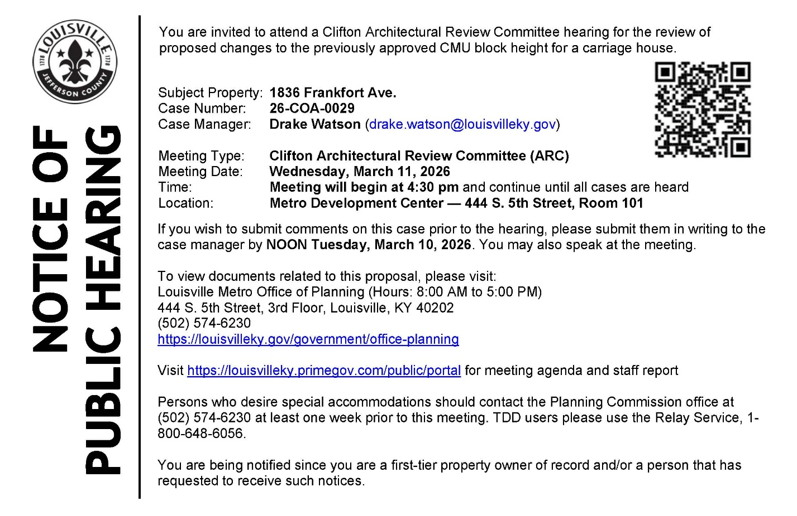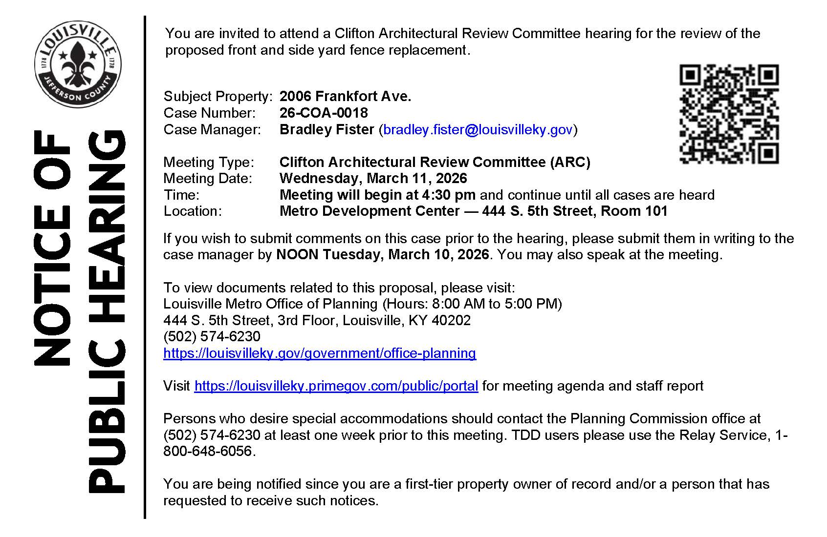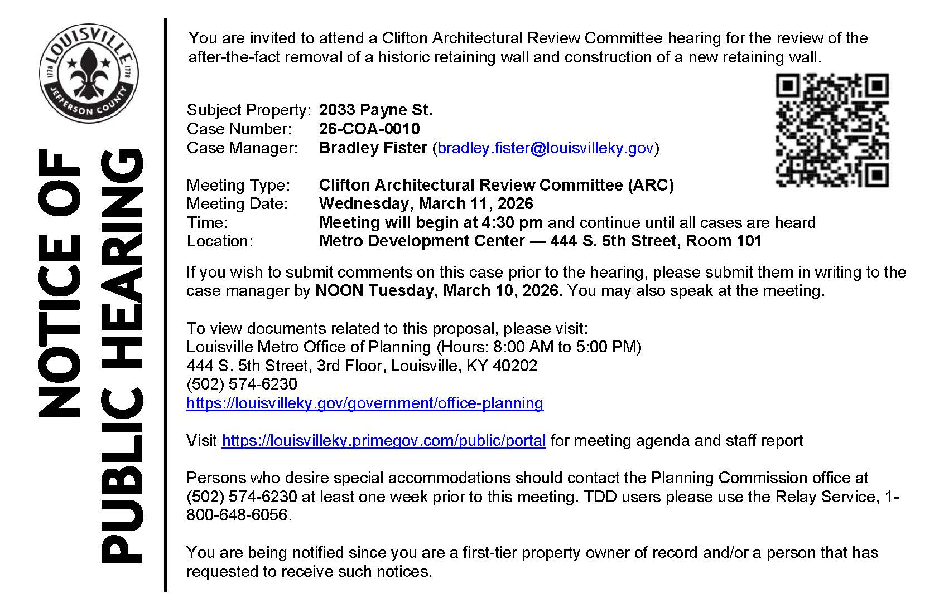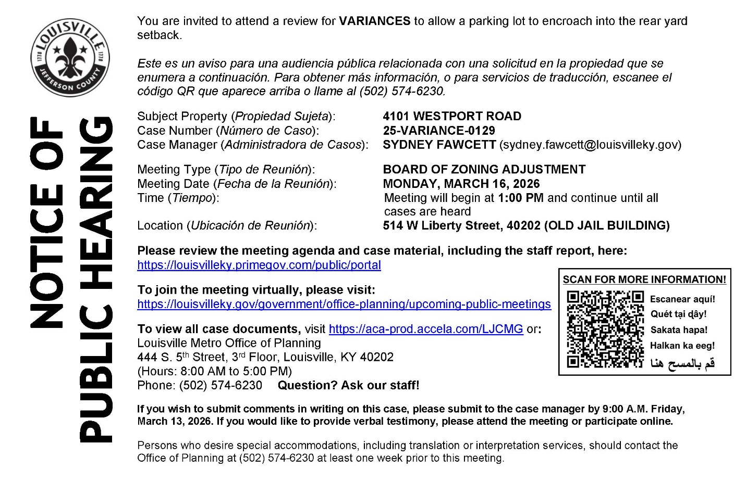
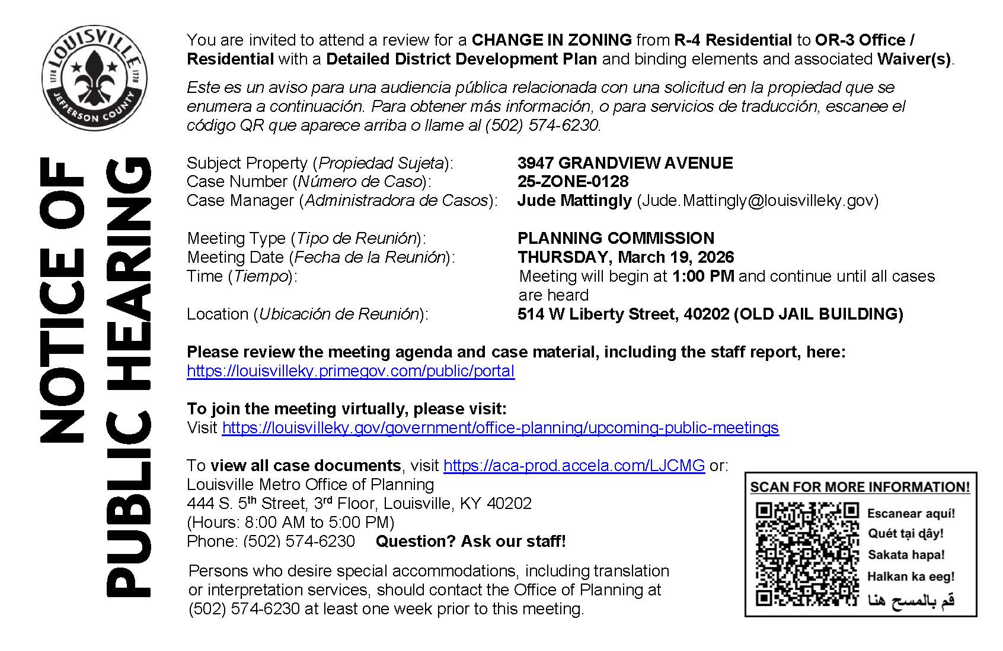
------------------------------------------------------------------------------------------------------

Alcoholic Beverage
Ad Date: 02/15/2026 | 30-Day Date: 03/17/2026
Protest must be submitted by: LMPD Division 5TH DIVISION

PUBLIC NOTICE
Serai LLC, 2311 Frankfort Ave Louisville, KY 40206, Hereby declares intention(s) to apply for a NQ2 Retail Drink License and Special Sunday Retail Drink license(s) no later than February 13, 2026. The business to be licensed will be located at 2311 Frankfort Ave Louisville, Kentucky 40206. The owner(s) are as follows: Sebastian Moh, owner, 3403 Fayette Ave Louisville, KY 40213. Any person, association, corporation, or body politic, may protest the granting of the license(s) by writing the Department of Alcoholic Beverage Control, 500 Mero St 2NE33, Frankfort, Kentucky, 40601 , within thirty (30) days of the date of legal publication. February 15 2026 LSBN0459361
------------------------------------------------------------------------------------------------------

District 9 Events

- Thursday, March 5, 2026 - 7:00pm: Danica Novgorodoff presents A Better World is Possible https://www.carmichaelsbookstore.com/event/danica-novgorodoff-presents-better-world-possible

- Tuesday, March 10, 2026 - 7:30pm: Markus Zusak Celebrates 20 Years of The Book Thief https://www.carmichaelsbookstore.com/event/ticketed-markus-zusak-celebrates-20-years-book-thief

- Wednesday, March 11, 2026 - 7:00pm: Mitchell L. H. Douglas discusses Universal Corner with Erin Keane https://www.carmichaelsbookstore.com/event/mitchell-l-h-douglas-discusses-universal-corner-erin-keane

- Wednesday, March 18, 2026 - 6:00pm: Katherine Applegate presents The Littlest Elephant https://www.carmichaelsbookstore.com/event/katherine-applegate-presents-littlest-elephant

- Saturday, March 21, 2026 - 3:00pm: Shannon Stocker presents The Roach King of Raleigh https://www.carmichaelsbookstore.com/event/shannon-stocker-presents-roach-king-raleigh

- Thursday, March 26, 2026 - 7:00pm: Zoë Slaughter presents Invisibly Allergic https://www.carmichaelsbookstore.com/event/zo%C3%AB-slaughter-presents-invisibly-allergic

- Saturday, March 28, 2026 - 9:00am-7:00pm: Unicorn Day at Carmichael's Kids https://www.carmichaelsbookstore.com/event/unicorn-day-carmichaels-kids

- Community Book Club: Monday, March 30-The Confidante by Christopher C. Gorham https://www.carmichaelsbookstore.com/event/carmichaels-community-book-club-44
- Banned Books Club: Monday, March 16- The Catcher in the Rye by J.D. Salinger https://www.carmichaelsbookstore.com/event/carmichaels-banned-books-club-12

