Louisville Metro Council
District 9 eNews | February 19, 2026

From the Desk of Councilman Owen
I certainly appreciate the frustration that has been shared with my office by our neighbors about the recent snowstorm and the lack of salt treatment and plowing on side streets, sidewalks, and alleys. I thought I would take this opportunity to share some facts and a bit of perspective.

First, seasonal sidewalk maintenance, which includes snow and ice removal, is the responsibility of the adjacent property owner, not Metro Government. That includes homeowners in residential areas and business owners along commercial corridors. In addition, if there is a slip and fall incident on the sidewalk in front of your house or business, the potential liability could be borne by the responsible party.

Second, if you are lucky enough to live on or have a business located on a snow emergency route or on a street that has been prioritized for one reason or another to be included on the Metro Snow Map, when the plow comes through to clear the roadways, the adjacent homeowner or business owner is responsible for clearing the “wall” of plowed snow that gets pushed in front of the driveways and curb cuts. There is simply no way around it. Also, if you park on one of the streets that is scheduled to be plowed, it is your responsibility to either move your car to a safer location or be prepared to dig your car out from under the snow that is inevitably plowed into it. Again, not ideal, but there is no way around it.

Third, I want to reiterate that Metro government is simply not currently built to treat and/or plow every street in our county, much less all of the alleys behind houses and businesses in the old urban services district. The responsibility to clear the streets and alleys and the potential liability ultimately falls on Metro government, but we simply do not currently have the resources or personnel in place to take care of it. We also understand that not clearing the side streets and alleys will likely have a significant negative impact on Metro Government’s ability to collect garbage and recycling but again, we simply don’t have the resources within Metro Public Works to do it all.

To be fair, this has always been the case. We have never allocated adequate resources in the annual Metro budget to prepare for these types of winter events. And other than a few memorable years, 1978, 1994, a couple of years in the early 2000’s, etc., it has never been a problem. The truth is, never in our modern history have we had large snow events like we have in the last two years followed by weeks of below freezing temperatures.

With that said, as a community, we are going to have to make the determination if the last two winters are the new normal, and, if we anticipate we are going to regularly have winter events similar to the upper Midwest, or whether these events are going to remain sporadic and rare. At this point, while I am prepared to recommend additional money is allocated in the next Metro budget to pay for supplemental contractor assistance, I am not prepared to support purchasing millions of dollars of equipment and adding personnel to the snow team that may never be used. If we have learned anything from climate change, we have learned to expect extreme weather, yes, but also to expect the unexpected. That could just as easily show up as months of Arctic temperatures as nary a flake shall fall.

I'm sure that is will be an ongoing conversation at Metro Council and in the community between now and May, when we debate and pass the FY 2027 budget.

Metro Council office worked with the administration and revisited our snow maps and routes after last winter and made some significant improvement over the year before Thanks for reaching out.

The Book Works Open House at Shelby Park Community Center
The Book Works open house at Shelby Park Community Center has been moved to February 20 from 3:00–6:00 p.m. Discover exciting new programs for youth and families, enjoy refreshments, participate in a community art project, and take home free books! Don’t miss this opportunity to connect and learn more about The Book Works.

New Meeting Added to Talk About Truck Traffic in Louisville
Louisville Metro’s Department of Transportation will host an additional public meeting to gather community feedback as part of the Freight Mobility Action Plan.
The open house-style meeting will take place on Tuesday, February 24, from 5 to 7 p.m. at the Edison Center, 701 W. Ormsby Avenue. This session provides another opportunity for residents to share their experiences and concerns related to truck traffic in their neighborhoods. Attendees may stop by at any time during the meeting to participate in informal, conversational discussions with the project team.
The Freight Mobility Action Plan is being developed in partnership with HDR Engineering, Inc. The plan aims to better understand how freight movement interacts with neighborhoods and to identify action steps that support a preferred freight network across Jefferson County while reducing impacts to residential areas.
For those unable to attend in person, the online public survey has been extended through March 6. Feedback collected through the meeting and survey will help shape safer, more efficient truck routes and reduce disruptions to neighborhoods across Louisville Metro.
The survey can be accessed here:
https://www.surveymonkey.com/r/JB6NFNN
Residents are encouraged to participate and help inform the future of freight movement in Louisville.
Inaugural Black History Gala — February 28, 2026
Join us for the Inaugural Black History Gala, an elegant black-tie evening designed to intentionally close out Black History Month with reflection, celebration, and legacy. Hosted at Roots 101, this unforgettable experience will feature a red carpet arrival, special guests, and a powerful celebration honoring Black history — past, present, and future.

Community members are invited to gather, reflect, and celebrate the legacy being built today in a space rooted in culture, excellence, and connection.

🎟 Tickets are available at: www.RegMorganDesigns.com
📅 February 28, 2026 |📍 Roots 101 Museum

Music for a Purpose Concert Series
Founded in 2022, Music for a Purpose produces musical performances that benefit local charities. To date, we have raised nearly $40,000 for organizations including The Healing Place, Louisville Nature Center, Olmsted Parks, Maryhurst, Center for Women and Families, Louisville Climate Action, and this program for the Louisville Urban League. Our concerts are funded through grants and fundraising, allowing them to remain open to the public for a donation to the featured charity.

Aliens – Are They Real?
Monday, March 2, 6:30– 7:30 PM
Aliens. Are they real? Are they here? Are we alone? Join NASA/JPL Solar System Ambassador Dan Price for a facts-based discussion of alien life. We’ll investigate the evidence, discuss the science, and look at the possibility for life across the Universe.

International Women's Day Breakfast Briefing: The Power of Her
Saturday, March 7, from 9am
Americana’s International Women’s Day Breakfast Briefing brings together leaders, partners, and community members for a morning of dialogue and collaboration. This gathering honors the resilience, leadership, and contributions of women across cultures while recognizing International Women’s Day as a global call to advance gender equity. The program will elevate the voices and experiences of immigrant and refugee women and focus on strengthening collective efforts to expand access to opportunity and inclusion.

Click Here for Tickets

Metro Career Fair 2026
Louisville Metro Government continues its push to find individuals eager to give back to their community by hosting a career fair allowing the public to interact with over 25 Metro Government departments looking to fill over 55 vacant positions. The event will be held on Tuesday, March 10, from 10 a.m. to 3 p.m. at Louisville Slugger Field, 501 East Market Street.

Ernestine Booth-Henry, Director of Human Resources for Metro Government, is happy to allow the public to meet face-to-face with representatives of every Metro Government department. “We have so many different agencies doing so many good things for our community, that everyone will be able to find a career opportunity that fits their experience level and life interests,” she said. “And when you consider how Metro Government touches the lives of every person in Louisville in so many ways, a career with Metro provides far more than just a job opportunity. It’s a way to live a life of service.”

The ElderBloom Trio at United Crescent Hill
📅 Thursday, March 12 | ⏰ 10:30 – 11:00 PM | 📍 150 S. State Street Louisville, KY 40206

MinistriesFeathers and Friends Gala
SAVE THE DATE - MARCH 21 - Harbor House is proud to kick off our Annual Ken-Ducky Derby season with our signature Feathers and Friends Gala—a celebration that directly supports our mission of serving children, adults with disabilities, and seniors through inclusive, community-based programs. Every dollar raised helps Harbor House provide life-enriching care, meaningful opportunities, and lifelong support for individuals and families across our community.
This year’s event will be hosted at Harbor House, 2233 Lower Hunters Trace, Louisville, KY 40216, and promises to be a night to remember. Guests will enjoy an immersive evening filled with Ducks & Diamonds, a speakeasy atmosphere, cigars, bourbon tastings, great music, and even better company. With a silent auction and a unique experience in every room, this unforgettable night sets the tone for a season of impact.
Get your tickets today: https://one.bidpal.net/feathersandfriends2026/welcome

This Year's First Pop-Up Drop-Off Event Announced!
Louisville Metro's first Pop-Up Drop-Off event of the year is right around the corner, and we want to make sure you have the official information. Please share the graphic below with friends, neighbors, and community groups.
We're thrilled to announce a new addition for 2026: Goodwill Kentucky will be on-site collecting gently used textiles and household items. It you've still got the bag of donations sitting in your trunk, this is the perfect chance to finally give those items a second life.
These events are designed to be a one-stop-shop for responsible decluttering - recycling, donating, and proper disposal all in one place. And your participation truly makes a difference. Last year, Pop-Up Drop-Offs achieved a 53% diversion rate, keeping more than half of all collected material out of the landfill. That's momentum worth building on.
As we kick off a new year, we're encouraging residents to embrace a reduce and reuse mindset rather than a throw-away one. Reducing waste starts long before items reach the curb or a Pop-Up Drop-Off - by choosing durable products, avoiding unnecessary purchases, and being mindful consumers. Every item donated, recycled, or avoided in the first place helps reduce waste and supports a cleaner, more sustainable Louisville.
We can't wait to see you at a Pop-Up Drop-Off this year! Join us at Sun Valley Park and Ashby Lane Baptist Church on March 21, 2026 for the first one. And mark your calendars for the second one at UofL Shelby Campus on April 4!
Invitation to Participate in Congressman McGarvey's Congressional Art Competition
COMPETITION: The Congressional Art Competition is an officially sanctioned bipartisan event designed to encourage the artistic talents of high school students nationwide. Winning artworks from each congressional district hang in the Cannon Tunnel of the U.S. Capitol for one year. With millions of visitors passing through the Capitol each year, the exhibition is among the most viewed student art displays in the country. For the KY-03 competition, a runner-up Community Winner will have their artwork displayed in Congressman McGarvey's Louisville office for one year.
ELIGIBILITY: This competition is open to all high school students residing in KY-03 between grades 9-12. Students should participate in the art competition taking place in the district where they reside, not where they attend school. You can find your Member of Congress here.
OVERVIEW: The competition is hosted online with public voting for the winning artwork. Two winners are selected - an overall winner and a community winner. The overall winner will receive two roundtrip tickets to Washington, D.C., to attend the national award ceremony and have their artwork displayed in the Cannon Tunnel of the U.S. Capitol for one year. A runner-up community winner will also receive prizes including having their artwork displayed in the Louisville office for one year.
INSTRUCTIONS:
- Review the 2026 Rules and Regulations BEFORE submitting.
- Review submission instructions and required paperwork on our website, including the Student Information and Release Form.
- Fully complete this form by March 29, 2026, at 11:59 PM ET to enter the 2026 Congressional Art Competition. Submissions are only accepted through this form. Your artwork does not need to be framed to enter the competition. Only the winning pieces will need to be framed.
- You may enter multiple pieces into the competition. Please submit one form for each entry.
- AI generated artwork is strictly prohibited. Students may not collaborate on an entry.
KEY DATES:
- Submission form opens: February 2nd
- Deadline for submissions (completing this form): March 29th by 11:59 PM ET
- Public online voting portal opens: March 31st
- Public online voting portal closes: April 23rd at 12 PM ET
- Overall and Community Award winners notified: April 28th
- Louisville award ceremony for both winners: TBA
- Washington D.C. award ceremony (Overall Winner only): June 25th (Winner and ONE GUEST may attend the national celebration. Roundtrip airfare for two provided. Winner is responsible for hotel accommodations and all D.C. related expenses such as excursions, transportation, meals, etc.)
Please contact ArtCompKY03@mail.house.gov or 502-582-5129 with any questions.
kNOw Waste Helps Louisville Businesses Waste Less and Do More
Are you looking to improve your waste management practices and reduce your environmental impact? kNOw Waste Louisville's Education Team is here to help!

Our Business Outreach Program offers free, hands-on support to help local businesses reduce waste, start or improve recycling, and work toward sustainability goals.

What we offer:
- Free waste audits: We’ll assess your current waste practices and identify opportunities to reduce, reuse, and recycle more effectively.
- Customized strategies: Whether you're starting from scratch or fine-tuning an existing program, we’ll help design tailored waste, recycling, and composting solutions that fit your operations.
- Staff training and educational materials: We provide on-site or virtual training sessions and easy-to-understand materials to engage your team and build lasting habits.
- Sustainability support: From setting goals to tracking progress, we’re here to help you meet your environmental commitments.

Why it matters:
Better waste management isn’t just good for the planet—it can also save your business money, improve workplace efficiency, and show your customers you care about sustainability.

Let’s work together to make Louisville cleaner, greener, and more sustainable—one business at a time.

📩 Ready to get started? Fill out this form.

Expanding Access to Naloxone, Strengthening Community Care
Louisville Metro Department of Public Health and Wellness’ Quick Response Team (QRT)is deepening its partnership with Louisville Metro Emergency Medical Services (EMS) to put lifesaving tools directly into the hands of residents when they need them most.
Last October, QRT and EMS launched a new naloxone leave-behind program. The program allows EMTs responding to an overdose to not only administer naloxone during an emergency, but also leave additional doses with patients and their loved ones for future use. This makes sure families have immediate access to overdose reversal medication if another emergency occurs, said QRT’s Community Health Supervisor Cillian Browne.
“This project is enabling someone to receive the lifesaving overdose reversal medication immediately after the incident occurred, which could mean restocking naloxone that was just used, or simply providing people who do not know about naloxone and showing them how to use it,” he said. “For many loved ones, an overdose can happen unknowingly, so providing them with the tools and education can really help.”
Since the program began, QRT has provided 100 units of naloxone to Metro EMS. In just two months, 50 units were distributed, demonstrating the urgent need for accessible overdose prevention tools in the community. At this pace, another 50 units are expected to be distributed this month, he said.
Beyond the numbers, the program is about care, dignity, and prevention. Overdoses often happen unexpectedly, and loved ones may not know how to respond. By leaving naloxone behind and explaining how to use it, EMTs are empowering residents with both the medication and the knowledge that can save a life.
“One of the big takeaways is witnessing the connection that is taking place between EMS and our residents. They are actively working to continuing to build trusting relationships with a population of folks who often feel judged and stigmatized,” Brown said. “EMS chose to take this opportunity to patiently connect with our residents while conducting their runs because they are people who genuinely care.”
Emergency Alerts and Preparedness
Sign up to receive emergency alerts on your cell phone! Text "LENSAlert" to 67283
Sign up for alerts in your language here
Download Louisville’s Official Emergency Preparedness App

Faster Hepatitis C Testing Streamlines Access to Care
Kentucky has one of the highest rates of Hepatitis C (HCV) in the United States, with over 2,000 new cases reported annually in Louisville. In response, our Harm Reduction Outreach Services (HROS) is enhancing the city's approach by launching on-site PCR testing to identify active HCV infections, which impact liver function.
Recently, HROS began utilizing the Cepheid HCV Xpress system detects active HCV from a simple fingerstick blood sample, providing results in approximately 50 minutes. Participants can receive clear health information and connect with care during a single visit.
“This resource allows our team to inform participants if there is any active Hepatitis C virus in their blood,” said HROS Community Health Manager Lauren Passmore. “This enables us to provide concrete health information and direct access to healthcare resources to meet their needs.”
Using this new testing system shortens wait times and increases access to critical treatment for HCV, Passmore said. Many people may have HCV but not show symptoms, making testing vital. Early intervention can help protect liver health and decrease the likelihood of transmission.
For more information about our Harm Reduction Outreach Services, please visit our webpage.
What Do Those Restaurant Letter Grades Mean?
Click here or the image above to view our YouTube video
Going out to eat? Diners can learn from our health inspectors how scores are calculated based on cleanliness, food handling, temperature control, and safety practices.
Each week, our videos highlight what A, B, and C grades mean at your favorite Louisville restaurant. This week, our health inspectors explain how restaurants earn an A rating.
You can also go to our dashboard to learn more about the restaurant inspection scores at local dining spots.
Knowing CPR Can Prevent a Heart Crisis and Safe a Life
February is recognized as American Heart Month, serving to increase awareness about cardiovascular disease, the leading cause of death in the United States, and to promote heart-healthy habits. Established in 1964, this observance encourages people to manage risk factors such as high blood pressure and cholesterol through diet, exercise, and regular check-ups.
The American Heart Association has set a target to double the survival rate from cardiac arrest by 2030. To save more lives from the approximately 350,000 cardiac arrests that occur outside of hospitals each year, it is crucial to enhance the number of individuals who respond to these emergencies by calling 911, providing high-quality CPR, and using an AED as soon as it becomes available.
In cardiac emergencies, the initial responder is often an everyday bystander rather than a uniformed professional. Cardiac arrest can happen anywhere, such as at the gym, in grocery stores, or during children's sports events. However, bystanders only intervene about 40% of the time, often due to uncertainty or lack of training.
It is not necessary to have medical training to save a life; what is needed is knowledge, courage, and the willingness to act.
Joining the Nation of Lifesavers is easier than ever with many learning options
- Learn CPR today so you are ready.
- Watch a 60-second video to learn Hands-Only CPR.
- Find a Heartsaver Training nearby
-- Source: American Heart Association
Research Opportunity for Parents and Children (Ages 3–12)
The University of Louisville’s College of Arts & Sciences is seeking parents and their children ages 3–12 to participate in an engaging two-visit research study. During the first visit (1.5–2 hours), parents will complete questionnaires while children take part in fun, game-based activities. The second visit (1–1.5 hours) includes a child-friendly brain-imaging session while children play additional games.

Participants can earn up to $80 for completing both visits. To learn more or begin the screening process, visit bit.ly/ANDLabScreener or scan the QR code provided in the flyer.

For questions, contact the research team at 502-852-9773 or andlab@louisville.edu.

Louisville Home Repair Hotline
The Louisville Home Repair Hotline, powered by Metro United Way, screens Jefferson County homeowners for possible assistance for home repairs. Free, anonymous, and confidential, the hotline shares details about home repair resources, reviews eligibility to receive services, and matches those in need with those who can help.
Call 211 or visit metrounitedway.org/211 and fill out the online form to see if you qualify for free home repairs.
You may also email questions to 211housingneeds@metrounitedway.org
The Dot Experience Update
There are several exciting updates for The Dot Experience! The groundwork has been completed for the new front sidewalk leading from the building entrance to Frankfort Avenue. The updated design features a straight, welcoming path through the front lawn that connects directly to the public sidewalk.

Inside, progress continues in the restrooms, where new tile has been installed in a striking contrast of dark walls and light floors. The new office areas are also taking shape, highlighted by the newly installed storefront glass.

Exciting progress is happening throughout!

MSD N. Galt Avenue Project
An MSD contractor will be investigating the stormwater drainage line on N. Galt Avenue this week — starting on Thursday — following a delay to the work that was caused by thick ice brought from the recent winter storm. During the work, traffic will once again go down to one lane near the railroad tracks, close to where N. Galt meets Frankfort Ave.

Will keep you all posted on further updates.

Winter Pause for Paving Operations
As temperatures drop, the Louisville Metro Department of Transportation is pausing paving operations for the winter season. Cold weather and moisture prevent asphalt from bonding and curing correctly, which can lead to weak pavement and shorter roadway life.

By waiting for warmer, more stable conditions -- our crews can ensure that new pavement is durable, long-lasting, and safe for everyone who travels our streets.

We appreciate the community’s patience and look forward to resuming paving work as soon as weather conditions allow. PAVING

Help Us Smooth the Ride — Report A Pothole
Four snow events this season, repeated freezing and thawing, and winter road treatments have taken a toll on Louisville Metro streets. These harsh conditions weaken pavement and lead to potholes.

In 2025 alone, Louisville Metro's Department of Transportation has filled more than 48,860 potholes.

Reporting potholes helps crews respond more quickly, keeping roads safer and smoother for everyone throughout the winter months.

You can report potholes by:
- Filling out the online form at LouisvilleKY.gov
- Using X (previously Twitter) by sending the location to @LouMetro311 and including #502pothole
- Calling Metro311 or 502-574-5000 to report potholes or other service issues

REMINDER: 2026 Winter Yard Waste Collection Update
Solid Waste Management Services will pause yard waste collection beginning the week of January 19. Regular curbside pickup will resume the week of March 23.

During this temporary suspension, all Jefferson County residents may bring their bundled yard waste to the Waste Reduction Center, located at 636 Meriwether Ave., where it can be dropped off free of charge.

This seasonal adjustment allows the Solid Waste team to use time and resources more efficiently while significantly less yard waste is generated during the winter months.

Key details
- Collection paused: Week of January 19
- Collection resumes: Week of March 23
- Free drop-off location: Waste Reduction Center, 636 Meriwether Ave.

Solid Waste Management Services appreciates the community's cooperation and commitment to keeping our city clean and sustainable

Metro Public Works is Hiring!
Serve the Louisville community through a rewarding public service career! The department of Louisville Metro Public Works is currently hiring.

IMPORTANT! The link below is for all of Metro jobs currently open. To learn about career opportunities specifically in Public Works, once you've clicked the link, follow these three easy steps:
- Click the filter tab
- Click "Departments"
- Click "Public Works" on the dropdown menu

https://www.governmentjobs.com/careers/louisvilleky

-------------------------------------------------------------------------------------------------------Public Hearings, Meetings, & Applications
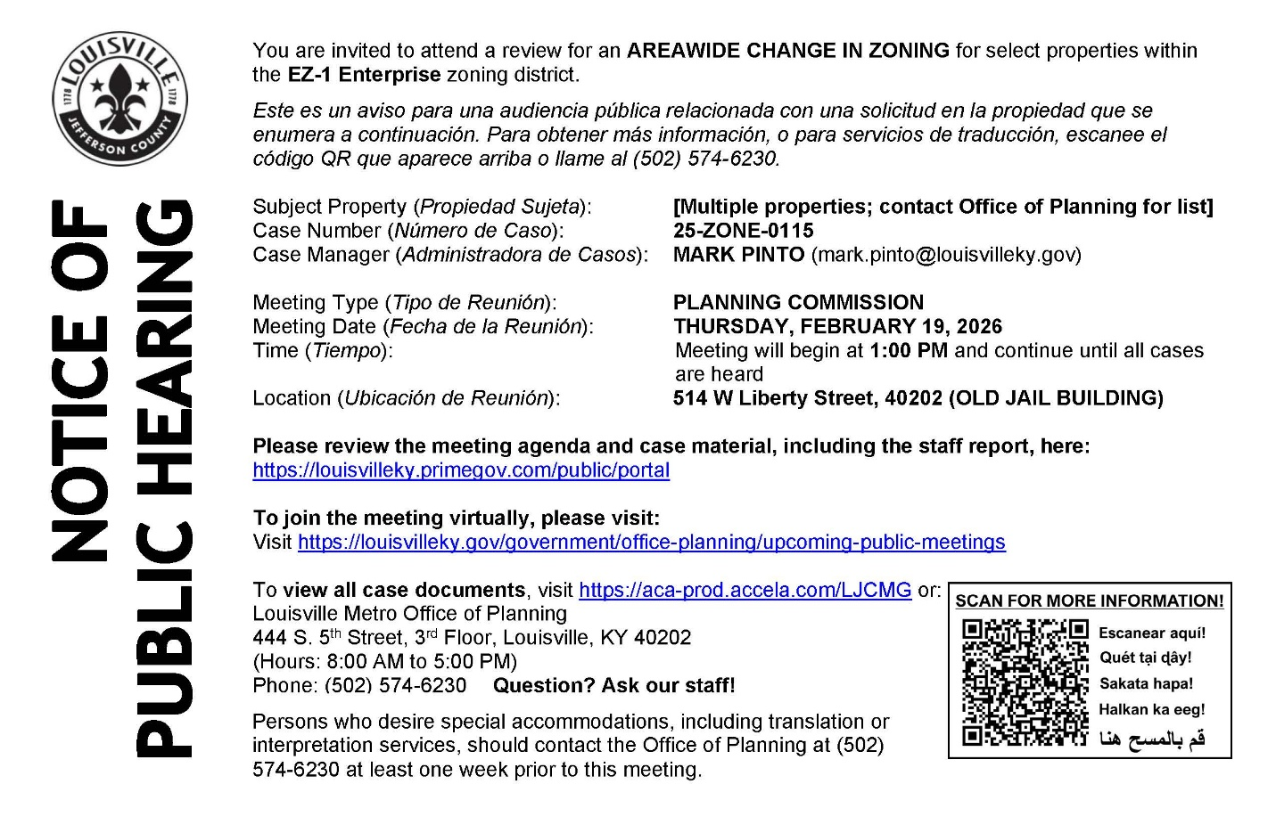
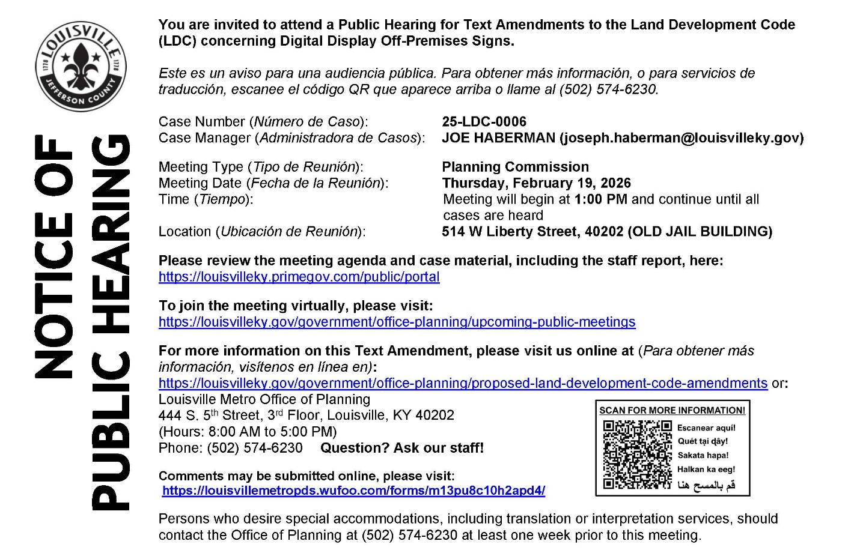
------------------------------------------------------------------------------------------------------

------------------------------------------------------------------------------------------------------

District 9 Events

Thursday, February 19, 2026 - 6:30pm: Butler Books Black History Month Celebration with Emma McElvaney Talbott, Michael L. Jones, and Ken Clay. https://www.carmichaelsbookstore.com/event/black-history-month-celebration-emma-mcelvaney-talbott-michael-l-jones-and-ken-clay

Monday, February 23, 2026 - 7:00pm: Carmichael’s Community Book Club. February's pick is Everything is Tuberculosis by John Green. https://www.carmichaelsbookstore.com/event/carmichaels-community-book-club-43

Thursday, February 26, 2026 - 7:00pm: Julie Marie Wade and Paul Griner Book Discussion. https://www.carmichaelsbookstore.com/event/julie-marie-wade-and-paul-griner-discuss-other-peoples-mothers-and-book-otto-and-liam
Friday, February 27, 2026 - 7:00pm: David Dominé presents A Dark Room in Glitterball City.
https://www.carmichaelsbookstore.com/event/david-domin%C3%A9-presents-dark-room-glitter-ball-city

