Louisville Metro Council
District 9 eNews | December 11, 2025

Hello, December.
Hello, December ❄️✨
The twelfth month is here — the grand finale of 2025! December isn’t just about endings, it’s about sparkle, joy, and setting the stage for what’s next. It’s a month of cozy lights, festive gatherings, and the excitement of turning the page to a brand-new year.
Let’s use this time to celebrate how far we’ve come, embrace the magic in the everyday, and step boldly into the future with hope and possibility. Here’s to closing out 2025 with cheer and opening the door to 2026 with confidence and joy!

Snow Team Responds to First Significant Winter Weather Event of the Season
Louisville Metro’s Snow Team responded to the first significant winter weather event of the season this week, after 3 to 4 inches of snow, mixed with rain and sleet early on, fell across the city Monday night into Tuesday morning.

Ahead of the storm, 14 Snow Team trucks pretreated nearly 500 miles of roadway with brine, focusing on high-traffic corridors and known trouble spots. Brine is a liquid mixture of salt and water sprayed onto pavement before a storm. It helps prevent snow and ice from bonding to the road surface, making plowing and salting more effective once precipitation begins.

Monday evening, crews began salting Louisville Metro’s 111 designated snow routes. As conditions shifted from a wintry mix to heavier snow, they moved into plowing and continued working through Tuesday. Snow fighters stayed on duty into the evening to keep treating streets and help prevent ice from forming overnight as temperatures dropped.
Wednesday our East, West, and Central Roads Districts continued to monitor conditions and respond to any issues that developed.

Louisville Metro’s Snow Team includes more than 200 staff members from Public Works (Louisville Department of Transportation and Solid Waste Management Services), Louisville Parks and Recreation, Fleet Services, Codes & Regulations, and Emergency Services. The team is made up of equipment operators, dispatchers, mechanics, communications staff, and support personnel who all play a critical role during winter weather.

When a snow event hits, they work around the clock -- rotating in 12-hour shifts -- to treat and clear approximately 2,750 miles of roadway across Louisville Metro, while also communicating timely updates to help keep residents informed.

A big thank-you to our Snow Team for working tirelessly before, during, and after the storm to keep Louisville’s roads safe. The hard work and long hours you put in, doesn't go unnoticed!

More Winter Weather on the Way: What Louisville Metro Residents Need to Know
Winter weather is expected to return to the Louisville Metro area, with the possibility of light snow showers tonight and more significant precipitation Thursday night into Friday. This could create slick conditions for the Friday morning commute.

Louisville Metro’s Snow Team and our partner agencies are already in communication and prepared to respond. Crews are ready to treat and plow Metro roadways as needed, depending on how conditions develop.

Where to find updates during a snow event
During winter weather, residents can find timely updates on:
- The Louisville Metro Snow Removal webpage at LouisvilleKy.gov/snow
- Our social media platforms: Facebook, Instagram, and X
These channels will share information on route progress, safety reminders, and any operational changes throughout the event.

How snow routes work
Louisville Metro Snow Team crews maintain 2,750 miles of roadway, divided into 111 designated snow routes. These routes focus on roads that carry the most traffic and connect residents to:
- Major employment centers
- Neighborhoods
- Schools
- Medical facilities
- Hospitals

Because Metro resources must prioritize these key corridors, neighborhood streets and roads not included in Metro’s designated snow routes are not plowed or treated by Louisville Metro crews.

During a snow event, you can track salting and plowing progress on our Snow Map.

If you live in a suburban city or municipality
Many suburban cities within Jefferson County manage their own snow removal operations. If your street is not part of a Metro snow route and you live in a city such as St. Matthews, Middletown, Jeffersontown, Lyndon, or other municipalities, snow and ice removal may be handled by your local public works team. Residents should check with their local city hall or public works department to learn how snow removal is handled in their area.

State-maintained roadways
Interstates and associated ramps are treated by the Kentucky Transportation Cabinet (KYTC). For statewide winter weather updates and highway conditions, visit:
SnowKY.KY.gov

Winter Weather Awareness Week: Stay Ready, Kentucky
This week (December 7 - 13) marks Winter Weather Awareness Week in Kentucky, a statewide effort to encourage preparedness for the many hazards winter can bring.
Winter isn’t just about snow — it can bring snow squalls, ice storms, freezing rain, heavy rain and flooding, high winds, and even occasional severe weather. The goal of this awareness week is to remind everyone to stay “Weather Ready” for all types of hazards.

What this means for Louisville Metro
- Two snow events have already impacted Louisville Metro this season, highlighting how quickly winter weather can arrive.
- During active winter weather events in Kentucky, the National Weather Service (NWS) may issue alerts such as:
  - Winter Weather Advisories for up to 4 inches of snow or combinations of snow, sleet, or freezing rain.
  - Winter Storm Watches/Warnings when more serious accumulations or storm conditions are expected.

These alerts serve as an early reminder to prepare homes, vehicles, and families for potential winter impacts.

How to be weather ready
During this week — and throughout the winter season — residents are encouraged to:
- Keep a winter emergency kit in your car (flashlight, blanket, extra clothes, etc.).
- Ensure your home is prepared (check heating systems, insulate pipes, test detectors).
- Plan safe travel — check the forecast, use caution on roads, and allow extra time for trips when weather turns cold or slick.
- Stay informed: follow updates from the NWS and sign up for LENSAlert to receive emergency notifications.

Learn more about how to be weather ready on the National Weather Service's webpage found on weather.gov.

For more tips and local resources visit "Mayor Greenberg's Snow Resource Page".
Stay prepared, stay warm, and stay safe this winter — because when winter weather arrives, readiness makes all the difference.

Understanding Louisville Metro’s Snow Routes and Snow Map
When winter weather arrives, one of the most common questions we receive is: “When will my street be plowed?”

Louisville Metro’s Snow Map is the best resource for residents to check snow route coverage and monitor treatment progress during a storm.

What are snow routes?
Louisville Metro treats and plows only the roads included in our 111 officially designated snow routes. These routes are selected because they carry the highest traffic volumes, connect neighborhoods to major corridors, and provide access to hospitals, schools, emergency services, and major employers.
Neighborhood streets and private roads are not part of Louisville Metro’s snow routes, and interstates and ramps are maintained by the Kentucky Transportation Cabinet (KYTC).
If your street isn’t on a Metro snow route and you live within a suburban city or municipality in Jefferson County, snow removal may be handled by your local government. Residents should check with their city hall or public works department for specifics.
Residents whose streets are not included should also consider planning ahead with neighbors, homeowner associations, or property managers to manage local snow and ice removal.

How to use the Snow Map
The Snow Map helps residents see which Metro routes have been treated or plowed during an active snow event.
Here’s how to use it:
- Visit louisvilleky.gov/snow and select “Snow Map.”
- Type your address into the search bar to see whether your street is part of a Metro snow route.
- View treatment progress; the map shows when a roadway on a Metro route was last treated or plowed.
- Keep in mind that a road marked as “plowed” does not mean it is fully clear or dry — especially if snow continues to fall or temperatures remain below freezing.
The Snow Map helps residents understand where crews are working, which roads are included in Metro’s responsibilities, and how snow operations progress during a storm. It also helps drivers make more informed travel decisions during winter weather.
For storm updates and to access the Snow Map, visit louisvilleky.gov/snow.

What’s New This Snow Season
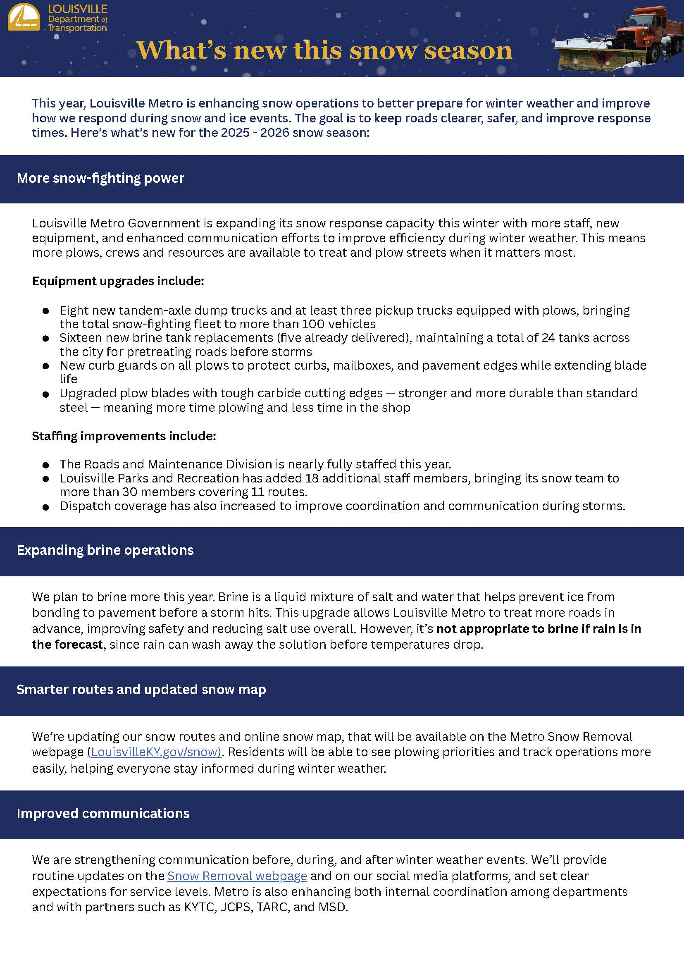
Public Works Helped Light Up Louisville for the Holiday Season
Public Works once again played a major role in bringing holiday cheer to downtown Louisville during Light Up Louisville. Before, during, and after the event, our teams worked behind the scenes to help make the city’s signature celebration shine.

It all began with the arrival of the Christmas tree. Public Works crews helped safely deliver the tree to Jefferson Square Park, setting the stage for the season. From there, our Electrical Maintenance Team hung between 20,000 and 25,000 lights on the tree itself, along with more than 100,000 additional lights throughout the park. Nearly every twinkling display had their craftsmanship behind it.

Our teams also blocked streets with our big orange trucks during Light Up Louisville to help keep everyone safe and to help traffic flow smoothly while the city celebrated.

Our Snow Team wrapped up the Lots of Lights Parade by rolling in with their highly decorated snowplows — featuring artwork from talented JCPS students.

This year's parade featured artwork from Brandeis Elementary and Coleridge-Taylor Montessori Elementary. Artwork from Carter Traditional Elementary and Klondike Elementary was unfortunately affected during the snow event the first week of December -- but we want to give a huge thank you to all the students who shared their creativity with us. Their designs brought joy to our Snow Team and helped brighten the season!

Join the Fun at Americana: Holiday Concert & Talent Show
Thursday, December 11th, from 5:00 p.m. to 7:00 p.m.

The community is invited to A Very Americana Holiday: Concert & Talent Show at the Americana World Community Center (4801 Southside Dr.). Enjoy youth performances, a holiday concert led by the Louisville Folk School, refreshments, and fun activities for all ages. This free event is open to everyone, with giveaways available while supplies last.

We will be at PetCo Friday December 11th
We will be at PetCo Friday December 11th

Petco and Louisville Metro Animal Services are teaming up for a festive Holiday Adoption Mash-Up and you’re invited to meet some of the sweetest adoptable dogs and puppies in town!

Bring the whole family and soak up the cozy holiday vibes as you meet dogs who are ready to head home just in time for the holidays. Even better? Every adoption fee is completely covered thanks to the generous support of Bissell Pet Foundation!
Expect wagging tails, fluffy faces, and lots of holly jolly cheer +++plus holiday tunes, cute photo ops, and staff & volunteers ready to help you find your match.

This is the perfect chance to give a pet the best gift of all: a loving home.
Come make a memory, save a life, and kick off the season with kindness. We can’t wait to see you there!

https://www.facebook.com/events/4107821002811790 (if you would like to share the event)

kNOw Waste: Thriftmas Is Here!
Celebrate the holidays with reuse and joy!

The holidays are upon us, and what better way to spread cheer than by choosing reuse over overconsumption? After all, we’ve already had a fabulous run this year: Secondhand September kicked things off, October brought us the Clothing Swap, and now December is shining bright with our newest tradition… Thriftmas! 🌟

What is Thriftmas?
You may be asking, “Thriftmas? What’s that all about?” Thriftmas is all about sustainable gifting — shopping secondhand instead of buying brand new. Whether it’s a cozy sweater, a quirky mug, or a vintage treasure, thrifted gifts carry more character, more thoughtfulness, and less impact on the planet.

Why Thriftmas matters
- Save money while still giving meaningful gifts.
- Reduce waste by keeping items out of landfills.
- Fight overproduction and overconsumption, which skyrocket during the holiday season.
- Avoid the landfill blues. Did you know many returned holiday items end up trashed instead of resold?
This year, let’s flip the script. Instead of contributing to the cycle of excess, let’s give gifts that tell a story, spark joy, and don't contribute to more waste.

🛍️ Local thrift and vintage treasures
Louisville is full of gems waiting to be discovered! Here are some fantastic spots to check out for your Thriftmas shopping spree:
- Fat Rabbit – eclectic finds for every personality
- Fleur de Flea – vintage vibes with flair
- Tickled Pink – quirky, colorful treasures
- What the LOU – local charm and unique gifts
- Barret Babes – trendy secondhand fashion
- Goodwill & St. Vincent de Paul – classics that never disappoint

Wrap it up with love
This holiday season, let’s celebrate not with piles of packaging and mass-produced goods, but with thoughtful, sustainable gifts that make both hearts and the planet happy. Thriftmas isn’t just a trend — it’s a movement toward mindful giving.
So grab your reusable shopping bag, put on your festive playlist, and head out to discover the magic of secondhand shopping. Who knows? The perfect gift might already be waiting for you on a thrift store shelf.
✨ Happy Thriftmas and Happy Holidays from the kNOw Waste Louisville Team! ✨

Contact Us

🎄 UCHM Community Holiday Party – Join Us! 🎅
Get ready for an evening of holiday joy at our UCHM Community Holiday Party! Bring your family and friends for a festive celebration filled with fun, food, and community cheer.

📅 Friday, December 12
⏰ 6:00pm–7:30pm
📍 150 State St., Louisville, KY 40206
Enjoy a variety of holiday activities including:
✨ Cookie decorating
✨ Arts and crafts
✨ Pictures with Santa
✨ Pizza, salad, and refreshments

This event is free and open to the community. We can’t wait to celebrate the season with you!

Christmas Connection Program – Help Make the Holidays Bright!
Each year, we partner with generous individuals, churches, and local businesses to provide holiday gifts, meals, and essential items to families in need right here in our community.

You can help make this season brighter by:
Making a financial contribution of $150 to support our Christmas Connection Program assistance

Learn more or sign up to give: www.uchmlouky.org

Donations accepted through December 12th at UCHM (150 S. State Street, Louisville) or online at uchmlouky.org/give

Santa Sprint & Stroll 5K — Sat., Dec. 20th at 9:00 AM (Cherokee Park)
Lace up for holiday fun that gives back! The 29th Annual Santa Sprint & Stroll 5K benefits UCHM’s mission to build a compassionate community through education, emergency assistance, health, wellness, and social activities. Register now—signups welcomed through race morning.

When/Where: Saturday, Dec. 20, 2025 @ 9:00 AM, Hogan’s Fountain (Cherokee Park)

Perks: Finisher medal, long-sleeve cotton-blend shirt (includes youth sizes), post-race refreshments, age-group awards, and photos with Santa.

Registration tiers: $30 (thru 12/19), $35 race day (12/20).

Register via the UCHM Events page: uchmlouky.org/events (click “Santa Sprint Information”).

Be a Sponsor: Sponsorships now open: Showcase your support and reach a community audience. Title, Gold, Silver, and Bronze packages available—and door-prize donations are welcome. Learn more and sign up at uchmlouky.org/santa-sprint-sponsor/.

Holiday Embroidery at Metro Arts Community Center
This beginner-friendly class is open to participants ages 10 and up! Make a small holiday themed embroidery project that can be used as an ornament on a tree or incorporated into any winter décor! All materials provided.

Tuesdays from 5:30PM -7:30PM | December 9th-16th

2025 Winter Break Camps
Looking for winter fun? Our Winter Break Camps are the perfect way to keep kids ages 5–12 active and creative during the holiday season! From games and crafts to outdoor play and new friendships, it’s all happening Dec. 29–Jan. 2 at community centers across Louisville. Registration is just $60. Sign up today by clicking here.

Free Weekly One-on-One Student Tutoring Announcement
Educational Justice offers free one-on-one tutoring/mentoring for 5th-8th grades across Jefferson County. It's mostly virtual, so transportation is not a problem. Last year, roughly 500 students participated, and saw significant grade-level gains.
Whooping Cough Cases Are Continuing to Rise
The Kentucky Department for Public Health (KDPH) has reported an increase in pertussis (whooping cough) cases in recent weeks. To date in 2025, there have been 566 reported cases across 93 counties in Kentucky, marking the highest total since 2012. Many U.S. states and other countries are also experiencing elevated levels of pertussis.

In Jefferson County, the number of pertussis cases is also on the rise:
- 2023: 2 total cases, 2 confirmed.
- 2024: 47 total cases, 39 confirmed and 8 probable.
- 2025 to date: 41 total cases, 36 confirmed and 5 probable.

Pertussis is a bacterial illness that causes severe coughing spells that can last for weeks or months. While the earliest symptoms of pertussis may resemble those of a common cold, the disease can become life-threatening, particularly for infants according to Dr. Kris Bryant, a pediatric infectious disease specialist and associate medical director for the Louisville Metro Department of Public Health and Wellness (LMPHW).

Dr. Bryant emphasized that three deaths is a significant number for any year and highlighted the heightened risk for infants.

“When pertussis cases go up, we expect to see cases in the most vulnerable people and that’s really infants,” said Dr. Bryant. “These young infants who died had not been immunized, and their mothers had not been immunized.”

Vaccination remains the most effective way to prevent pertussis. The vaccine for children is known as DTaP, while the booster for adolescents and adults is called Tdap. Both DTaP and Tdap provide protection against pertussis, as well as tetanus and diphtheria. Children generally begin receiving immunizations at 2 months of age, with a series of five doses completed by 4 to 6 years of age.

Dr. Bryant stressed the importance of keeping vaccinations up to date. “When children receive all recommended immunizations on time, our whole community benefits. High childhood vaccination rates help to create community immunity, which offers widespread protection against contagious diseases. By coming together to support immunization programs, our community can ensure that all children get the opportunity to grow up healthy and strong.”

The American College of Obstetricians and Gynecologists recommends all pregnant women should be immunized with every pregnancy to protect their babies.

The American Academy of Pediatrics recommends infants be immunized when they are 2 months, 4 months, 6 months and 12 to 15 months old. Children should be immunized before starting kindergarten. Teenagers should be immunized when 11 to 12 years old. Teens and adults should be immunized at least every 10 years or sooner if an injury occurs, or to protect a newborn.

Parents who do not have health insurance and wish to have their child vaccinated can contact the Louisville Metro Department of Public Health and Wellness at 574-5380 or visit our Immunizations webpage to schedule an appointment.

Call for Artists: Applications Now Open for The Eighth Annual Art in City Hall Exhibition
🎨 Now Accepting Applications!
Louisville Metro Council and Louisville Visual Art are calling for local artists to submit original two-dimensional works for the 8th annual Art in City Hall exhibition! Selected artists will have their work displayed throughout historic City Hall from February 2026–January 2027 and receive a $500 honorarium.
🔗 Apply by January 12, 2026: https://form.jotform.com/233044869578167
📄 More info: https://louisvilleky.gov/government/metro-council/art-city-hall-2026-2027

Mayor Greenberg Announces Two New Sumatran Orangutans Join the Zoo Family for the First Time in Nearly 30 Years
NOTE: media b-roll here and images attached: https://youtu.be/ZzOuxLpgRSs

Media availability will be 2 to 3 p.m. today for additional b-roll/visuals and sound.

LOUISVILLE, Ky. (December 4, 2025) – Mayor Greenberg and the Louisville Zoo are thrilled to announce the arrival of two new Sumatran orangutans — the first to join the Zoo in 28 years.

Meet Sumagu (sue MA goo), a 38-year-old female orangutan, and her seven-year-old daughter, Kera (care ah). Both come to Louisville from the Cheyenne Mountain Zoo.
After completing a standard quarantine and ongoing acclimation period, the pair are now rotating with the Zoo’s three other orangutans in the dayroom at the Islands habitat. When winter temperatures give way to spring, they will also be visible in the Islands’ outdoor habitats.

“I am delighted that families in our community will have new animals to enjoy, learn from and build memories with this winter and beyond,” said Mayor Greenberg. “The Zoo offers fun experiences and learning opportunities for all ages, and the fact that it’s open year-round makes it an even greater resource for our city.”

Currently, Sumagu and Kera will be exhibited together with the plan of joining the other two females, Bella and Amber eventually. The Zoo’s male orangutan, Segundo, will also be part of the habitat rotation, though males are typically solitary or occasionally paired with females.

The Zoo’s website will be updated daily to indicate when the pair can be seen in their habitat. Visit louisvillezoo.org/plan and check the animal viewing schedule for details.
Sumagu comes with a future breeding recommendation from the Association of Zoos and Aquariums (AZA) Orangutan Species Survival Plan (SSP) with our male, Segundo. Aimed at maintaining the genetic diversity of managed animal populations in human care, the SSP contributes to the conservation of this species.

“We are absolutely thrilled to welcome Sumagu and Kera to the Louisville Zoo family,” said Louisville Zoo Director Dan Maloney. “Both are gorgeous, and we encourage every member of our community to come see our newest residents. This is a great time of the year to visit the Zoo during Kroger’s Wild Winter Days running now through the end of February. Bring a canned food item and receive a discount.”

About orangutans
Orangutans are the largest arboreal mammals. They are the most socially solitary of the great apes. There are three species – Bornean, Sumatran and a recently identified Tapanuli.
The International Union for Conservation of Nature (IUCN) Red List of Threatened Species lists all three as critically endangered due to habitat loss with forests being extensively logged and converted to agriculture and palm plantations. All three species are listed as such.

Zoo Hours
The Zoo is open daily year-round. Now through March 20, 2026, hours are 10 a.m. to 4 p.m., with guests exiting by 5 p.m. The Zoo is closed on Thanksgiving, Christmas, and New Year’s Day. Visit louisvillezoo.org for more information.

Café LOUIE Is Coming Back!
Café LOUIE: Connect with Your Elected Officials
Café LOUIE is a free, informal event where community members can meet with their state and local elected officials to discuss important issues. All Metro and state elected officials are invited to participate, giving constituents an opportunity to ask questions, share concerns, and engage in meaningful conversations. Anyone is welcome to attend as a guest to meet officials and join the discussion.

How Café LOUIE Works
- Grab a cup of Heine Brothers coffee when you arrive.
- Write down your question(s) on a provided notecard.
- A trained facilitator will guide the discussion, ensuring officials have a chance to respond.
- Meetings start at 9:00 a.m. and are held at Louisville Free Public Library locations.
Learn more by watching this video: https://youtu.be/r3i6tU8A83I

Tap Here for More Information

Join the Next Cohort of Global Louisville Leadership Academy
The Global Louisville Leadership Academy (GLLA) is now accepting applications for its 2026 cohort. This free leadership training program, sponsored by the Louisville Metro Office for Immigrant Affairs, equips community leaders with the knowledge and networks to advocate for and support their communities. Participants will learn about city government, civic engagement, and leadership while building strong connections with local institutions. Deadline is January 9

Submit Your Application

Donations & Volunteers
United Crescent Hill Ministries (UCHM) is looking for volunteers and donations to support our Food Pantry and 60+ Adult Program.

Volunteer: Help stock the food pantry, do data entry, or spend time with our 60+ program.

🥫 Donate: We especially need canned foods with pop-top lids, canned meats, ready-to-eat pasta, and hygiene products.

Additional Food Pantry Needs:
Use of our pantry has surged, and with SNAP benefits not renewing for many neighbors next week, we expect even more visitors. Here’s how you can help right now:

Most-Needed Items: Canned meat, canned fruits/vegetables (pop-tops preferred) shelf-stable boxed milk, sugar, flour, jelly, coffee and tea, rice, pasta, pasta sauce, cooking oil, salt, pepper, basic spices, dish soap and period products

Please Avoid: Expired or opened food.

Drop off items Mon–Thurs, 9 AM–3 PM at UCHM, 150 S. State Street, Louisville.
Louisville, KY 40206

Give online: https://www.uchmlouky.org/get-involved/give/

Learn more: uchmlouky.org

Together, we’re building compassionate community one neighbor at a time.

Knowing The Right Number Can Make a Difference
Need help but not sure who to call?
- Text, call, or chat 988 for help with mental health, suicide, and substance use problems.
- Call 911 for emergencies involving immediate physical danger.

Understanding the appropriate number is vital.

Seasonal Affective Disorder: Tips Help You to Prep Your Body and Mind for the Dark Days of Winter
Courtesy of Johns Hopkins University

As the days shorten and daylight decreases, some individuals may experience feelings of sadness. While many people may feel the "winter blues," others might encounter a type of depression known as seasonal affective disorder (SAD).

The first step is to assess how significantly your symptoms impact your daily life.

Are your symptoms mild and have they persisted for less than two weeks?
- Feeling down yet still able to care for yourself and others.
- Experiencing some difficulty sleeping.
- Having reduced energy but still managing job, school, or household tasks.

Engaging in certain activities may help improve your mood:
- Participating in enjoyable activities.
- Spending time outdoors in natural light.
- Connecting with friends and family.
- Eating a balanced diet while limiting sugary foods.

If these activities do not provide relief or if symptoms worsen, consult a healthcare provider.

Do you have more severe symptoms that have lasted more than two weeks?
- Social withdrawal
- Oversleeping
- Gaining weight
- Craving foods with lots of sugar like cakes, candies, and cookies

Seek professional help
- Light therapy
- Psychotherapy (talk therapy)
- Medications
- Vitamin D supplements

If you or someone you know is struggling or in crisis, help is available. Call or text 988 or chat 988lifeline.org to reach the 988 Suicide & Crisis Lifeline. You can also visit our Community Mental Health Services webpage for a listing of mental health resources.
Are you looking for a wellness provider? Visit Mental Health Lou for a listing of local professionals.

Caregiver Research Study
If you care for someone with dementia, we'd love to talk with you about this one week study to better understand the physiological effects of caregiving. (Participants will be compensated)

You May be Eligible if....
- You care for someone with Dementia who is between 60-99 years old.
- The person with Dementia lives at home.
- You and your care partner speak English.
- You are comfortable using electronic devices.
For more information, click HERE

Make Food Safety Your Main Course (REMINDER)
Graphic and content courtesy of FDA.gov

Parties, family dinners, and gatherings with food are aspects of holiday celebrations. However, the enjoyment can turn into discomfort if food causes illness.

Common symptoms of foodborne illness, or food poisoning, include vomiting, diarrhea, and flu-like symptoms, which may appear anywhere from hours to days after ingesting contaminated food or drinks.

Typically, these symptoms are short-lived in healthy individuals, lasting a few hours or days, and usually resolve without medical treatment. Nevertheless, foodborne illness can be serious and potentially life-threatening, particularly for those at higher risk:
- older adults
- infants and young children
- pregnant women
- people with diabetes, HIV/AIDS, cancer, or any condition that weakens their immune system
- people who take medicines that suppress the immune system; for example, some medicines for lupus, psoriasis and rheumatoid arthritis
The good news is that practicing four basic food safety measures can help prevent foodborne illness.

1. Clean
The first rule of safe food preparation in the home is to keep everything clean.
- Wash hands with warm water and soap for 20 seconds before and after handling any food. To help you remember, it takes about 20 seconds to sing "Happy Birthday" two times.
- Wash food-contact surfaces (cutting boards, dishes, utensils, countertops) with hot, soapy water after preparing each food item and before going on to the next item.
- Rinse fruits and vegetables thoroughly under cool running water and use a produce brush to remove surface dirt.
- Do not rinse raw meat and poultry before cooking. Washing these foods makes it more likely for bacteria to spread to areas around the sink and countertops.

2. Separate
Don't give bacteria the opportunity to spread from one food to another (cross-contamination).
- Keep raw eggs, meat, poultry, seafood, and their juices away from foods that won't be cooked. Take this precaution while shopping in the store, when storing in the refrigerator at home, and while preparing meals.
- Consider using one cutting board only for foods that will be cooked (such as raw meat, poultry, and seafood) and another one for foods that will not be cooked (such as raw fruits and vegetables).
- Keep fruits and vegetables that will be eaten raw separate from other foods such as raw meat, poultry or seafood — and from kitchen utensils used for those products.
- Do not put cooked meat or other food that is ready to eat on an unwashed plate that has held any raw eggs, meat, poultry, seafood, or their juices.

3. Cook
Food is safely cooked when it reaches a high enough internal temperature to kill harmful bacteria.
- Color is not a reliable indicator of doneness. Use a food thermometer to make sure meat, poultry, and fish are cooked to a safe internal temperature. To check a turkey for safety, insert a food thermometer into the innermost part of the thigh and wing and the thickest part of the breast. The turkey is safe when the temperature reaches 165ºF. If the turkey is stuffed, the temperature of the stuffing should be 165ºF.
- Bring sauces, soups, and gravies to a rolling boil when reheating.
- Cook eggs until the yolk and white are firm. When making your own eggnog or other recipe calling for raw eggs, use pasteurized shell eggs, liquid or frozen pasteurized egg products, or powdered egg whites.
- Don't eat uncooked cookie dough, which may contain raw eggs and raw flour.

4. Chill
Refrigerate foods quickly because harmful bacteria grow rapidly at room temperature.
- Refrigerate leftovers and takeout foods — and any type of food that should be refrigerated — within two hours.
- Set your refrigerator at or below 40ºF and the freezer at 0ºF. Check both periodically with an appliance thermometer.
- Never defrost food at room temperature. Food can be defrosted safely in the refrigerator, under cold running water, or in the microwave. Food thawed in cold water or in the microwave should be cooked immediately.
- Allow the correct amount of time to properly thaw food. For example, a 20-pound turkey needs four to five days to thaw completely when thawed in the refrigerator.
- Leftovers should be used within three to four days.

For more information, visit our Holiday Food Safety for Home Cooks webpage.

New Flu Strain: What You Need to Know
A mutated strain of Influenza A H3N2 is spreading in the United States and other countries, leading to warnings that this could be a severe flu season. This mutated strain emerged over the summer in the Southern hemisphere and is causing outbreaks of flu in multiple counties in the Northern hemisphere.

The Louisville Metro Department of Public Health and Wellness flu data dashboard shows that cases of flu are increasing in Jefferson County.

If you have symptoms of flu, consider getting tested. Fee rapid flu tests are available at all Louisville Metro Parks Community Centers while supplies last. You can also purchase them at local pharmacies and grocery stores. Many viral illnesses just have to run their course but there are antiviral medications to treat flu. They are most effective when started within the first two days of experiencing symptoms. Treatment is especially important for people at higher risk of complications from flu.

The flu vaccine still matters. It can:
- Reduce how sick you get
- Prevent hospitalizations
- Protect against multiple strains

Bottom line: It's important year to get vaccinated against flu. To have the best protection, get your flu shot as soon as possible. Once you have been vaccinated, it takes 10-14 days for your immune system to develop antibodies that can protect you against a flu infection.

Resources for more information:
- The Flu Vaccine: What Parents Need to Know
- The Flu Vaccine and Pregnancy
- Key Facts about the 2025 – 2026 Flu Season
- People at Increased Risk for Severe Respiratory Illnesses

Listen Learn Act's 28-day Anti-Racism Challenge
It's time again for the Anti-Racism Challenge!

We can't think of a better time to recommit to justice than January 2026!

Anti-Racism Challenge (ARC) begins January 2nd. The free 4-Week Challenge works in much the same way as a food challenge or lifestyle challenge: by regularly participating in anti-racism activities, we naturally develop better habits of noticing and challenging racism in our daily lives. Each week, participants will receive a free email with a list of 12 antiracism activities, such as read an article, view a documentary, contact an elected official, etc; we ask that you complete 3. It’s individual, you don’t report to anyone. Learn more and sign up here: https://lp.constantcontactpages.com/sl/kXPcuQm

Cherokee & Seneca Park Connector Project Update
Progress on this project has been slow due to recent weather constraints. ADA crosswalks and sidewalk installations are now complete. The installation of the new crosswalk pavement markings has begun, and additional pavement markings will be installed as temperature and weather allow. The rumble strip should be installed this week in the buffer zone. After the final pavement markings and rumble strip has been installed, delineator posts will be set to physically separate the multi-use path from the drive lanes. Project completion is now expected around the second week of December.

The Dot Experience Update
The Dot Experience recently helped the Portland Library celebrate its grand reopening. During the weekend celebration activities, The Connect the Dots team hosted a table demonstrating how images can be transformed into tactile experiences. WAVE 3 News covered the event. Watch the WAVE 3 News story.

As a leadup to the October 2026 opening of The Dot Experience, Connect the Dots has participated in various events hosted at local library branches throughout the city, in partnership with the Louisville Free Public Library. The events aim to create a space that welcomes everyone by providing education and insight into the world of blindness and low vision. Visit The Dot Experience website.

Image description: Two members of the Connect the Dots team sit behind a table. Two guests look at the materials on the table.

Pet of the Week: TWIGGY
We’ve got an awesome dog to share with you, her name is TWIGGY! Twigs was taken from a neglectful owner but isn’t letting that (or anything tbh) get her down.
She is a HAPPY GIRL! She is the happiest when she is playing with her favorite people (you and everyone else) and her favorite toys (any and all of them).

Twiggy is housetrained too, no messes for this mature madam! Twiggy is around 5yrs old and abouts 50lbs.
Twiggy knows sit, lay down, and paw! She is a smartie pants and easy to train because she LOVES food!!

Twiggy is a CHAMPION at #YourCityShelter! That means her adoption comes with perks!
No adoption fee, Freedom Harness with leash, crate, starter bag of food, and 6 months of heartworm prevention. She will also have a lifetime free license and a 3 years of core vaccines thanks to Friends of Metro Animal Services.

Twigs is available for SAME DAY ADOPTION! You can fall in love and move her in the same day!

Meet Twiggy at Animal House TODAY!! Ask for her BY NAME!

LMAS Animal House
3516 Newburg Rd, Louisville
Open daily 12–6pm
Adopt, foster, volunteer & more: linktree.com/yourcityshelter
#Yourcityshelter #Todayattheshelter

Louisville Water Company Updates
Louisville Water's Reservoir Relining Project
The north basin of the reservoir has been drained, and our contractor is on site with their equipment. They are finalizing installation of a conveyor system which will make sediment removal faster and more efficient. Trucks are also hauling sediment out of the basin. Reservoir Avenue will remain closed on weekdays between Frankfort Avenue and Mary T. Meagher Aquatic Center to allow the work to continue safely and smoothly. Reservoir Avenue will reopen at the close of business every Friday and stay open until Monday morning. Access to Mary T. Aquatic Center will always remain open. The closure is expected to be in place for the duration of the project.

The reservoir remains closed to the public. One half is closed because of construction activity, and the second half is closed because the existing railing is no longer a safe barrier between the walkway and the reservoir. This was determined after a recent inspection found that it has deteriorated to a point that it’s now unsafe to allow visitors. Once the safety of the railing is addressed, we remain committed to reopening the reservoir when feasible. We are working with a historical advisory group to help us decide the best way to address the aging railing.
For updates on the project, go to LouisvilleWater.com/ReservoirReliningProject.

Louisville Water Residual Line Work at Crescent Hill
Beginning this month, Louisville Water will start construction of a new underground pipeline on our Crescent Hill Treatment Plant property. The residual line is necessary to remove the treatment residual from the plant. Our filtration process produces residuals that must be removed. Initial construction will begin on our property adjacent to the fountain. This work will not impact access to the fountain or sidewalk. Construction activity will then move across the street. Below is a map of the impacted area. The entire project is expected to last approximately 12-months. Customers’ water service will not be impacted.

Winter Pause for Paving Operations
As temperatures drop, the Louisville Metro Department of Transportation is pausing paving operations for the winter season. Cold weather and moisture prevent asphalt from bonding and curing correctly, which can lead to weak pavement and shorter roadway life.

By waiting for warmer, more stable conditions -- our crews can ensure that new pavement is durable, long-lasting, and safe for everyone who travels our streets.

We appreciate the community’s patience and look forward to resuming paving work as soon as weather conditions allow. PAVING
-------------------------------------------------------------------------------------------------------Public Hearings, Meetings, & Applications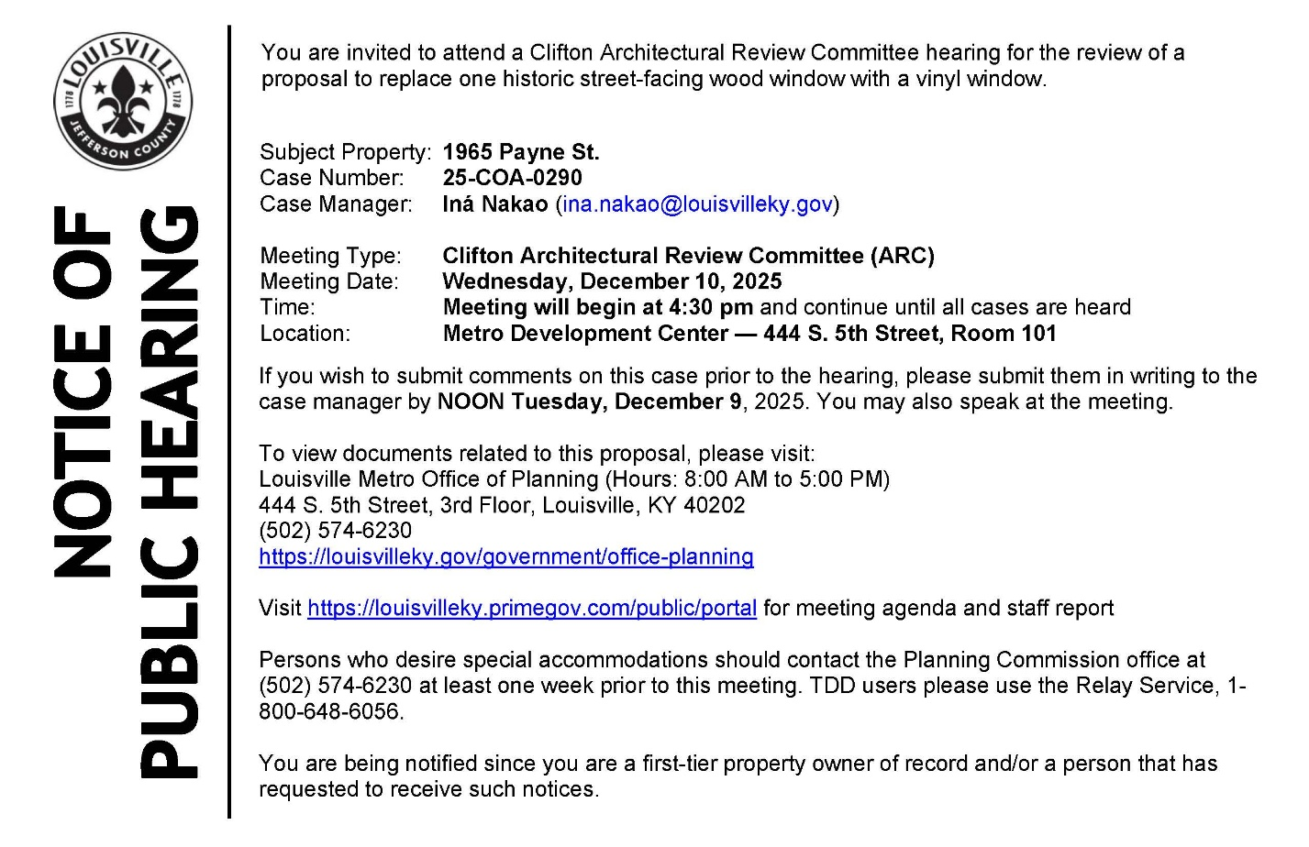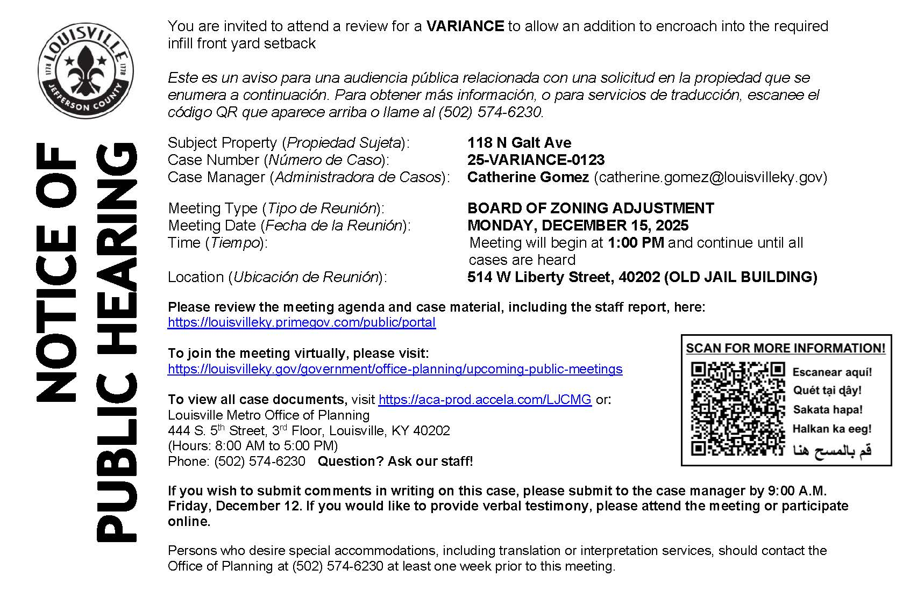
------------------------------------------------------------------------------------------------------

Alcoholic Beverage
Ad Date: 11/26/2025 | 30-Day Date: 12/26/2025
Protest must be submitted by: LMPD Division 5TH DIVISION

PUBLIC NOTICE
Daniel Regneri David Richardson, 1800 Frankfort Avenue, Louisville, KY, 40206, Hereby declares intention(s) to apply for a NQ2 Sunday Special license(s) no later than November 21, 2025. The business to be licensed will be located at 1800 Frankfort Avenue,Louisville, Kentucky 40206 doing business as Clifton Tavern. The Members are as follows: Daniel Regneri, Member 243 Delmont Avenue, Louisville, KY, 40206 David Richardson, Member 748, Greenridge Lane, Louisville, KY, 40207. Any person, association, corporation, or body politic, may protest the granting of the license(s) by writing the Department of Alcoholic Beverage Control, 500 Mero St 2NE33, Frankfort, Kentucky, 40601 , within thirty (30) days of the date of legal publication. November 26 2025 LSBN0413624
------------------------------------------------------------------------------------------------------
DOWNTOWN HOLIDAY EVENTS
Christmas Tree Lane, Waterfront Park, 301 Witherspoon St., Nov. 21 – Dec. 21
Tinsel Tavern, Pizza Bar, Fourth Street Live!, Nov. 21 – Dec. 30
Lights on Main, Frazier History Museum, Nov. 25 – Jan. 4
Murder Under the Mistletoe: A Murder Mystery Food Tour,
Whiskey Alley, 112 W Washington St., Nov. 28 – Dec. 26.
Gardens Aglimmer, Waterfront Botanical Gardens, Nov. 28 – Dec. 30
Fête De Noël Winter Holiday Festival, Paristown Point, Nov. 28 – Dec. 24
Sir Sant Applause mini photoshoot,
ROOTS-101 African American Museum, Nov. 30 – Dec. 20
Carols with the River Cities Concert Band, First Unitarian Church, Dec. 2
Holiday Cookie Decorating Class with The Louisville Cookie Company,
The Craftery DIY Studio & Bar, Dec. 2
Martinis & Mistletoe, KMAC Contemporary Art Museum, Dec. 4
A Christmas Carol, Actor’s Theatre, Pamela Brown Auditorium, Dec. 4
Krampus Cruise, Mary M. Miller, Dec. 6 & 13
Light Up Louisville, Jefferson St., between 5th and 6th streets, Dec. 6
Breakfast with Santa, Louisville Slugger Field, Dec. 6
Magic Inc. presents Nutcracker In A Nutshell, The Louisville Palace, Dec. 6
Holiday Nightmare at Caufield’s on Main Street, Caufield’s Novelty, Dec. 6 - 7
The Best Christmas Pageant Ever, KPA, Bomhard Theater, Dec. 6 – 21
Cookies with Captain Santa, Mary M. Miller, Dec. 6, 13, & 20
Stained Glass Snowflake, Kentucky Science Center, Dec. 6, 13, & 20
Sara Evans: Holiday Road Tour, The Louisville Palace, Dec. 7
NUTCRACKER! Magical Christmas Ballet, The Louisville Palace, Dec. 9
Preservation Hall Jazz Band Creole Christmas, KPA, Bomhard Theater, Dec. 10
An Acoustic Christmas with Over the Rhine, KPA, Bomhard Theater, Dec. 11
Cirque Musica Holiday Wonderland, The Louisville Palace, Dec. 12
Jon McLaughlin & Friends Home for the Holidays, KPA, Whitney Hall, Dec. 12
The Brown-Forman Nutcracker, KPA, Whitney Hall, Dec. 12 – 22
Perfect Christmas Cookies, KPA, MeX Theater, Dec. 13
Under the Streetlamp Hip to the Holidays, Brown Theatre, Dec. 14
Mr. and Mrs. Claus at Louisville Slugger Museum & Factory,
Louisville Slugger Museum & Factory, Dec. 14 & 21
Breakfast with Santa, Walker’s Exchange, Galt House, Dec. 14 & 21
An Evening with Peter Billingsley & A Christmas Story, Brown Theatre, Dec. 17
Christmas Movie in the Conservatory, The Conservatory, Galt House, Dec. 19
Lindsey Stirling: The Snow Waltz Tour, KFC Yum! Center, Dec. 19
Christmastime with Trisha Yearwood: 12 Days of Christmas Tour,
The Louisville Palace, Dec. 20
Vienna Light Orchestra Christmas Tour 2025, Louisville Memorial Auditorium, Dec. 20
Free Admission for Kids Under 12 at Louisville Slugger Museum & Factory, Louisville Slugger Museum & Factory, Dec. 20 – 23
New Year’s Eve Celebration w/ Louisville Public Media + LIVE Broadcast,
The Louisville Palace, Dec. 31
New Year’s Eve 2026 at Howl at the Moon,
Howl at the Moon, Fourth Street Live!, Dec. 31
New Year’s Eve Live!, Fourth Street Live!, Dec. 31
New Year’s Bash, Mary M. Miller, Dec. 31

District 9 Events
Computer Tune Up & Repair
Computer Tune Up & Repair Returning to the St. Matthews Eline Library. FREE computer tune-up and repair service will be offered the first Saturday of each month from 1-4 PM. Help will be limited to the first 3 persons, to make a reservation email taylor_rae@hotmail.com Participants must bring any additional devices that they may need such as a keyboard, monitor, and mouse for desk tops. If participants are bringing a laptop, please bring your battery charger.

Weekly Re-Occurring Programs at St Matthews Library:
Every Week on Mondays, 6:00-7:00 pm: English Conversation Club:
English Conversation Club allows English language learners to practice English with volunteers of native or near-native fluency. For English language learners, ECC is a great way to practice English while getting to know their neighbors and American culture.

Every Week During Library Hours at St Matthews Library: Computer Help by Appointment - Please call 574-1771 to set up an appointment with a library staff member to answer your computer questions.

Weekly Storytimes at St Matthews Library
Ages are a guide – please come on the day and time that works best for you.
Every Wednesday from 10:15-11:00 am: Baby Storytime - Ages 0 to 2.
Every Wednesday from 11:15-11:45 am: Toddler Storytime - Ages 2 to 3.
Every Thursday from 10:15-11:00 am: Preschool Storytime - Ages 3 to 5.
Every Thursday from 11:15-11:45 am: Family Storytime - Ages 0 to 6.

