RUDY LANE STREETLIGHT PROJECT
Link to legislation: https://louisville.legistar.com/LegislationDetail.aspx?ID=5216615&GUID=303D51EC-9E74-47E9-B610-49EEB25A2AD0&Options=ID|Text|&Search=O-601-21
The project:
- The project will install 5 LED streetlights along the sidewalk of Rudy Lane along the frontage of the property at 2501 Rudy Lane.
- The project is between Ambridge Drive and Regency Lane, but the project would not extend all the way to Regency Lane. It will end at the boundary of 2501 Rudy Lane. At the border of 2501 Rudy Ln. begins residential properties, and the lighting installation will not extend into these residential properties.
- The plan is to space the lights about 150’ apart with a total of 5 lights along the sidewalk to improve pedestrian safety.
- The Colonial Lights were selected by Public Works for the project and are a cost-efficient LED option.
Aerial of the sidewalk that will be lit by these lights:
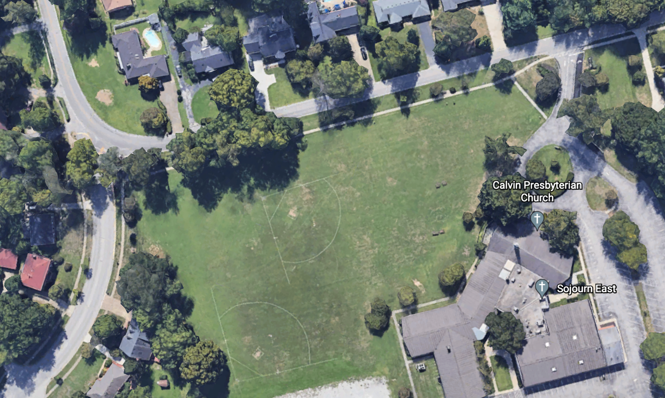

Scope of the work:
