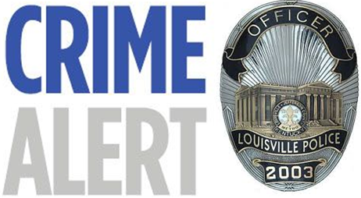
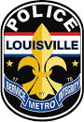
Seventh Division
Community Outreach
7201 Outer Loop
Louisville, KY 40228

***Important Notice***
Due to the cold weather in recent weeks, we have noticed an increase of Stolen Autos in the 7th Division. Most of these reports are a result of people warming their vehicles up in the morning and leaving them unattended. Please be mindful of this when you go to warm up your car on these cold winter days and follow the tips below.

- If you need to warm up your vehicle, please remain with it.
- Always make sure your doors are locked and no extra keys are left in the vehicle.
- Always make sure to remove valuables from your vehicle and if you can’t, place them in the trunk.
- If you observe suspicious activity in your neighborhood, please call LMPD.

