Important Message to FABA Members!

FABA Newsletter
October 2014
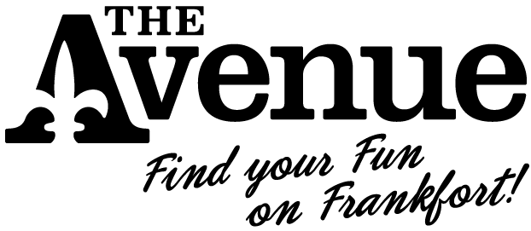
Hope everyone had a wonderful 10 year Trolley!! The weather was perfect and we had lots of visitors to the Avenue. Winner of the gift basket will be drawn at tomorrow morning’s FABA meeting. Join us at 8:30 am. FABA meetings take place at the United Crescent Hill Ministries (150 South State St.).
2014/2015 FABA maps are published!
The new FABA maps are published. If you are a Trolley Sponsor ($350 and above), contact Nancy Alvey or a FABA Board member and we will make sure you receive some. If you are not a Trolley Sponsor, you may pick them up from FABA Secretary, Kathy Schmitt, at the Crescent Hill Trading Company or from John Johnson at the Wine Rack.
Halloween on the Avenue!
Our PR firm, M2 Maximum Media, is compiling a list of “Top 5 or 10 Halloween Activities on Frankfort Avenue” to use for Facebook promotion and a media pitch. Ex: Walk Hillcrest Avenue to look at the decorations, Attend the FAT Friday Halloween Hop, etc. Please let us know if you are organizing a Halloween-themed event/activity, please send to Ali Hawthorne at ali@m2-maximummedia.com or Jennifer Montgomery at jennifer@m2maxmedia.com by this Friday, October 3rd for inclusion in a press release.
Santa Sprint on the Avenue - Old-Tyme Christmas!
The FABA sponsored 19th Annual Santa Sprint & Stroll is scheduled for Saturday, December 6, 2014. This is a major fundraiser for the United Crescent Hill Ministries (UCHM) and they are asking your support in their efforts. Founded in the wake of the Tornado of 1973, UCHM serves our neighbors with programs, activities, and services that enrich their lives physically, mentally, spiritually, and socially.
Please consider being a 2014 sponsor. A list of sponsorship levels and the sponsorship form are attached (they can also be found online at www.uchmlouky.org). Response is requested no later than November 7th. A volunteer from the Santa Sprint Sponsorship Committee will be calling you shortly to ask for your support. In the meantime, if you’d like to add your name to our list of sponsors, please call Sue Gentry at (502) 893-0346.

H

Find us on Facebook | Find us on Twitter | Find us on Instagram

Copyright © 2014 FABA
All rights reserved.

Unsubscribe

